HP DevOps Solution

Version: 1.0

DevOps R3.5 Implementation Guide

|  |  |
| --- | --- |
| Document Release Date: November, 2014  Software Release Date: November, 2014 |  |

Legal Notices

Authorized Use

Use is governed by the END USER LICENSE FOR TEMPLATE SOLUTION included with this package.

Confidential Information

The contents herein are proprietary to HP and contain HP Confidential Information. The contents may not be disclosed in whole or in part without the express written authorization of HP.

Copyright Notices

© Copyright 2014 Hewlett-Packard Development Company, L.P.

Document Information

|  |  |
| --- | --- |
| Document Title: | DevOps R3.5 Implementation Guide |
| Prepared By: | Vasil Mitov |
| Document Owner: | Ajay Nair |
| Document Version No: | 1.0 |
| Document Version Date: | 11/Nov/2014 |

Version History

|  |  |  |  |
| --- | --- | --- | --- |
| Version No. | Version Date | Revised by | Revision details |
| R.01.00 | 11/Nov/2014 | Vasil Mitov |  |
| R.01.00 | 11/Nov/2014 | Annapurna Ramala |  |
| R.01.00 | 11/Nov/2014 | Bhavya N |  |
| R.01.00 | 11/Nov/2014 | Walid Hbeika |  |
| R.01.00 | 11/Nov/2014 | Andrea Simonini |  |
|  |  |  |  |
|  |  |  |  |

Contents

Introduction 8

System requirements 9

Software components 9

Configuration requirements 13

DevOps Integration Service 15

Download the distribution file 15

Setup HP Operations Orchestration content 18

Deploy HP OO 10.x content 18

CSA Flows 19

SiteScope Flows 20

SM Flows 20

UCMDB Flows 21

OO System Accounts 22

OO System Properties 22

Setup HP Cloud Service Automation 4.1 23

Import HP CSA 4.1 Service Offerings content 23

Service Offerings 25

Identify the Organization Name, CatalogId, ServiceDefinitionId and UserName 27

Setup HP Service Manager Content 28

Backup the SM related content 28

Import the DevOps Service Manager content. 31

Verify the HP Service Manager Process Designer configuration 32

DevOps change workflows details 33

DevOpschange workflow design 33

Standard_DevOpschange workflow design 35

Normal_DevOps change workflow design 36

SM Changes for SM-ALM Synchronizer 38

Add Fields in Service Manager 38

External Access Definition on Service Manager 38

Create Sub Form 39

Add Sub Form to Problem Management 41

Add Format Control and Validation 41

Setup HP Universal CMDB content 43

Import UCMDB CI type package 43

Import the UCMDB CI type. 43

Setup HP Service Manager - HP Universal CMDB Integration 44

HP Universal CMDB Discovery probe: 44

HP Service Manager – HP Universal CMDB integration: 44

Setup HP UCMDB DevOps CIs (Business Service, Business Application, Staging Node, Production Node) 45

Setup Business Service CI: 45

Setup Business Application CI: 46

Setup Staging Node CI: 48

Setup Production Node CI: 49

Setup HP Service Manager DevOps RFCs (Release, Staging, Production) 51

Setup the required Change Models: 51

Setup new Release RFC: 53

Setup new Staging RFC: 54

Setup new Production RFC: 55

Setup HP SiteScope 57

Configure SiteScope credentials profiles 57

Import SiteScope content 58

Configure SiteScope monitor groups 59

Release 3.5 Demo Applications - iBank Java and iBank dotNet 62

3rd Party Tools configuration 63

Set up Tomcat 63

Install Tomcat 63

Set up Wget 63

Install Wget 63

Set up FlowInvoke 64

Install Flowinvoke 64

Setup Curl 64

Install Curl 64

Setup Git 64

Install Git 64

Setup Sonatype Nexus OSS 65

Install Nexus 65

Configure the custom nexus repositories for DevOps 65

Setup SCM Manager (Subversion, Git, Bazaar, etc - repository manager) 67

Install SCM 67

Create new Git repository for the iBank Java (iBank InternetBanking) application 68

Create new Git repository for the iBank dotNet (iBank Investor) application (OPTIONAL) 69

Import the iBank Java application (iBank InternetBanking) source code to the Git repository 70

Import the iBank dotNET application (iBank Investor) source code to the Git repository (OPTIONAL) 71

Setup iBank Java GIT hook to trigger Jenkins build on a new code change 72

Setup iBank dotNet GIT hook to trigger Jenkins build on a new code change (OPTIONAL) 73

Setup Maven 74

Install Maven 74

Setup Jenkins 74

Jenkins installation 74

Jenkins content installation 75

Jenkins views and jobs for DevOps (Main, Modules, Lib and Pipeline) 76

Jenkins plug-in configuration for DevOps (System Configuration) 83

Jenkins credentials configuration for DevOps (SCM/GIT/TFS repository credentials) 84

Jenkins slave configuration for DevOps (ALM, SV, MSTools slaves) 85

Jenkins jobs configuration for DevOps (Step Configuration) 88

Deploy iBank Java (iBank Internet Banking) on Tomcat 94

MS Tools configuration 96

Install Microsoft .NET Framework 96

Install Nunit 96

Install NunitASP 96

Install Microsoft Team Foundation Server 97

Install Microsoft Web Deployment Tool 97

Install Microsoft Visual Studio Professional 97

Install Microsoft Visual Studio 2010 Shell (Isolated) Redistributable Package 98

Install Microsoft Team Explorer 98

Install Git tools for Microsoft Visual Studio 98

Install HP TFS ALI service 98

Create TFS team project for iBank dotNet (iBank Investor) application 100

Import iBank dotNet (iBank Investor) source code to the TFS team project 101

Setup iBank dotNet TFS webservice hook to trigger Jenkins build on a new code change 104

Subscribe the TFS webservice hook to TFS Event 105

Deploy iBank dotNet (iBank Investor) on IIS 106

Integrate iBank dotNet (iBank Investor) and iBank Java (iBank Internet Banking) 108

Setup Enterprise Chef 111

Install Enterprise Chef Server 111

Setup Chef Client (workstation) 114

Install Chef Client 114

Install Chef Client plugins 114

Install the knife plugins 114

Configure Chef Client with Chef Server 115

Import the DevOps Chef Content 116

Setup Virtual Service using HP Service Virtualization Designer/Server 118

Configure virtual service in HP Service Virtualization Designer 118

Configure iBank dotNet (iBank Investor) to use Virtual Service 120

Start/Stop the Virtual Service simulation from Jenkins 124

Setup Eclipse 126

Install Eclipse 126

Setup eclipse with HP ALM / HP AGM /Jenkins 126

Install and configure the HP ALI DEV plugin 126

Setup Eclipse with GIT 127

Configure the iBank Java Git repository in eclipse 127

Setup Microsoft Visual studio 132

Configure the iBank-dotNet TFS repository in Visual Studio 132

Configure the iBank-dotNet-VS GIT repository in Visual Studio (OPTIONAL) 137

Configure HP Application Lifecycle Management 140

Setup DEVOPS ALM Projects. 140

HP ALM Management Setup (Build servers, SCM repositories) 142

Add Build Servers in ALM for both iBank_InternetBanking and iBank_Investing projects 142

Add SCM GIT repository in ALM for iBank_IntenetBanking project 148

Add SCM TFS repository in ALM for iBank_Investing project 152

Add SCM GIT repository in ALM for iBank_Investing project (OPTIONAL) 156

HP ALM Lab Resources Setup 160

UFT Testing Hosts 160

PC Testing Server & Hosts 163

HP ALM FunctionalTesting Setup 167

Add & Configure UFT test for iBank-Java (iBank Internet Banking). 167

Add & Configure UFT test for iBank-dotNet (iBank Investor). 169

Add & Configure UFT test for iBank-dotNet-MT (iBank Investor). 170

Configure the UFT / PC parameterized file. 172

Setup the Functional Test Set for iBank-Java (iBank Internet Banking). 173

Setup the Functional Test Sets for iBank-dotNet (iBank Investor). 175

HP ALM Testing Setup for PC 179

Add & Configure PC Tests sets in ALM for iBank-Java (iBank Internet Banking) 179

Setup the Performance Test Set for iBank-Java (iBank Internet Banking). 181

Add & Configure PC Tests sets in ALM for iBank-dotNet (iBank Investor) 186

Setup the Performance Test Set for iBank-dotNet (iBank Investor). 188

Setup HP Network Virtualization 194

iBank Java (iBank Internet Banking) performance testing with NV: 194

HP ALM Customization for SM-ALM Synchronizer and AGM-ALM Synchronizer 195

Creating Customization Template Project in ALM 195

Link existing/new ALM project to Template Project in ALM 196

Apply Customization to ALM Project 197

Setup HP AGM-ALM Synchronizer 199

Install AGM-ALM Synchronizer 199

Create Link in Synchronizer 200

Configure Release Link 202

Configure Defect Link 203

Configure Requirement Link 204

Test the Link (Requirement) 207

Test the Link (Release) 207

Setup HP SM-ALM Synchronizer 209

Install HP Synchronizer 209

Setting up HP SM-ALM Synchronizer 209

Creating link in Synchronizer 210

Define Field mappings Synchronizer 212

Test the Link in Synchronizer 213

Scheduling in Synchronizer 215

Introduction

[Introduction]

System requirements

Software components

The following table shows the major components and version requirement to use this implementation.

Table 1: Major software components required

|  |  |  |
| --- | --- | --- |
| Component | | Version |
| Hewlett-Packard: | |  |
| HP Operations Orchestration (HP OO) | | 10.10 |
| HP OO Content Packs | Virtualization | 1.1.0 |
|  | SM | 1.0.1 |
|  | HP Solutions | 1.1.2 |
|  | Cloud | 1.1.0 |
|  | Base | 1.1.1 |
|  | SA | 1.0.2 |
|  | CSA | 4.10.0000 |
|  | HP_DevOps | 1.0.2 |
| HP Cloud Service Automation(CSA) | | 4.1 |
| HP Application Lifecycle Management (HP ALM) | | 12.00 |
| HP Performance Ceter Server (HP PCS) | | 12.00 |
| HP Performance Ceter Host (HP PCH) | | 12.00 |
| HP Agile Manager (HP AGM) | | 2.10-97-OP |
| HP ALM-SM Synchronizer | | 1.60.0.1227 |
| HP ALM-AGM Synchronizer | | 0.54.0.189 |
| HP Unified Functional Testing (HP UFT) | | 12.01 |
| HP SiteScope (HP SS) | | 11.20 |
| HP Universal CMDB (HP UCMDB) | | 9.05 |
| HP Data Flow Probe (HP UCMDB DFP) | | 9.05 |
| HP Service Manager (HP SM) | | 9.30.201 |
| HP SM Content Pathes | Process Designer | 9.30.027 |
|  | UCMDB Integration | 9.30.0 |
| HP Service Virtualization (HP SV) | | 3.60 |
| HP Service Virtualization Designer (HP SVD) | | 3.60 |
| HP Network Virtualization (HP NV) | | 8.5 SP1 |
|  | |  |
| Microsoft: | |  |
| Microsoft Team Foundation Server (MS TFS) | | 2012, update 4 |
| Microsoft Team Explorer (MS TF) | | 2012, update 4 |
| Microsoft Web Deployment Tool (MS WDT) | | 3.0 |
| Microsoft .NET Framework | | 4.5 |
| Microsoft Visual Studio Professional (MS VS) | | 2012, update 4 |
| MS VS plugins | Microsoft team foundation git provider | 1.0.0.0 |
|  | |  |
| Third party: | |  |
| Enterprise Chef On-Premises | | 11.1.3 |
| Chef Client | | 11.14.2 |
| Sonatype Nexus OSS | | 2.8.1-01 |
| SCM | | 1.37 |
| Maven | | 3.2.2 |
| Git | | 1.9.1 |
| Nunit | | 2.6.3 |
| NunitASP | | 2.0 |
| Eclipse | | 4.3.2 |
| Eclipse plugins | HP ALI Dev | 3.5.0 |
| Jenkins | | 1.565.3 |
| Jenkins plugins | Ant Plugin | 1.2 |
|  | Any Build Step Plugin | 0.1 |
|  | ArtifactDeployer Plugin | 0.31 |
|  | [Build Pipeline Plugin](https://wiki.jenkins-ci.org/display/JENKINS/Build+Pipeline+Plugin) | 1.4.3 |
|  | [Cobertura Plugin](http://wiki.jenkins-ci.org/display/JENKINS/Cobertura+Plugin) | 1.9.5 |
|  | Conditional Buildstep | 1.3.3 |
|  | [Copy Artifact Plugin](http://wiki.jenkins-ci.org/display/JENKINS/Copy+Artifact+Plugin) | 1.31 |
|  | Copy To Slave Plugin | 1.4.3 |
|  | Credentials Plugin | 1.15 |
|  | CVS Plug-in | 2.12 |
|  | CVS Tagging Plug-in | 1.7 |
|  | EnvInject Plugin | 1.89 |
|  | External Monitor Job Type Plugin | 1.2 |
|  | Flexible Publish Plugin | 0.12 |
|  | Git Client Plugin | 1.10.1 |
|  | Git Parameter Plug-In | 0.3.2 |
|  | Git Plugin | 2.2.4 |
|  | Git support for Jenkins HP ALI integration | 2.2.10-133.879 |
|  | Git-notes Plugin | 0.0.4 |
|  | Groovy Postbuild Plugin | 1.10 |
|  | HP Application Automation Tools | 3.0.5 |
|  | Integration with HP ALI | 2.2.10-97-OP.1128 |
|  | Javadoc Plugin | 1.2 |
|  | Job Import Plugin | 1.2 |
|  | jQuery plugin | 1.7.2-1 |
|  | jQuery UI plugin | 1.0.2 |
|  | LDAP Plugin | 1.10.2 |
|  | Mailer | 1.10 |
|  | MapDB API Plugin | 1.0.1.0 |
|  | Matrix Authorization Strategy Plugin | 1.2 |
|  | Matrix Project Plugin | 1.3 |
|  | Maven Project Plugin | 2.5 |
|  | MSBuild Plugin | 1.24 |
|  | Nexus Task Runner Plugin | 0.9.2 |
|  | NUnit plugin | 0.16 |
|  | OWASP Markup Formatter Plugin | 1.2 |
|  | PAM Authentication Plugin | 1.1 |
|  | Parameterized Remote Trigger Plugin | 2.1.3 |
|  | Parameterized Trigger plugin | 2.25 |
|  | Prerequisite build step plugin | 1.1 |
|  | Promoted Builds Plugin | 2.17 |
|  | Quality Center Plugin | 1.2.1 |
|  | Repository Connector Plugin | 1.0.0 |
|  | ruby-runtime | 0.12 |
|  | Run Condition Extras Plugin | 0.1 |
|  | Run Condition Plugin | 1.0 |
|  | SCM API Plugin | 0.2 |
|  | SSH Credentials Plugin | 1.7.1 |
|  | SSH plugin | 2.4 |
|  | SSH Slaves plugin | 1.6 |
|  | Subversion Plugin | 2.4.1 |
|  | Subversion Tagging Plugin | 1.16 |
|  | Team Foundation Server Plug-in | 3.1.1 |
|  | TFS support for Jenkins HP ALI integration | 2.2.10-97-OP.1128 |
|  | Token Macro Plugin | 1.10 |
|  | Translation Assistance plugin | 1.11 |
|  | Windows Slaves Plugin | 1.0 |

Configuration requirements

The following configuration should be completed and tested before you can set up this implementation.

Hewlett-Packard:

* HP Operations Orchestration must be installed with the required content packs.
* HP Cloud Service Automation must be installed and configured with required content packs.
* HP Service Manager with Process Designer and UCMDB Integration pack must be installed.
* HP Universal CMDB must be installed with DDM advanced license.
* HP Data Flow Probe must be installed.
* HP Application Lifecycle Management must be installed.
* HP Agile Manager must be installed
* HP ALM-SM Synchronizer must be installed.
* HP ALM-AGM synchronizer must be installed.
* HP Unified Functional Testing must be installed.
* HP Performance Center Server and Host must be installed and configured.
* HP SiteScope must be installed.
* HP Service Virtualization Server and Designer must be installed.
* HP Network Virtualization Server must be installed.
* HP TFS ALI service must be installed on the TFS server

Microsoft:

* Microsoft Team Foundation Server must be installed.
* Microsoft .NET Framework must be installed on the TFS server.
* Microsoft Web Deployment tool must be installed on the TFS server.
* Microsoft Visual Studio Professional must be installed with all required plugins.
* Microsoft Visual Studio 2010 Shell (Isolated) Redistributable Package must be installed on the TFS server.
* Microsoft Team Explorer must be installed on the TFS server.
* Git tools for Microsoft Visual Studio must be installed.

VMWare:

* VMWare vCenter must be available.
* VMWare Windows (Server 2008R2) and Linux (Ubuntu 14.04.1 LTS) templates and customizations scripts must be available.

Third party:

* Enterprise Chef On-Premises must be installed.
* Chef Client must be installed and configured on the Jenkins server.
* Git must be installed.
* Sonatype Nexus OSS must be installed and the required DevOps repositories must be created.
* Jenkins must be installed with all required plugins.
* Maven must be installed on the Jenkins server.
* Nunit must be installed on the TFS server.
* NunitASP must be installed on the TFS server.
* Wget, Curl and Zip must be installed on the Jenkins server.
* Eclipse IDE must be installed with all required plugins.

DevOps Integration Service

Download the distribution file

Download the distribution zip file **DevOps_R3.5_Solution.zip** and unpack it in a temporary location. The files listed in the following table are included in the distribution zip file.

Table 2: Contents of the distribution file

|  |  |  |  |
| --- | --- | --- | --- |
| Folder | | File name | Description |
| Content files | hp_oo | HP_DevOps-cp-1.0.2.jar | HP Operations Orchestration 10.x Content Pack |
| hp_csa | SO_VCENTER_R3.5.zip | HP CSA Service Offering export - Provision Windows and Linux servers in vCenter. |
| SO_VCENTER_R3.5_Windows.zip | HP CSA Service Offering export - Provision Windows server in vCenter. |
| SO_VCENTER_R3.5_Linux.zip | HP CSA Service Offering export - Provision Linux server in vCenter. |
| hp_sm | DevOps_R3.5_script.unl | HP Service Manager unload script |
| DevOps_R3.5_content.unl | HP Service Manager unload content |
| hp_ucmdb | business_application.xml | HP UCMDB custom device type for the Business Application CI type |
| DataPush_TQLs_SM9.x_adapter.zip | HP UCMDB custom TQL files for the Data Push to HP Service Manager |
| hp_sitescope | sitescope_R3.5 | HP SiteScope monitor templates |
| hp_pc | iBank_JAVA_PC.zip | PC scripts for iBank Java (iBank Internet Banking) web application |
| iBank_dotNet_PC.zip | PC scripts for iBank dotNet (iBank Investor) web application |
| hp_uft | iBank-JAVA-FT.zip | UFT scripts for iBank Java (iBank Internet Banking) web application |
| iBank-dotNet-without-Integration.zip | UFT scripts for iBank dotNet (iBank Investor) web application |
| iBank-dotNet-with-Integration.zip | UFT scripts for iBank dotNet (iBank Investor) & iBank Java (iBank Internet Banking) web application integration |
| PC_UFT_Test.dat | UFT / PC configuration file with iBank web application parameters |
| hp_alm | ALMSync_Template.qcp | SM – ALM - AGM Customization template |
| jenkins | configuration_R3.5.zip | Sample jenkins views, jobs, slaves, users and configurations for R3.5 |
| git | post-receive | GIT post-receive hook example script for Linux |
| tfs | TFSJenkinsService.zip | TFS webservice hook example package for IIS |
| ALI27_UG.pdf | HP ALI TFS Installation and configuration guide. |
| chef | cookbooks.zip | Sample recipes and templates for Deploying/Re-Deploying iBank applications on Windows Server 2008R2 and Linux Ubuntu 14.04 VM templates. |
| chef | roles.zip | Sample roles for Deploying/Re-Deploying iBank applications on Windows Server 2008R2 and Linux Ubuntu 14.04 VM templates. |
| eclipse | HPAliDevForEclipse_3.5.0_InstallationGuide.pdf | HP ALI DEV installation guide |
| Connecting_to_HP_ALM_Quality_Center.html | HP ALI DEV configuration guide |
| iBank | iBank-dotNet.zip | iBank Investor source files |
| iBank-Java.zip | iBank Internet Banking source files |
| webapps |  |
| Installation files | jenkins | jenkins.war | Jenkins installation file |
| flowinvoke | flowinvoke.pl | Perl script to trigger OO from Jenkins |
| maven | apache-maven-3.2.2-bin.tar.gz | Maven installation archive |
| nexus | nexus.war | Nexus installation archive |
| scm | scm.war | SCM manager installation archive |
| nunit | NUnit-2.6.3.msi | Nunit install package |
| NUnitAsp-2.0.zip | NunitASP install package |
| Documentation | DevOps_R3.5_Implementation_Guide 0.1.docx | | DevOps R3.5 implementation document |
| HP_Network_Virtualization_R3.5_Guide.docx | | HP NV guide for iBank Java (iBank Internet Banking) performance testing |
| HP_UCMDB_9_05_Data_Flow_Probe_Installation_Guide.docx | | UCMDB Data Flow Probe installation document |
| HP_SM_UCMDB_Integration_SM9.x_adapter_R3.5_Guide | | HP SM – UCMDB Integration and configuration document |

Setup HP Operations Orchestration content

Deploy HP OO 10.x content

To deploy the HP Operations Orchestration (HP OO) Content, complete the following steps:

1. Open the HP Operations Orchestration Central URL.

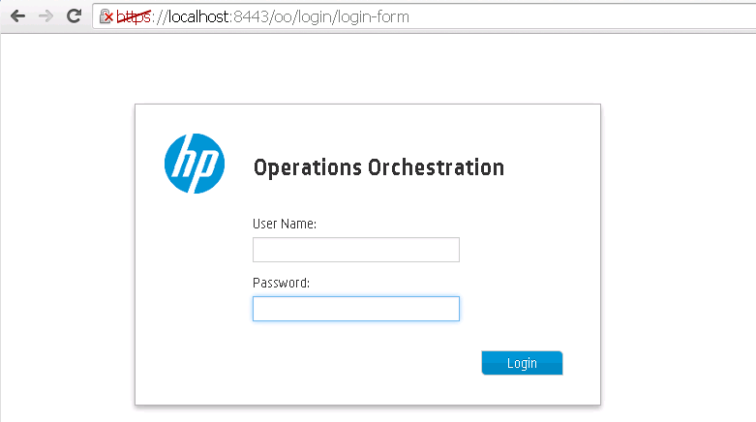

1. Log on using an account with administrator privileges.
2. Click **Content Management** > **Content Packs** and verify the following Content Packs are already present.

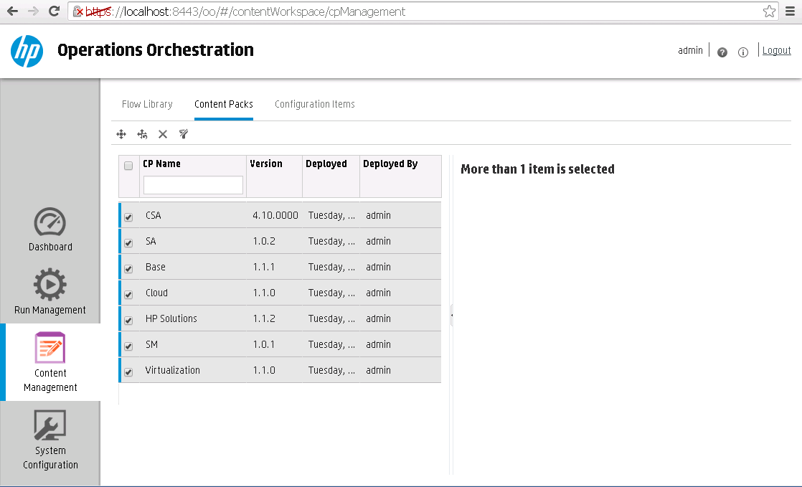

1. Click the  button to deploy new content pack. In the **Deploy New Content** dialog browse to select the **HP_DevOps-cp-1.0.2.jar** file in the **Content Files > hp_oo** folder.

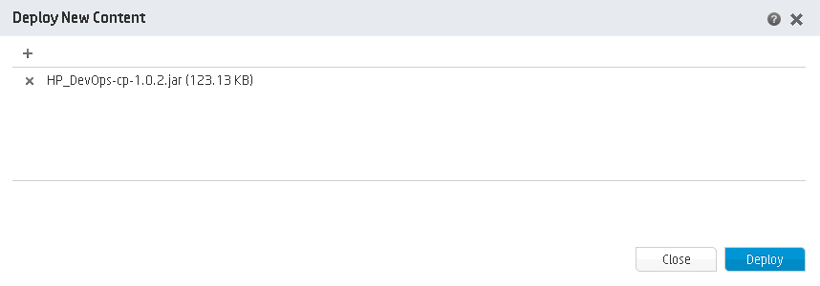

1. Click Deploy. The Import process will start.
2. Expand the **HP_DevOps** content pack Library tree to check the new workflows.

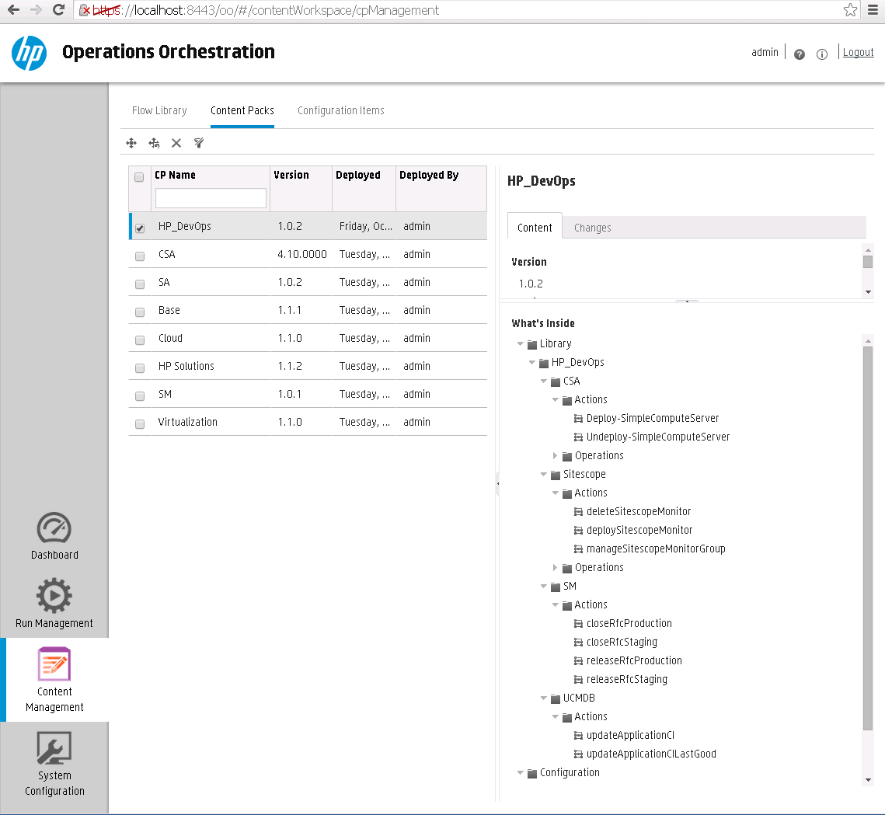

Flows introduction

CSA Flows

|  |  |
| --- | --- |
| Added Flows | Description |
| Deploy-SimpleComputeServer | This flow will deploy new virtual machine(s) from VMWare template(s), by executing published Service in the CSA Consumer portal.  **Important:** To create new virtual machine(s) in vCenter, the vCenter resource provider should be configured in CSA.  This flow requires the following inputs: *DevOpsCsaUser, CatalogId, Organization, ProjectName, ServiceDefinitionId*  **Note**: In CSA, the deployed virtual machine’s using this flow will have a default valid period of 24 hours. |
| Undeploy-SimpleComputeServer | This flow will undeploy virtual machine(s), by cancelling the subscribed Service in the Consumer portal of CSA.  This flow requires the following inputs: *svcSubscriptionId* |

SiteScope Flows

|  |  |
| --- | --- |
| Added Flows | Description |
| deploySitescopeMonitor | This flow will deploy a SiteScope template monitor to a selected host or list of hosts, based on the provided inputs for *sitescopeHostname*, *sitescopePort*, *sitescopeProtocol*,*destinationPath*,*monitorHostList* and *delimiterHostsList*.  The SiteScope template must be manually created and provided in the *sourcePath* parameter. |
| deleteSitescopeMonitor | This flow will delete a SiteScope monitor from a selected host, based on the provided inputs for  *sitescopeHostname*, *sitescopePort*, *sitescopeProtocol*, *monitorGroupPath*,*monitorGroupDelimiter*,*remoteServerName*and *remoteServerPlatform*. |
| manageSitescopeMonitorGroup | This flow will enable or disable SiteScope template monitor(s) on a selected host, based on the provided inputs for *sitescopeHostname, sitescopePort, sitescopeProtocol, monitorGroupState, monitorGroupPathList* and *delimiterMonitorGroupPathList.* |

SM Flows

|  |  |
| --- | --- |
| Added Flows | Description |
| closeRfcStaging | This flow will close a specific DevOps staging RFC ticket based on the provided input for *rfcId*.  The DevOps staging RFC must be manually created in SM, by using the *Standard_DevOps* workflow. The change ticket must be in the *Execution* phase and all mandatory fields needs to be populated. |
| closeRfcProduction | This flow will close a specific DevOps production RFC ticket based on the provided input for *rfcId*.  The DevOps production RFC must be manually created in SM, by using the *Normal_DevOps* workflow. The change ticket must be in the *Deployment* phase and all mandatory fields needs to be populated. |
| releaseRfcStaging | This flow will update the DevOps release RFC ticket phase based on the provided input for *rfcId*.  The DevOps release RFC must be manually created in SM, by using the *DevOps* workflow. The change ticket must be in one of the following phases:  *Change Approval* – if this is the first promotion to staging from Jenkins.  *Change Implementation - Promoted to ST* – if this is not the first promotion to staging from Jenkins. |
| releaseRfcProduction | This flow will update the DevOps release RFC ticket phase based on the provided input of *rfcId*.  The DevOps release RFC must be manually created in SM, by using the *DevOps* workflow. The change ticket must be in the *Change Implementation - Promoted to ST* phase. |

UCMDB Flows

|  |  |
| --- | --- |
| Added Flows | Description |
| updateApplicationCI | This flow will update the DevOps application CI attributes (*devops_version, devops_status*), based on the provided inputs for *applicationCiName, applicationCiStatus, majorVersion* and *buildNumber*.  The DevOps application CI must be manually created in UCMDB, using the *BusinessApplication* CI type. |
| updateApplicationCILastGood | This flow will update the DevOps application CI attribute (*devops_lastgood*), based on the provided inputs for *applicationCiName, majorVersion* and *buildNumber*.  The DevOps application CI must be manually created in UCMDB, using the *BusinessApplication* CI type. |

OO System Accounts

|  |  |
| --- | --- |
| Added Flows | Description |
| CSA_REST_CREDENTIALS | The HP CSA REST credentials. This account is used to communicate to the CSA using the REST APIs  A sample value for this system account is: Username : *admin* Password : *cloud* |
| DevOpsSmAccount | HP Service Manager credentials. This account will be used to update the DevOps change tickets based on build requests from Jenkins.  A sample value for this system account is: Username : *falcon* Password : |
| DevOpsUcmdbAccount | HP Universal CMDB credentials. This account will be used to update the DevOps CIs in UCMDB, based on build requests from Jenkins.  A sample value for this system account is: Username : *admin* Password : *admin* |
| DevOpsSiteScopeAccount | HP SiteScope credentials. This account will be used to configure the DevOps monitoring in SiteScope, based on build requests from Jenkins.  A sample value for this system account is: Username : *admin* Password : *admin* |

OO System Properties

|  |  |
| --- | --- |
| Added Flows | Description |
| CSA_CONSUMPTIONAPI_URI | The URI for the recently introduced CSA 4.X REST APIs.  Sample Value: *https://<CSA_SERVER_IP>:8444/csa/api* |
| CSA_OO_USER | The OO User defined in CSA to get the user identifier id , which is required to communicate to CSA using REST API  Sample Value: *admin* |
| CSA_REST_URI | The REST URI for CSA.  Sample Value : *https://<CSA_SERVER_IP>:8444/csa/rest* |
| DevOpsSmHost | HP Service Manager hostname  Sample Value : *<SM_SERVER_IP*> |
| DevOpsUcmdbHost | HP Universal CMDB hostname  Sample Value : *<UCMDB_SERVER_IP>* |

Setup HP Cloud Service Automation 4.1

Import HP CSA 4.1 Service Offerings content

To import the HP Cloud Service Automation (HP CSA) Content, complete the following steps:

1. Open the HP Cloud Service Automation Management Console portal.
2. Log on using an account with administrator privileges and click on **Offerings**.

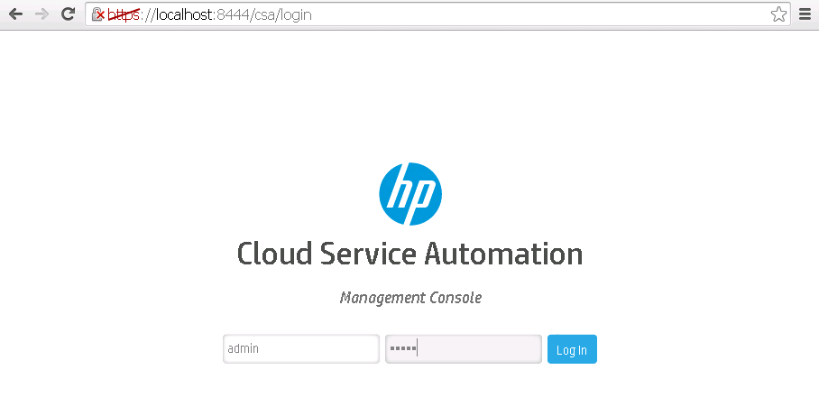

1. Click **Import**.

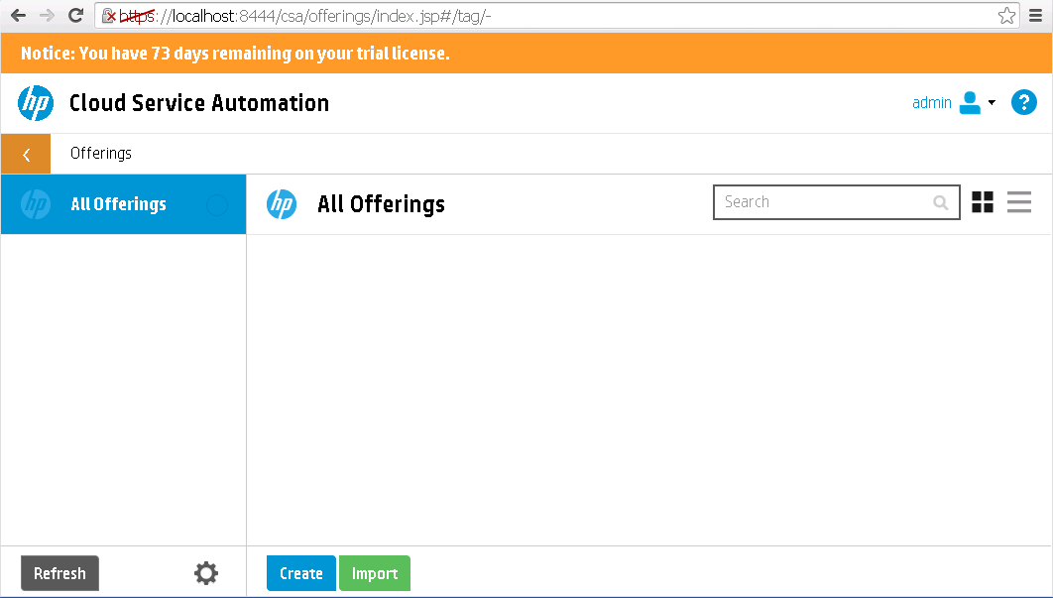

1. In the **Import Offering** dialog browse to select the **SO_VCENTER_R3.5.zip** file in the **Content Files > hp_csa** folder. Click **Import**.

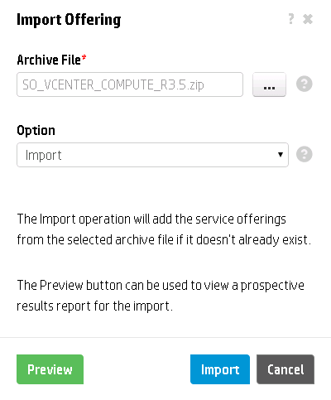

1. Repeat the same step for the other two Service Offerings:

* **SO_VCENTER_R3.5_Linux.zip**
* **SO_VCENTER_R3.5_Windows.zip**

1. Verify the three Service Offerings are imported successfully.

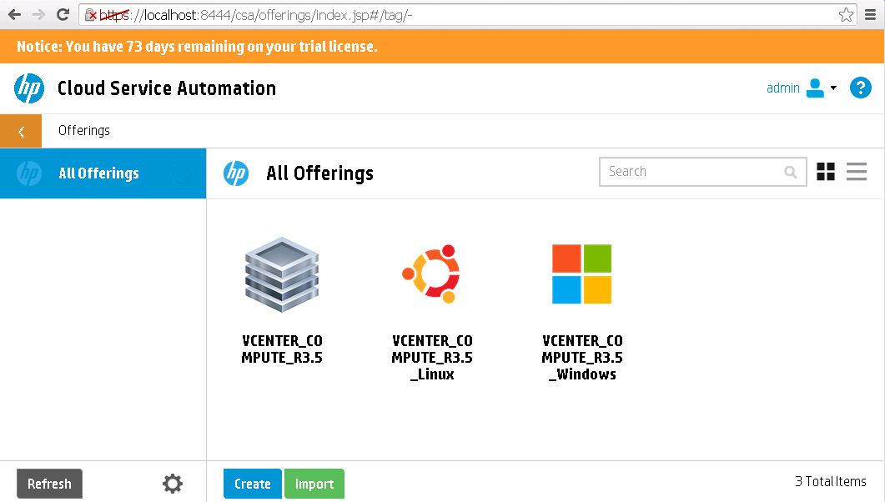

**Note**: See the table below for the descriptions on the imported service offerings

|  |  |
| --- | --- |
| Name | Description |
| VCENTER_COMPUTE_R3.5 | HP Cloud Service Offering which is designed to deploy one Windows server and one Linux server using predefined VMWare templates. |
| VCENTER_COMPUTE_R3.5_Linux | HP Cloud Service Offering which is designed to deploy only one Linux server using predefined VMWare template. |
| VCENTER_COMPUTE_R3.5_Windows | HP Cloud Service Offering which is designed to deploy only one Windows server using predefined VMWare template. |

1. Publish the three Service Offerings in the CSA Global Shared Catalog.
2. On the HP Operations Orchestration server, verify that the CSA content pack is installed.  
   **Note:** The Solution is only tested with CSA Content Pack version 4.10.0000.
3. On the HP Cloud Service Automation server, verify the OO flows for CSA were already mapped with the Process Definiton Tool.

For more details on how to use this tool, please follow the Process Definition Tool guide supplied in the CSA documentation.

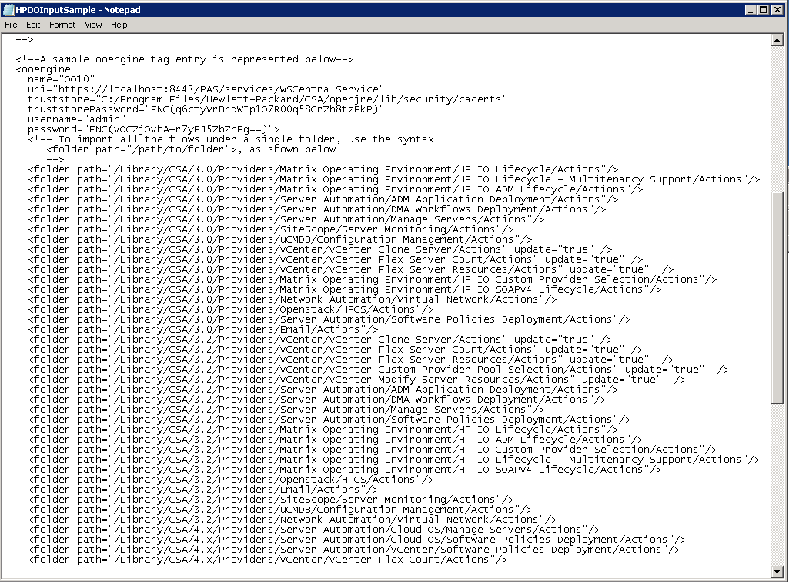

1. In the CSA Management Console, click on **Designs > Sequenced > Designer**. Verify that the following Service Designs are present:

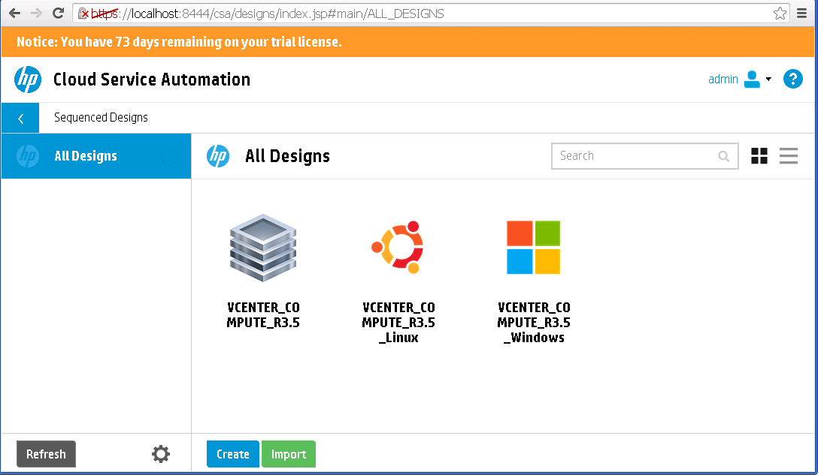

1. Click on one of Designs, and select **Designer**. Configure the **Server** component properties based on your environment.

Figure 5: CSA Service Designs

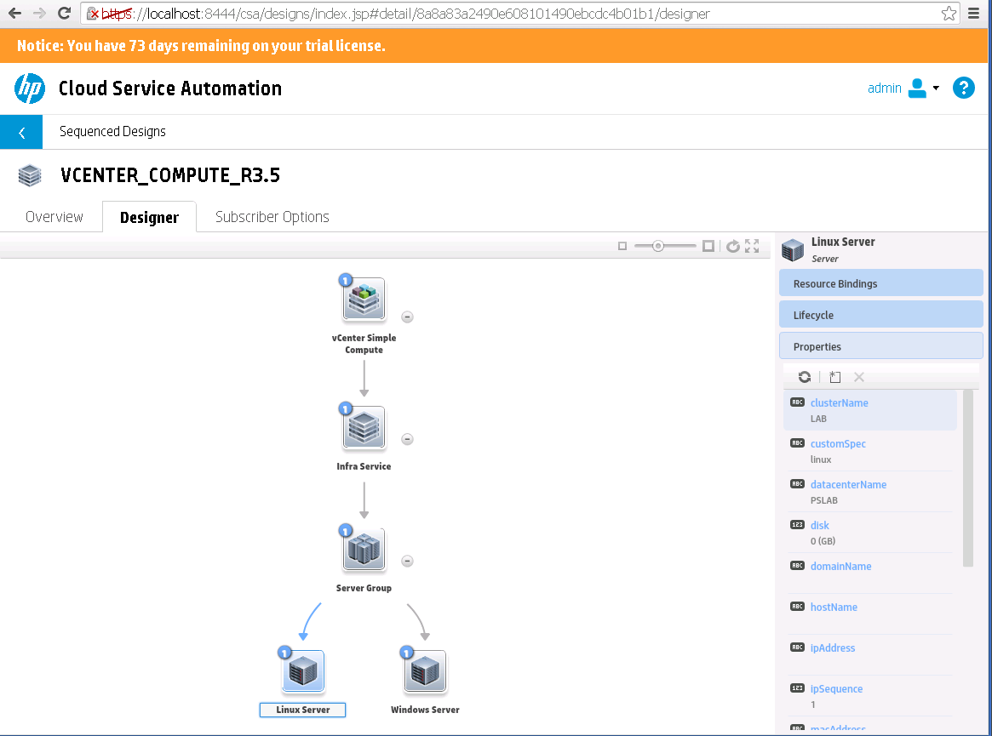

1. Repeat the same step for the other two Service Designs:

* **VCENTER_COMPUTE_R3.5_Linux**
* **VCENTER_COMPUTE_R3.5_Windows**

Identify the Organization Name, CatalogId, ServiceDefinitionId and UserName

Identify and make a note of the following details:

|  |  |
| --- | --- |
| Configuration Items | Description |
| OrganizationName | HP CSA Organization Name used for the DevOps project  Sample Value : *CSA_CONSUMER* |
| CatalogId | The Id of the Catalog where the Service Offerings are published  Sample Value : *90d9650a36988e5d0136988f03ab000f* |
| DevOpsCsaUser | HP CSA Marketplace Consumer user for the Organization  Sample Value : *consumer* |
| ServiceDefinitionIds | The Id of the three Service Definitions Listed in the Catalog of the Marketplace portal   * VCENTER_COMPUTE_R3.5 Sample Value : *8a8a83a2490e608101490ed23b58026c* * VCENTER_COMPUTE_R3.5_Linux   Sample Value : *8a8a83a2491d974c014937d6fcb52e35*   * VCENTER_COMPUTE_R3.5_Windows   Sample Value *: 8a8a83a2491d974c014937d76b7f2e48* |

Setup HP Service Manager Content

Backup the SM related content

It is a good practice to back up the SM related content, before the **DevOps_R3.5**_**content** unload is imported. To achieve that, complete the following steps:

1. Login to the HP Service Manager windows client with an administrator user.
2. Type **db** in the command window on top left corner and click the **run** button.

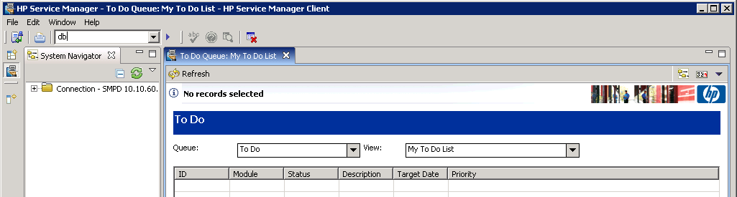

1. In the new **Database Manager** window, right click on the blank area and choose **import/load**.

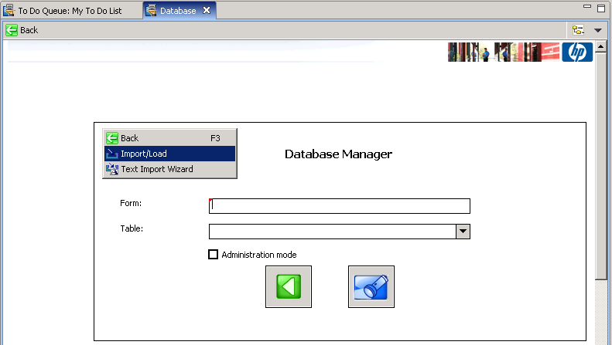

1. Browse to select the unload script **DevOps_R3.5_script.unl** file in the **Content Files > hp_sm** folder.
2. Click **load FG** to load the unload script in SM.

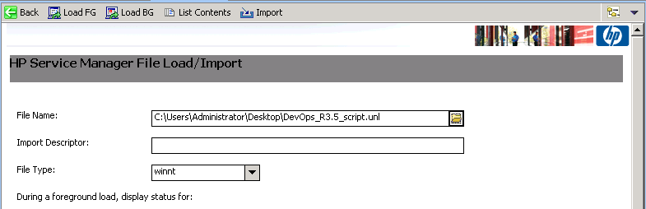

1. Check the message window for any errors.
2. Type **unload** in the command window on top left corner and click the **run** button.

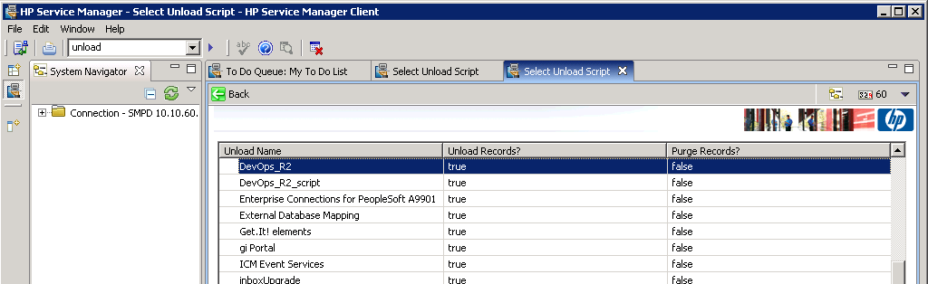

1. Scroll down and double click on the **DevOps_R2** unload in the list to see the script content.

**Note:** The internal unload script name is DevOps_R2.

Service Manager will show the unload script definition and all objects that will be modified. 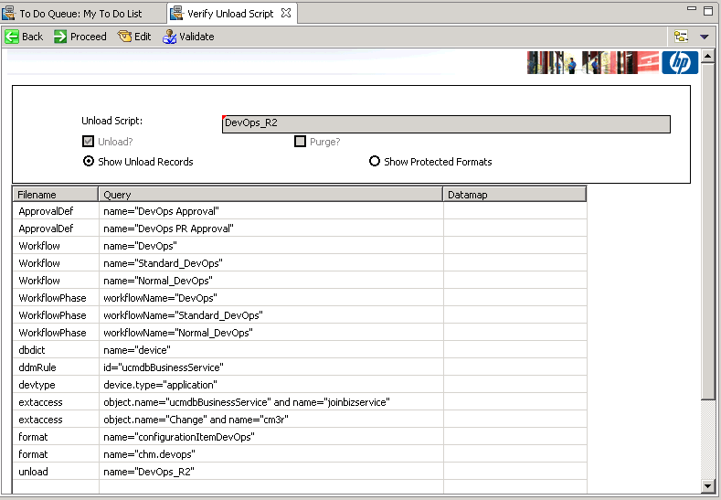

1. Review the list. If needed create new unload script with all items, which are already present in your SM instance and you want to backup.

The SM content could override the following objects:

* The dbdict of table **device**
* The web service definition of **ucmdbBusinessService**
* The web service definition of **Change**
* DEM rules definition for **ucmdbBusinessService**
* The devtype for **application**

To archive the selected items before the changes, open the new unload script and click the **Proceed** button.

On the next screen, click the  button, create a backup file, and then click Open. Make sure all options are selected like on the picture below. Click **Proceed** to back up the selected objects.

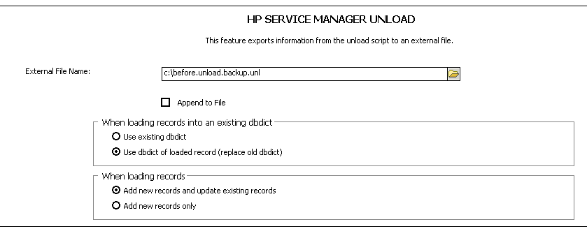

**Notes:** It is highly recommended to test and verify the SM content import into a non-production environment first.

This solution works with SM Server 9.30.201 with Process Designer content patch.

Import the DevOps Service Manager content.

1. Login to the HP Service Manager windows client with an administrator user.
2. Type **db** in the command window and click the **run** button.



1. In the new **Database Manager** window, right click on the blank area and choose **import/load**.



1. Browse to select the unload script **DevOps_R3.5_content.unl** file in the **Content Files > hp_sm** folder.
2. Click **load FG** to load the content in SM.

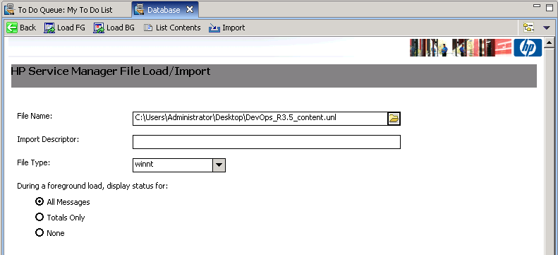

Check the message window in SM clients for any import errors.

Verify the HP Service Manager Process Designer configuration

This solution is designed to work with an SM instance that has the Process Designer (PD) installed.

Complete the steps below, to verify the SM Process Designer configuration in your environment

**Note**: Make sure the Process Designer is enabled for your Change Management module. Check with your SM administrator to ensure that the PD content patch released by HP is already installed.

1. Login to the SM web client with an administrator account
2. Go to the menu **Change Management > Configuration > Change Workflows**. If you can see the list of workflows, it means the PD is installed and ready for use:

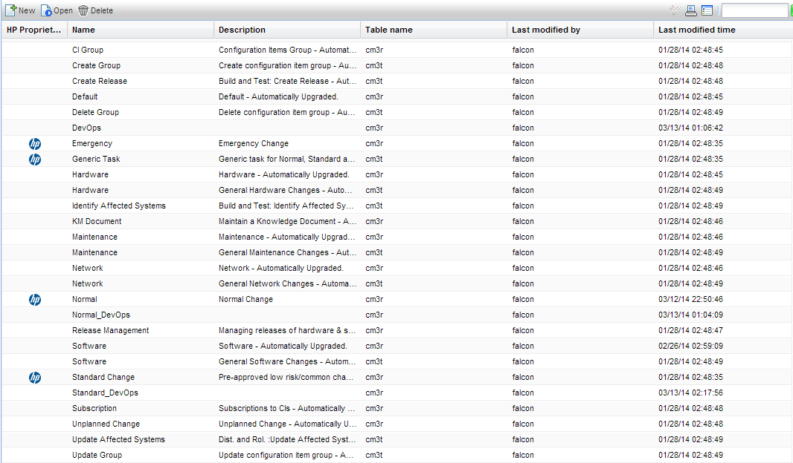

Make sure the highlighted DevOps workflows were imported in the Change Management module

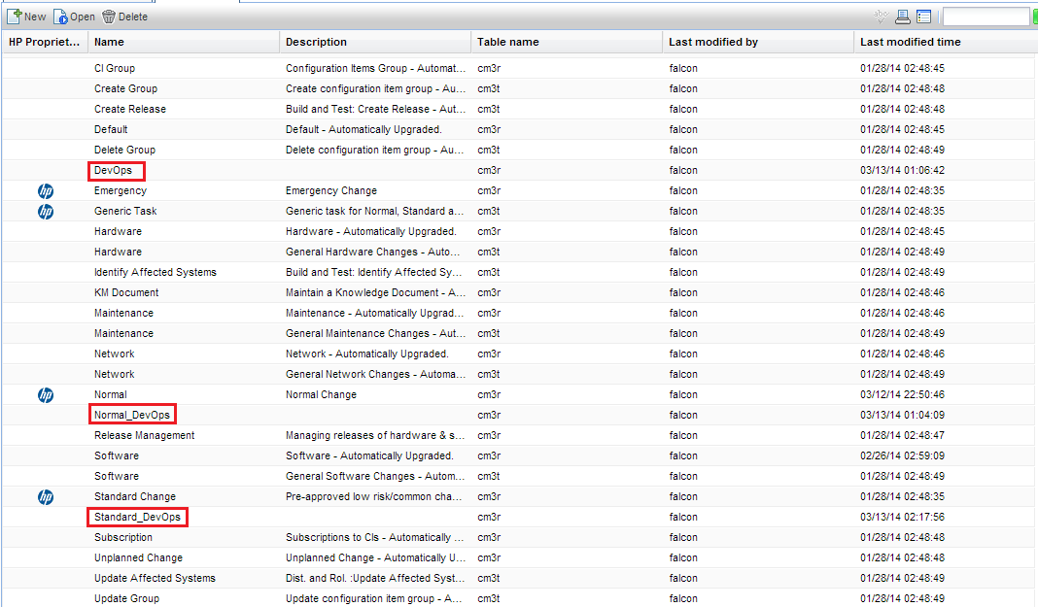

DevOps change workflows introduction

The following custom workflows are required by this solution. Each workflow is designed with different phases to accommodate the requests started from Jenkins.

DevOpschange workflow design

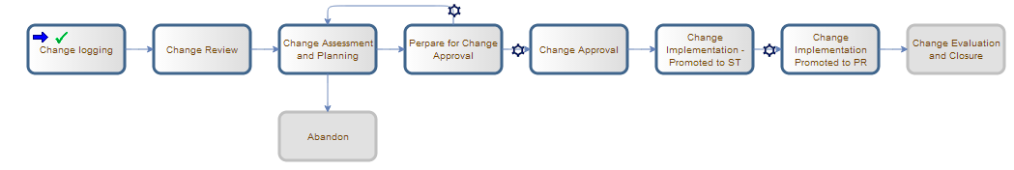

This change workflow is designed to track the DevOps release status. It must be set up before the actual code development is started and manually configured to the **Change Approval** phase, providing the required information and approvals:

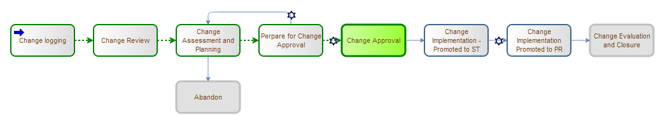

The release workflow is required to allow or deny each Jenkins promotion to staging or production.

To allow Jenkins promotion to staging, the release RFC must be in one of the following phases:

* + - If this is the first promotion to staging – **Change Approval**
    - If this is not the first promotion to staging – **Change** **Implementation – Promoted to ST**

To allow Jenkins promotion to production, the release RFC must be in the **Change Implementation Promoted to PR** phase.

ReleaseRFC example**:**

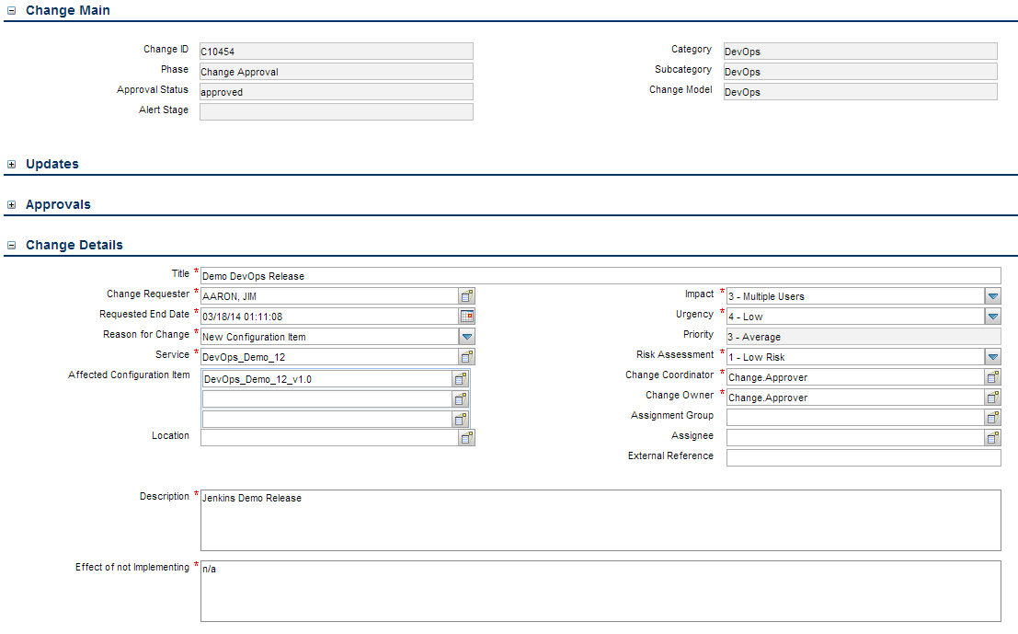

ReleaseRFC fields**:**

|  |  |  |
| --- | --- | --- |
| RFC field | Example Value | Description |
| Title | DevOps Project - Demo | SM RFC title |
| Change Requester | FALCON, JENNIFER | SM RFC change requester |
| Requested End Date | 10/10/14 20:00:00 | SM RFC requested end date |
| Reason for Change | New Configuration Item | SM RFC reason for change |
| Service | DevOps_Business_Service | The Business Service CI created in UCMDB for this DevOps project |
| Affected Configuration Item | DevOps_Application | The Application CI created in UCMDB for this DevOps project |
| Impact | 3-Multiple Users | SM RFC impact |
| Urgency | 1 –Low Risk | SM RFC urgency |
| Change Coordinator | Change.Approver | SM RFC change coordinator |
| Change Owner | Change.Approver | SM RFC change owner |
| Category | DevOps | SM RFC category |
| Subcategory | DevOps | SM RFC subcategory |
| Change Model | DevOps | SM RFC change model |
| Phase | Change Approval | SM RFC phase must be Change Approval before the DevOps project is started in Jenkins |
| Approval Status | approved | SM RFC must be approved before the DevOps project is started from Jenkins |
| Description | Demo | SM RFC description |
| Effect of not Implementing | N/A | SM RFC effect of not implementing |

Standard_DevOpschange workflow design

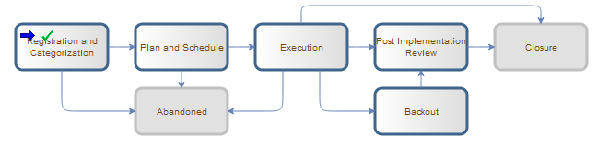

This change workflow is designed to track artifact deployment to a staging environment. Before the Jenkins deployment request is triggered, a new **staging** RFC must be created and manually moved to the **Execution** phase:

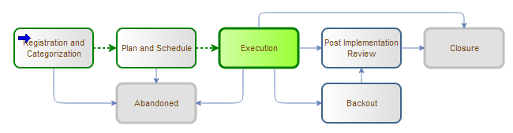

The number of this RFC must be configured in Jenkins, before each manual promotion to staging. If the artifact deployment is successful the RFC will be automatically closed, otherwise it won’t be updated.

Staging RFC example**:**

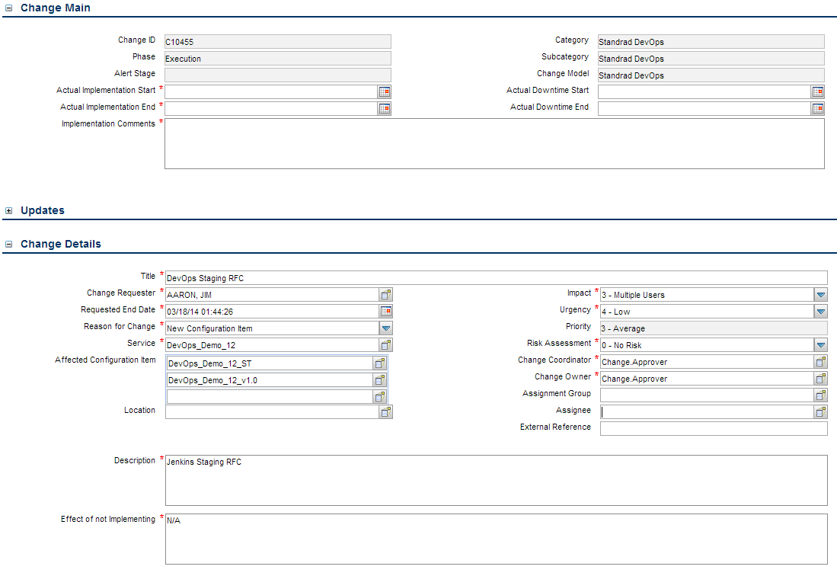

StagingRFC fields:

|  |  |  |
| --- | --- | --- |
| RFC field | Example Value | Description |
| Title | DevOps Project - Staging | SM RFC title |
| Change Requester | FALCON, JENNIFER | SM RFC change requester |
| Requested End Date | 10/10/14 20:00:00 | SM RFC requested end date |
| Reason for Change | New Configuration Item | SM RFC reason for change |
| Service | DevOps_Business_Service | The Business Service CI created in UCMDB for this DevOps project |
| Affected Configuration Item | DevOps_Application | The Application CI created in UCMDB for this DevOps project |
| DevOps_Staging | The Staging Computer CI created in UCMDB for this DevOps project |
| Impact | 3-Multiple Users | SM RFC impact |
| Urgency | 1 –Low Risk | SM RFC urgency |
| Priority | 3 - Average | SM RFC priority |
| Risk Assessment | 0 – No Risk | SM RFC risk assessment |
| Change Coordinator | Change.Approver | SM RFC change coordinator |
| Change Owner | Change.Approver | SM RFC change owner |
| Category | Standard DevOps | SM RFC category |
| Subcategory | Standard DevOps | SM RFC subcategory |
| Change Model | Standard DevOps | SM RFC change model |
| Phase | Execution | SM RFC phase must be Execution before the deployment to staging is triggered from Jenkins |
| Description | Demo | SM RFC description |
| Effect of not Implementing | N/A | SM RFC effect of not implementing |

Normal_DevOps change workflow design

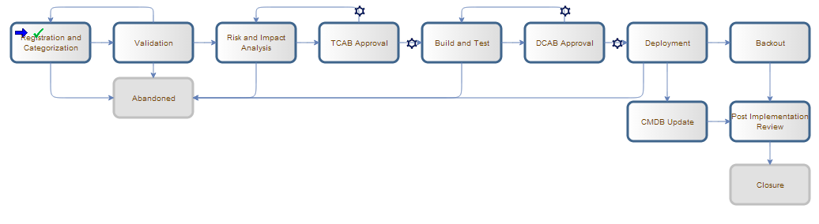

This change workflow is designed to track single artifact deployment to production environment. Before the Jenkins deployment request is triggered, the **production** RFC must be created and manually moved to the **Deployment** phase:

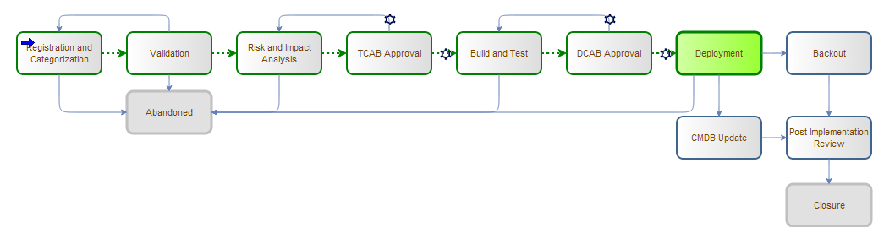

The number of this RFC must be configured in Jenkins, before each manual promotion to production. If the artifact deployment is successful the RFC will be automatically closed, otherwise it won’t be updated.

Production RFC example:

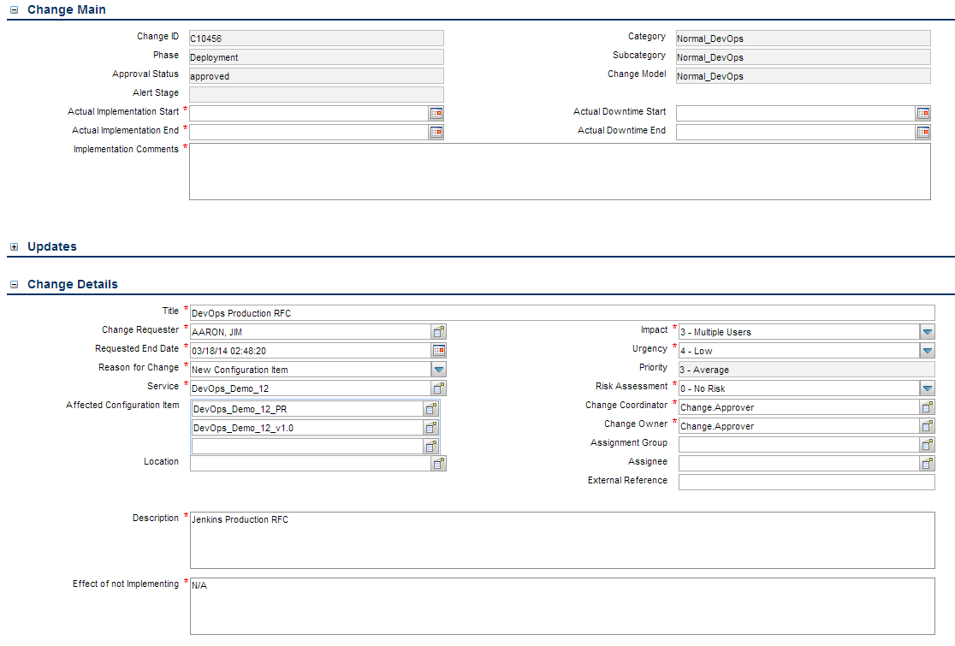

Production RFC fields:

|  |  |  |
| --- | --- | --- |
| RFC field | Example Value | Description |
| Title | DevOps Project - Production | SM RFC title |
| Change Requester | FALCON, JENNIFER | SM RFC change requester |
| Requested End Date | 10/10/14 20:00:00 | SM RFC requested end date |
| Reason for Change | New Configuration Item | SM RFC reason for change |
| Service | DevOps_Business_Service | The Business Service CI created in UCMDB for this DevOps project |
| Affected Configuration Item | DevOps_Application | The Application CI created in UCMDB for this DevOps project |
| DevOps_Production | The Production Computer CI created in UCMDB for this DevOps project |
| Impact | 3-Multiple Users | SM RFC impact |
| Urgency | 1 –Low Risk | SM RFC urgency |
| Priority | 3 - Average | SM RFC priority |
| Risk Assessment | 0 – No Risk | SM RFC risk assessment |
| Change Coordinator | Change.Approver | SM RFC change coordinator |
| Change Owner | Change.Approver | SM RFC change owner |
| Category | Normal_DevOps | SM RFC category |
| Subcategory | Normal_DevOps | SM RFC subcategory |
| Change Model | Normal_DevOps | SM RFC change model |
| Phase | Deployment | SM RFC phase must be Deployment before the deployment to Production is triggered from Jenkins |
| Approval Status | Approved | SM RFC approval status |
| Description | Demo | SM RFC description |
| Effect of not Implementing | N/A | SM RFC effect of not implementing |

SM Changes for SM-ALM Synchronizer

To customize Service Manager for Problem Management, following tasks need to be performed.

1. Add new fields
2. Specify External Access Definition on SM
3. Create SubForm to hold ALM field values and add the same to Problem Management Form
4. Add format control and validations on the Sub form

Add Fields in Service Manager

Following new fields with respect to ALM has to be added in rootcausetable.

|  |  |
| --- | --- |
| Field | Service Manager |
| qcintegration.type | Character |
| qcintegration.id | Number |
| qcintegration.project | Character |

External Access Definition on Service Manager

1. Create a custom External Access Definition **QCIntProblemService** by clicking **Tailoring** **> Web Services** **> WSDL configuration** on Service Manager.
2. Set the External Access Definition as the table below

|  |  |
| --- | --- |
| Field | Value |
| Service Name | QCIntProblemService |
| Name | rootcause |
| Object Name | QCIntProblem |
| Alowed Action/Action Names | Add/Create |
| Alowed Action/Action Names | Save/Update |



1. Enable following fields in Web service

|  |  |  |
| --- | --- | --- |
| Field | Caption | Type |
| id | ProblemID | StringType |
| sysmodtime | Modified | DateTimeType |
| qcintegration.id | QCEntityID | IntType |
| qcintegration.project | QCProject | StringType |
| qcintegration.type | QcIntegrationType | StringType |
| severity | Severity | StringType |
| description | Description | StringType |



1. Define following expressions for Webservice

* cleanup($pm.activity);cleanup($rc.update);if same(update in $L.file, update in $L.file.save) then ($L.need.to.update=true)
* $rc.update=update in $L.file;if (denull($rc.update)={}) then ($rc.update={"QC update sent"})
* if ($L.need.to.update=true) then ($rc.update={"QC update sent"})
* update in $L.file=update in $L.file.save



Create Sub Form

1. Create a global list by clicking **Tailoring** **>** **Tailoring Tools** **>** **Global Lists** on Service Manager with the following parameters

|  |  |
| --- | --- |
| **Parameter** | **Value** |
| List Name | SMQC Integration PM Project List |
| Regen Every | 1 00:00:00 |
| Build List on startup? | Yes (Check box) |
| List Variable | $G.qcintegration.problem.project |
| User Defined List? | Yes (Check box) |
| Value List | {"server1/domain1/project1", "server2/domain2/project2"} |

1. Save Global list and click Rebuild Global List on the menu
2. Create sub-form **pm.qcint.subform** with the following components by clicking **Tailoring** **>** **Forms** **Designer** on Service Manager.

|  |  |  |
| --- | --- | --- |
| **S.No.** | **Component** | **Properties** |
| 1 | Label | Caption: Synchronize with QC: |
| 2 | Combo Box | Input: qcintegration.type  Value List: 0;1;  Display List: 0 - Not Synchronize;1 - Synchronize with QC Defect  Select Only: Yes  Read-Only Condition: [$qcint.type.readonly] |
| 3 | Label | Caption: Defect ID: |
| 4 | Text | Input: qcintegration.id  Read-Only: Yes |
| 5 | Label | Caption: Server/Domain/Project: |
| 6 | ComboBox | Input: qcintegration.project  Value List: $G.qcintegration.problem.project  Read-Only Condition: [$qcint.project.readonly]  Mandatory Condition: [qcintegration.type]>0 |



Add Sub Form to Problem Management

1. From Forms Designer, search and open the default form of a Problem Management phase (PM.Problem.logging, PM.problem.investigation)

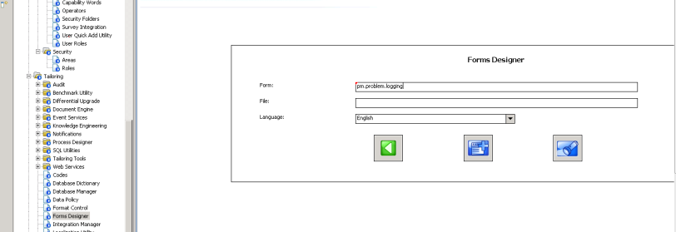

1. Click on Design to go to Design mode for the form

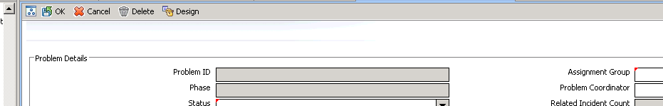

1. Add a section in *Problem Details*  and name it QC Integration

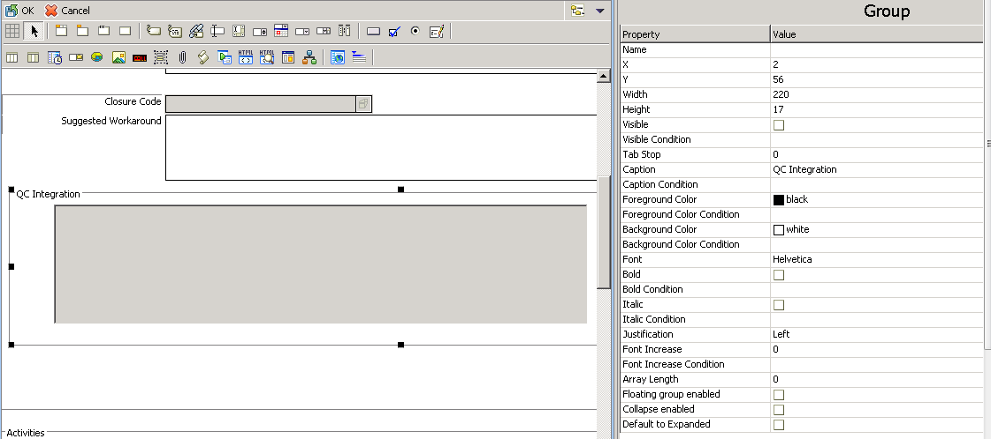

1. Add Sub-form to the QC Integration section and align it.

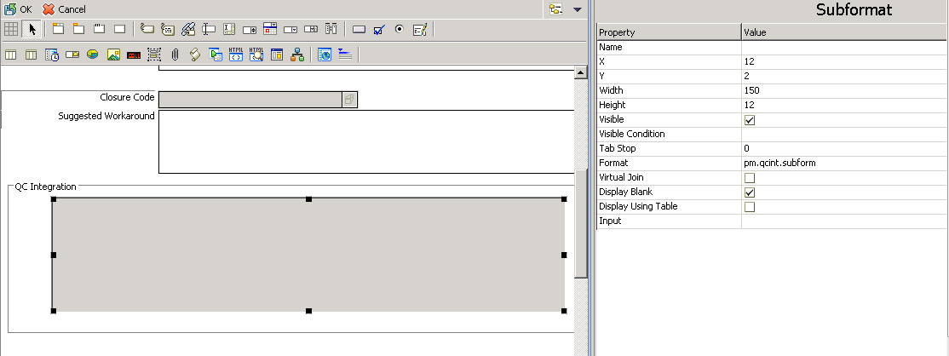

1. Save the changes.
2. This has to be done on two forms – **pm.problem.logging** and **pm.problem.investigation**

Add Format Control and Validation

1. Open the format control on the above main forms
2. Click **calculations** and add following 2 rows

|  |  |  |
| --- | --- | --- |
| **Record** | **Parameter** | **Value** |
| 1 | Display | True |
| Initial | True |
| Calculation | $qcint.type.readonly=2;if (qcintegration.type in $file~=0) then  ($qcint.type.readonly=1) |
| 2 | Display | True |
| Initial | True |
| Calculation | $qcint.project.readonly=2;if (qcintegration.type in $file~=0 and not  null(qcintegration.project in $file)) then ($qcint.project.readonly=1) |

1. Click **validations** and add one row with following values:

|  |  |
| --- | --- |
| **Parameter** | **Value** |
| Validation | not null(qcintegration.project in $file) |
| Message | The Server/Domain/Project is required |
| Add | qcintegration.type in $file~=0 |
| Update | qcintegration.type in $file~=0 |
| Set Focus To | qcintegration.project |

Setup HP Universal CMDB content

Import UCMDB CI type

The import process will affect the **Business Application** CI type in your UCMDB environment. So if you already made some modifications for this CI type, do a backup before the import.

Business Application CI type changes:

* New attribute - devops_version
* New attribute - devops_status
* New attribute - devops_lastgood

1. Login to your UCMDB environment with administrative account.
2. Click on **Managers >****Modeling** **>** **CI Type Manager**
3. Click import XML, then browse to select the **business_application.xml**  file in **Content Files > hp_ucmdb** folderand start the import:

* manage objects->Configuration Item->Business Element->business application

Setup HP Service Manager - HP Universal CMDB Integration

HP Universal CMDB Discovery probe:

To set up the HP Universal CMDB discovery probe, please read and follow the steps in the provided document:

**DevOps_R3.5_Solution\Documentation\HP_UCMDB_9_05_Data_Flow_Probe_Installation_Guide.**

HP Service Manager – HP Universal CMDB integration:

To set up the integration between HP Universal CMDB and HP Service Manager, please read and follow the steps in the provided document:

**DevOps_R3.5_Solution\Documentation\HP_SM_uCMDB_Integration_SM9.x_adapter_R3.5_Guide**.

Setup HP UCMDB DevOps CIs

There are four UCMDB CIs, which are required by the DevOps solution. They should be creted manually, before the Jenkins pipeline is triggered for first time.To set up the required DevOps UCMDB CIs, please complete the following steps:

Setup Business Service CI:

To set up the DevOps UCMDB Business Service CI:

1. Login to your UCMDB environment with administrative account.
2. Click **Managers >****Modeling** **>** **IT Universe Manager**.
3. Click **Operations** **>** **New** **CI**.
4. Click **Managed Object > ConfigurationItem > BusinessElement > Service > BusinessService**.
5. Enter **Name** and Description for the new BS CI:

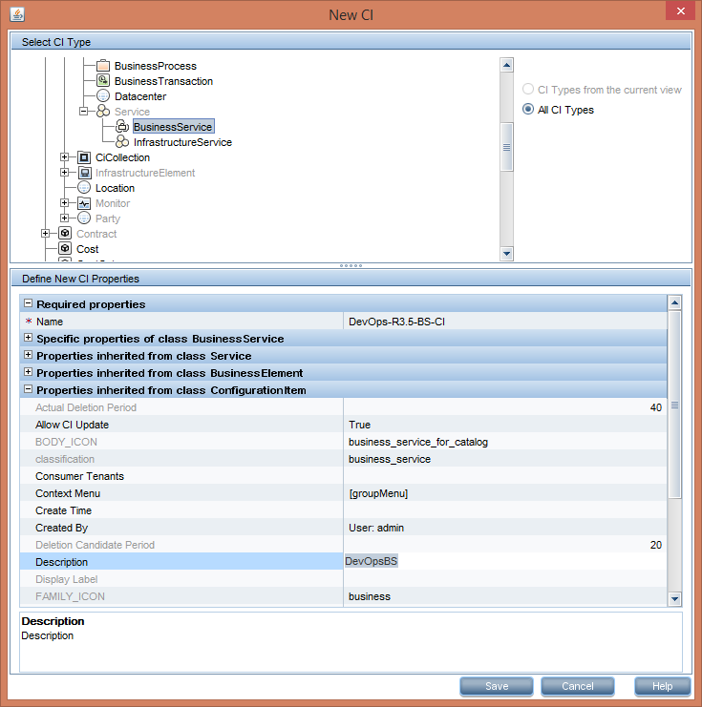

**Important:** the **Description** must be **DevOpsBS**, since it is used to define the CI type, when this CI is synchorized to Service Manager.

1. Click **Save** and close the New CI window.
2. Search for the newly created BS CI to confirm.

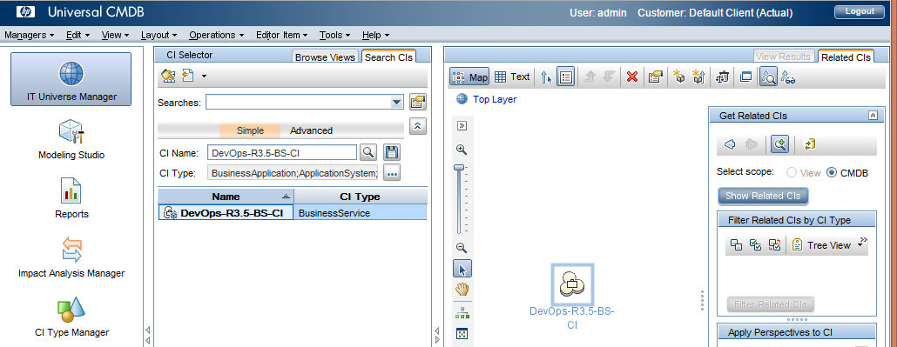

Setup Business Application CI:

To set up the DevOps UCMDB Business Application CI:

1. Search for the newly created BS CI, from the previous step:



1. Select the **DevOps-R3.5-BS-CI** and click **Operations** **>** **New** **Related** **CI**.
2. Click **Managed Object > ConfigurationItem > BusinessElement > BusinessApplication**.
3. Enter **Name** and **Description** for the new BA CI**:**

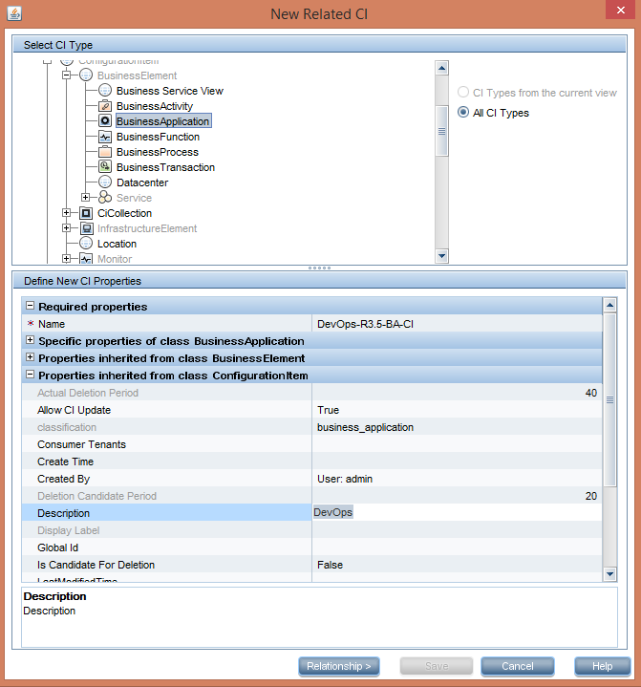

**Important:** The **Description** must be **DevOps**, since it is used to define the CI type, when this CI is synchorized to Service Manager.

1. Click **Relationship** and select **Containment**,then click **Save** andclose the New Related CI window.

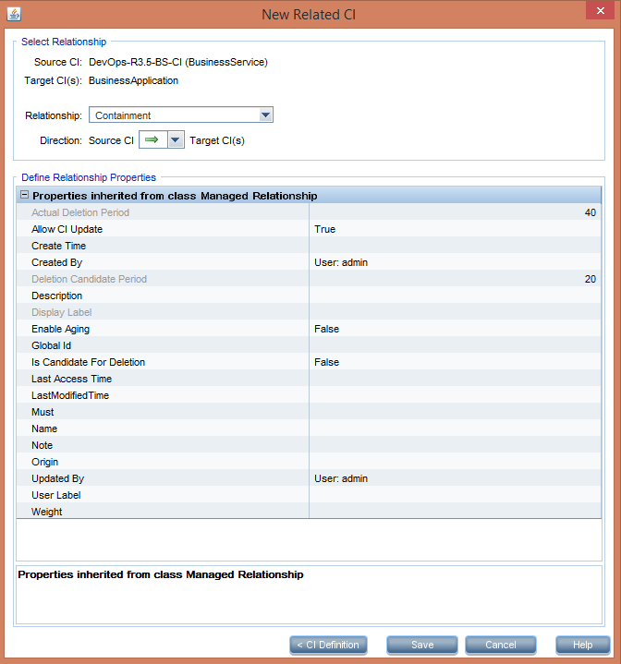

1. Note down the Business Application CI, since it should be configured in the DevOps main project DevOps-R3.5-1-BUILD.

Setup Staging Node CI:

To set up the DevOps UCMDB Staging Node CI:

1. Search for the newly created BA CI, from the previous step:

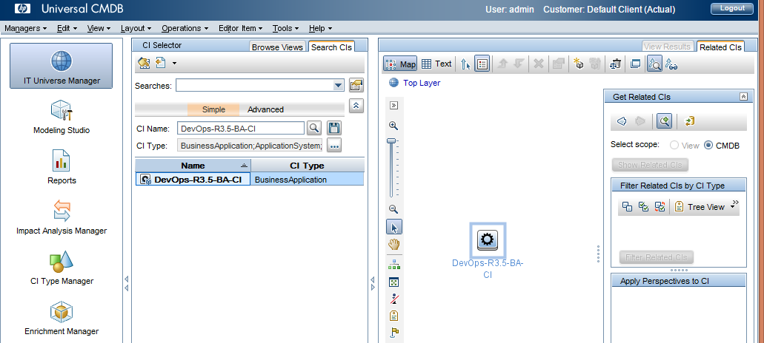

1. Select the **DevOps-R3.5-BA-CI** and click **Operations** **>** **New** **Related** **CI**.
2. Click **Managed Object > ConfigurationItem > InfrastructureElement > Node**.
3. Enter **Name** and **Description** for the new Node CI**:**

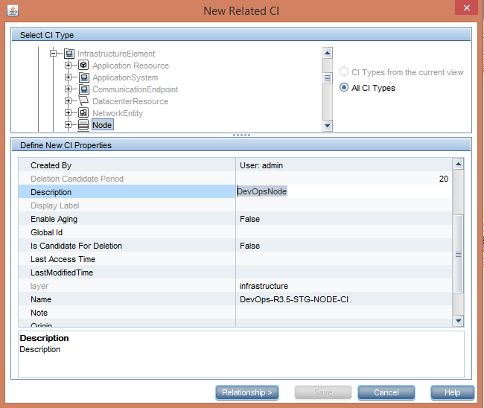

**Important:** The **Description** must be **DevOpsNode**, since it is used to define the CI type, when this CI is synchorized to Service Manager.

1. Click **Relationship** and select **Containment**,then click **Save** andclose the New Related CI window.

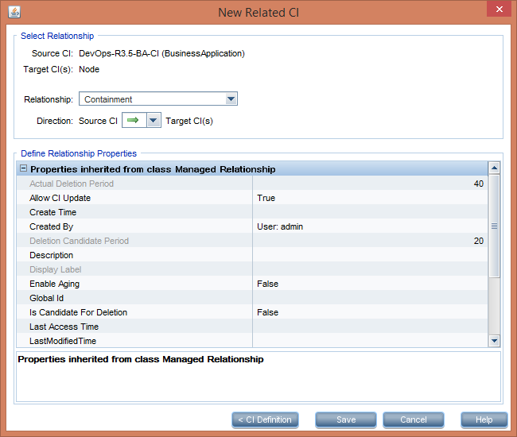

Setup Production Node CI:

To set up the DevOps UCMDB Production Node CI:

1. Search for the newly created BA CI, from the previous step:



1. Select the **DevOps-R3.5-BA-CI** and click **Operations** **>** **New** **Related** **CI**.
2. Click **Managed Object > ConfigurationItem > InfrastructureElement > Node**.
3. Enter **Name** and **Description** for the new Node CI**:**

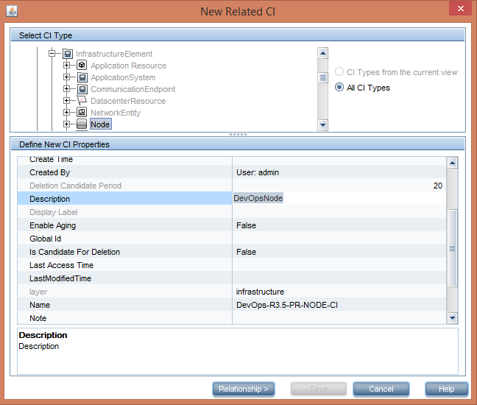

**Important:** The **Description** must be **DevOpsNode**, since it is used to define the CI type, when this CI is synchorized to Service Manager.

1. Click **Relationship** and select **Containment**,then click **Save** andclose the New Related CI window.



Setup HP Service Manager DevOps RFCs

There are three SM RFCs, which are required by the DevOps solution. They should be creted manually, before the Jenkins pipeline is triggered for first time and for each new application release. To set up the required DevOps RFCs, please complete the following steps:

Setup the required Change Models:

There are three Change Models that must be created manually, to allow RFC creation for the new DevOps change workflows. To create those change models, complete the following steps:

1. Login to HP Service Manager web client:
2. Go to **Change Management > Configuration > Change Models** and create the following Change Models:

**DevOps Model:**

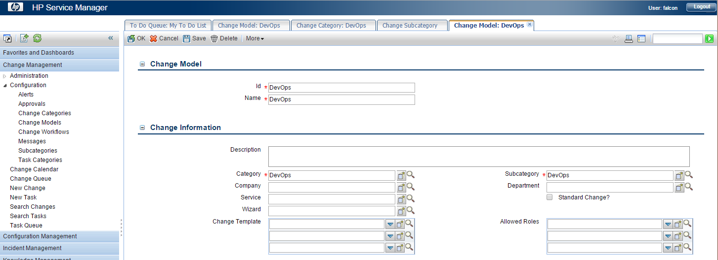

DevOps Category, required by the DevOps Model:

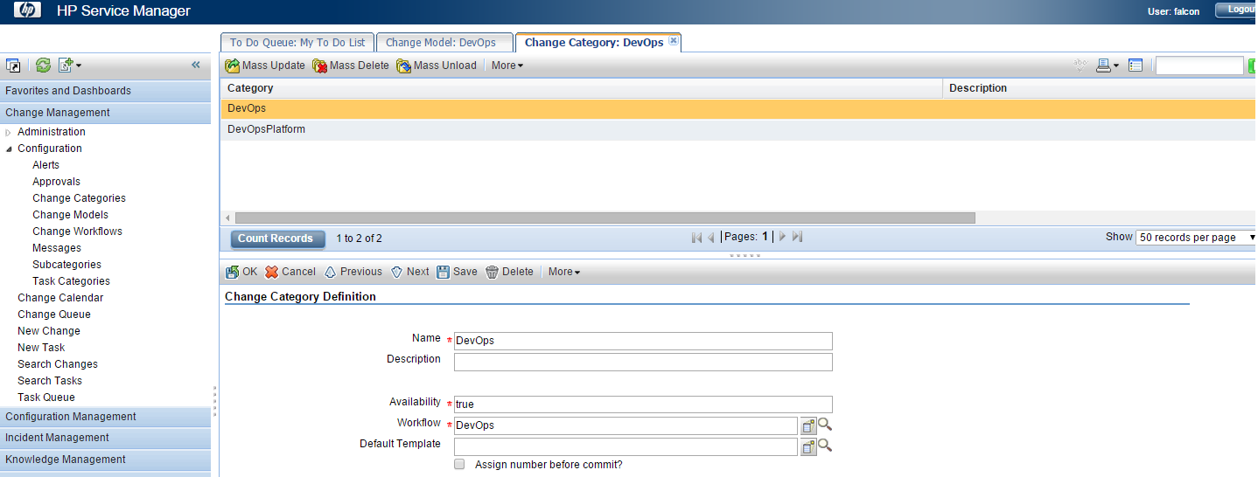

DevOps Subcategory, required by the DevOps Model:

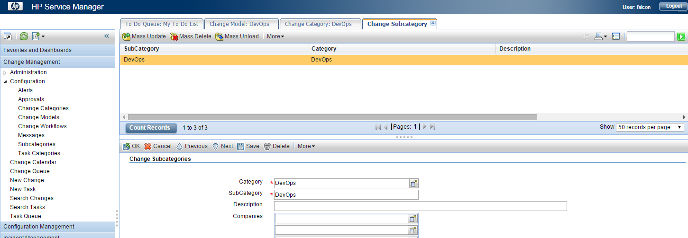

**Standard DevOps Model:**

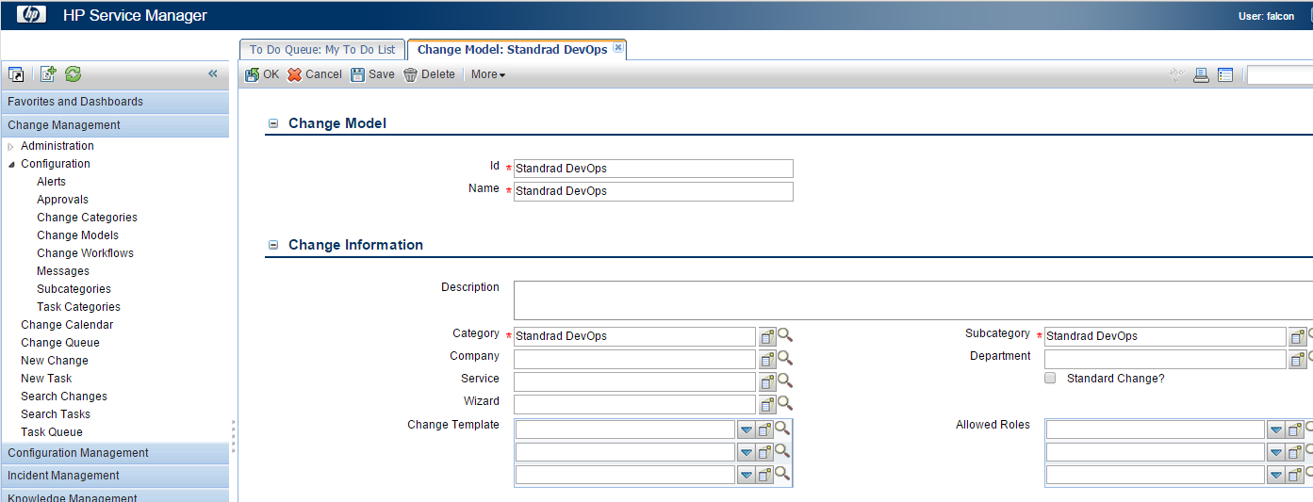

Standard DevOps Category, required by the Standard DevOps Model:

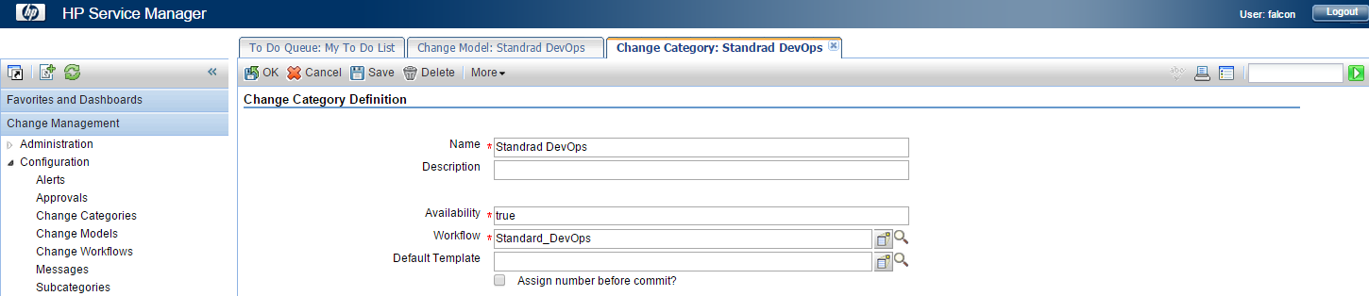

Standard DevOps Subcategory, required by the Standard DevOps Model:

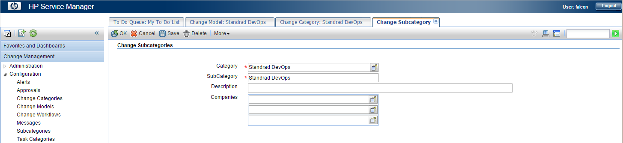

**Normal DevOps Model:**

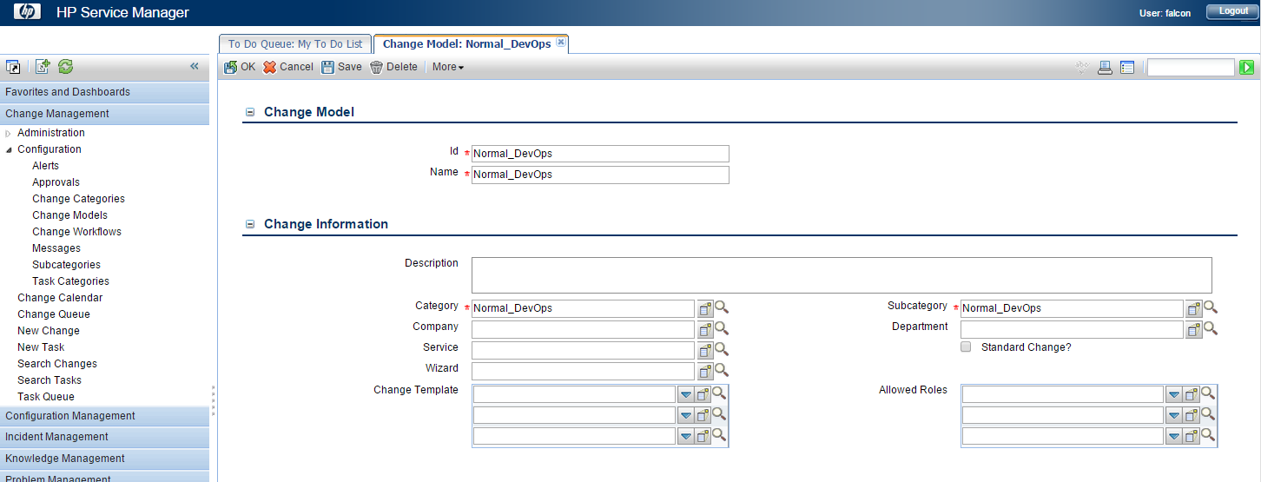

Normal DevOps Category, required by the Normal DevOps Model:

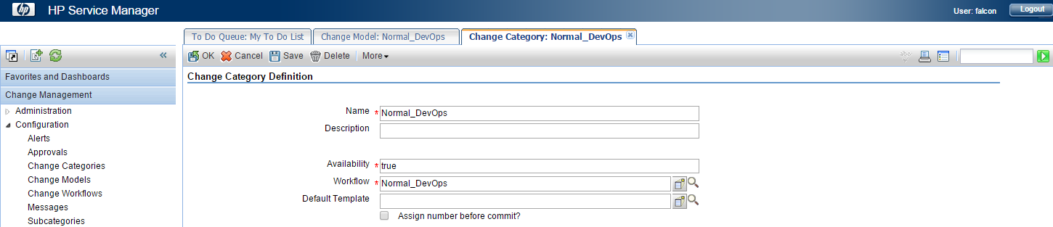

Normal DevOps Subcategory, required by the Normal DevOps Model:

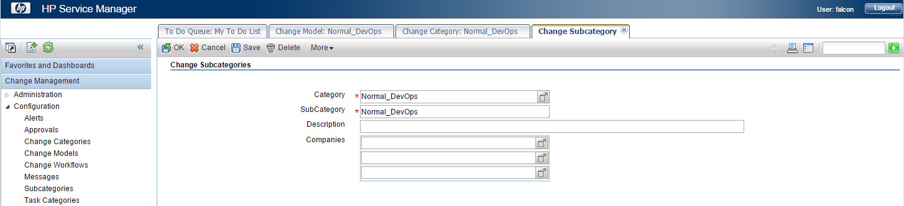

1. All required Change Models are now created and the new DevOps RFCs can be created in the next sections.

Setup new Release RFC:

To set up new DevOps SM Release RFC:

1. Login to HP Service Manager web client:
2. Click **Change Management > New Change** and select:

Category: DevOps

Subcategory: DevOps

1. Click the **DevOps** change model to create new RFC with DevOps change workflow.

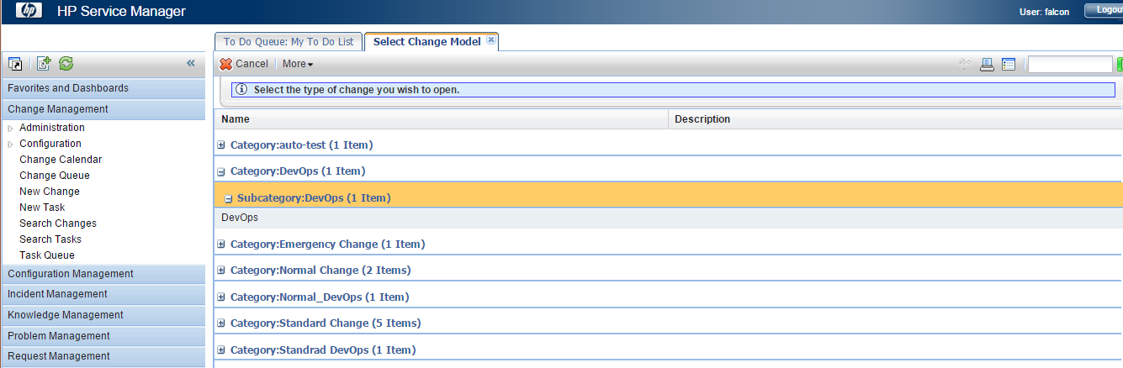

1. Enter all mandatory fields.

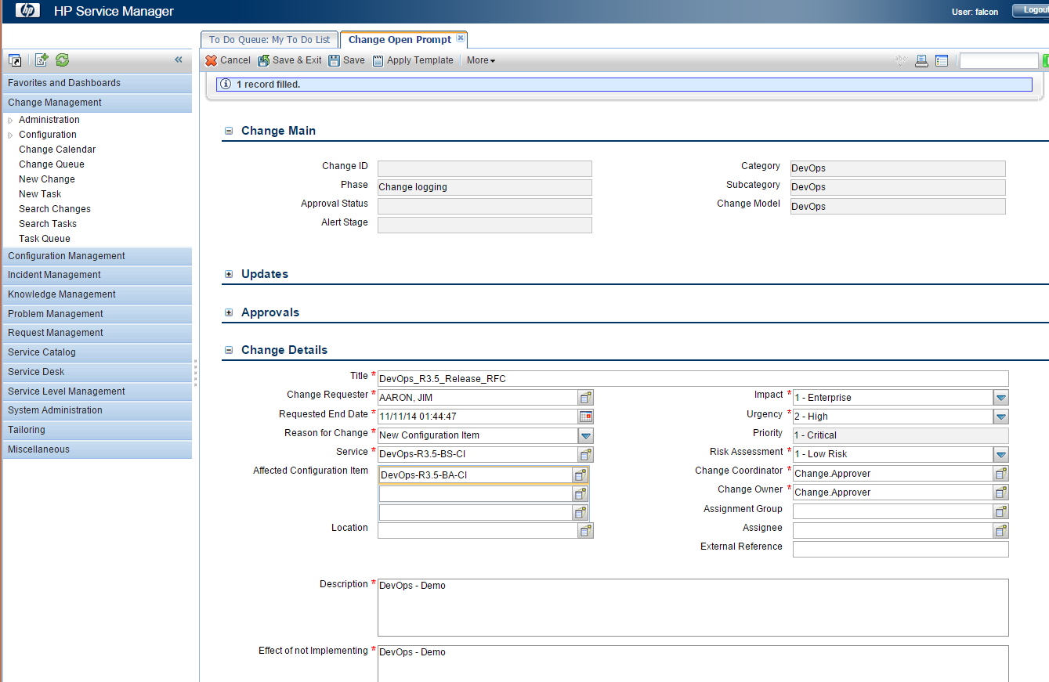

**Important:** For **Service**, select the Business Service CI created in the UCMDB section previously – **DevOps-R3.5-BS-CI**, which is automatically synchronized to SM. For **Affected Configuration Item**  select the Business Application CI - **DevOps-R3.5-BA-CI**.

1. Save the ticket.
2. Move the ticket to the **Change Approval** phase**.**
3. Note down the Release RFC ticket number, since it should be configured in the DevOps main project DevOps-R3.5-1-BUILD.

Setup new Staging RFC:

To set up new DevOps SM Staging RFC:

1. Login to HP Service Manager web client:
2. Click **Change Management > New Change** and select:

Category: Standard Devops

Subcategory: Standard Devops

1. Click the **Standard Devops** change model to create new RFC with **Standard** **DevOps** change workflow.

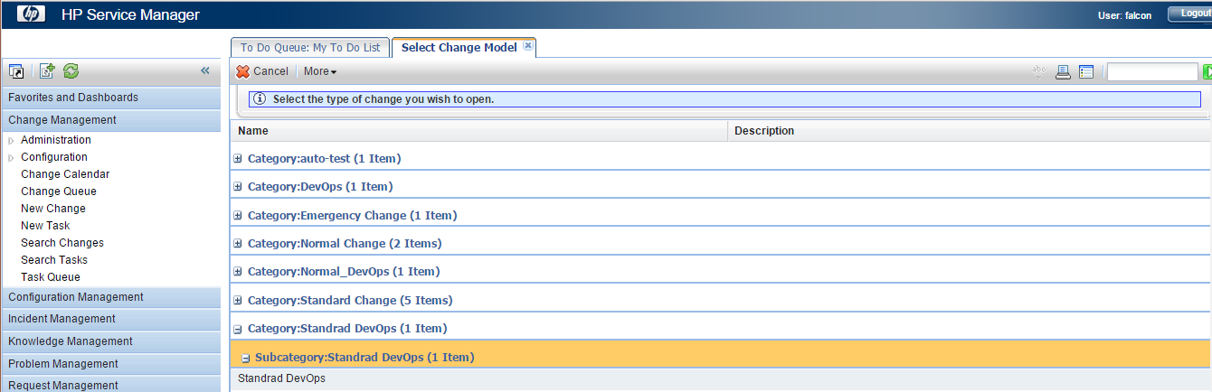

1. Enter all mandatory fields.

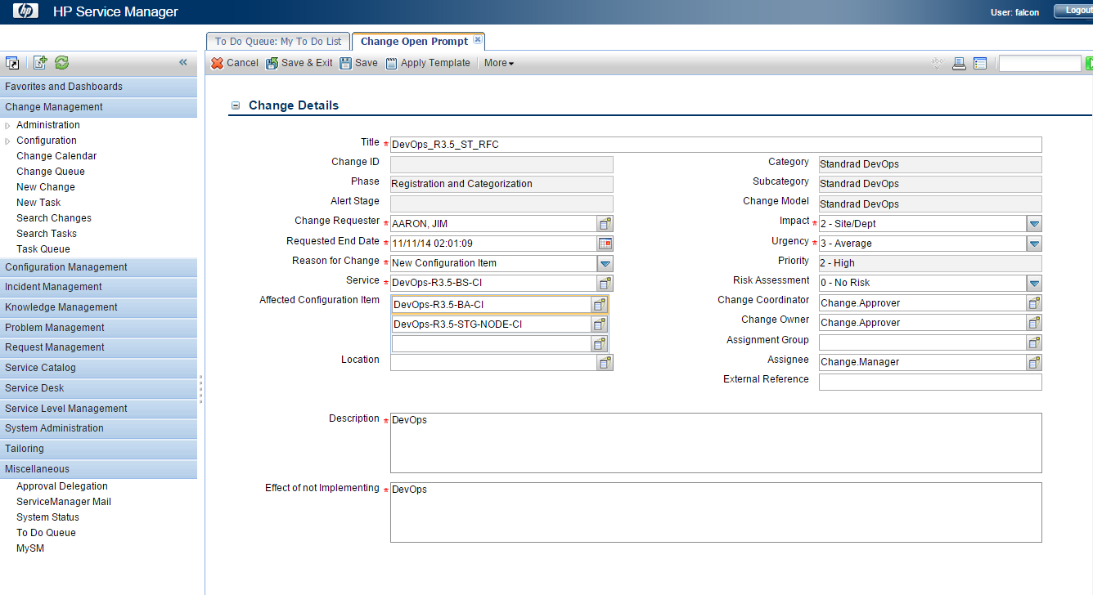

**Important:** For **Service** select the Business Service CI created in the UCMDB section previously – **DevOps-R3.5-BS-CI**, which is automatically synchronized to SM. For **Affected Configuration Item**  select the Business Application CI - **DevOps-R3.5-BA-CI** and the Node CI – **DevOps-R.3.5-STG-NODE-CI**.

1. Save the ticket.
2. Move the ticket to the **Execution** phase**.**
3. Note down the Staging RFC ticket number, since it should be configured in the DevOps main project DevOps-R3.5-1-BUILD.

Setup new Production RFC:

To set up new DevOps SM Staging RFC:

1. Login to HP Service Manager web client:
2. Click **Change Management > New Change** and select:

Category: Normal Devops

Subcategory: Normal Devops

1. Click the **Normal** **Devops** change model to create new RFC with **Normal** **DevOps** change workflow.

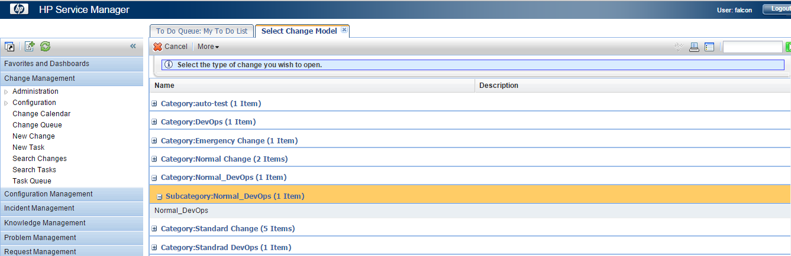

1. Enter all mandatory fields.

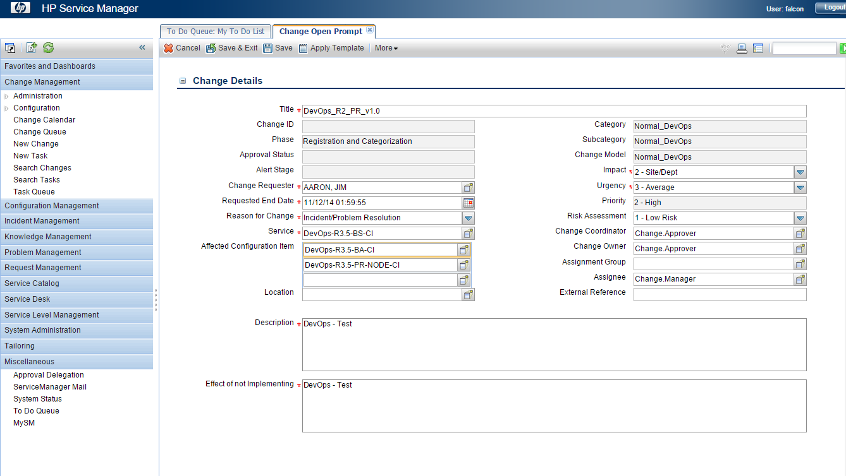

**Important:** For **Service** select the Business Service CI created in the UCMDB section previously – **DevOps-R3.5-BS-CI**, which is automatically synchronized to SM. For **Affected Configuration Item**  select the Business Application CI - **DevOps-R3.5-BA-CI** and the Node CI – **DevOps-R.3.5-PR-NODE-CI**.

1. Save the ticket.
2. Move the ticket to the **Deployment** phase**.**
3. Note down the Production RFC ticket number, since it should be configured in the DevOps main project DevOps-R3.5-1-BUILD.

Setup HP SiteScope

Configure SiteScope credentials profiles

Credential preferences provide centralized credential management for SiteScope resources. It enables you to input usernames and passwords for SiteScope monitors, templates, and remote hosts once as a credential profile, and then have SiteScope automatically supply that information when we configure those resources.

1. Login to the SiteScope web UI with the administrator username and password.
2. Go to **Preferences** and select **Credential Preferences** from the navigation pane.

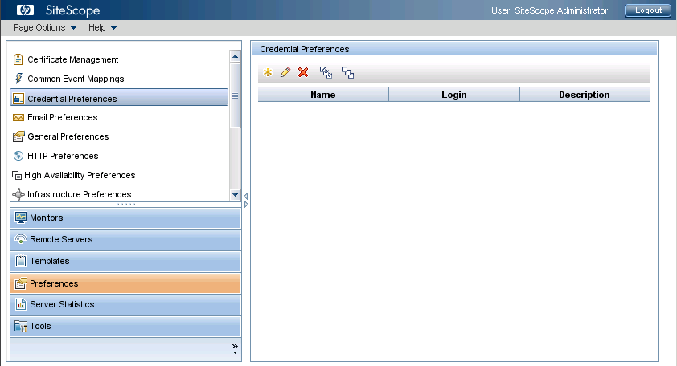

1. To create new Credentials Profile, click on the  button and enter the **Username** and **Password** credentials in the **New Credential Profile** window.

Create two credential profiles: **Windows** and **Linux**.

**Note**: The DevOps SiteScope content is configured with the following credential profile names:

* DevOps_Windows
* DevOps_Linux

If you use other profile names, please update them in the provided content later on.

Example Linux credentials profile setup for DevOps:

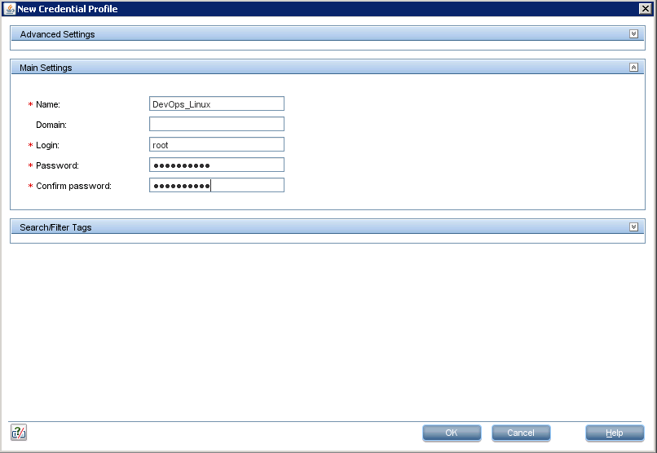

Import SiteScope content

To import sample monitoring templates used by the provided DevOps solution, complete the following steps:

1. Login to the SiteScope web UI with the administrator username and password.
2. Go to **Templates**, select **SiteScope**, and then right-click on **SiteScope** root element and select **Import**.

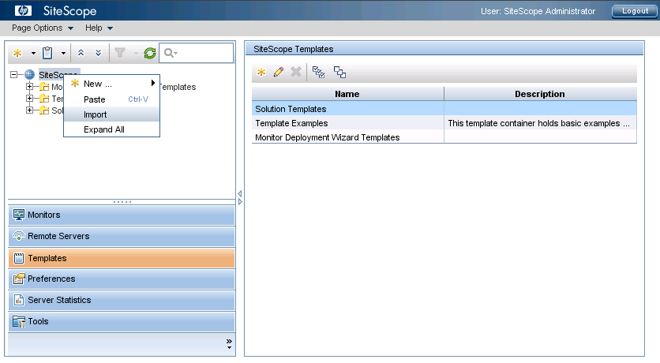

1. In the new window **HP SiteScope Content Import** select **Template** and then browse to select **sitescope_R3.5** file in the **Content Files >** **hp_sitescope** folder. Click the **OK** button to finish the import.

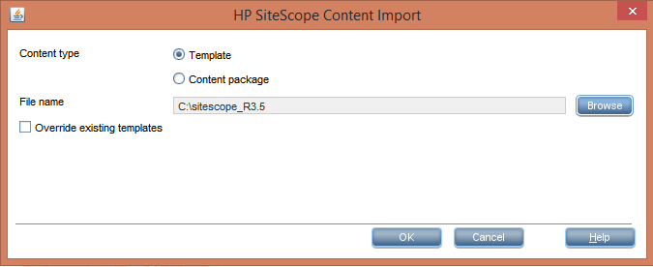

1. Verify the template folder **DevOps_CF_Monitor_Templates** is successfully created, under the **Templates** tree view section:

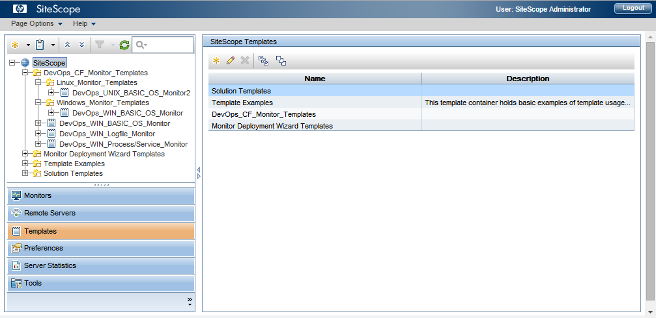

Configure SiteScope monitor groups

To configure the required DevOps monitoring groups, complete the following steps.

1. Login to the SiteScope web UI with the administrator username and password.
2. Go to **Monitors**, right-click on the **SiteScope** root element and select **New**->**Group**.

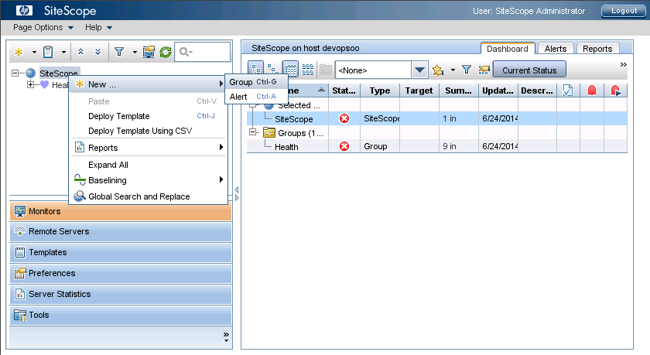

1. In the **New** Group window, enter the new following monitors group for the **Group name** and click **OK**.

**Note**: Repeat the step to create the groups, required by the DevOps solution:

* HP_DevOps
* HP_DevOps/App_Monitors
* HP_DevOps/OS_Monitors

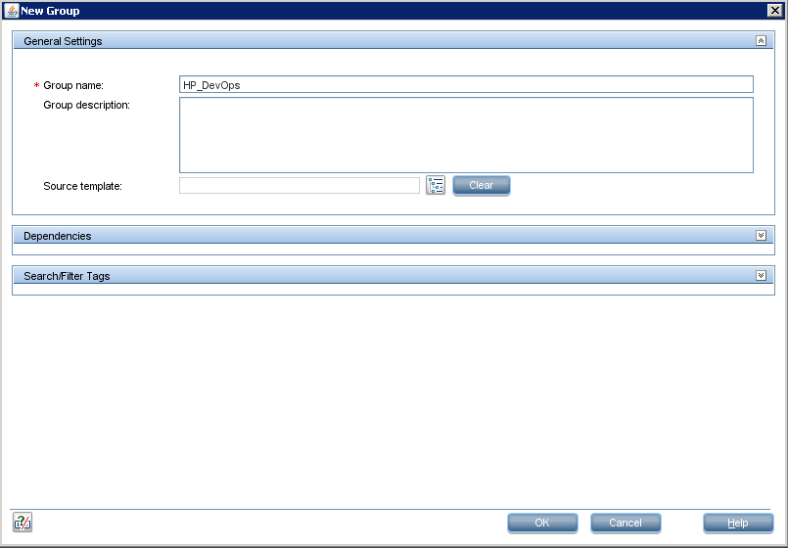

1. Verify the new groups are created successfully:

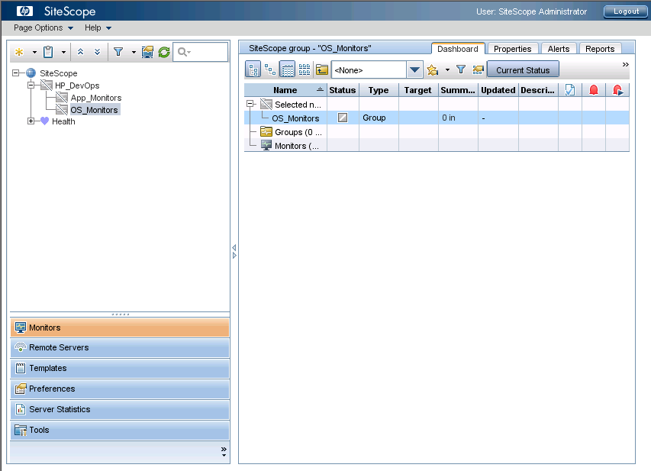

Demo Applications - iBank Java and iBank dotNet

DevOps Release 3.5 has the following demo applications, developed on two different technologies.

1. iBank Java (iBank Internet Banking) - Java based web application.

**iBank Internet Banking** has features related to standard Banking operations that includes Account Statements, Funds transfer between accounts, Bill pay, etc.

It also exposes two REST API (Web services) for retrieving account details for a user id and perform transaction for an account(credit/debit)

It is J2EE Struts 2.0 based application and can be deployed on any Java based application server (Tomcat). It is supported on Windows and Linux platform.

It does not have databases, instead it uses xml files to hold user, account and transactions details.

Refer to the3rd Party tools section Example deployment is provided in the.

2. iBank dotNet (iBank Investor) - .Net based web application.

**iBank Investor** is an online trading account which allows user to view his portfolio, buy/sell stocks and transfer funds from/to trading account.

It consumes REST API of iBank Internet Banking to perform transactions between Trading account and Bank account for the given user.

As it is .Net based Web application, it has to be deployed on IIS 7 or higher. It is supported on Windows platform only. It also uses flat files (XML files) to hold user, account and stock information.

**Important:** Example deployment is provided in the MS Tools section.

**Important:** Example integration with iBank Java (iBank Internet Banking) is provided in the MS Tools section.

3rd Party tool configurations

For our DevOps solution, all the 3rd party tools, including Jenkins, SCM, Nexus, Maven and Chef workstation, can run on one machine. Please see examples installation and configuration of these tools.

See the table below for the details of the 3rd party tools for the sample development environment.

|  |  |
| --- | --- |
| Operating system | Ubuntu 14.04 LTS |
| Application server | Tomcat 7 |
| Build trigger for Jankins | Wget |
| OO trigger from Jankins | FlowInvoke |
| File transfer tool | Curl |
| Version control tool | Git |
| Artifacts repositories manager | Nexus OSS |
| Source code repositories manager | SCM Manager |
| Artifacts build tool | Maven |

Set up Tomcat

Install Tomcat

Example installation on Ubuntu 14.04 LTS:

1. Start a new console and execute:

|  |
| --- |
| sudo apt-get install tomcat7 |

1. Change the ownership of tomcat home directory to tomcat:

|  |
| --- |
| chown –R tomcat7.tomcat7 /usr/share/tomcat7 |

1. Open /etc/tomcat7/tomcat-users.xml and add roles and add one user

|  |
| --- |
| <role rolename="manager-gui"/>  <role rolename="manager-script"/>  <role rolename="manager-jmx"/>  <role rolename="manager-status"/>  <user username="devops" password="devops" roles="manager-gui,manager-script,manager-jmx,manager-status"/> |

Set up Wget

Install Wget

Wget is required to trigger automatic builds in Jenkins, by creating http post requests from a git hook script..

Example installation on Ubuntu 14.04 LTS:

1. Start a new console session and execute:

|  |
| --- |
| sudo apt-get install wget |

1. To verify the wget is installed successfully execute:

|  |
| --- |
| wget --version |

Set up FlowInvoke

Install Flowinvoke

Flowinvoke.pl is required to trigger OO 10.x workflows from Jenkins.

Example installation on Ubuntu 14.04 LTS:

1. Start a new console session and execute the following command to install perl json module:

|  |
| --- |
| sudo apt-get install libjson-perl |

1. Execute the following command to install perl lwp module:

|  |
| --- |
| sudo apt-get install libwww-perl |

1. Copy DevOps**_R3.5_Solution/Installation files/flowinvoke/flowinvoke.pl** perl script to the tomcat home ($TOMCAT_HOME) folder on your 3rd Party Tools server.

Change the ownership of the flowinvoke.pl perl script tomcat:

|  |
| --- |
| chown –R tomcat7.tomcat7 /usr/share/tomcat7/flowinvoke.pl |

Setup Curl

Install Curl

Curl is used to upload/download the build artifacts to/from the Nexus repositories.

Example installation on Ubuntu 14.04 LTS::

1. Start a new console session and execute:

|  |
| --- |
| sudo apt-get install curl |

1. To verify the curl is installed successfully execute:

|  |
| --- |
| curl --version |

Setup Git

Install Git

Git is a popular version control tool..

Example installation on Ubuntu 14.04 LTS::

1. Start a new console session and execute:

|  |
| --- |
| sudo apt-get install git |

1. Configure the GIT settings. Open new console session and execute the following commands :

|  |
| --- |
| git config --global user.name "Your Name Here"  git config --global user.email "your_email@example.com" |

Setup Sonatype Nexus OSS

Install Nexus

Nexus is required to store the iBank build artifacts into remotely accessible repositories.

Example installation on Ubuntu 14.04 LTS:

**Note**: Verify that JDK (version 6 or later) has already been installed. It is required for the Nexus installation.

1. Copy **DevOps_R3.5_Solution/Installation files/nexus/nexus.war** file to a temporary folder on your nexus server.
2. Copy nexus.war to $TOMCAT_HOME/webapps
3. Tomcat automatically deploys the application and it should be accessible on http://<hostname>:8080/nexus
4. Start a new web browser window and navigate to the Nexus web UI:

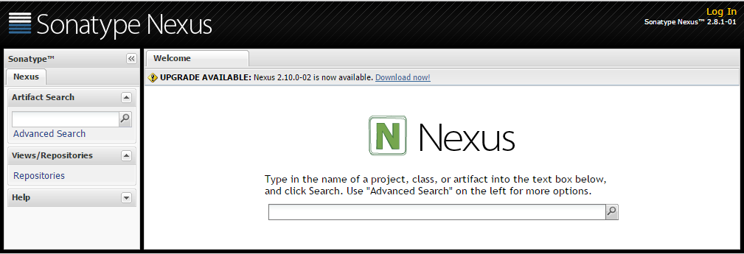

**Note**: Default nexus username/password are **admin**/**admin123**

Configure the custom nexus repositories for DevOps

To create new nexus repository, you must be logged in first.

1. Open the nexus Web UI and log in as **admin**.
2. Click **Repositories** from the menu.

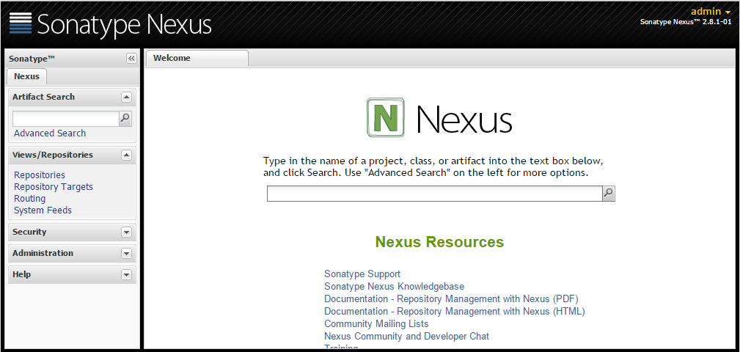

1. Click **Add**->**Hosted Repository**:

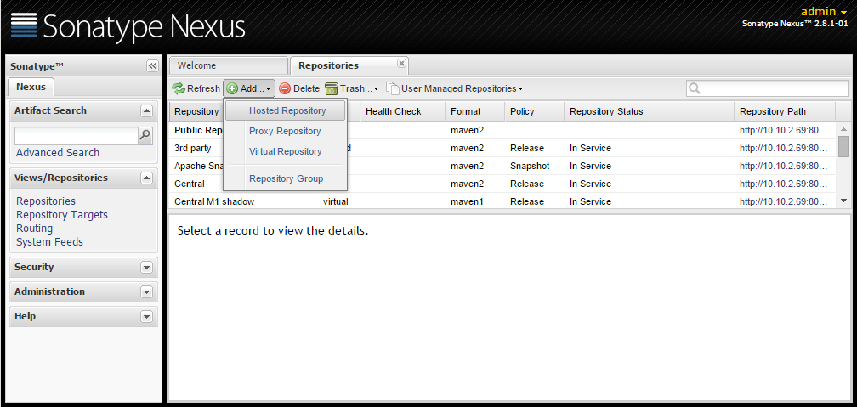

1. Enter new **Repository ID**, **Repository Name** and select the **Repository Policy** – **Release**. Click **Save.**

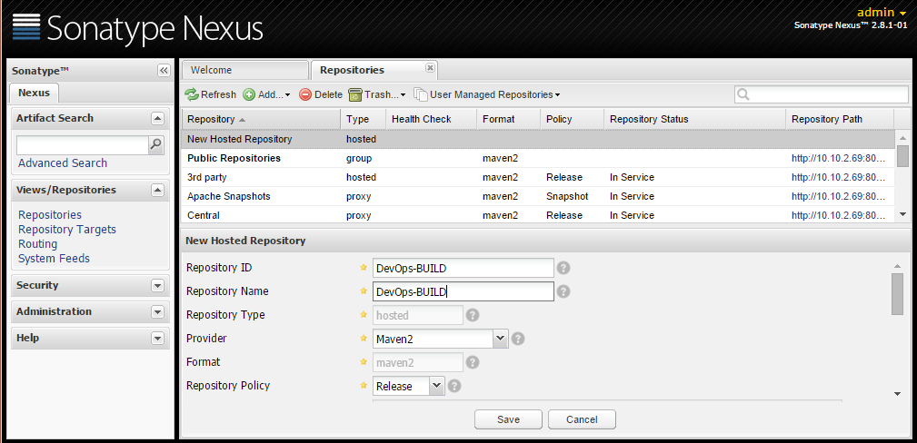

1. Repeat steps 3 and 4 to create the following repositories:

* DevOps-BUILD
* DevOps-DEV
* DevOps-QA
* DevOps-STG
* DevOps-PROD

1. Verify the repositories are created successfully:

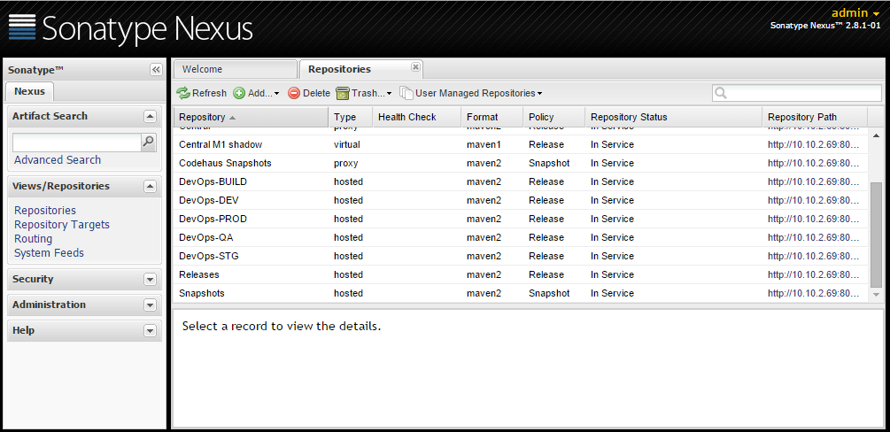

Setup SCM Manager

Install SCM

SCM is required to store the iBank source code under version control tools like Subversion, Git, etc.

Example installation on Ubuntu 14.04 LTS:

**Note**: Verify that JDK (version 6 or later) has already been installed. It is required for the SCM installation.

1. Copy **DevOps_R3.5_Solution/Installation files/scm/scm.war** file to a temporary folder on your scm server.
2. Copy scm.war to $TOMCAT_HOME/webapps
3. Tomcat automatically deploys the application and it should be accessible on http://<hostname>:8080/scm
4. Start a new web browser window and navigate to the SCM Manager web UI:

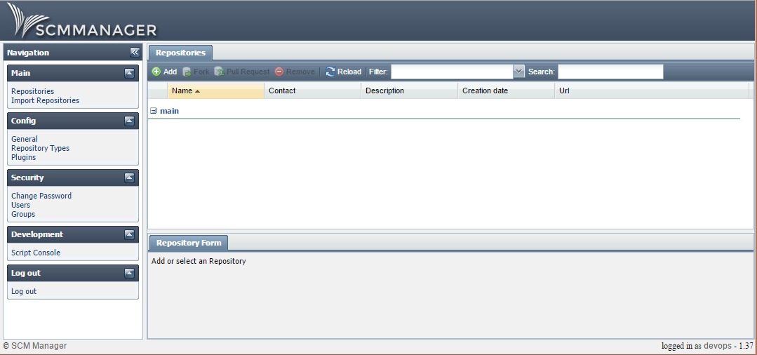

**Note**: Default scm username/password are inherited from tomcat - **devops**/**devops**

Create new Git repository for the iBank Java (iBank InternetBanking) application

To create new git repository, you must be logged in first.

1. Open the scm manager Web UI and log in.
2. Click **Repositories > Add** from the menu. In the Settings window enter **Name**, select GIT for **Type**, enter **Contact** and **Description** and click Ok.

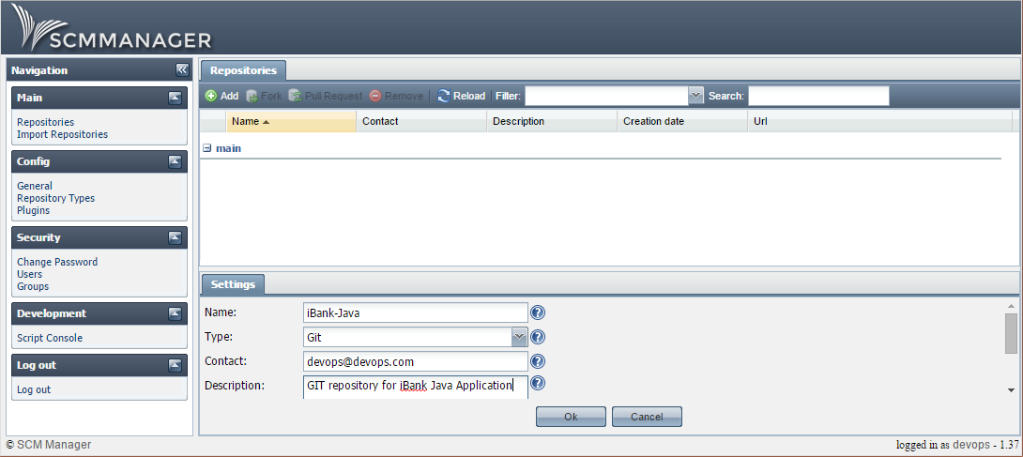

1. Verify the new repository is created.

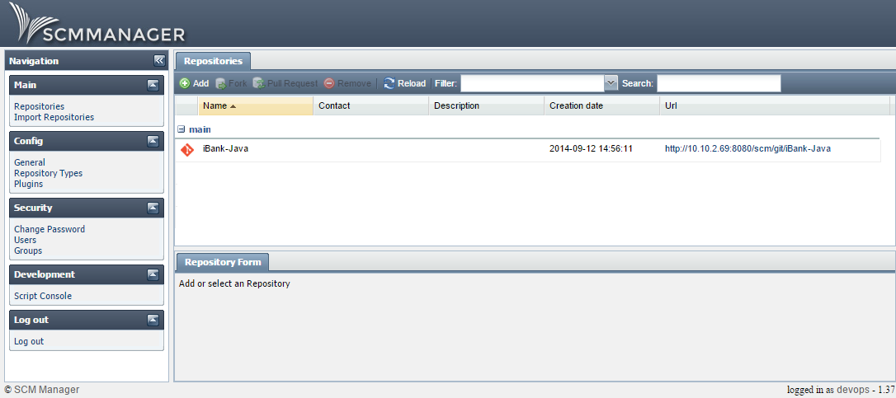

Create new Git repository for the iBank dotNet (iBank Investor) application (OPTIONAL)

To create new git repository, you must be logged in first.

1. Open the scm manager Web UI and log in.
2. Click **Repositories > Add** from the menu. In the Settings window enter **Name**, select GIT for **Type**, enter **Contact** and **Description** and click Ok.

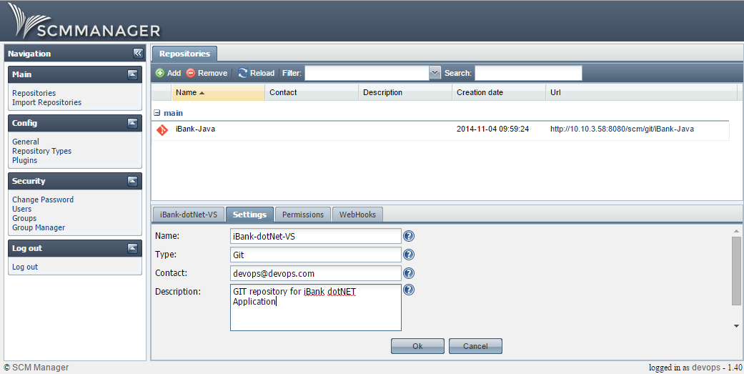

1. Verify the new repository is created.

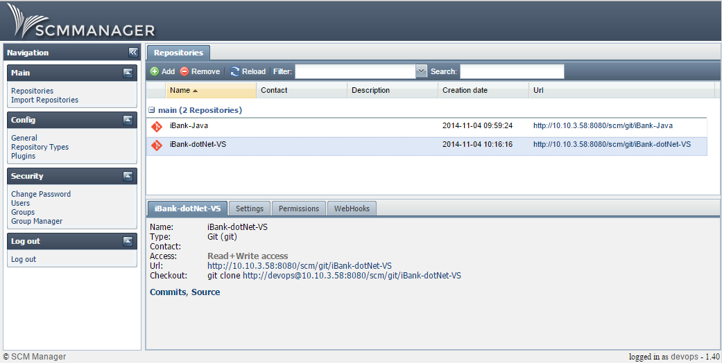

Import the iBank Java application (iBank InternetBanking) source code to the Git repository

To import the iBank Java application source to the git repository, complete the following steps.

1. Copy **DevOps_R3.5_Solution/Content files/iBank/iBank-Java.zip** file to a temporary folder on your scm server and extract the archive.
2. Start a new console session and execute:

|  |
| --- |
| cd iBank-Java  git init  git add *  git commit –m “Initial import”  git remote add origin http://localhost:8080/scm/git/iBank-Java  git push origin master |

**Note:** When prompted for scm username/password, enter the default credentials inherited from tomcat – **devops**/**devops**

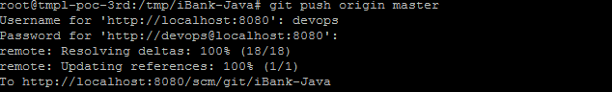

1. Open the scm manager Web UI and log in. Click **Repositories** and select **iBank-Java** from the list.

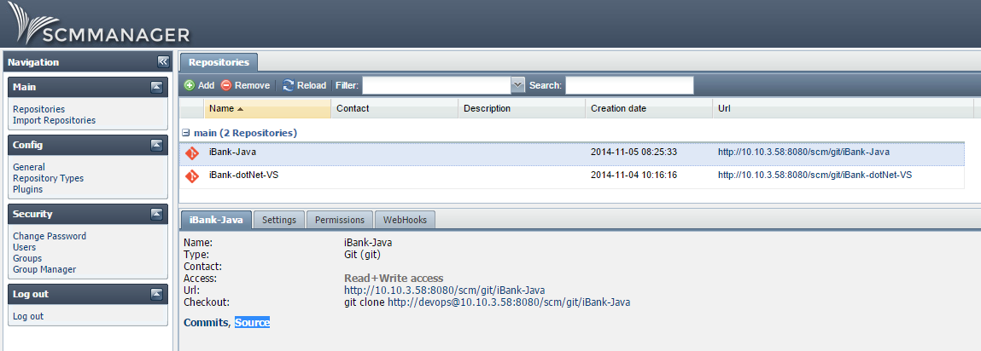

1. Click **Source** from the menu below and verify the source files are available.

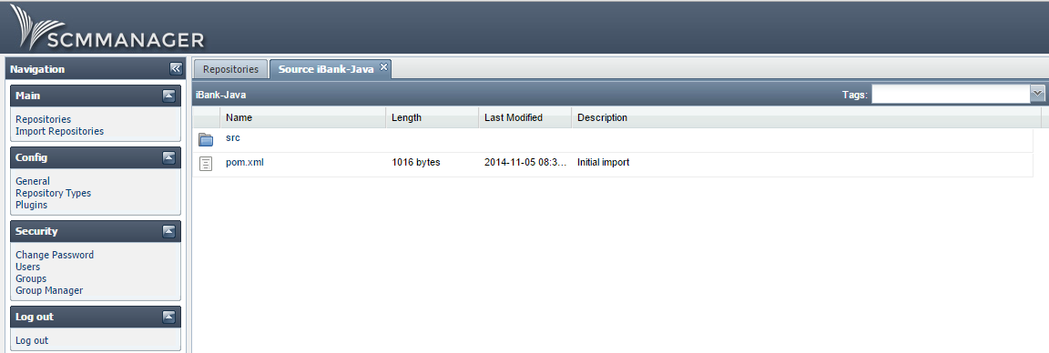

Import the iBank dotNET application (iBank Investor) source code to the Git repository (OPTIONAL)

To import the iBank dotNet application source to the git repository, complete the following steps.

1. Copy **DevOps_R3.5_Solution/Content files/iBank/iBank-dotNet.zip** file to a temporary folder on your scm server and extract the archive.
2. Start a new console session and execute:

|  |
| --- |
| cd iBank-dotNet  git init  git add *  git commit –m “Initial import”  git remote add origin http://localhost:8080/scm/git/iBank-dotNet-VS  git push origin master |

**Note:** When prompted for scm username/password, enter the default credentials inherited from tomcat – **devops**/**devops**

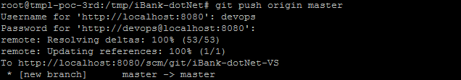

1. Open the scm manager Web UI and log in. Click **Repositories** and select **iBank-dotNet-VS** from the list.

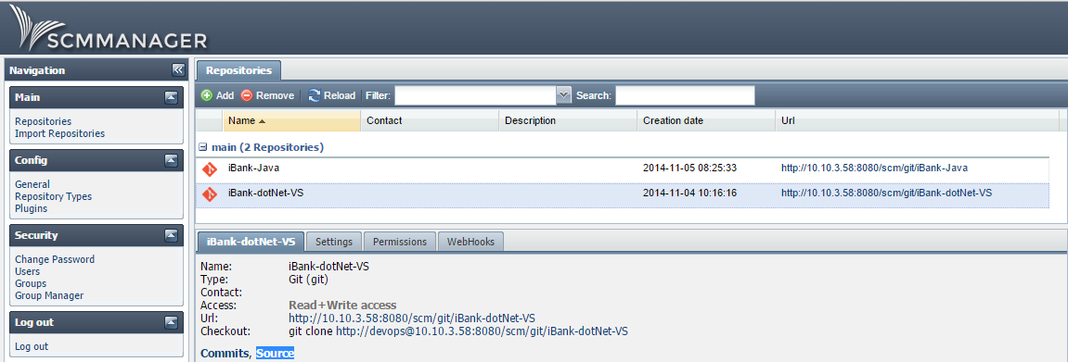

1. Click **Source** from the menu below and verify the source files are available.

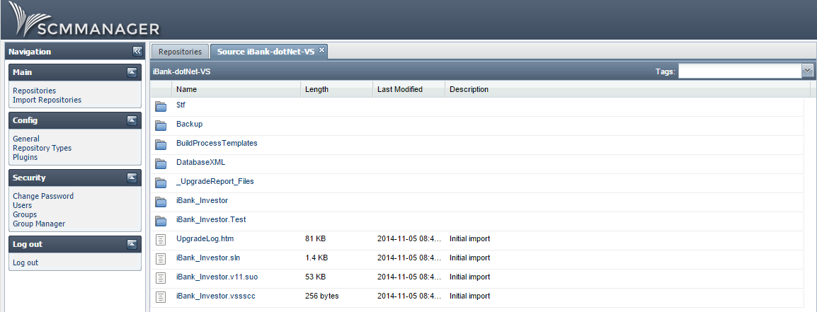

Setup iBank Java GIT hook to trigger Jenkins build on a new code change

To setup iBank Java GIT hook, complete the following steps.

1. Copy **DevOps_R3.5_Solution/Content files/git/post-receive** file to a temporary folder on your scm server.
2. Open the **post-receive** file and if required update the jenkins credentials and URL. Then save the file:

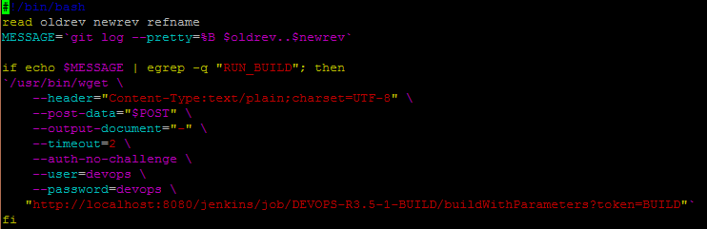

1. Start a new console session and copy the post-receive file to the iBank-Java Git repository hooks folder and make the file executable:

|  |
| --- |
| cp post-receive /usr/share/tomcat7/.scm/repositories/git/iBank-Java/hooks/  chmod +x /usr/share/tomcat7/.scm/repositories/git/iBank-Java/hooks/post-receive |

**Note:** The new hook will start the **DEVOPS-R3.5-1-BUILD** Jenkins job on each push with commit message containing **RUN_BUILD**.

Setup iBank dotNet GIT hook to trigger Jenkins build on a new code change (OPTIONAL)

To setup iBank dotNet GIT hook, complete the following steps.

1. Copy **DevOps_R3.5_Solution/Content files/git/post-receive** file to a temporary folder on your scm server.
2. Open the **post-receive** file and if required update the jenkins credentials and URL. Then save the file:



1. Start a new console session and copy the post-receive file to the iBank-dotNet-VS Git repository hooks folder and make the file executable:

|  |
| --- |
| cp post-receive /usr/share/tomcat7/.scm/repositories/git/iBank-dotNet-VS/hooks/  chmod +x /usr/share/tomcat7/.scm/repositories/git/iBank-dotNet-VS/hooks/post-receive |

**Note:** The new hook will start the **DEVOPS-R3.5-1-BUILD** Jenkins job on each push with commit message containing **RUN_BUILD**.

Setup Maven

Install Maven

Maven is required to compile the java source files to a build artifact.

Example installation on Ubuntu 14.04 LTS:

1. Download maven binaries:

|  |
| --- |
| wget http://mirror.olnevhost.net/pub/apache/maven/maven-3/3.2.2/binaries/apache-maven-3.2.2-bin.tar.gz |

1. Extract the archive to temp folder:

|  |
| --- |
| tar zxf apache-maven-3.2.2-bin.tar.gz |

1. Move the binaries to the designated location, e.g.

|  |
| --- |
| mv apache-maven-3.2.2 /var/lib/ |

**Note**: Be sure to add the apache-maven-3.2.2/bin directory to the PATH variable.

1. To verify that the maven installation is successful:

|  |
| --- |
| mvn --version |

Setup Jenkins

Jenkins installation

Jenkins is required to orchestrate the DevOps CI (Continuous Integration) and CD (Continuous Deployment). It is available for different Operating Systems – Unix/Linux and Windows. For more details on each supported OS and installation instructions, please check the Jenkins documentation.

Example installation on Ubuntu 14.04 LTS:

**Note**: Verify that java is already installed. It is required for the Jenkins installation.

1. Copy the **DevOps_R3.5_Solution/Installation files/jenkins/jenkins.war** file to a temporary folder on your Jenkins server.

**Note:** The required Jenkins plugins for this release are packaged in the jenkins.war file. There is no need to install them later.

1. Copy jenkins.war to $TOMCAT_HOME/webapps
2. Tomcat automatically deploys the application and you can access it at http://<hostname>:8080/jenkins
3. Grant Java security permissions to Jenkins.
4. Go to /etc/tomcat7/policy.d/04webapps.policy
5. Add the following contents:

|  |
| --- |
| grant codeBase "file:/var/lib/tomcat7/webapps/jenkins/-"  {  permission java.security.AllPermission;  }; |

1. Start a new web browser window and navigate to the Jenkins web UI:

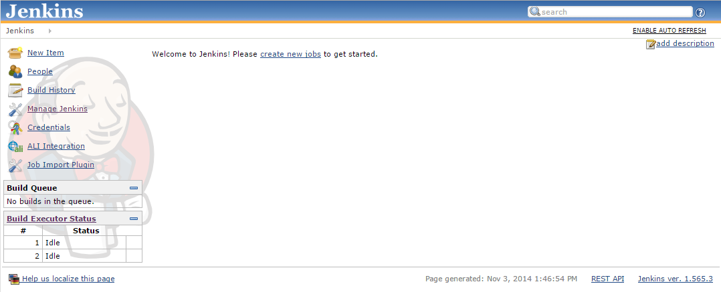

Jenkins content installation

The provided Jenkins content contains the DevOps R3.5 sample configuration (views, jobs, slaves, users and system configuration). To import the content, complete the following steps:

Example import on Ubuntu 14.04 LTS:

**Note**: Verify that java is already installed. It is required for the Jenkins installation.

1. Copy the **DevOps_R3.5_Solution/Content files/jenkins/configuration_R3.5.zip** file to a temporary folder on your Jenkins server and extract the archive.
2. List the extracted files and folders:

|  |
| --- |
| ls configuration_R3.5 |

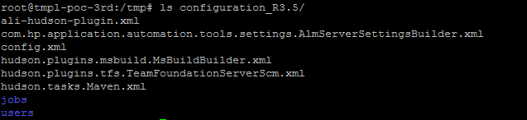

1. Copy all files and folders to the **.jenkins** home folder:

|  |
| --- |
| cp -R configuration_R3.5/. /usr/share/tomcat7/.jenkins/ |

1. Change the ownership of jenkins home to tomcat:

|  |
| --- |
| chown –R tomcat7.tomcat7 /usr/share/tomcat7/.jenkins/ |

1. Restart tomcat:

|  |
| --- |
| /etc/init.d/tomcat7 restart |

1. Open the Jenkins web UI and log in:

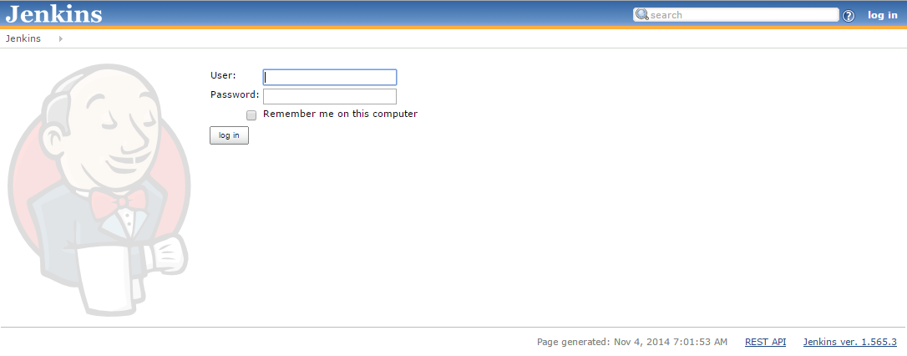

**Note**: Default jenkins username/password are **devops**/**devops**

1. Verify the sample views, jobs and slaves are created successfully:

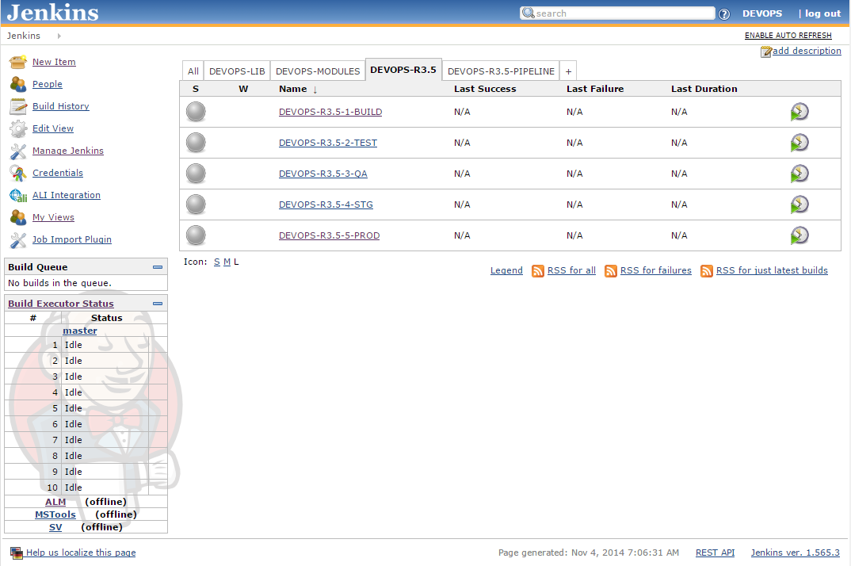

Jenkins views and jobs for DevOps (Main, Modules, Lib and Pipeline)

The Jenkins jobs are grouped together in four different views to support the entire DevOps solution.

Each view/job has specific purpose, requirements and functionality.

**DEVOPS-R3.5**:This view contains the Release 3.5 DevOps main jobs. Their purpose is to add flexible configuration by using modular structure, e.g trigger Jenkins module jobs(sub-projects) from within the main jobs.

|  |  |  |  |
| --- | --- | --- | --- |
| **Job Name** | **Job Execution** | **Execution Requirements** | **Job Description** |
| DEVOPS-R3.5-1-BUILD | Automatic | New GIT or TFS commit event that contains the **RUN_BUILD** string in the commit message. | This job will:   1. Update the UCMDB Business Application CI **status** and **version** attributes. 2. Trigger two module jobs to compile the **iBank-Java** and **iBank-dotNet** applications and to store the build artifacts on the Nexus **DevOps-BUILD** repository. |
| DEVOPS-R3.5-2-TEST | Automatic | Successful build for **DEVOPS-R3.5-1-BUILD** job. | This job will:   1. Provision new DEV environment (Linux and Windows servers). 2. Bootstrap the DEV servers to Chef and deploy the required applications and build artifacts. 3. Add SiteScope monitors for the new DEV servers. 4. Test the new build artifacts using HP ALM, HP UFT and HP PC. 5. Download the build artifacts from the Nexus **DevOps-BUILD** repository to Jenkins, using Curl. 6. Upload the build artifacts from Jenkins to the Nexus **DevOps-DEV** repository, using Curl. 7. Delete the SiteScope monitors for the new DEV servers. 8. Un-provision the DEV environment and remove the DEV servers from the Chef managed servers list. |
| DEVOPS-R3.5-3-QA | Manual (Trigger from the **DEVOPS-R3.5-PIPELINE** view) | Successful build for **DEVOPS-R3.5-2-TEST** job. | This job will:   1. Provision new QA environment (Linux and Windows servers). 2. Bootstrap the QA servers to Chef and deploy the required applications and build artifacts. 3. Add SiteScope monitors for the new QA servers. 4. Test the new build artifacts using HP ALM, HP UFT and HP PC. 5. Download the build artifacts from the Nexus **DevOps-DEV** repository to Jenkins, using Curl. 6. Upload the build artifacts from Jenkins to the Nexus **DevOps-QA** repository, using Curl. 7. Delete the SiteScope monitors for the new QA servers. 8. Un-provision the QA environment and remove the QA servers from the Chef managed servers list. |
| DEVOPS-R3.5-4-STG | Manual (Trigger from the **DEVOPS-R3.5-PIPELINE** view) | Successful build for **DEVOPS-R3.5-3-QA** job.  The release RFC must be in **Change Approved** or **Change Implementation – Promoted to ST** phase.  The staging RFC must be in **Execution** phase. | This project will:   1. Verify if the release RFC is configured to allow promotion to staging. 2. Update the release RFC phase to **Change Implementation – Promoted to ST**. 3. Update the UCMDB Business Application CI **status** attribute. 4. Provision new STG environment (Linux and Windows servers). 5. Bootstrap the STG servers to Chef and deploy the required applications and build artifacts. 6. Add SiteScope monitors for the new STG servers. 7. Test the new build artifacts using HP ALM, HP UFT and HP PC. 8. Download the build artifacts from the Nexus **DevOps-QA** repository to Jenkins, using Curl. 9. Upload the build artifacts from Jenkins to the Nexus **DevOps-STG** repository, using Curl. 10. Delete the SiteScope monitors for the new STG servers. 11. Un-provision the STG environment and remove the STG servers from the Chef managed servers list. 12. Update the UCMDB Business Application CI **Last Known Good** attribute with the current release number. 13. Close the staging RFC. |
| DEVOPS-R3.5-5-PROD | Manual (Trigger from the **DEVOPS-R3.5-PIPELINE** view) | Successful build for **DEVOPS-R3.5-4-STG** job.  The Release RFC must be in “Change Implementation – Promoted to PR”.  The Production RFC must be in “Deployment” phase. | This project will:   1. Verify if the release RFC is configured to allow promotion to production. 2. Update the release RFC phase to **Change Implementation – Promoted to PR**. 3. Update the UCMDB Business Application CI **status** attribute. 4. Disable the SiteScope application monitors on the PROD servers. 5. Re-deploy the required build artifacts from Nexus to the PROD servers, using Chef Recipes. 6. Enable the SiteScope application monitors on the PROD environment. 7. Test the new build artifacts on the PROD environment using HP ALM, HP UFT and HP PC. 8. Download the build artifacts from the Nexus **DevOps-STG** repository to Jenkins, using Curl. 9. Upload the build artifacts from Jenkins to the Nexus **DevOps-PROD** repository, using Curl. 10. Close the production RFC. |

**DEVOPS-MODULES:** This view contains the DevOps module jobs. Their purpose is to simplify the main job’s configurations by spliting different functionalities into different modules. This will allow developers to easily develop, test and plug a new feature to the DevOps solution. These moduless are release specific and their name is used to identify in which release they are used. In future these modules will increase with each new release.

Example: DEVOPS-R3.5-… , means that this module is developed and tested in R3.5.

|  |  |
| --- | --- |
| **Job Name** | **Job Description** |
| DEVOPS-R3.5-ALM-UFT-PC-TEST-DOTNET | This module job will:  Create/update the PC_UFT_Test.dat file on the ALM server. This file contains parameters used during the **iBank-dotNet** application functional and performance testing.  Trigger the **Root\iBank\iBank-dotNET(Functional Tests)** functional testing.  Trigger the **Root\iBank\iBank-dotNET(Performance Test)** performance testing.  ALM project details – iBank-dotNET:  Domain: **DEVOPS**  Project: **iBank_Investing** |
| DEVOPS-R3.5-ALM-UFT-PC-TEST-JAVA | This module job will:  Create/update the PC_UFT_Test.dat file on the ALM server. This file contains parameters used during the **iBank-Java** application functional and performance testing.  Trigger the **Root\iBank\iBank-dotNET(Functional Tests)** functional testing.  Trigger the **Root\iBank\iBank-Java(Performance Tests)** performance testing.  ALM project details – iBank-Java:  Domain: **DEVOPS**  Project: **iBank_InternetBanking** |
| DEVOPS-R3.5-ALM-UFT-PC-TEST-MT | This module job will:  Create/update the PC_UFT_Test.dat file on the ALM server. This file contains parameters used during the **iBank-dotNet** and **iBank-Java** applications functional and performance testing.  Trigger the **Root\iBank\iBank-MT(Functional Tests)** functional testing.  Trigger the **Root\iBank\iBank-dotNET(Performance Test)** performance testing.  Trigger the **Root\iBank\iBank-Java(Performance Tests)** performance testing.  ALM project details – iBank-Java:  Domain: **DEVOPS**  Project: **iBank_InternetBanking**  ALM project details – iBank-dotNET:  Domain: **DEVOPS**  Project: **iBank_Investing** |
| DEVOPS-R3.5-BUILD-iBank-GIT-DOTNET | This module job will:  Check out the iBank-dotNET application source code from GIT.  Create new build artifact (**MyProj.Web.zip** IIS package), using the **MSBuild.exe** on the **MSTools** Jenkins slave. |
| DEVOPS-R3.5-BUILD-iBank-TFS-DOTNET | This module job will:  Check out the iBank-dotNET application source code from TFS.  Create new build artifact (**MyProj.Web.zip** IIS package), using the **MSBuild.exe** on the **MSTools** Jenkins slave. |
| DEVOPS-R3.5-CHEF-DEPLOY | This module job will:  Bootstrap new servers to Chef.  Update node attributes on those servers.  Attach and run a chef role/recipe on those servers to deploy the required applications and build artifacts. |
| DEVOPS-R3.5-CHEF-MANAGE | This module job will:  Update node attributes on iBank production servers.  Attach and run a chef recipe on those servers to re-deploy the required build artifacts. |
| DEVOPS-R3.5-CHEF-UNDEPLOY | This module job will:  Delete servers from the Chef managed server list. |
| DEVOPS-R3.5-CSA-PROVISION | This module job will:  Trigger the **DEVOPS_LIB_OO_10** lib job with parameters to provision new server(s) through CSA service published in the Global Shared catalog.  Parse the OO result file to get the ip address(es) for the new server(s).  The CSA services are configured to provision Linux/Windows servers in VMWare vCenter, by cloning predefined Virtual Machine templates. |
| DEVOPS-R3.5-CSA-UNPROVISION | This module job will:  Trigger the **DEVOPS_LIB_OO_10** lib job with parameters to un-provision existing server(s), which was/were created through CSA service. |
| DEVOPS-R3.5-DV-INT-DOTNET | This module job will:  Provision new DV-INT-DOTNET environment (Windows server).  Bootstrap the DV-INT-DOTNET server to Chef and deploy the required applications and build artifact.  Start SV simulation for the **iBank-Java** application.  Test the new build artifact using HP ALM, HP UFT and HP PC.  Stop the SV simulation for the **iBank-Java** application.  Un-provision the DV-INT-DOTNET environment and remove the DV-INT-DOTNET server from the Chef managed servers list. |
| DEVOPS-R3.5-DV-INT-JAVA | This module job will:  Provision new DV-INT-JAVA environment (Linux server).  Bootstrap the DV-INT-JAVA server to Chef and deploy the required applications and build artifact.  Test the new build artifact using HP ALM, HP UFT and HP PC.  Un-provision the DV-INT-JAVA environment and remove the DV-INT-JAVA server from the Chef managed servers list. |
| DEVOPS-R3.5-JENKINS-iBank-GIT-DOTNET | This module job will:  Trigger the **DEVOPS-R3.5-BUILD-iBank-GIT-DOTNET** Jenkins module job to create new iBank-dotNET build artifact from the GIT repository and will download the build artifact to the local workspace.  Upload the new iBank-dotNet build artifact from the local workspace to the Nexus **DevOps-BUILD** repository, by using Curl. |
| DEVOPS-R3.5-JENKINS-iBank-GIT-JAVA | This module job will:  Check out the iBank-JAVA application source code from GIT.  Create new build artifact (**ibank-1.0.war** package),by using **Maven**.  Upload the new **iBank-JAVA** build artifact to the Nexus **DevOps-BUILD** repository.  Trigger the **DEVOPS-R3.5-DV-INT-JAVA** module job to execute DV Integration testing on the iBank-JAVA application. |
| DEVOPS-R3.5-JENKINS-iBank-TFS-DOTNET | This module job will:  Trigger the **DEVOPS-R3.5-BUILD-iBank-TFS-DOTNET**Jenkins module job to create new iBank-dotNET build artifact from the TFS repository and will download the build artifact to the local workspace.  Upload the new iBank-dotNet build artifact from the local workspace to the Nexus **DevOps-BUILD** repository, by using Curl.  Trigger the **DEVOPS-R3.5-DV-INT-DOTNET** module job to execute DV Integration testing on the **iBank-dotNET** and **iBank-Java** application, by using SV simulation for the **iBank-Java** application. |
| DEVOPS-R3.5-SITESCOPE-MANAGE | This module job will:  Trigger the **DEVOPS_LIB_OO_10** lib job with parameters to disable Sitescope application monitors for the iBank-Java and iBank-dotNET applications in production environment. |
| DEVOPS-R3.5-SITESCOPE-MONITOR | This module job will:  Trigger the **DEVOPS_LIB_OO_10** lib job with parameters to add Sitescope monitors for the iBank-Java and iBank-dotNET applications. |
| DEVOPS-R3.5-SITESCOPE-UNMONITOR | This module job will:  Trigger the **DEVOPS_LIB_OO_10** lib job with parameters to delete Sitescope monitors for the iBank-Java and iBank-dotNET applications. |
| DEVOPS-R3.5-SM-CLOSE-PROD | This module job will:  Trigger the **DEVOPS_LIB_OO_10** lib job with parameters to close the SM production RFC ticket. |
| DEVOPS-R3.5-SM-CLOSE-STG | This module job will:  Trigger the **DEVOPS_LIB_OO_10** lib job with parameters to close the SM staging RFC ticket. |
| DEVOPS-R3.5-SM-RELEASE-PROD | This module job will:  Trigger the **DEVOPS_LIB_OO_10** lib job with parameters to verify that the SM release RFC phase is **Change Implementation – Promoted to PR**. |
| DEVOPS-R3.5-SM-RELEASE-STG | This module job will:  Trigger the **DEVOPS_LIB_OO_10** lib job with parameters to update the SM release RFC phase to **Change Implementation – Promoted to ST**. |
| DEVOPS-R3.5-SV-MANAGE | This module job will:  Trigger the **DEVOPS_LIB_OO_10** lib job with parameters to start/stop a simulation on the SV server.  **Note:** This module job must be executed on the **SV** Jenkins slave. |
| DEVOPS-R3.5-UCMDB-LAST-GOOD-CI | This module job will:  Trigger the **DEVOPS_LIB_OO_10** lib job with parameters to update the UCMDB Business Application CI **last_known_good** attribute with the current release build number. |
| DEVOPS-R3.5-UCMDB-UPDATE-CI | This module job will:  Trigger the **DEVOPS_LIB_OO_10** lib job with parameters to update the UCMDB Business Application CI **status** and **version** attributes with the current release status and build number. |

**DEVOPS-LIB:** This view contains the DevOps lib jobs. Their purpose is to simplify the main and module job’s configurations by spliting single functionality into re-usable lib jobs. Those jobs are NOT release specific and will be used in all future releases.

|  |  |
| --- | --- |
| **Job Name** | **Job Description** |
| DEVOPS_LIB_OO_10 | This module job will:  Invoke the **flowinvoke.pl** with parameters to trigger a new OO workflow on a selected HP Operations Orchestration server.  The job will wait for the OO workflow to finish and will store the OO results into a file in the job’s workspace.  Flowinvoke.pl input parameters:  --host $OO_HOST (the OO server ipaddress/hostname/FQDN)  --uuid $UUID (the OO workflow UUID)  --user $OO_USERNAME (clear text OO username)  --password $OO_PASSWORD (clear text OO password)  --input $OO_PARAM_NAME=$OO_PARAM_VALUE (for each OO input parameter provided as key=value pair)  --credentials $OO_CREDENTIALS (the encrypted combination for username:password, using the ./flowinvoke –e option) |

**DEVOPS-R3.5-PIPELINE:** This view is used to dislay the DevOps pipeline. It is also required to trigger manual promotion from **DEVOPS-R3.5-2-TEST** to **DEVOPS-R3.5-3-QA**, **DEVOPS-R3.5-2-QA** to **DEVOPS-R3.5-2-STG** and **DEVOPS-R3.5-2-STG** to **DEVOPS-R3.5-2-PROD**. The pipeline view will display the relationship between all used Main jobs, Module jobs and Lib jobs used in the specific release.

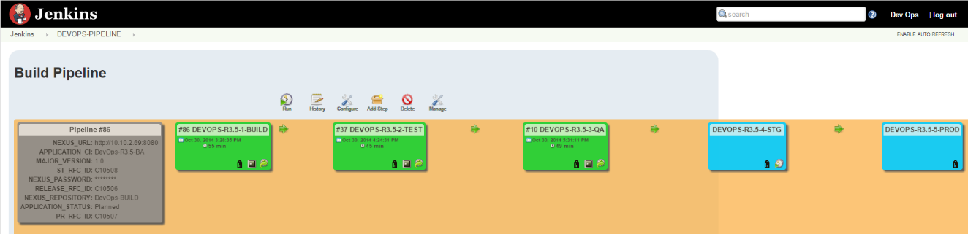

Jenkins plug-in configuration for DevOps (System Configuration)

This solution requires basic configuration for some of the already installed Jenkins plugins. Please, complete the following steps:

1. Open the Jenkins web UI, and go to **Manage Jenkins** -> **Configure System**.
2. Configure ALI Integration:

The **ALI plugin** is used to synchronize test results information with HP ALI. To configure default Jenkins to ALI synchronization, enable the **default HP AGM Server Connection** option and enter the required inputs.

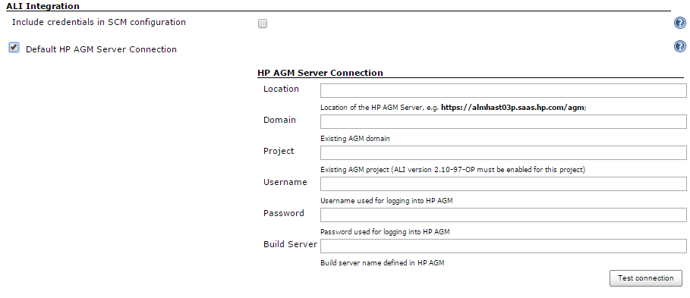

Configure the HP ALM Server access URL:

Update the **ALM server URL** field.

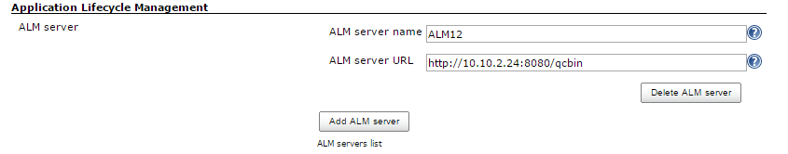

Configure the path to the MSBuild executable:

Update the **Path to MSBuild** field.

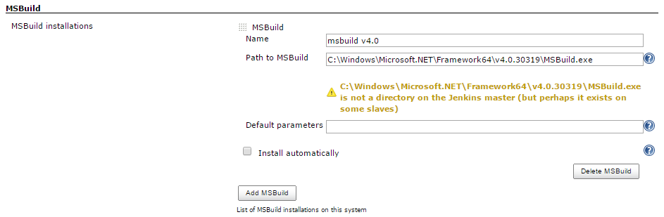

**Note:** All Jenkins jobs that use MSBuild.exe, must be configured to run on the MSTools slave.

Verify the maven home is correct:

If the maven home is different, update the **MAVEN_HOME** field.

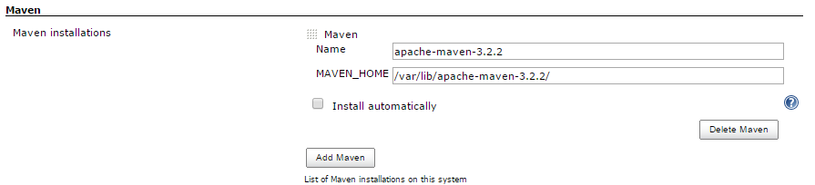

Configure the path to the TF executable – Microsoft Team Explorer:

Update the **TF command line executable** field.



**Note:** All Jenkins jobs that use TF.exe, must be configured to run on the MSTools slave.

Jenkins credentials configuration for DevOps (SCM/GIT/TFS repository credentials)

The SCM/GIT repositories configured previously require authentication. To setup jenkins credential profiles for them, complete the following steps:

1. Open the Jenkins web UI, and go to **Credentials** -> **Global credentials**.

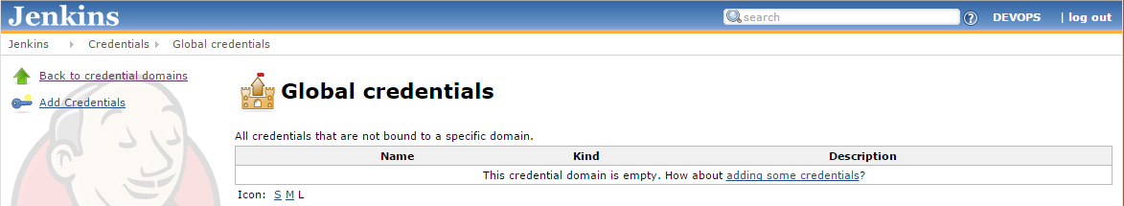

Click on **Add Credentials**, enter the required fields.

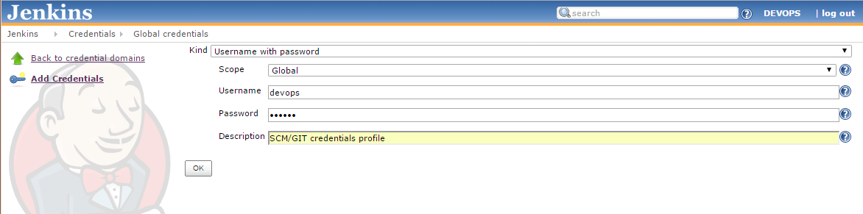

**Note:** The default SCM username/password is inherited from tomcat – **devops**/**devops**

Click **OK**.

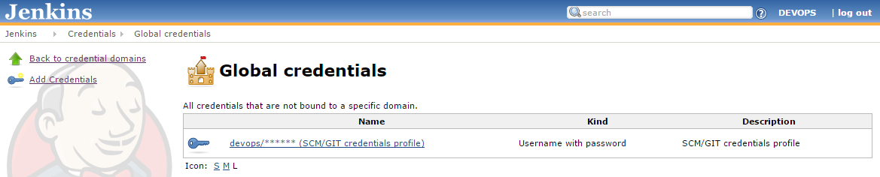

Open the **DEVOPS-R3.5-JENKINS-iBank-GIT-JAVA** job configuration page. Click on **configure** and scroll down to the **Source Code Management** section.

Update the **Repository URL** field and select the new credentials profile from the **Credentials** drop-down list.

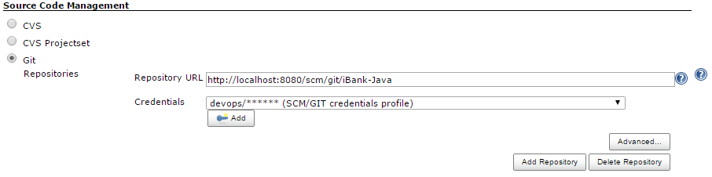

Open the **DEVOPS-R3.5-BUILD-iBank-TFS-DOTNET** job configuration page. Click on **configure** and scroll down to the **Source Code Management** section.

Update the **Server URL**, **Project path**, **Login name and User password** fields with your TFS server access details.

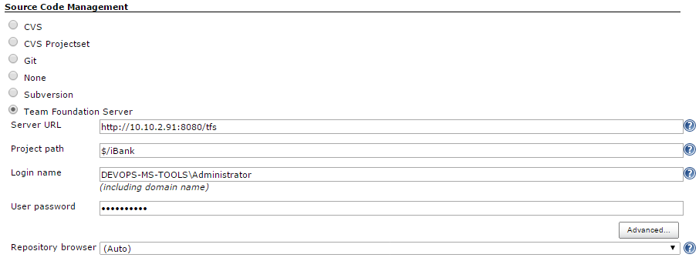

Open the **DEVOPS-R3.5-BUILD-iBank-GIT-DOTNET** job configuration page. Click on **configure** and scroll down to the **Source Code Management** section.

Update the **Repository URL** field and select the new credentials profile from the **Credentials** drop-down list.

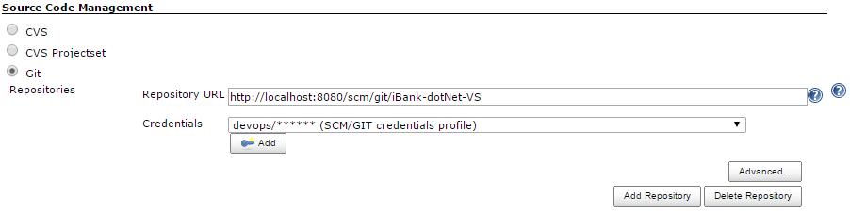

**Note:** This job is optional. It is not configured in the default R3.5 pipeline, since for iBank-dotNET the default configuration uses MS TFS as SCM repository.

Jenkins slave configuration for DevOps (ALM, SV, MSTools slaves)

There are three required slaves for this DevOps release.

**ALM** slave is required to trigger the functional and performance testing on the ALM server.

**SV** slave is required to start/stop the iBank-Java simulation on the SV server.

**MSTools** slave is required to compile the iBank-dotNET application on the MSTools server.

To setup the Jenkins **ALM** slave, complete the following steps:

1. Login to the ALM server.
2. Verify that Java JDK 7 or later is installed.
3. Open the Jenkins web UI, and log in.
4. Navigate to **Manage Jenkins > Manage Nodes** and click on the **ALM** slave:

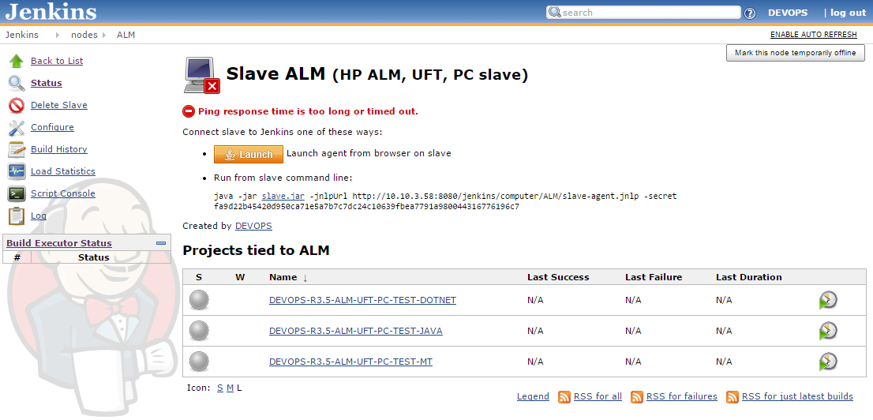

1. Click  and save the **slave-agent.jnlp** file on the **ALM** server.
2. Create new directory on the ALM server - **C:\Jenkins**
3. Start the **slave-agent.jnlp** file and verify that the slave service is connected to the master.

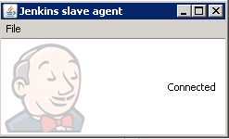

1. Click **File > Install as service** and click **OK** in the new confirmation window.

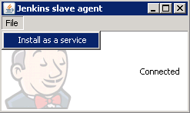

1. Now the Jenkins **ALM** slave is installed as service and will start automatically on boot.

To setup the Jenkins **SV** slave, complete the following steps:

1. Login to the SV server.
2. Verify that Java JDK 7 or later is installed.
3. Open the Jenkins web UI, and log in.
4. Navigate to **Manage Jenkins > Manage Nodes** and click on the **SV** slave:

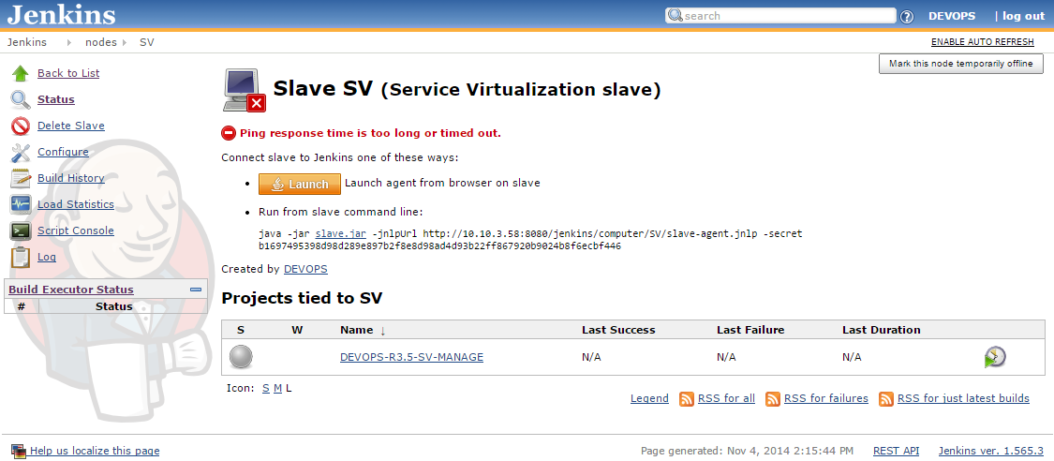

1. Click  and save the **slave-agent.jnlp** file on the **SV** server.
2. Create new directory on the SV server - **C:\Jenkins**
3. Start the **slave-agent.jnlp** file and verify that the slave service is connected to the master.



1. Click **File > Install as service** and click **OK** in the new confirmation window.



1. Now the Jenkins **SV** slave is installed as service and will start automatically on boot.

To setup the Jenkins **MSTools** slave, complete the following steps:

1. Login to the MSTools server – This is the windows server (MSTool server) with the following tools installed on it:
2. Microsoft TFS server 2012, update 4
3. Microsoft Team Explorer 2012, update 4
4. Microsoft .NET framework 4.5
5. Microsoft Web Deployment Tool 3.0
6. Nunit 2.6.3
7. NunitASP 2.0
8. Verify that Java JDK 7 or later is installed.
9. Open the Jenkins web UI, and log in.
10. Navigate to **Manage Jenkins > Manage Nodes** and click on the **MSTools** slave:

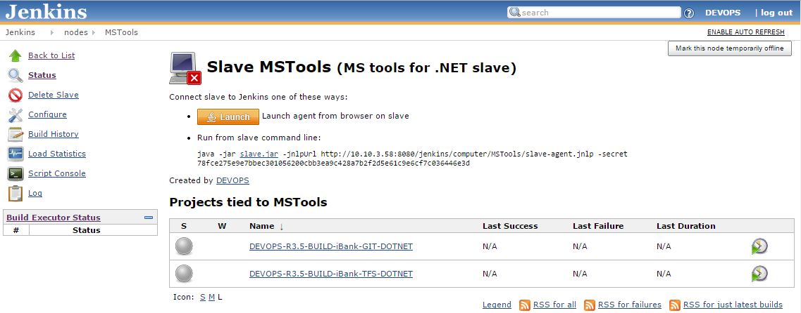

1. Click  and save the **slave-agent.jnlp** file on the MSTools server.
2. Create new directory on the MSTools server - **C:\Jenkins**
3. Start the **slave-agent.jnlp** file and verify that the slave service is connected to the master.



1. Click **File > Install as service** and click **OK** in the new confirmation window.



Now the Jenkins **MSTools** slave is installed as service and will start automatically on boot.

Jenkins jobs configuration for DevOps (Step Configuration)

This solution requires basic configuration for some of the already installed Jenkins jobs. Please, complete the following steps:

1. Open the Jenkins web UI, and open the **DevOps-R3.5-1-BUILD** job configuration.
2. Update the following input parameters, based on your environment:

**MAJOR_VERSION** – This is the Release major version. It is used in many places (UCMDB, Nexus, Chef, etc) to store the application release number – MAJOR_VERSION + Jenkins build number.

**APPLICATION_CI** – This is the UCMDB Business Application CI name, created previously. Its attributes will be updated from the Jenkins pipline.

**RELEASE_RFC_ID** – This is the SM Release RFC ticket number, created previously. It will be automatically updated from the Jenkins pipline.

**ST_RFC_ID** – This is the SM Staging RFC ticket number, created previously. It will be automatically updated/closed from the Jenkins pipline.

**PR_RFC_ID** – This is the SM Production RFC ticket number, created previously. It will be automatically updated/closed from the Jenkins pipline.

**NEXUS_PASSWORD** – This is the admin password for Nexus. It is used to upload the new iBank build artifacts to the selected artifact repository.

**NEXUS_URL** – This is the Nexus URL.

1. Click **Save** to apply the new changes.
2. Open the **DevOps-R3.5-2-TEST** job configuration.

Update the following input parameters, based on your environment:

**ADMIN_PASSWORD** – This is the Administrator/root password used for both the Windows and Linux templates. Adjust the templates so that they use the same password. For example: Administrator/1Q2w3e4r5t and root/1Q2w3e4r5t.

1. Open the **DevOps-R3.5-3-QA** job configuration.

Update the following input parameters, based on your environment:

**ADMIN_PASSWORD** – This is the Administrator/root password used for both the Windows and Linux templates. Adjust the templates so that they use the same password. For example: Administrator/1Q2w3e4r5t and root/1Q2w3e4r5t.

1. Open the **DevOps-R3.5-4-STG** job configuration.

Update the following input parameters, based on your environment:

**ADMIN_PASSWORD** – This is the Administrator/root password used for both the Windows and Linux templates. Adjust the templates so that they use the same password. For example: Administrator/1Q2w3e4r5t and root/1Q2w3e4r5t.

1. Open the **DevOps-R3.5-5-PROD** job configuration.

Update the following input parameters, based on your environment:

**ADMIN_PASSWORD** – This is the Administrator/root password used for both the Windows and Linux templates. Adjust the templates so that they use the same password. For example: Administrator/1Q2w3e4r5t and root/1Q2w3e4r5t.

**OO_ipAddress_1**– This is the ip address of a server which has the iBank Java (iBank Internet Banking) web application deployed. To create this server, clone new virtual machine from the Linux VMware template. Bootstrap the new virtual machine under chef, update the node properties and use the **ibank-java-deploy** role to depoy the iBank Java application.

**OO_ipAddress_2**– This is the ip address of a server which has the iBank dotNet (iBank vestor) web application deployed. To create this server, clone new virtual machine from the Windows VMware template. Bootstrap the new virtual machine under chef ,update the node properties and use the **ibank-deploy** role to depoy the iBank dotNet application.

1. Open the **DEVOPS-R3.5-DV-INT-DOTNET** module job configuration.
2. Update the following input parameters, based on your environment:

**ADMIN_PASSWORD** – This is the Administrator/root password used for both the Windows and Linux templates. Adjust the templates so that they use the same password. For example: Administrator/1Q2w3e4r5t and root/1Q2w3e4r5t.

1. Update the path to the SV DevOps project for **SV_HOME** in the trigger **DEVOPS-R3.5-SV-MANAGE** steps:

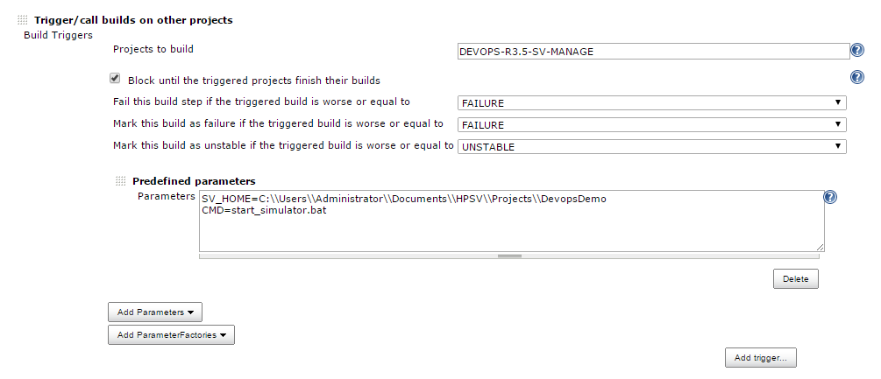

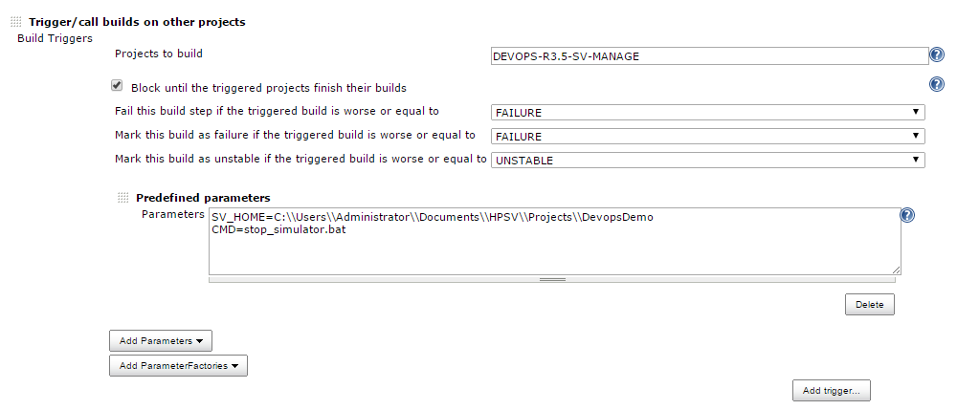

1. Update the TAB delimited parameters provided for **VALUES** in the trigger **DEVOPS-R3.5-ALM-UFT-PC-TEST-DOTNET** step.

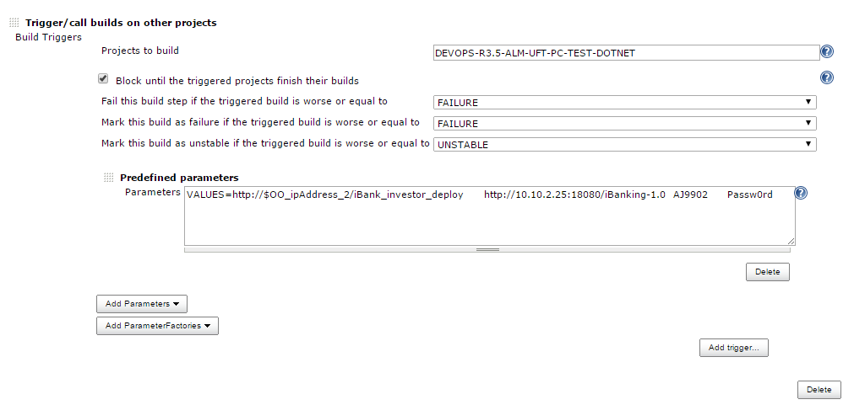

**Important:** Only the second parameter, needs to be updated with the iBank-Java URL, which was set during the iBank-Java deployment on the 3rd Party Tools server and recorded in SV.

1. Open the **DEVOPS-R3.5-DV-INT-JAVA** module job configuration.
2. Update the following input parameters, based on your environment:

**ADMIN_PASSWORD** – This is the Administrator/root password used for both the Windows and Linux templates. Adjust the templates so that they use the same password. For example: Administrator/1Q2w3e4r5t and root/1Q2w3e4r5t.

1. Update the TAB delimited parameters provided for **VALUES** in the trigger **DEVOPS-R3.5-ALM-UFT-PC-TEST-JAVA** step.

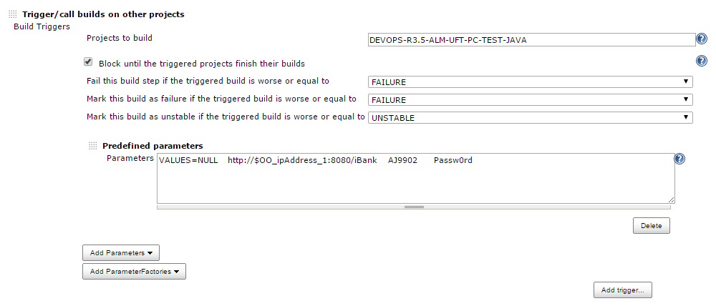

**Important:** Only the second parameter, needs to be updated with the iBank-dotNet URL, which was set during the iBank-dotNet deployment on the MSTools server.

1. Open the **DEVOPS-R3.5-ALM-UFT-PC-TEST-DOTNET** module job configuration.
2. Update the ALM admin **Password**, based on your environment:

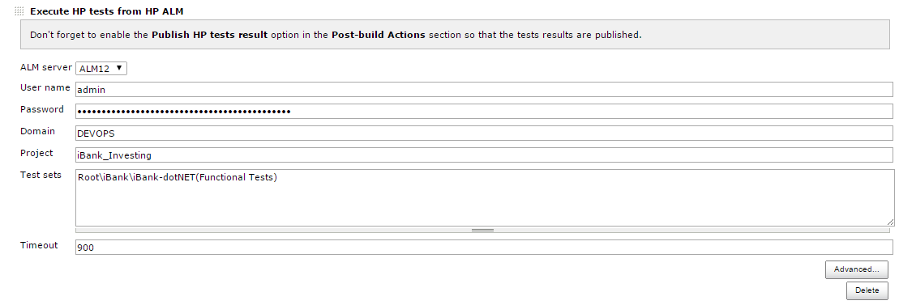

1. Update the ALM admin **Password**, **Test ID** and **Test Instance ID**, based on your environment:

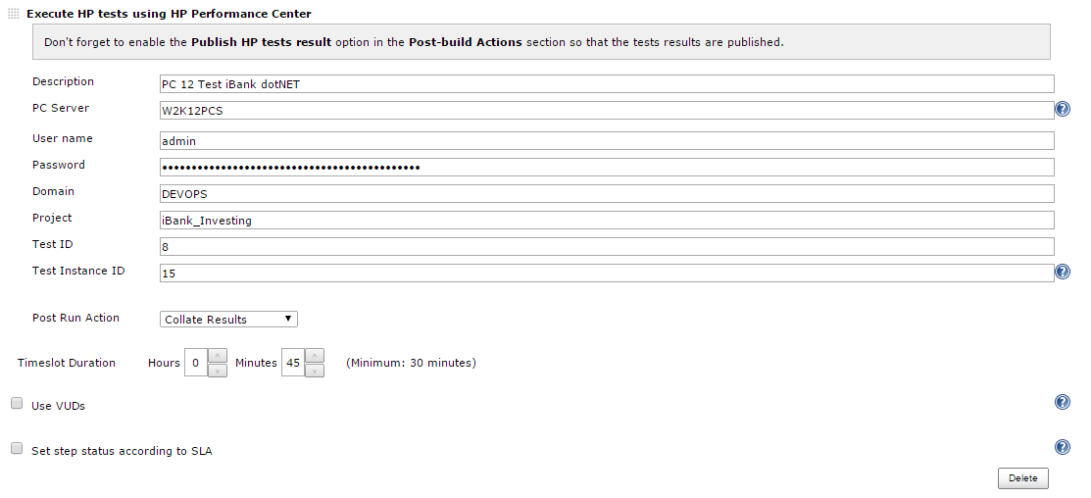

**Important:** The **Test ID** and **Test Instance ID** values will be available once the iBank-dotNet PC scripts and Tests Sets are added in ALM. This is done in the ALM Configuration section further in the document.

1. Open the **DEVOPS-R3.5-ALM-UFT-PC-TEST-JAVA** module job configuration.
2. Update the ALM admin **Password**, based on your environment:

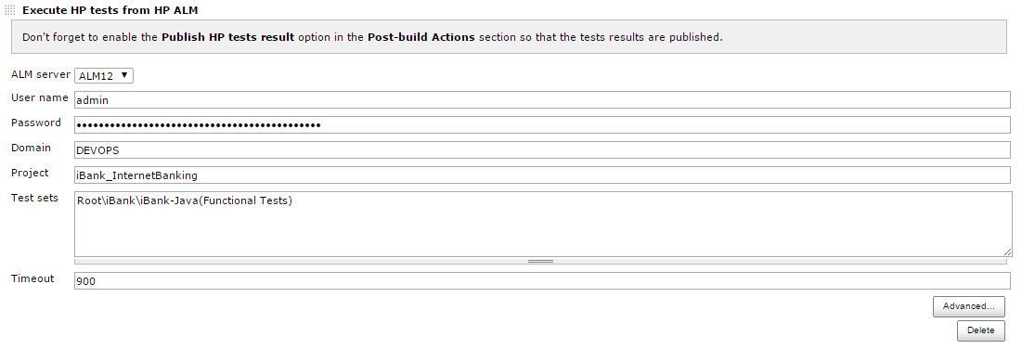

1. Update the ALM admin **Password**, **Test ID** and **Test Instance ID**, based on your environment:

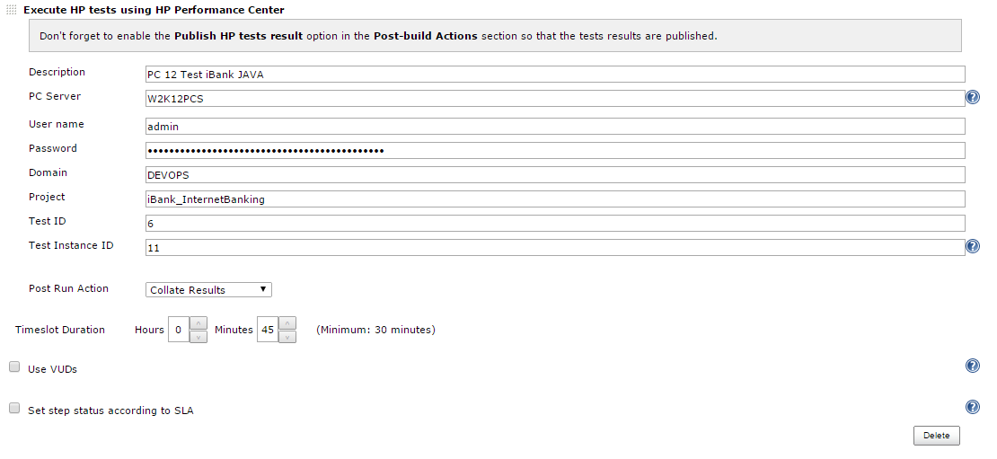

**Important:** The **Test ID** and **Test Instance ID** values will be available once the iBank-Java PC scripts and Tests Sets are added in ALM. This is done in the ALM Configuration section further in the document.

1. Open the **DEVOPS-R3.5-ALM-UFT-PC-TEST-MT** module job configuration.
2. Update the ALM admin **Password**, based on your environment:

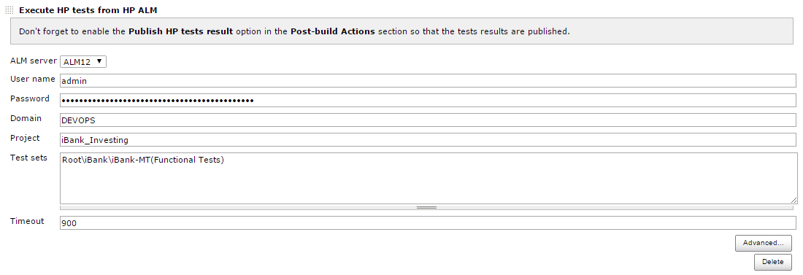

1. Update the ALM admin **Password**, **Test ID** and **Test Instance ID**, based on your environment:

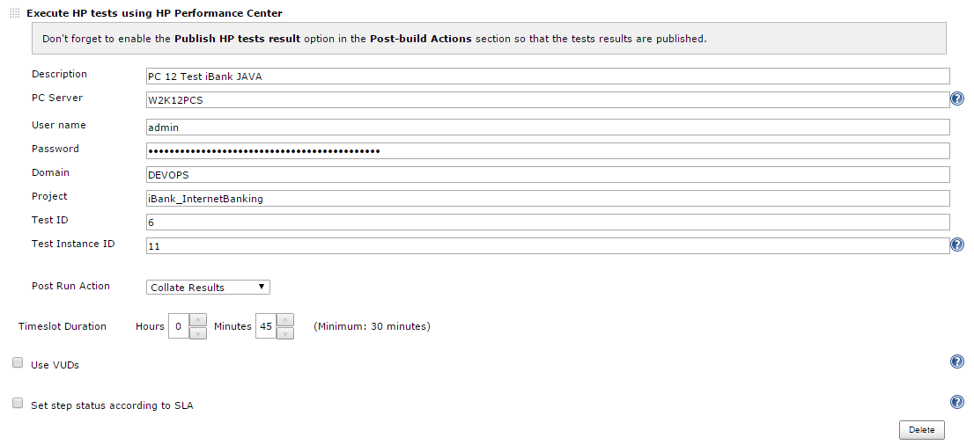

**Important:** The **Test ID** and **Test Instance ID** values will be available once the iBank-Java PC scripts and Tests Sets are added in ALM. This is done in the ALM Configuration section further in the document.

1. Update the ALM admin **Password**, **Test ID** and **Test Instance ID**, based on your environment:

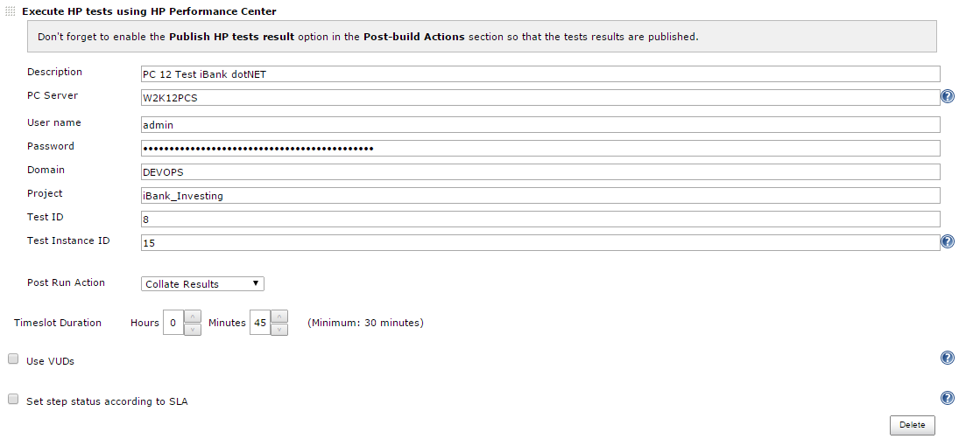

**Important:** The **Test ID** and **Test Instance ID** values will be available once the iBank-dotNet PC scripts and Tests Sets are added in ALM. This is done in the ALM Configuration section further in the document.

1. Open the **DEVOPS-R3.5-SITESCOPE-MANAGE** module job configuration.

Update the following input parameters, based on your environment:

**sitescopeHostname** – This is the Sitescope hostname/ip address, where the configured iBank App monitors will be disabled/enabled.

1. Open the **DEVOPS-R3.5-SITESCOPE-MONITOR** module job configuration.

Update the following input parameters, based on your environment:

**sitescopeHostname** – This is the Sitescope hostname/ip address, where the configured iBank App monitors will be added.

1. Open the **DEVOPS-R3.5-SITESCOPE-UNMONITOR** module job configuration.

Update the following input parameters, based on your environment:

**sitescopeHostname** – This is the Sitescope hostname/ip address, where the configured iBank App monitors will be deleted.

1. Open the **DEVOPS_LIB_OO_10** lib job configuration.

Update the following input parameters, based on your environment:

**OO_HOST** – This is the OO server hostname/ip address, where the OO workflows will be triggered from Jenkins.

**OO_CREDENTIALS**– This is the encrypted user:password string with flowinvoke.pl.

Deploy iBank Java (iBank Internet Banking) on Tomcat

1. Copy **DevOps_R3.5_Solution/Installation files/iBank/webapps/iBank-Java.war** file in the tomcat webapps folder.
2. Open the following URL to launch iBank Java (Internet banking) web application.

|  |
| --- |
| http://<hostname>:8080/iBank-Java/ |

**Note:** replace hostname with the 3rd party tools server hostname.

1. Restart tomcat:

|  |
| --- |
| /etc/init.d/tomcat7 restart |

1. Login with default credentials.

Username: **AJ9902**

Password: **Passw0rd**

**Note:** the sixth character is zero.

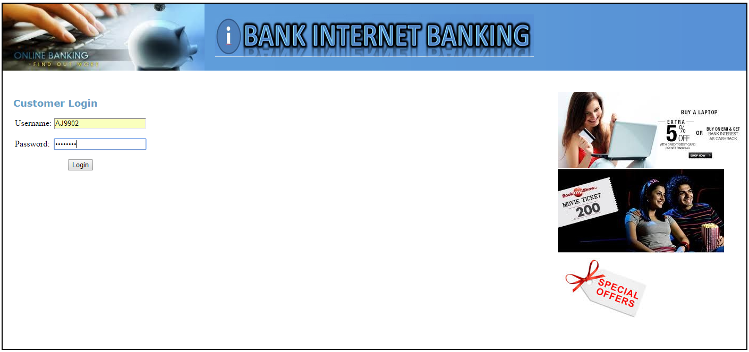

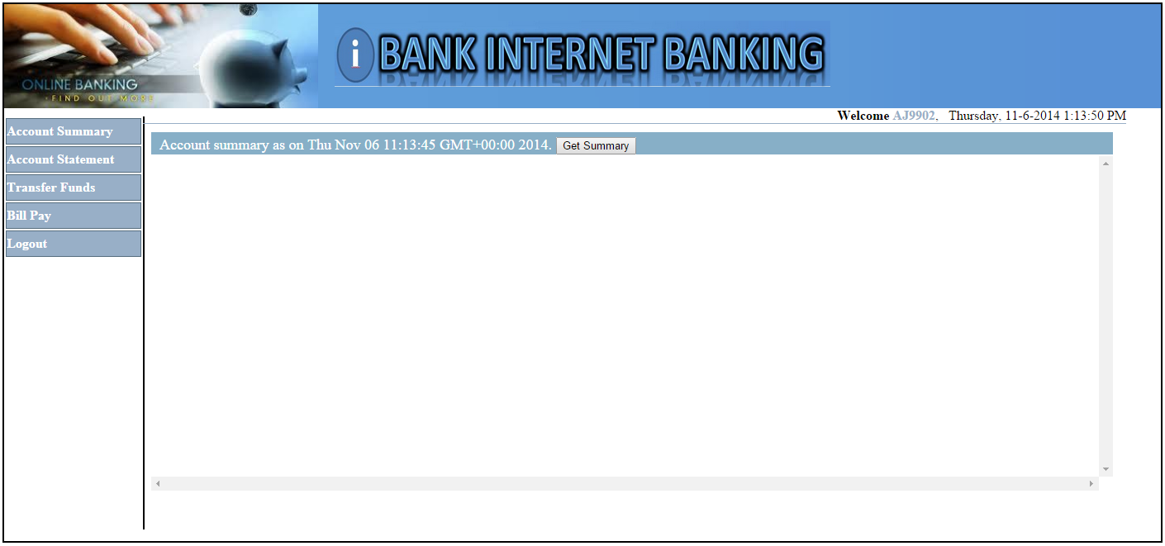

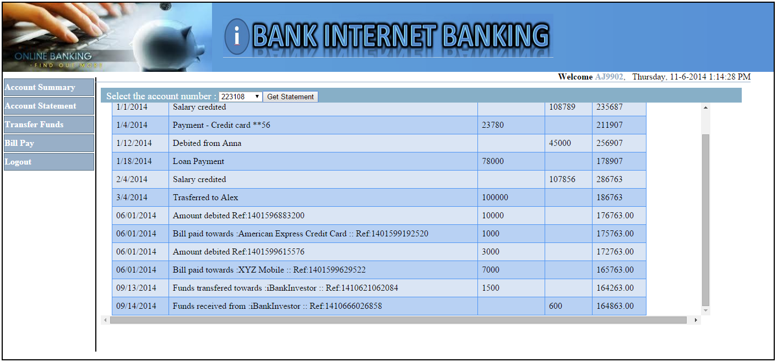

MS Tools configuration

For DevOps Release 3.5, all Microsoft tools, including .NET Framework, Nunit, NunitASP, Team Foundation Server, Web Deployment Tool, Visual Studio Professional, Visual Studio 2010 Shell Redistributable package, Team Explorer and HP TFS ALI service should run on one machine called **MSTools**. Please see example installation and configuration of these tools.

Install Microsoft .NET Framework

Example installation on Windows server 2008 R2:

1. Download the Microsoft .NET Framework install package.

**Tip**: One place to download the package

*http://download.microsoft.com/download/b/a/4/ba4a7e71-2906-4b2d-a0e1-80cf16844f5f/dotnetfx45_full_x86_x64.exe*

1. Double click the dotnetfx45_full_x86_x64.exe installer.

Accept the license agreement and click **Install**.

Click **Finish** to close the installation window.

Install Nunit

Example installation on Windows server 2008 R2:

1. Copy **DevOps_R3.5_Solution/Installation files/nunit/NUnit-2.6.3.msi** file to a temporary folder on the MSTools server:
2. Start the **Nunit-2.6.3** installer and click **Next**.

Accept the license agreement and click **Next**.

Click **Complete** to choose the setup type.

Click **Install** to start the installation.

Click **Finish** to close the installation window.

Install NunitASP

Example installation on Windows server 2008 R2:

1. Copy **DevOps_R3.5_Solution/Installation files/nunit/NUnitAsp-2.0.zip** file to a temporary folder on the MSTools server:
2. Extract the **NUnitAsp-2.0.zip** archive to the **C:\Program Files (x86)\NUnitAsp-2.0** folder:

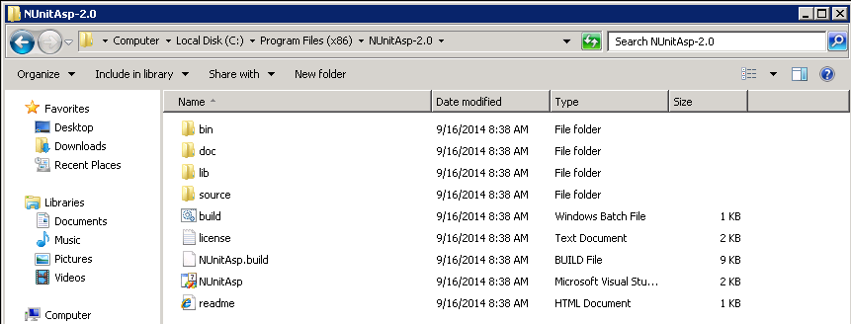

Install Microsoft Team Foundation Server

Example installation and configuration on Windows server 2008 R2:

1. Download the Microsoft Team Foundation Server 2012, update4 web installer.

**Tip**: One place to download the package

*http://www.microsoft.com/en-us/download/confirmation.aspx?id=38185*

1. Double click the **tfs_server.exe** web installer.
2. Accept the license agreement and click **Install**.
3. Enter the product key or choose trial and click **Activate**.
4. Choose **Basic** configuration and click **Start Wizard**.
5. Click **Next** on the Basic Configuration Welcome page.
6. Choose **SQL Express** to install MSSQL Express or provide existing MSSQL instance. Click **Next**.
7. Review the TFS configuration and click **Next**.
8. Click **Configure** to complete the TFS installation.
9. Click **Next**.
10. Click **Close**.
11. Click **Close** again to exit from the TFS installer.

Install Microsoft Web Deployment Tool

Example installation on Windows server 2008 R2:

1. Download the Microsoft WDT install package.

**Tip**: One place to download the package

*http://download.microsoft.com/download/1/B/3/1B3F8377-CFE1-4B40-8402-AE1FC6A0A8C3/WebDeploy_amd64_en-US.msi*

1. Start the **WebDeploy_amd64_en-US.msi** installer and click **Next**.
2. Accept the license agreement and click **Next**.
3. Click **Complete** to choose the setup type.
4. Click **Install** to start the installation.
5. Click **Finish** to close the installation window.

Install Microsoft Visual Studio Professional

Example installation on Windows server 2008 R2:

1. Download the Microsoft Visual Studio Professional 2012, update 4 web installer.

**Tip**: One place to download the package

*http://www.microsoft.com/en-us/download/confirmation.aspx?id=30682*

1. Start the **vs_professional.exe** web installer.
2. Accept the license agreement and click **Next**.
3. Select all features option and click **Install**.
4. Close the installer.

Install Microsoft Visual Studio 2010 Shell (Isolated) Redistributable Package

Example installation on Windows server 2008 R2:

1. Download the Microsoft VS 2010 shell redistributable package.

**Tip**: One place to download the package

*http://www.microsoft.com/en-us/download/confirmation.aspx?id=1366*

1. Start the **VSIsoShell.exe** installer and click **Next**.
2. Accept the license agreement and click **Next**.
3. Click **Install**.
4. Click **Restart now** finish the installation.
5. Start Visual Studio, when the server is back.
6. Select **Web Development** and click **Start Visual Studio**.

Install Microsoft Team Explorer

Example installation on Windows server 2008 R2:

1. Download the Microsoft Team Explorer 2012 web installer.

**Tip**: One place to download the package

*http://www.microsoft.com/en-us/download/confirmation.aspx?id=30656*

1. Start the **vs_teamExplorer.exe** web installer.
2. Accept the license agreement and click **Install**.
3. Close the installer.

Install Git tools for Microsoft Visual Studio

Example installation on Windows server 2008 R2:

1. Download the Visual Studio Git tools installer.

**Tip**: One place to download the package

*https://visualstudiogallery.msdn.microsoft.com/abafc7d6-dcaa-40f4-8a5e-d6724bdb980c*

1. Start the **Microsoft.TeamFoundation.Git.Provider.msi** installer.
2. Accept the license agreement and click **Install.**
3. Click **Finish** to close the installation window.

Install HP TFS ALI service

Application Lifecycle Intelligence (ALI) tracks development activities and links them to Application Lifecycle Management (ALM) entities. ALI integrates your Source Code Management (SCM) with Application Lifecycle Management(ALM) and links activities such as code changes and code coverage analyses from your SCM to ALM entities such as Releases, Requirements, Defects, and Tests.

As pre-requisite, in ALM Site Administration, enable the ALI extension for every project in which you want to use ALI.

Example installation on Windows server 2008 R2:

1. Download the HP ALI 2.7 bundle from:

*https://hpln.hp.com/group/application-lifecycle-intelligence*

**Note:** To download the ALI 2.7 Bundle, you need to sign up with your HP passport account.

1. Extract the **ALI27_0.zip** archive and copy the following file to the TFS server.

|  |
| --- |
| ALI27_0\agents\scm-integration\windows\ali-tfs-services.zip |

1. Extract the archive to a temporary folder on the TFS server and start the **HP-ALI-TFS-Services-Installer.msi** installer located under **ali-tfs-services\HP-ALI-TfsServices** folder.

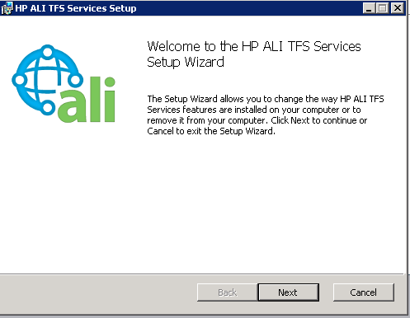

1. Click **Next**.
2. Leave the default setup type, or select the component that you want to install. Click **Next**.
3. Select the application site, where you want to store the HP ALI TFS service and choose the name for the new IIS application.

**Note:** We recommend to use the existing site **Team Foundation Server**, since HP ALI TFS services will share ports with TFS.

1. Click **Next**.
2. Enter values for the required fields: **IIS Application Pool**, **Domain**, **User**, **Password** and click **Next**.
3. Choose the destination folder where the IIS service data will be installed and click **Next**.
4. Enter values for the required fields or leave the default values: **TFS Collection URL**, **ALI Agent Configuration file**, **ALI Agent Configuration folder** and click **Next**.

**Note:** You can leave the **ALI Agent Configuration file** value empty. If the configuration file doesn't exist the HP ALI SCM Push will be stil enabled. You can change those settings in the windows registry later:

|  |
| --- |
| SOFTWARE\Hewlett-Packard Development Company\ALI\TFS\Services\TfsConfigurationFile |

1. Click **Next**. Review the summary page and click **Next** again.
2. Click **Install** to start the ALI TFS services installation.
3. Click **Finish**  to close the installer.

**Important:** For more detailed installation and configuration instructions, please refer to the ALI TFS pdf guide- **ALI27_UG.pdf**, located in the **DevOps_R3.5_Solution\Content files\tfs** folder.

Create TFS team project for iBank dotNet (iBank Investor) application

Example configuration on Windows server 2008 R2:

1. Start Visual Studio and click on **VIEW > Team Explorer**.

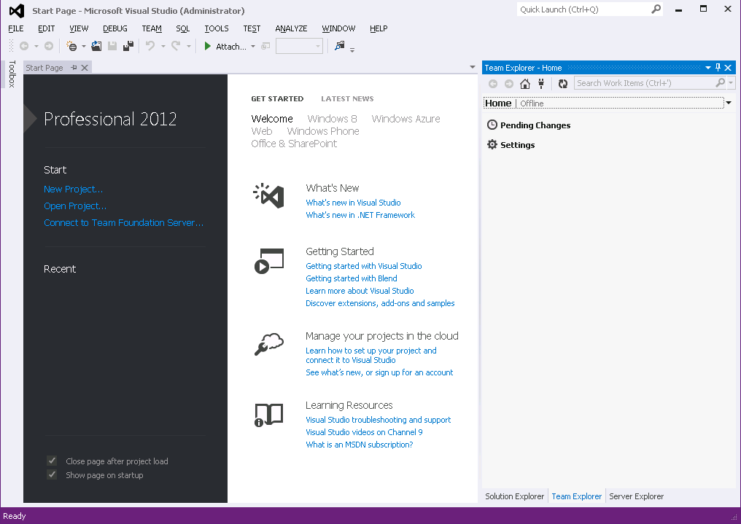

1. Click  , and then click **Connect** under **Team Foundation Service** to connect to a TFS server.
2. Select the TFS server from the drop-down list and click **Connect**.
3. Click **Home > Project and My Teams > New Team Project…**

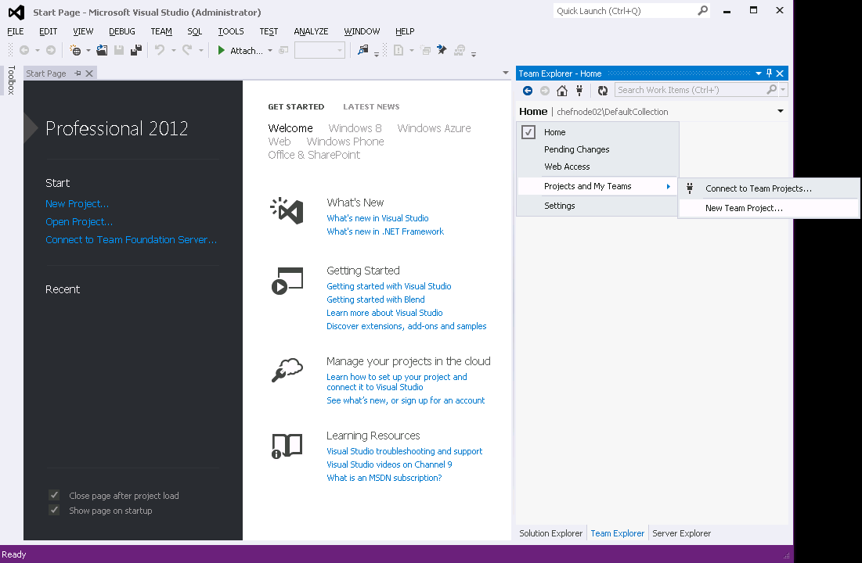

1. Enter the new project name and click **Next**.

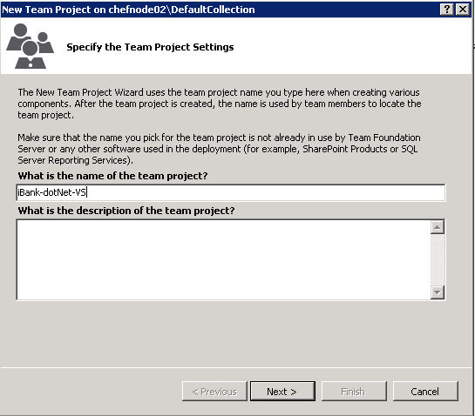

1. Accept the default Process Template and click **Finish**.
2. Click **Close** to finish the project configuration.

Import iBank dotNet (iBank Investor) source code to the TFS team project

1. Copy **DevOps_R3.5_Solution/Content files/iBank/iBank-dotNet.zip** file to a temporary folder on the MSTools server:
2. Extract the **iBank-dotNet.zip** archive to the **C:\** drive:
3. Open Visual Studio, connect to the TFS server and click **VIEW >** **Team Explorer**. Click on **Source Control Explorer**, under **Pending Changes**.

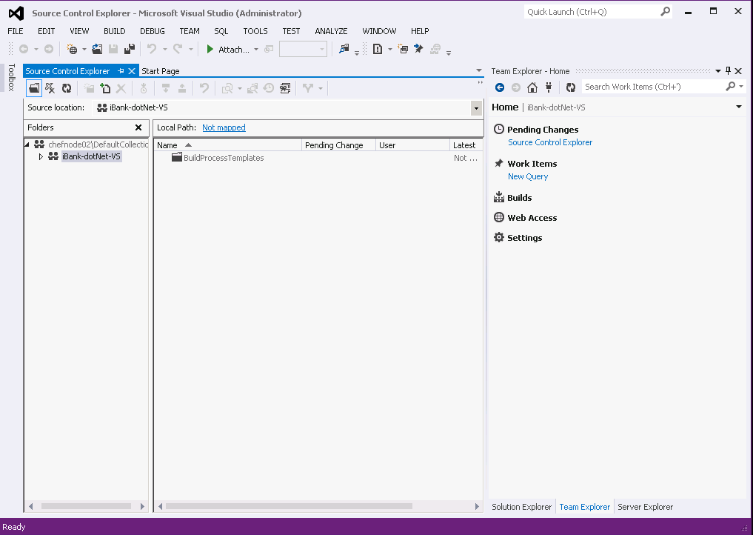

1. Select the **iBank-dotNet-VS** project and click on the **Not mapped** link, next to **Local Path**.
2. Enter **C:\iBank-dotNet-VS** for **Local folder** and click **Map**.

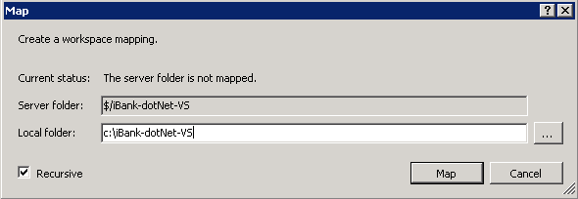

1. Click **Yes** to download all newly mapped files.

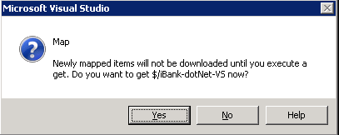

1. Click  from the main **Source Control Explorer** toolbar to add new items to the TFS repository.

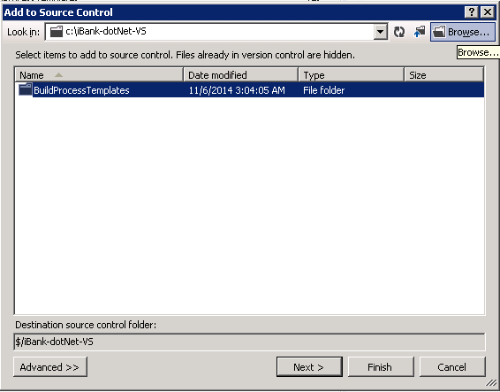

1. Click **Browse** and select the extracted **iBank-dotNet** source code folder and click **OK**.
2. Select all new items and click **Finish**.

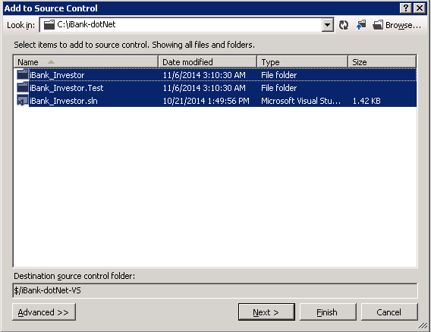

1. Click **HOME > Pending Changes**, under the **Team Explorer** view. Provide new check-in **Comment** and click the **Check In** button.

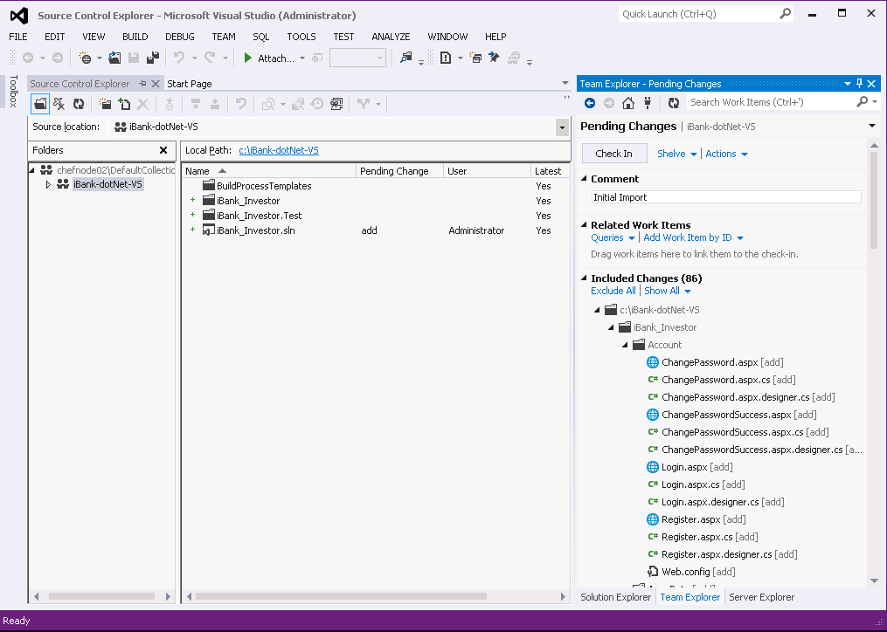

1. All changes are now stored in the TFS repository.

Setup iBank dotNet TFS webservice hook to trigger Jenkins build on a new code change

TFS webservice hook is required to trigger the build in Jenkins when user commits code to TFS Source Control Management Tool. In TFS hook is created by subscribing webservice to an event.

For DevOps, a Jenkin Trigger webservice is created and deployed. The webservice is subscribed to TFS Checkin Event with filters. Any check in (commit) to TFS containing the string RUN_BUILD, invokes the web service which in-turn triggers the Jenkins build.

1. Copy **DevOps_R3.5_Solution/Content files/tfs/TFSJenkinsService.zip** file to a temporary folder on your MSTools server and extract the archive.
2. Open new Windows command prompt and run the following commands, to register ASP.NET with .NET framework 4:

|  |
| --- |
| %WINDIR%/Microsoft.NET/Framework64/v4.0.30319/aspnet_regiis.exe –i  %WINDIR%/Microsoft.NET/Framework/v4.0.30319/aspnet_regiis.exe –i  iisreset |

1. Change the working directory to the extracted **TFSJenkinsService** folder and run the following command:

|  |
| --- |
| EventService.deploy.cmd /Y |

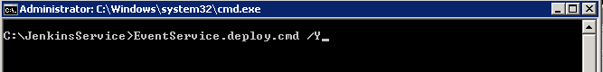

1. Go to the **TFSJenkinsService** IIS folder – **c:\inetpub\wwwroot\TFSJenkinsService** and open the **Web.config** file. Update your Jenkins **URL** and **credentials** in the **<appSettings>** xml section:

|  |
| --- |
| <appSettings>  <add key="username" value="**#username#**"/>  <add key="password" value="**#password#>**"/>  <add key="url" value="http://**#hostname#**:**#port#**/jenkins/job/**#JOB_NAME#** /buildWithParameters?token=BUILD&amp;cause=TFS_Code_Change"/>  </appSettings> |

**Note** : update the **username**, **password**, **hostname** and **port** fields with the Jenkins server details.

**Important**: update **JOB_NAME** with **DEVOPS-R3.5-1-BUILD**

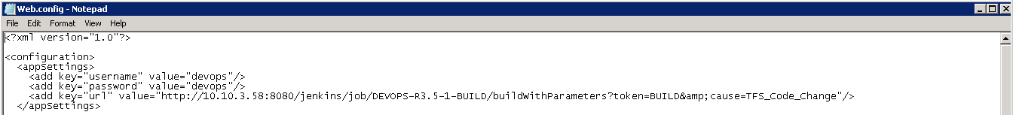

1. Restart the IIS service, with the following command:

|  |
| --- |
| iisreset |

1. To test the TFS Jenkins webservice hook, open new browser and navigate to the following URL :

|  |
| --- |
| http://**<host>**/TFSJenkinsService/JenkinsService.svc |

**Note** : update the **host** with the MSTools server hostname.

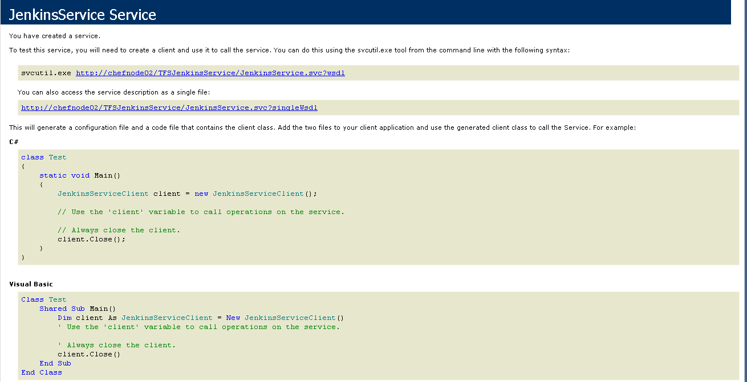

Subscribe the TFS webservice hook to TFS Event

1. Open new command prompt window and change the working directory to the TFS Tools folder - **C:\Program Files\Microsoft Team Foundation Server 11.0\Tools**.
2. To subscribe the webservice, run the following command in TFS Server

|  |
| --- |
| BisSubscribe.exe /eventType CheckInEvent /address http://**<IIS_Host>**/TFSJenkinsService /JenkinsService.svc /deliveryType Soap /collection http://**<TFS_Host>**:**<TFS_Port>**/tfs/**<Collection>** /filter "TeamProject = '**<Project>**' AND Comment MATCH 'RUN_BUILD'" |

**Note:** Where the following parameters, must be updated with the IIS/TFS details:

**<IIS_Host>** - localhost

**<TFS_Host>** - localhost

**<TFS_Port>** - 8080

**<Collection>** - DefaultCollection

**<Project>** - iBank-dotNet-VS

Example command:

|  |
| --- |
| BisSubscribe.exe /eventType CheckInEvent /address http://localhost/TFSJenkinsService/JenkinsService.svc /deliveryType Soap /collection http://localhost:8080/tfs/DefaultCollection /filter "TeamProject = 'iBank-dotNet-VS' AND Comment MATCH 'RUN_BUILD'" |

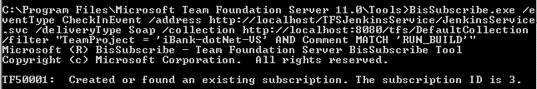

Deploy iBank dotNet (iBank Investor) on IIS

1. Copy **DevOps_R3.5_Solution/Installation files/iBank/webapps/iBank-dotNet.zip** file and extract the archive to c:\webapp.

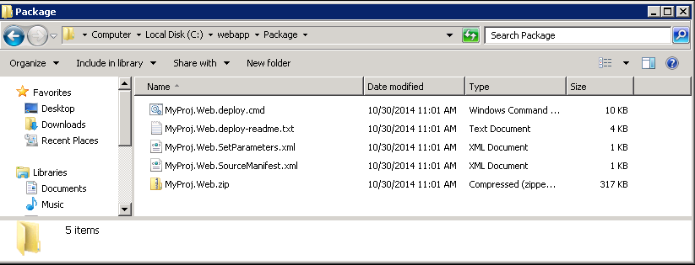

1. Go to the package folder c:\webapp\Package and open new Windows command prompt window.
2. Run the following commands to deploy the web package in IIS.

|  |
| --- |
| Set MSDeployPath=C:/Program Files/IIS/Microsoft Web Deploy V3  MyProj.Web.deploy.cmd /Y |

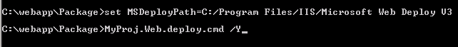

1. Restart IIS with the following command:

|  |
| --- |
| iisreset |

1. Open the iBank dotNet URL to launch the web application.

|  |
| --- |
| http://**<hostname>**/iBank_Investor_deploy/ |

**Note:** replace hostname with the IIS server hostname.

1. Login with default credentials:

Username : **AJ9902**

Password: **Passw0rd**

**Note:** the sixth character is zero.

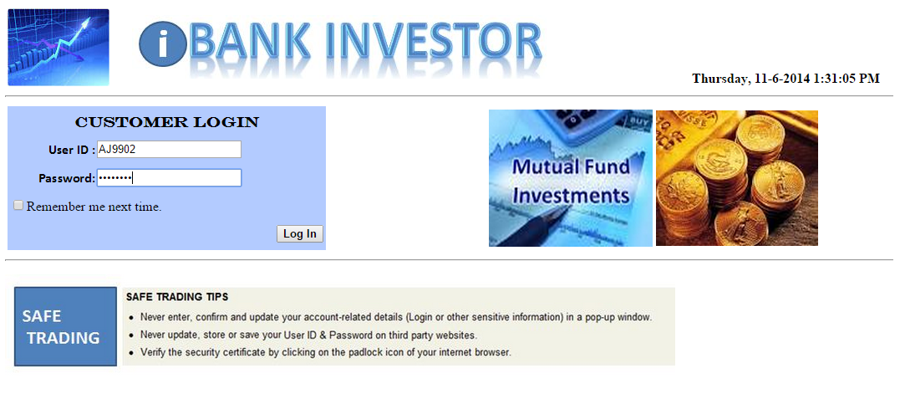



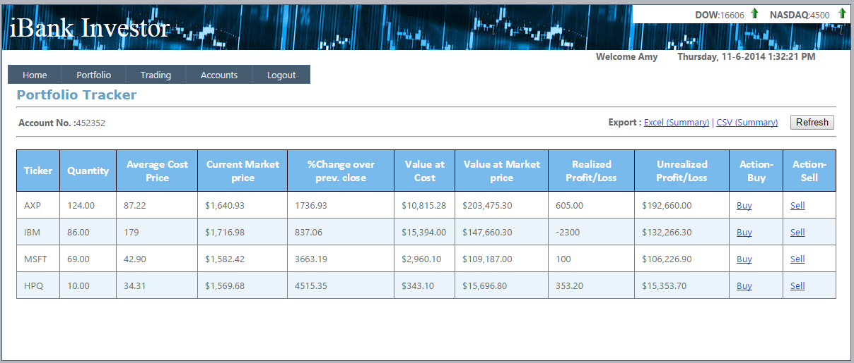

Integrate iBank dotNet (iBank Investor) and iBank Java (iBank Internet Banking)

iBank Investor uses the REST API of iBank Internet Banking application to perform funds transfer from Trading account to Bank account.

1. REST API urls of iBank Internet banking application has to be configured in iBank Investor application.

Go to the **DatabaseXML** folder in iBank Investor deployment folder:

|  |
| --- |
| C:\inetpub\wwwroot\iBank_Investor_deploy\DatabaseXML |

1. Update **Webservice.xml** file with iBank Internet Banking server details:

|  |
| --- |
| <webservice>  <accountdetails>http://**<host>**:**<port>**/**<app>**/restaccount</accountdetails>  <transactiondetails>http://**<port>**:**<port>**/**<app>**/resttransaction.xml</transactiondetails>  </webservice> |

**Note** : update the host, port, app fields with the iBank Internet Banking details.

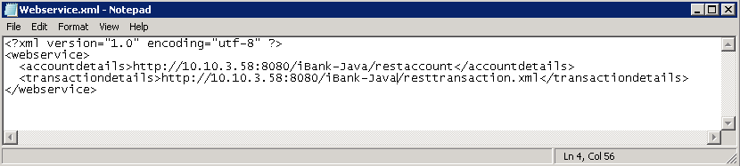

1. Open the iBank dotNet URL to launch the web application.

|  |
| --- |
| http://**<hostname>**/iBank_Investor_deploy/ |

**Note:** replace hostname with the IIS server hostname.

1. Login with default credentials:

Username : **AJ9902**

Password: **Passw0rd**

**Note:** the sixth character is zero.

1. Change the **C:\inetpub\wwwroot\iBank_Investor_deploy** folder to have full permissions for the Users group.

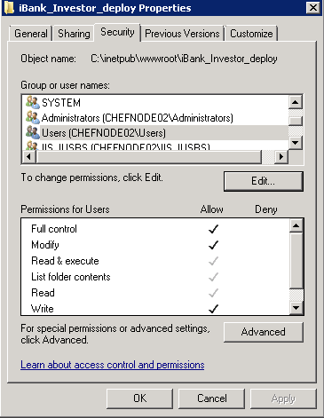

1. Click Accounts. Enter some money to transfer and select the **To** option on the right side. Click **Transfer**.

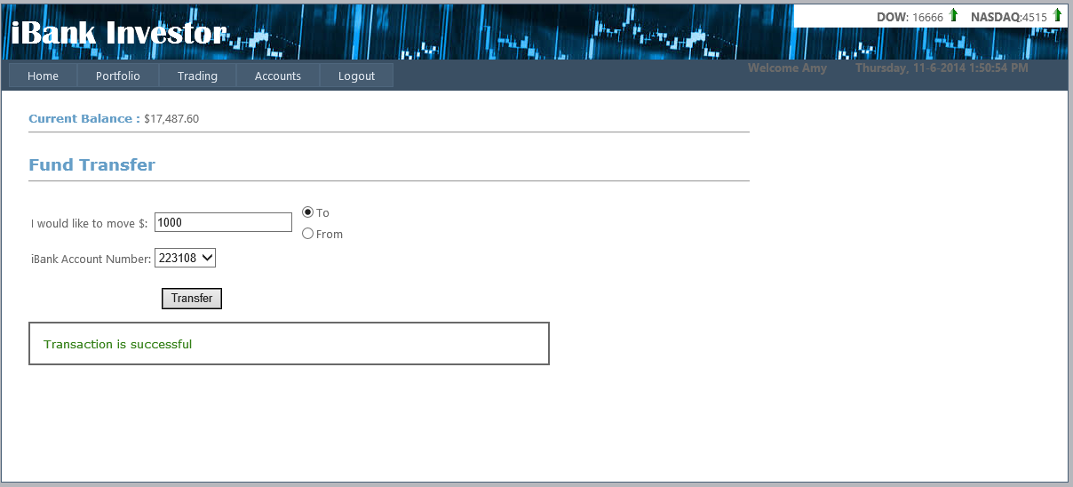

1. To verify the transaction is successful, Open the following URL to launch iBank Java (Internet banking) web application.

|  |
| --- |
| http://<hostname>:8080/iBank-Java/ |

**Note:** replace hostname with the 3rd party tools server hostname.

1. Login with default credentials.

Username: **AJ9902**

Password: **Passw0rd**

**Note:** the sixth character is zero

1. Click on **Account Statement**. Select account number **223108** and click **Get Statement.**
2. Verify the transaction is successful.

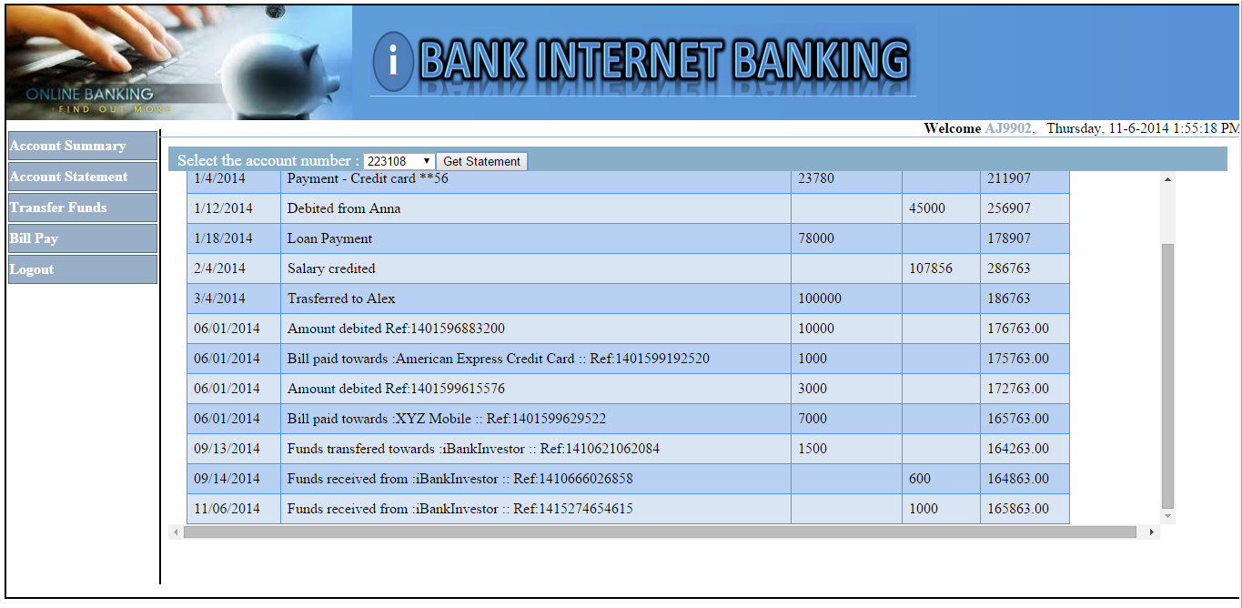

Setup Enterprise Chef

Install Enterprise Chef Server

Chef Server is an automatic configuration management platform that automatically provision and configure new machines. It is available for different Linux Operating Systems – CentOS, RedHat and Ubuntu. For more details on each supported OS and installation instructions, please check the Chef documentation.

Enterprise Chef can be configured in several ways to support Scaled Front End (API handling/web interface), Scaled Back End (node information/user databases), and High Availability (both scaled front & back ends).

**Note**: This guide covers an example installation of a chef server on a single system (referred to as **Standalone**).

Example installation on Red Hat 6.3:

1. Go to the chef website to download **Enterprise Chef**.

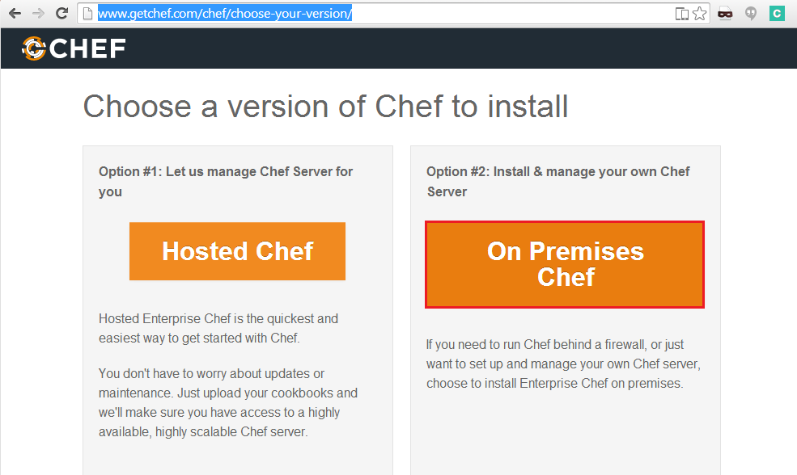

1. The following chef components must be downloaded:

Enterprise Chef (private-chef-x.x.x-x…)

Reporting (opscode-reporting-x.x.x-x…)

Push Jobs server (opscode-push-jobs-server_x.x.x-x…)

Chef Manage (opscode-manage_x.x.x-x…)

1. Verify the following requirements before installation

**Important**

The chef server hostname must be resolvable by FQDN

The system’s time must be set correctly

The system has internet connection

Ports 80 and 443 must be opened on inbound traffic by the firewall

1. Connect to your chef server and install the required chef components

Installing Private Chef:

1. Install the chef server, with the following command:

**Note**: The rpm version might be different, but only the listed one was tested with the provided DevOps solution.

|  |
| --- |
| sudo rpm -Uvh private-chef-11.1.3-1.el6.x86_64.rpm |

1. Re-configure the chef server, with the following command:

|  |
| --- |
| sudo private-chef-ctl reconfigure |

1. Verify the chef server, with the following command:

|  |
| --- |
| sudo private-chef-ctl test |

Insalling Reporting:

1. Install the chef reporting, with the following command:

**Note**: The rpm version might be different, but only the listed one was tested with the provided DevOps solution.

|  |
| --- |
| sudo rpm -Uvh opscode-reporting-1.1.1-1.el6.x86_64.rpm |

1. Re-configure the chef reporting, with the following command:

|  |
| --- |
| sudo opscode-reporting-ctl reconfigure |

1. Restart the chef reporting, with the following command:

|  |
| --- |
| sudo private-chef-ctl restart opscode-reporting |

1. Verify the chef reporting, with the following command:

|  |
| --- |
| sudo opscode-reporting-ctl test |

Installing Push Jobs Server:

1. Open the ports 10000-10003 to inbound traffic on the chef server.
2. Install the chef push jobs server, with the following command:

**Note**: The rpm version might be different, but only the listed one was tested with the provided DevOps solution.

|  |
| --- |
| sudo rpm -Uvh opscode-push-jobs-server-1.1.1-1.el6.x86_64.rpm |

1. Re-configure the push jobs server, with the following command:

|  |
| --- |
| sudo opscode-push-jobs-server-ctl reconfigure |

1. Re-configure the chef server, with the following command:

|  |
| --- |
| sudo private-chef-ctl reconfigure |

1. Verify the push jobs server, with the following command:

|  |
| --- |
| opscode-push-jobs-server-ctl test |

Installing Chef Manage:

1. To disable the legacy web UI, open the **/etc/opscode/private-chef.rb** configuration file and change or add the following line: **opscode_webui['enable'] = false**
2. Re-configure the chef server, with the following command:

|  |
| --- |
| sudo private-chef-ctl reconfigure |

1. Install the management console, with the following command:

**Note**: The rpm version might be different, but only the listed one was tested with the provided DevOps solution.

|  |
| --- |
| sudo rpm -Uvh opscode-manage-1.3.1-1.el6.x86_64.rpm |

1. Re-configure the management console, with the following command:

|  |
| --- |
| sudo opscode-manage-ctl reconfigure |

1. To verify the management console installation, start new web browser window and navigate to the chef server URL. Click the sign-up link and create the first chef user.

Setup Chef Client (workstation)

Install Chef Client

Chef Client (workstation) is a tool to administer your chef server managed objects and cookbooks. It is available for different Operating Systems – Windows and Linux. For more details on each supported OS and installation instructions, please check the Chef documentation.

The Chef client (workstation) can be installed on a standalone server or on a shared one. Since the Sample Jenkins projects provided with this solution are configured to run local chef client commands via the knife utility, in this example the chef client will be installed on the Jenkins server (3rd party tools server).

Example chef client installation on Ubuntu 14.04 LTS:

1. Go to the chef website and go to the download section for **Chef Client**. Select the Operating system details and chef client version and click on the download link.

**Note**: The chef client version might be different, but only version **11.14.2-1** was tested with the provided DevOps solution.

1. Download chef_11.14.2-1_amd64.deb using wget (or uploading it from local machine with scp) to the Jenkins server

|  |
| --- |
| wget https://opscode-omnibus-packages.s3.amazonaws.com/ubuntu/13.04/x86_64/chef_11.14.2-1_amd64.deb |

1. Remove any previous chef installations (apt-get remove chef)
2. Install Chef.

|  |
| --- |
| dpkg –I chef_11.14.2-1_amd64.deb |

1. Verify chef installation by typing ‘knife’ from command line

Install Chef Client plugins

The DevOps implementation requires the following chef client plugins to be installed:

* **knife-attribute** – plugin used to manage Chef Server Node attributes. Supported operations – add, update and delete node attributes from the knife utility.
* **knife-windows** – plugin used to add chef support for managing windows servers.

Install the knife plugins

1. Install ruby and ruby-dev:

|  |
| --- |
| apt-get install ruby  apt-get install ruby-dev |

1. Install required ruby gems:

|  |
| --- |
| /opt/chef/embeeded/bin/gem install knife-attribute knife-windows |

1. To verify the knife plugins are successfully installed, go to the chef-repo folder and execute the following commands:

|  |
| --- |
| knife node attribute –help  knife winrm –help |

Configure Chef Client with Chef Server

The Chef Client requires a **chef repository**, where the configuration files, cookbooks, roles are managed.

To install the **chef repository**, complete the following steps:

1. Login to the Enterprise Chef web UI and go to the Administration. Select your organization from the list and click on **Starter Kit** from the menu.

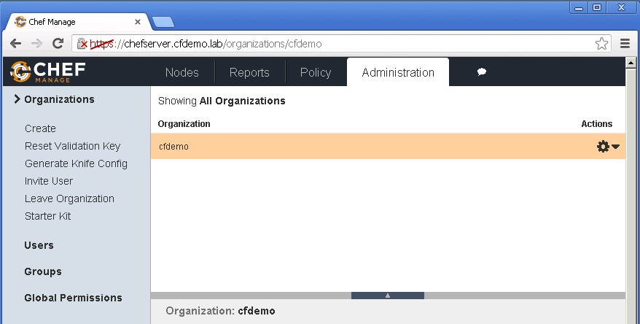

1. Copy the chef **started kit** archive to your chef client server, when the download is completed.
2. Extract the **starter kit** archive to a selected folder on your filesystem.
3. Go to the **chef-repo** folder and execute the following commands:

Init the Git repository

|  |
| --- |
| git init |

Add the chef repo files

|  |
| --- |
| git add * |

Commit the changes

|  |
| --- |
| git commit -m "My initial commit message" |

1. To verify the chef client configuration is successful, execute the following command from the chef-repo folder:

**Note**: You should see at least one entry **<your-organization>-validator**.

|  |
| --- |
| knife client list |

Import the DevOps Chef Content

To import the sample DevOps cookbooks and roles to the chef server, complete the following steps:

1. Copy the **DevOps_R3.5_Solution\Content files\chef\cookbooks.zip** to a temporary folder on your chef client workstation and extract the archive:
2. Copy the following cookbooks to the **chef-repo** **> cookbooks** folder.

|  |
| --- |
| chef_handler  windows  ms_dotnet45  Deploy-iBank  Deploy-iBank-java |

1. Open new console session and change the working directory to the **chef-repo** folder. Execute the following commands to upload the above cookbooks to the chef server:

|  |
| --- |
| knife cookbook upload chef_handler  knife cookbook upload windows  knife cookbook upload ms_dotnet45  knife cookbook upload Deploy-iBank  knife cookbook upload Deploy-iBank-java |

1. Update the HP Service Virtualization server **IP address** and **Port** values in the following chef cookbook file:

* ../cookbooks/Deploy-iBank/attributes/default.rb

Attribute name: **default['Deploy-iBank']['ie_proxy_host']**

Example: **<sv_server>:<sv_port>**

1. To verify the cookbooks are successfully uploaded, login to the Enterprise Chef web UI and go to the **Policy** tab.

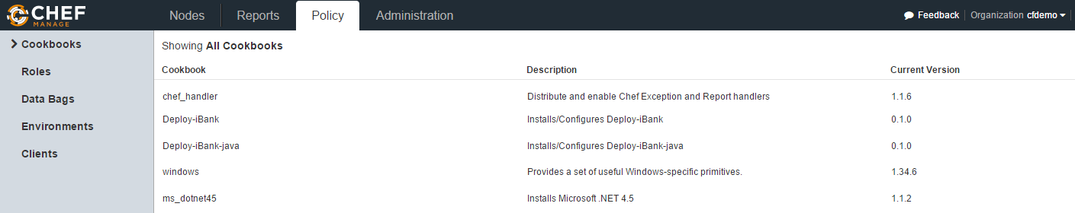

1. Copy the **DevOps_R3.5_Solution\Content files\chef\roles.zip** to a temporary folder on your chef client workstation and extract the archive:
2. Copy the following json files to the **chef-repo** **> roles** folder.

|  |
| --- |
| ibank-deploy.json  ibank-java-deploy.json |

1. Open new console session and change the working directory to the **chef-repo** folder. Execute the following commands to upload the above roles to the chef server:

|  |
| --- |
| knife role from file ibank-deploy.json  knife role from file ibank-java-deploy.json |

1. To verify the roles are successfully uploaded, login to the Enterprise Chef web UI and go to the **Policy** tab **> Roles**.

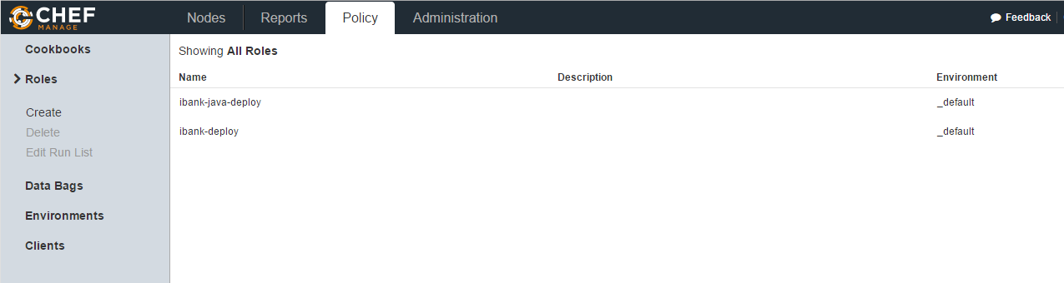

Setup Virtual Service using HP Service Virtualization Designer/Server

HP Service Virtualization is used to virtualize web services being used across composite applications.

In DevOps Release 3.5, the **iBank dotNet** (iBank Investor) web application uses REST API of **iBank Java** (iBank Internet Banking) web application to retrieve account details and perform transaction.

HP Service Virtualization Designer is used to create and configure virtual service for **iBank Java** (iBank Internet Banking) web application.

Configure virtual service in HP Service Virtualization Designer

To configure virtual service in **HP Service Virtualization Designer**, complete the following steps:

1. Launch HP SV Designer application and create new project.

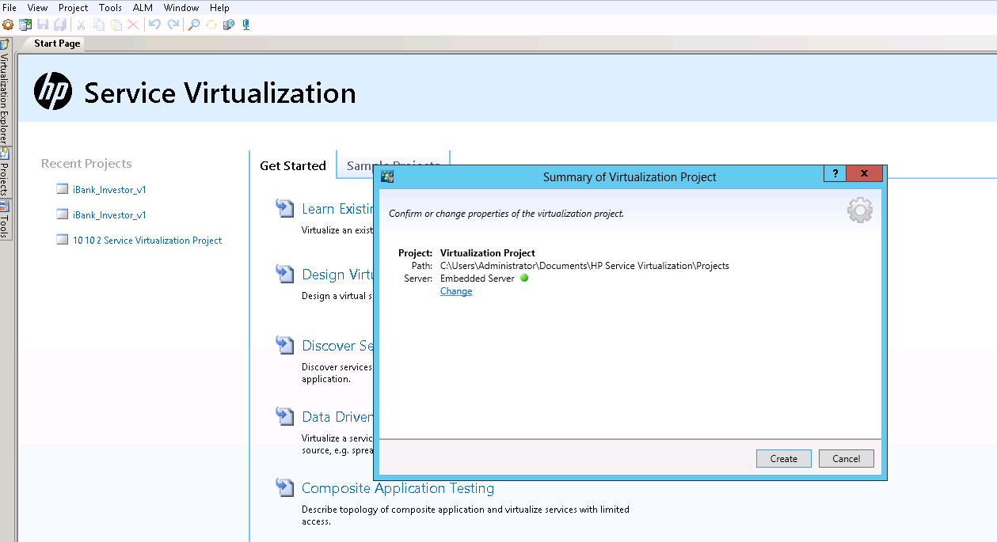

1. Add **Virtual Service** to the project created.

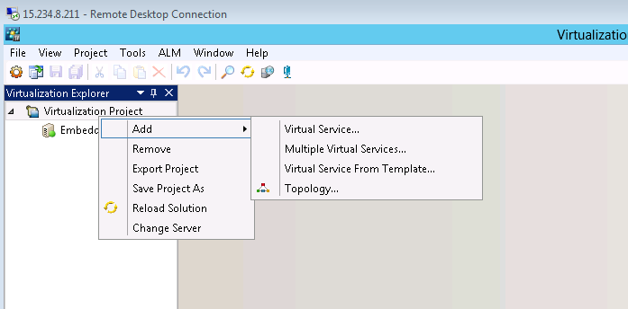

1. Choose **REST** protocol for the virtual service.

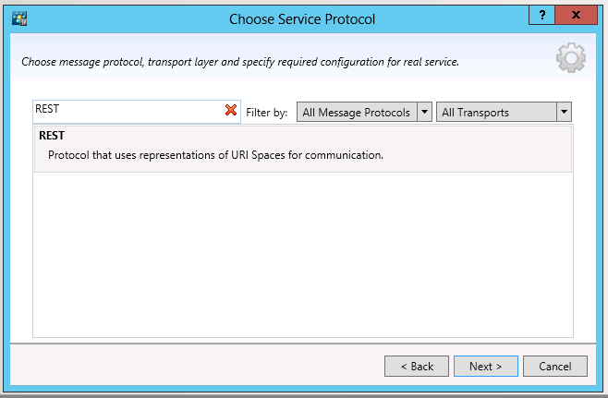

1. Provide the **iBank Java** (Ibank Internet Banking) REST API endpoints, which were deployed on the 3rd Party Tools server.

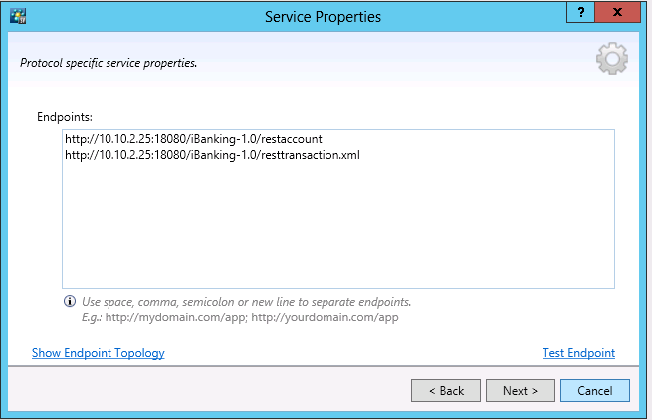

**Note:** Replace the Endpoints from the picture with the iBank Java (iBank Internet Banking) endpoints.

1. Click **Virtualize** to virtualize the selected endpoints.

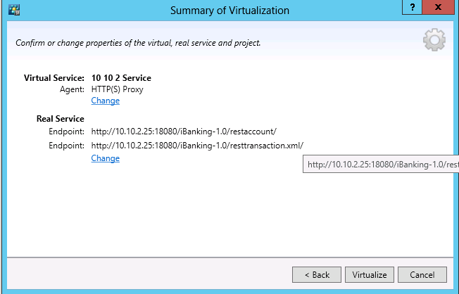

1. Configure data formats for the REST API as mentioned below.

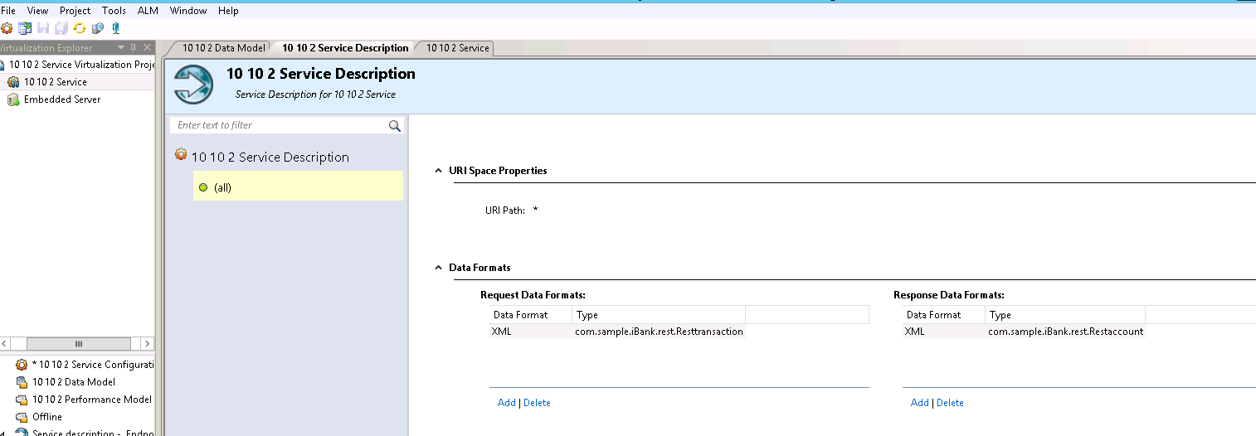

1. Click **Learn** to start Service Virtualization in learning mode.

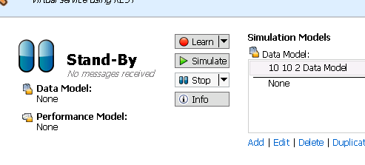

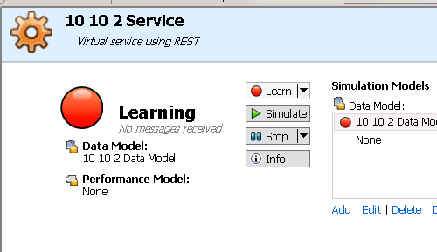

Configure iBank dotNet (iBank Investor) to use Virtual Service

To use Virtual REST API, update the proxy settings of iBank dotNet (iBank Investor) web application with the **HP Service Virtualization Designer** server ip address and port.

1. Go to the MSTools server, where **iBank dotNet** (iBank Investor) is deployed.
2. Configure the Internet Explorer proxy settings to point to the **HP Service Virtualization Designer** server ip address and port as shown below.

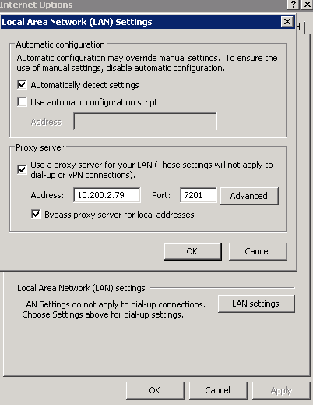

**Note:** replace the ip address and port with your **HP Service Virtualization Designer** server ip address and port.

1. Launch the **iBank dotNet** (iBank Investor) web application. Log in and go to Accounts. In this section, the web application invokes **iBank Java** (iBank Internet Banking) web application REST API

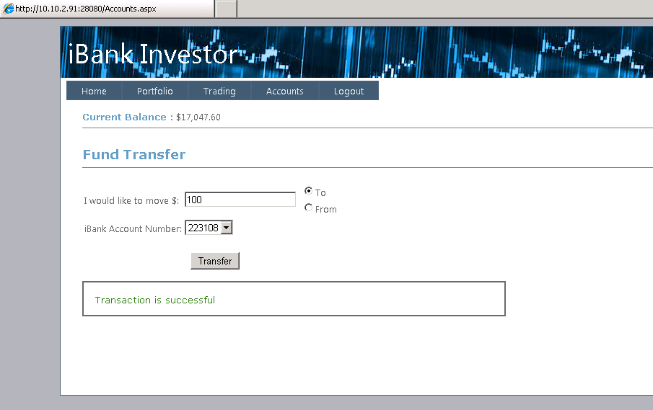

1. In **HP Service Virtualization Designer**, you should see messages being intercepted and learned.

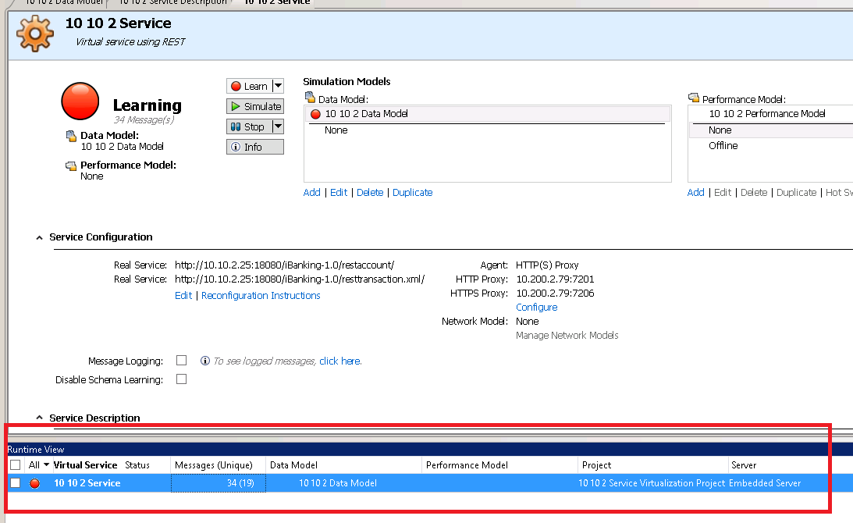

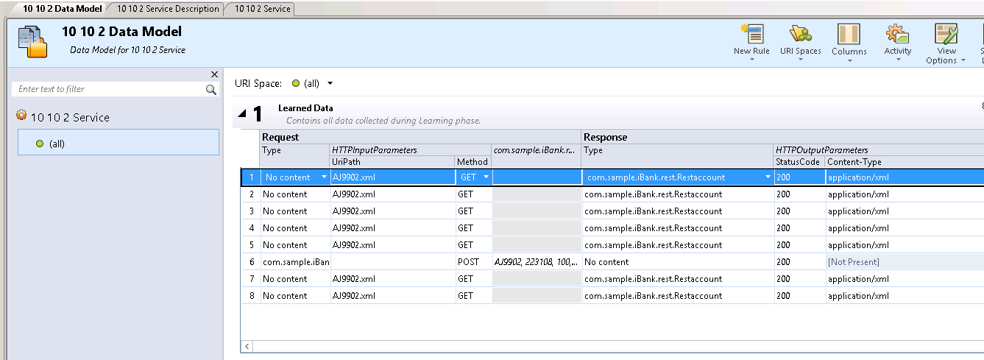

**Note:** Once the learning process is complete the virtual service can be tested by putting it in simulation mode.

1. Test the Service Virtualization in simulation mode.

Stop **iBank Java** (iBank Internet Banking) web application from tomcat and run the SV service in simulation mode. Test the **iBank dotNet** (iBank Investor) web application – by going to the **Accounts** page, which should receive data from the SV service, instead of the real **iBank Java** (iBank Internet Banking) web application.

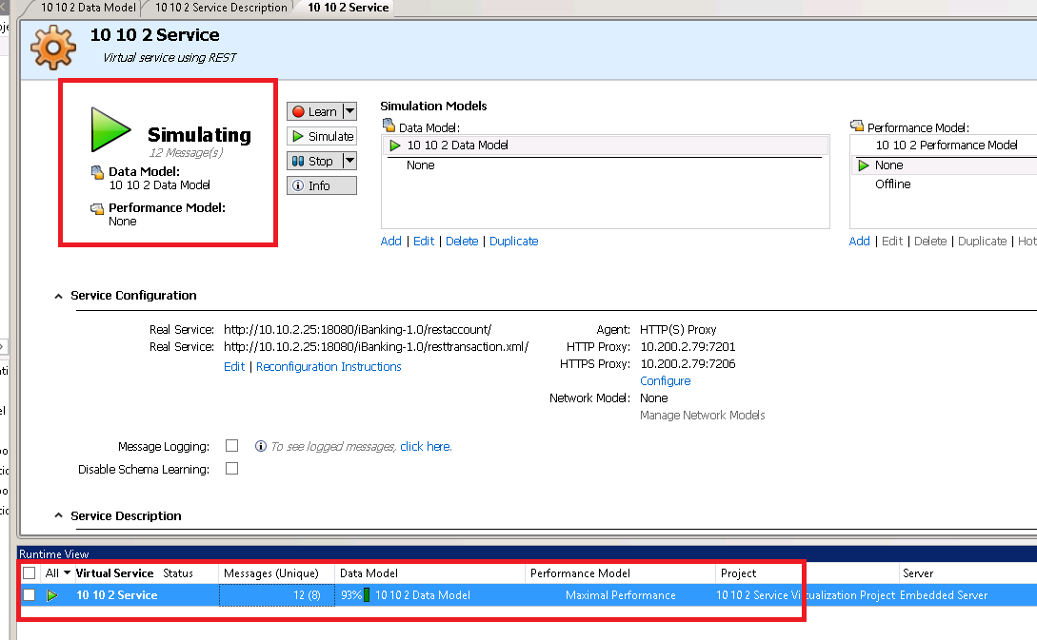

You will see messages being served from SV service and the percentage of learned data being used in simulation mode.

**NOTE:** The “Design” phase of the virtual service ends when the consuming application behaves as expected with the simulator acting on behalf of the real service needed by the application. The virtual service up to that point has been hosted by the local embedded server in the **HP Service Virtualization Designer** and can now be transferred to be hosted by the **HP Service Virtualization** Server.

1. Deploy the vertual service on the **HP Service Virtualization** Server

There are two approaches to transferring the created virtual service from the local server to its final destination on an **HP Service Virtualization** server.

Select **Project > Change server** from the main menu.

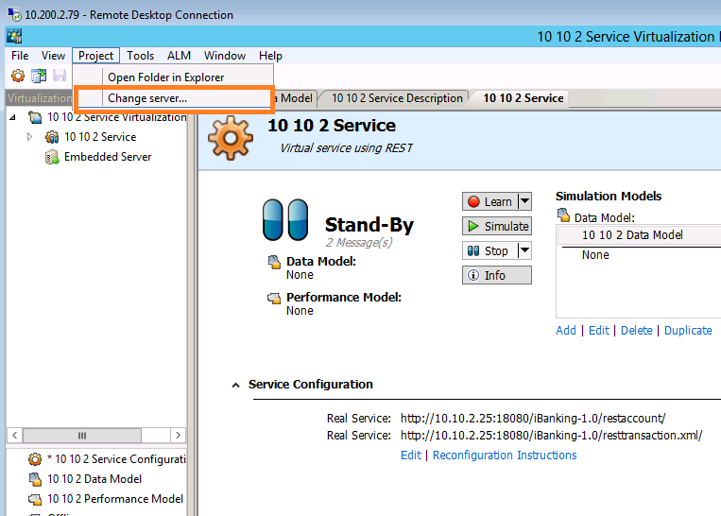

Enter the URL of the SV Server Management Console

http://**<sv_server>**:**<sv_port>**/management and click **Next**.

**Note:** replace **sv_server** and **sv_port** with your **HP Service Virtualization** server hostname and port.

Select the HTTP(s) Proxy agent type

Virtual service will then be deployed and running on an agent placed on the HP Service Virtualization server.

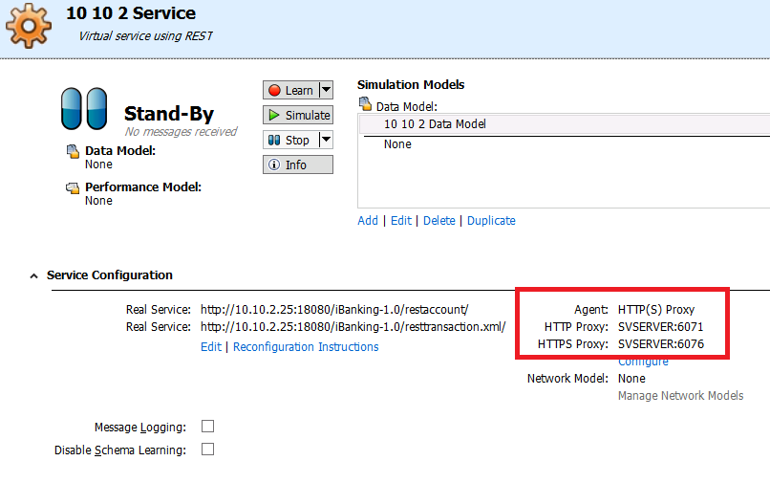

Reconfigure the Internet Explorer proxy on the MSTools server to use the HP Service Virtualization server ip address and port. (to allow the **iBank dotNet** (iBank Investor) web application to use the virtualized service on the HP Service Virtualization server)

(This step is identical to the step where the virtual service was running on the **HP Service Virtualization Designer** embedded server with the exception of a new location of the http(s) proxy server running on the **HP Service Virtualization Server**).

Start/Stop the Virtual Service simulation from Jenkins

With the availability of the virtual service testing dependencies can be reduced by eliminating the need to have 3rd party services or applications available in support of any testing. In the continuous integration/continuous delivery model the virtual service behavior should remain in sync with the testing lifecycle, in other words a virtual sevice state should be controlled based on whether testing is in progress or complete. When the test is about to be triggered the virtual service should automatically switch to “simulation” mode and when the test is complete it should revert back to “standby” mode. HP SV provides batch commands that use REST APIs to bypass the User Interface and control virtual service behavior for the purpose of automation. These commands will be used by Jenkins to orchestrate the steps needed before and after the testing occurs with respect to virtual service behavior.

The utility that provides that functionality is the SVConfigurator.cmd

Batch commands invoked by Jenkins.

|  |  |
| --- | --- |
| Server path location | svserver\C$\Users\Administrator\Documents\HPSV\Projects\DevopsDemo |
| Start simulator batch file | **Start_simulator.bat**  Content:  *C:\Progra~1\HP\HPserv~1\Tools\SVConfigurator\bin\svconfigurator.cmd CHANGEMODE -url http://svserver:6080/management -usr administrator -pwd XXXXXXX -dm "10 10 2 Data Model" "10 10 2 Service" SIMULATING* |
| Stop simulator batch file | **Stop_simulator.bat**  Content:  C:\Progra~1\HP\HPServ~1\Tools\SVConfigurator\bin\svconfigurator.cmd CHANGEMODE -url http://svserver:6080/management -usr administrator -pwd XXXXXXX "10 10 2 Service" STAND_BY |

Setup Eclipse

Install Eclipse

Eclipse is the most commonly used IDE for developers. It is available for different Operating Systems – Linux and Windows. For more details on each supported OS and installation instructions, please check the eclipse documentation.

Example installation on Windows Server 2008 R2:

1. Download the Eclipse archive.

Tip: One place to download the Eclipse archive

*https://hudson.eclipse.org/sapphire/job/Java-8-Packages/lastSuccessfulBuild/artifact/releng/java-8/packages/eclipse-standard-kepler-SR2-Java8-win32-x86_64.zip*

1. Unzip the eclipse archive to a selected location. Example c:\eclipse
2. To verify the eclipse installation is successful, start the **eclipse.exe** file:

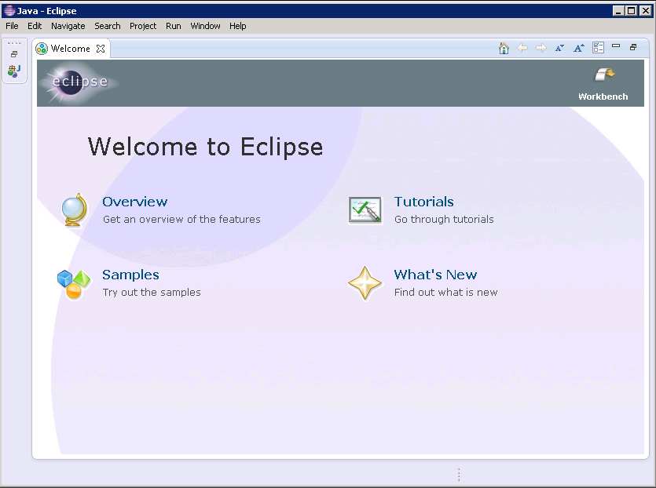

Setup eclipse with HP ALM / HP AGM /Jenkins

Install and configure the HP ALI DEV plugin

To configure eclipse integration with HP ALM / HP AGM /Jenkins, complete the following steps:

1. Download the **Eclipse IDE Integration Content for ALI** from:

*https://hpln.hp.com/group/ide-ali*

**Note:** To download the Eclipse IDE Integration Content for ALI - **hp-ali-dev-eclipse.zip**, you need to sign up with your HP passport account.

1. To install the HP ALI DEV plugin, follow the **HPAliDevForEclipse_3.5.0_InstallationGuide** pdf guide located in the **DevOps_R3.5_Solution\Content files\eclipse** folder .
2. To configure eclipse with HP ALM / HP AGM read the **Connecting_to_HP_ALM_Quality_Center** html guide located in the **DevOps_R3.5_Solution\Content files\eclipse** folder.

Setup Eclipse with GIT

Configure the iBank Java Git repository in eclipse

1. Open eclipse and do a right CTo create new subversion project in eclipse, click on **File > Import**.

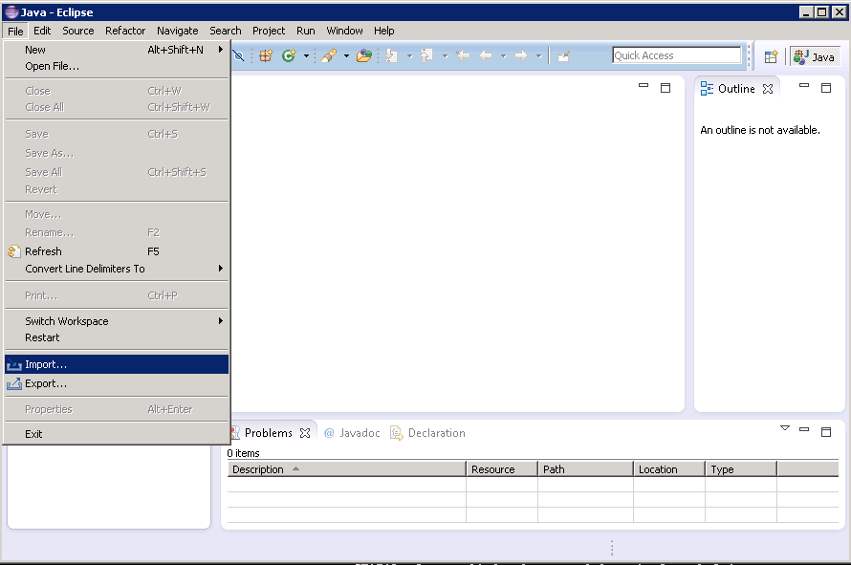

1. Select **Git > Projects from Git,** and then click **Next** to continue**.**

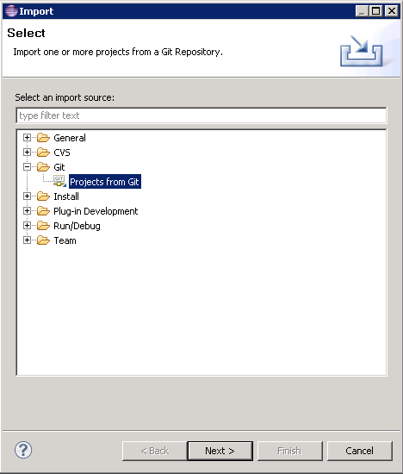

1. Select **Clone URI** and click **Next** to continue.

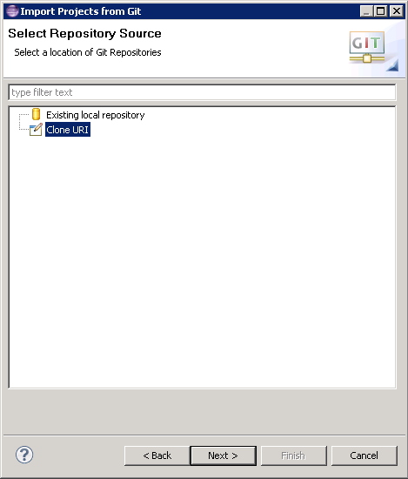

1. Enter the git repository **URI**, **Username** and **Password** and click the **Next** button.

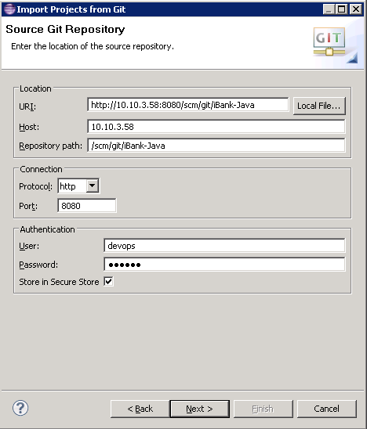

1. Click **Next** to select the **master** branch.
2. Click **Next** to accept the default destination.
3. Select the **Import as general project** option and click **Next**.
4. Enter the **project Name** and click **Finish.**

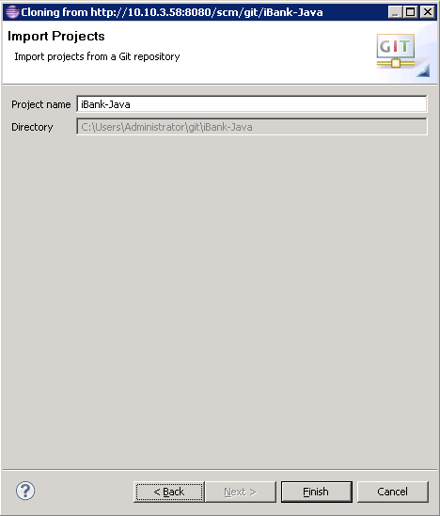

1. Open the **Project** view by selecting **Window**->**Show View**->**Project Explorer** and close the **Welcome** tab:

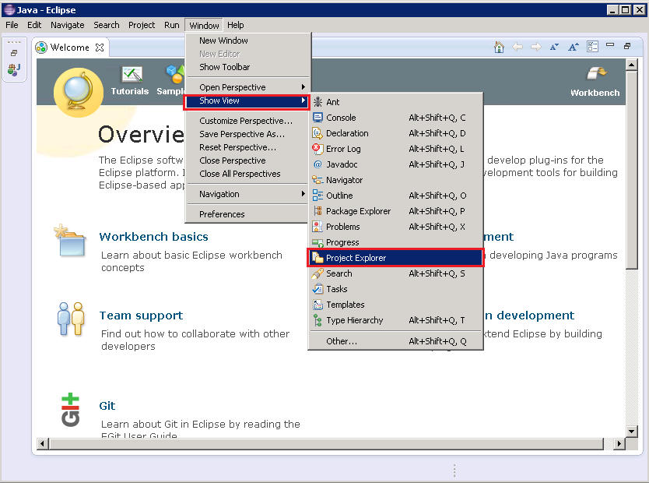

1. Verify the **iBank-Java** source files are now available in the new git project, under the **Project Exporer** view.

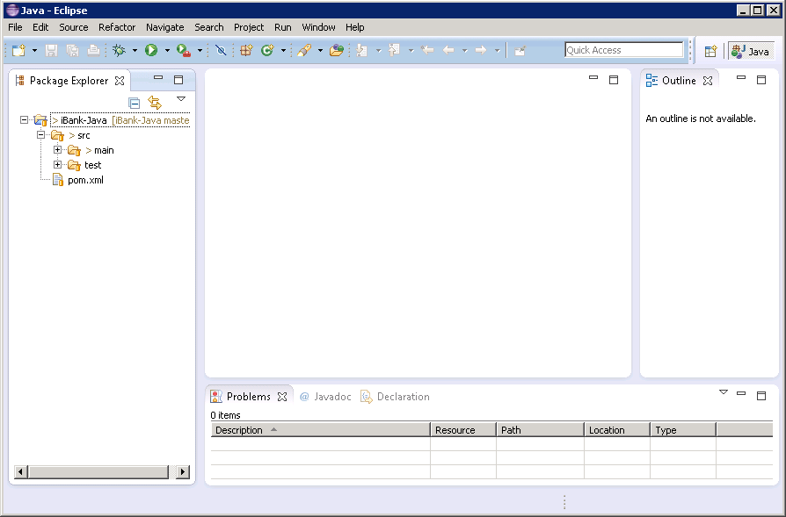

Setup Microsoft Visual studio

Microsoft Visual Studio is the most commonly used IDE for MS developers. For more details on each supported OS and installation instructions, please check the Visual Studio online documentation.

Configure the iBank-dotNet TFS repository in Visual Studio

1. Open Visual Studio. Click **VIEW > Team Explorer** and click on **Connect** under the **Team Foundation Service**.

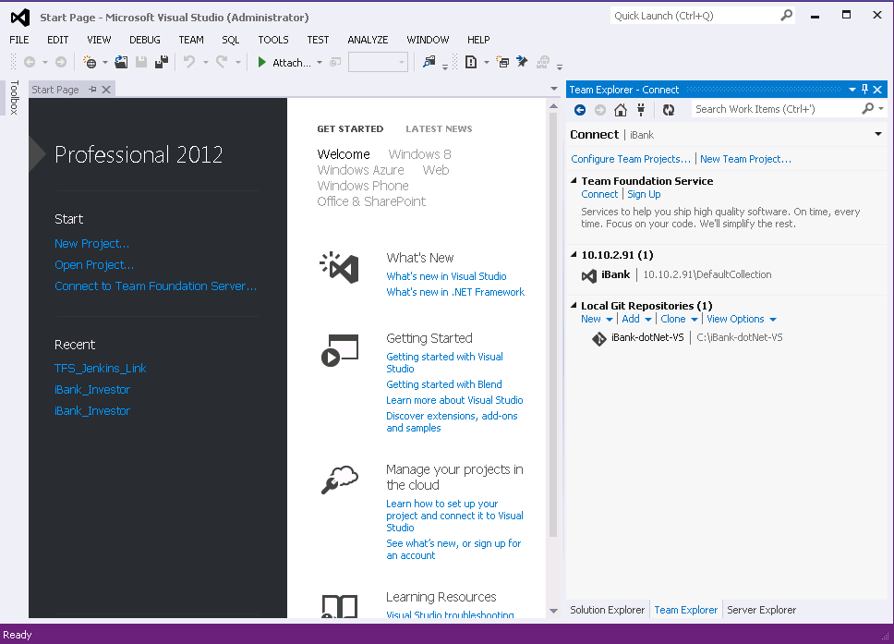

1. Click **Servers > Add** and add the TFS server details, where the **iBank-dotNet-VS** repository was created.

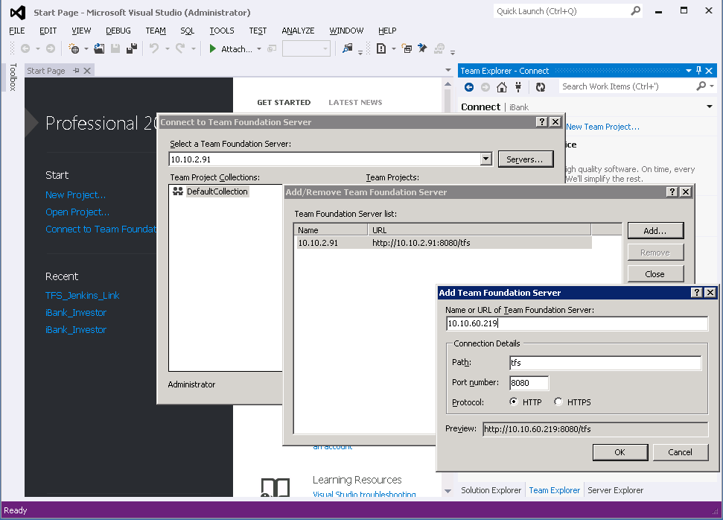

1. Enterthe TFS server windows **Username/Password** to authenticate and click **OK**. Click **Close**.

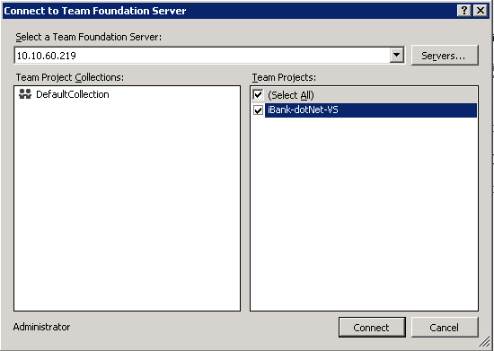

1. Select the **iBank-dotNet-VS** Team Project and click **Connect**.
2. Click **Source Control Explorer**, under **Pending Changes**.

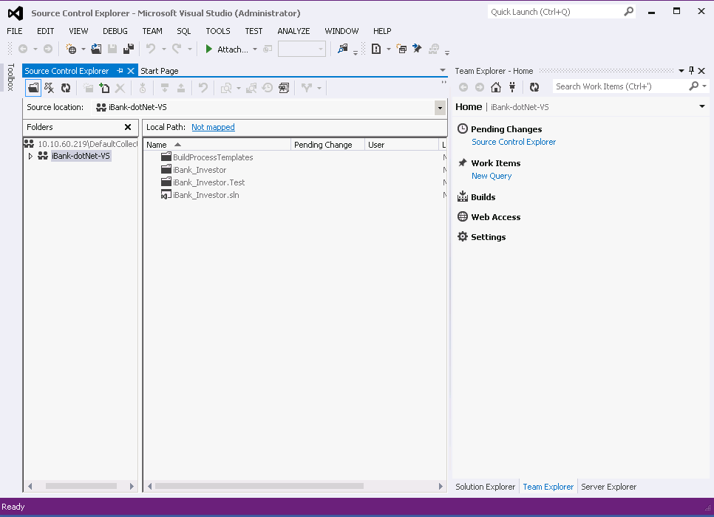

1. Click **Not mapped** link, next to **Local Path** in the **Source Control Explorer** window. Enter the full path for the local iBank-dotNet-VS working copy.

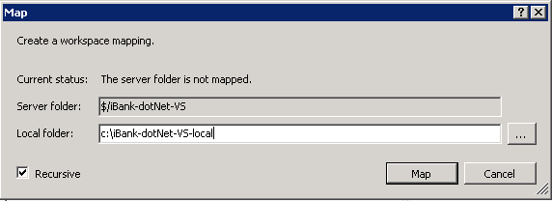

1. Click **Map**, then click **Yes** to download all source files from the TFS repository.
2. Close **Visual Studio** and open the new **iBank-dotNet-VS-local** folder

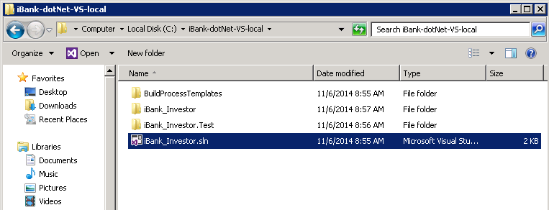

1. Double click **iBank_Investor.sln** to open the project in Visual Studio. Click **OK**, on the warining screen.
2. Select **VIEW > Solution Explorer** to see the iBank-dotNet-VS source files

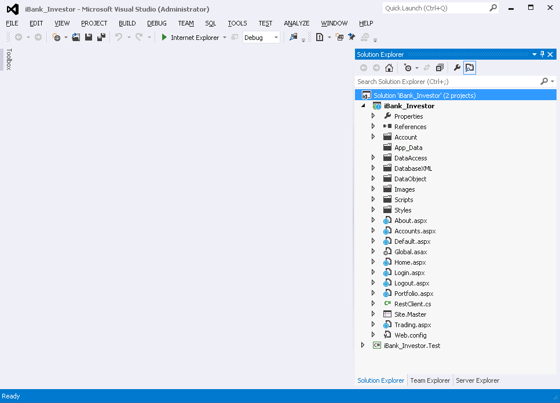

1. Modify one source file and save the change.

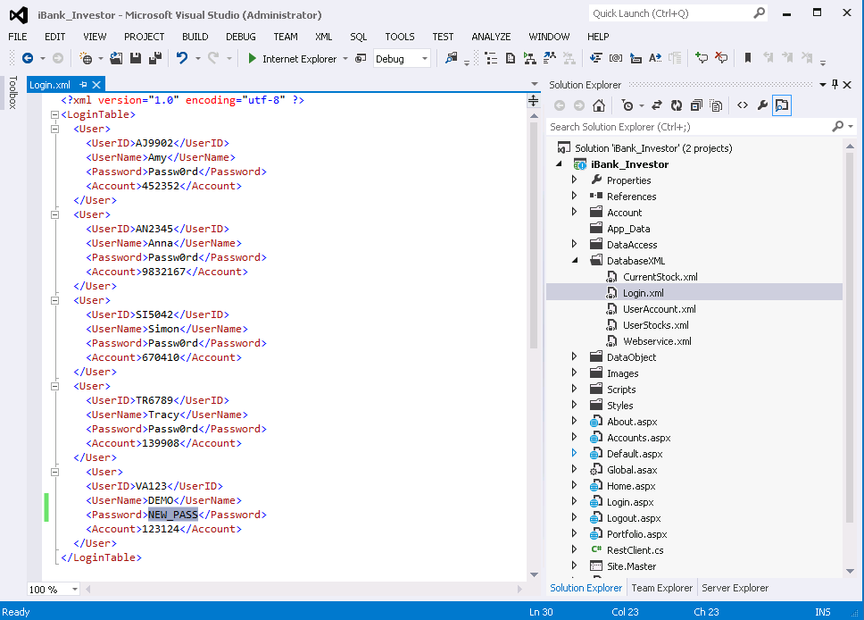

1. Click on **VIEW > Team Explorer** and select **Pending Changes**. Provide new check-in **Comment** and click the **Check In** button to store the new change in the TFS server repository.

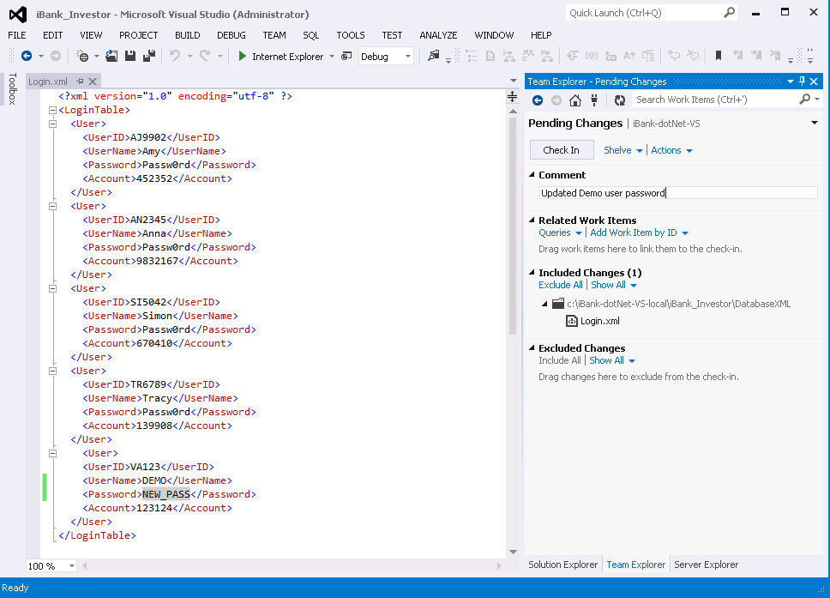

1. Your change is successfully stored in the TFS server repository.

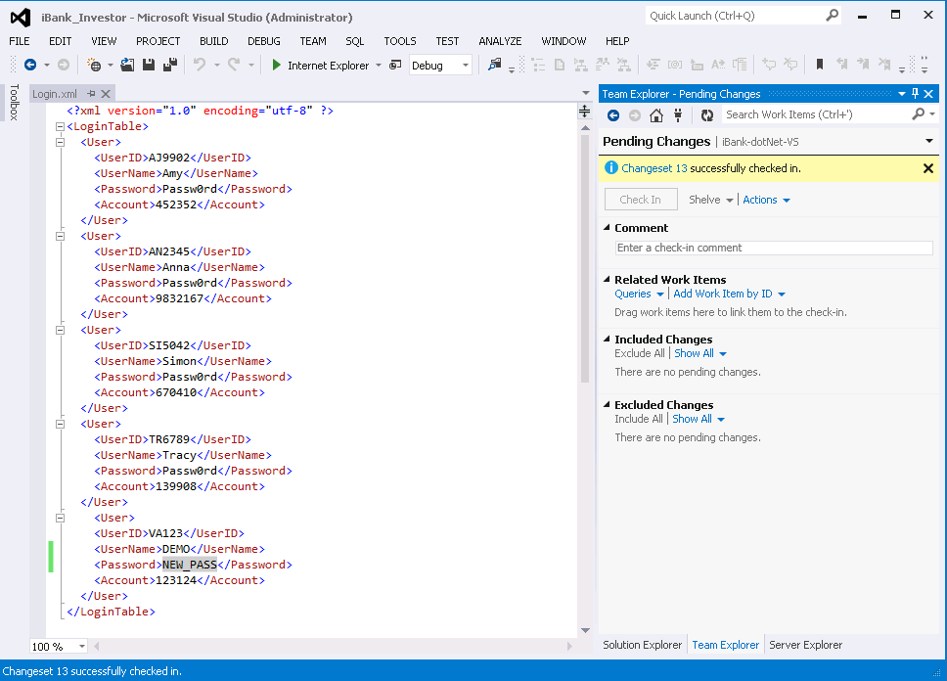

Configure the iBank-dotNet-VS GIT repository in Visual Studio (OPTIONAL)

1. Open Visual Studio. Click **VIEW > Team Explorer** and click on **Connect** under the **Team Foundation Service**.



1. Click **clone**, under **Local Git Repositories** and enter the iBank-dotNet-VS GIT repository **URL** and the local **Path** where the git clone will be created. Click **Clone**.

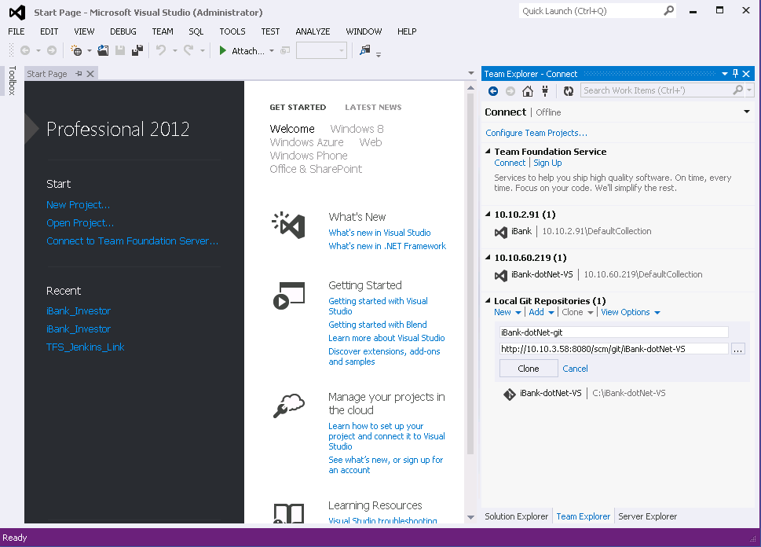

**Note:** If prompted, provide the GIT repository credentials inherited from Tomcat – **devops**/**devops**.

1. Close **Visual Studio** and go to the new **iBank-dotNet-VS-local-GIT** repository folder.

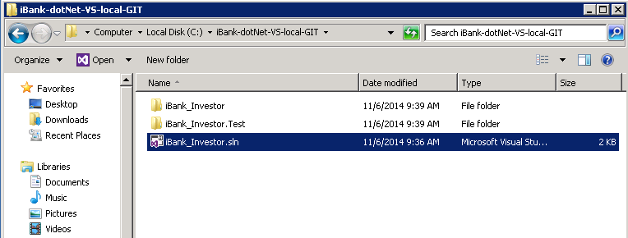

1. Double click the **iBank_Investor.sln** file to open the project in Visual Studio. Click **OK** on the warning screen.
2. Modify one source file and save the change

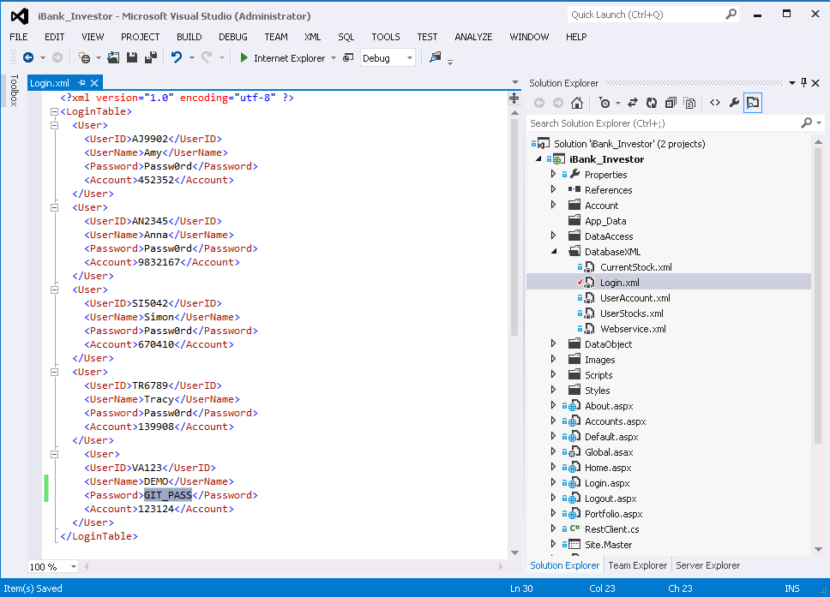

1. Select **VIEW >** **Team Explorer** and click on **HOME >** **Changes**.

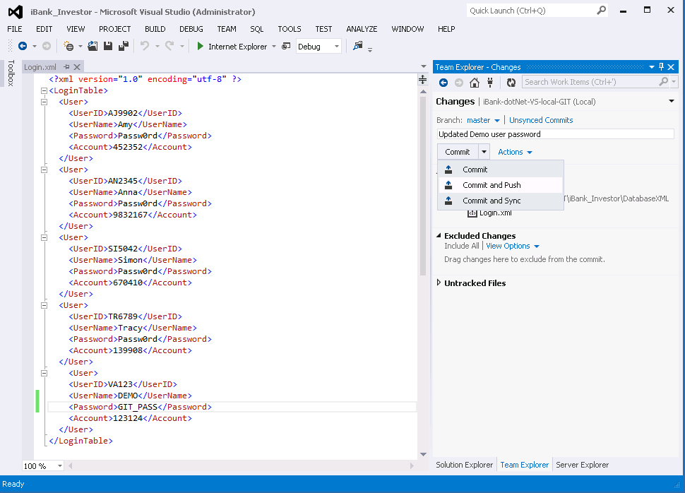

1. Click **Commit and Push** to update the **iBank-dotNet-VS** GIT repository.
2. Your change is now successfully stored in the **iBank-dotNet-VS** GIT repository.

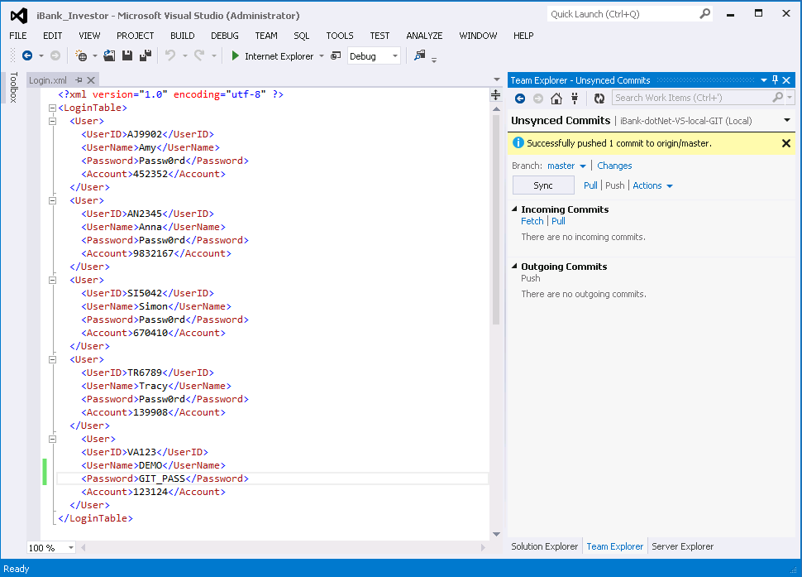

Configure HP Application Lifecycle Management

Setup DEVOPS ALM Projects.

To set up the ALM required projects for this release, complete the following steps:

1. Logon to the ALM Site Administration portal.

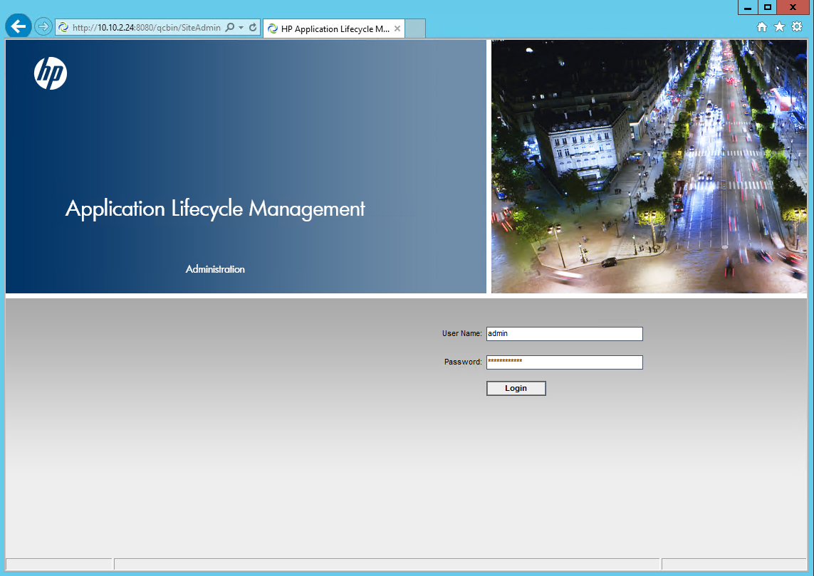

1. Create a new **Domain** and two new **Projects**:

**Domain**: DEVOPS

**Projects**:

* iBank_InternetBanking – the **iBank-Java** (iBank Internet Banking) web application project.
* iBank_Investing – the **iBank-dotNet** (iBank Investor) web application project.

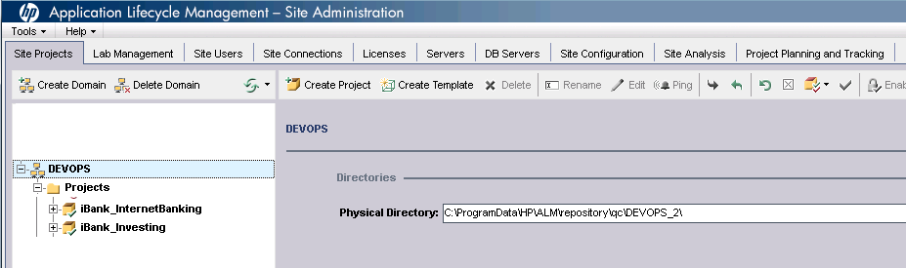

1. For each of these two projects, enable the **ALI extension**, under **Project Extensions**.

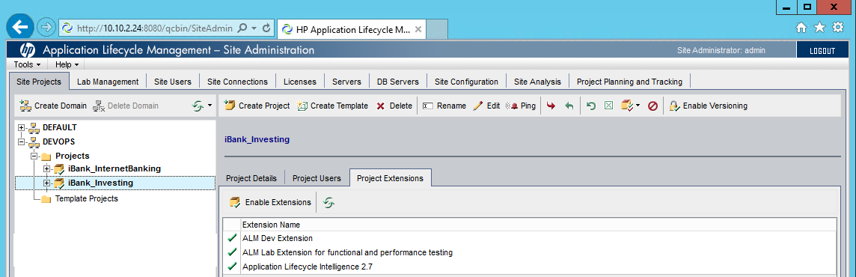

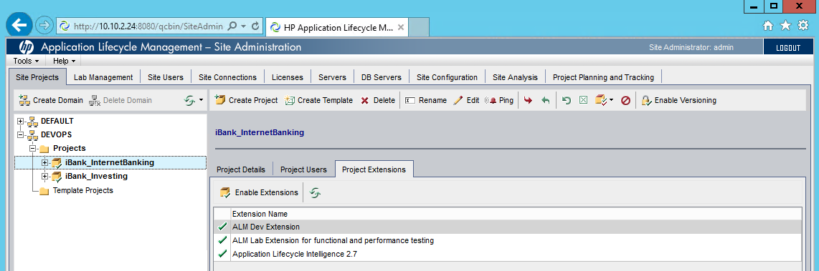

**Note:** This extension is required for the ALM management setup (build servers,SCM repositories)

HP ALM Management Setup (Build servers, SCM repositories)

Add Build Servers in ALM for both iBank_InternetBanking and iBank_Investing projects

Application Lifecycle Intelligence (ALI) tracks development activities and links them to Application Lifecycle Management (ALM) entities. ALI integrates Build Management tools (Jenkins) with Application Lifecycle Management(ALM) and links activities related to builds from Build Management tools to ALM entities such as Releases, Requirements, Defects, and Tests.

As pre-requisite, in ALM Site Administration, enable the ALI extension for every project in which you want to use ALI.

To set up HP ALM integration with a Jenkins build server, complete the following steps:

1. Open the HP ALM Desktop client.

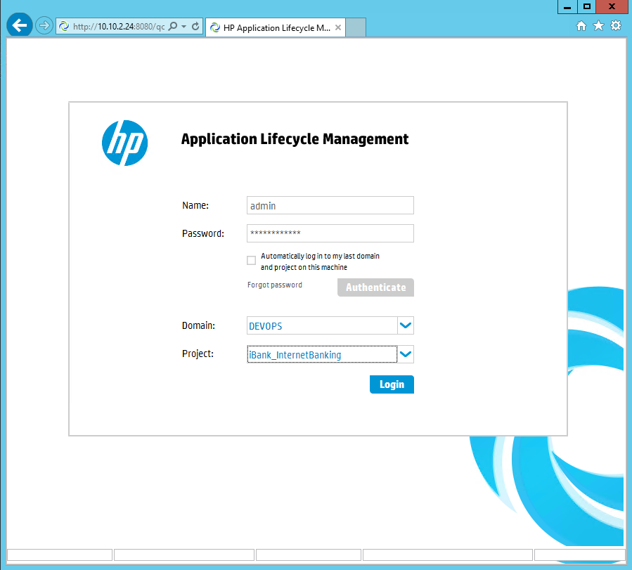

1. Enter **Login Name** and **Password** and click **Authenticate**. Select **Domain** and **Project** and then click **Login**.

**Important:** The steps below are required for both projects in the previously created Domain. Please repeat the same steps for the **iBank_Investing** project, the example below is with **iBank_InternetBanking**.

**Domain:** DEVOPS

**Projects:** iBank_InternetBanking and iBank_Investing

1. Click **Management** -> **Build Servers:**

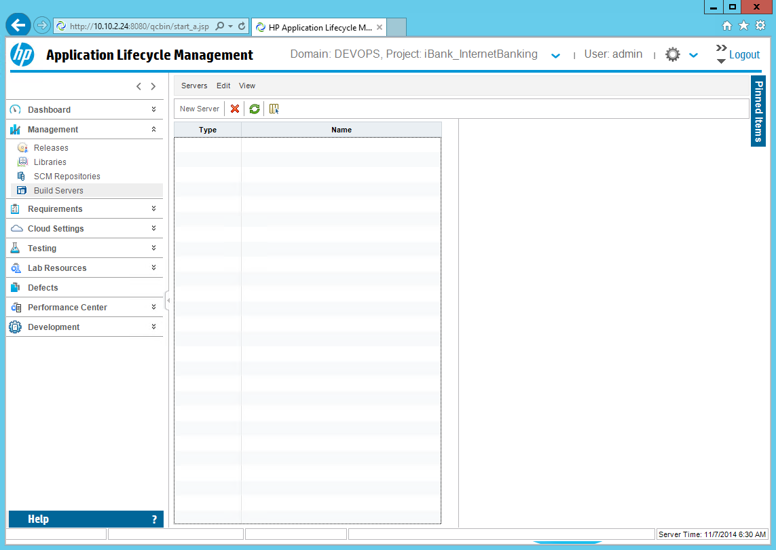

1. Click the **New Server** button and select the **Hudson/Jenkins Build Server** option. Then click **OK**.

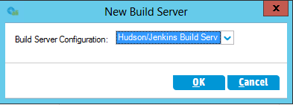

1. Enter the required inputs: **Name**, **Location**, **Username**, **Password** and **Description**.

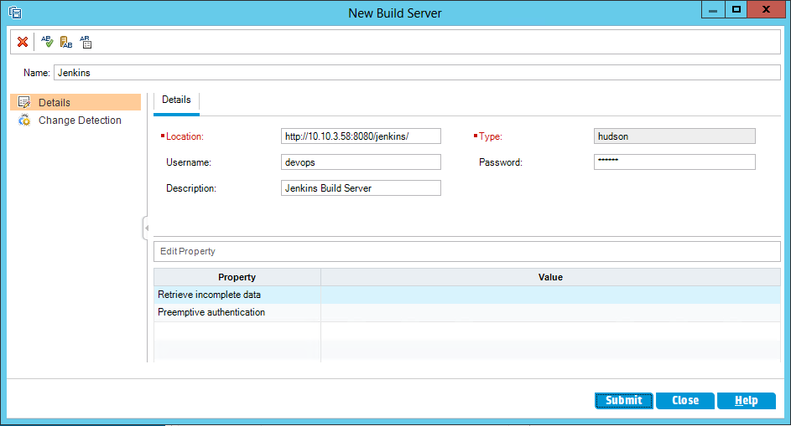

**Note:** replace **Location** with the full Jenkins URL. Default Jenkins username/password are **devops**/**devops**.

1. Click **Change Detection** tab and enable the **Read changes from build server** and **Receive builds transmitted by build server agent(s)** options:

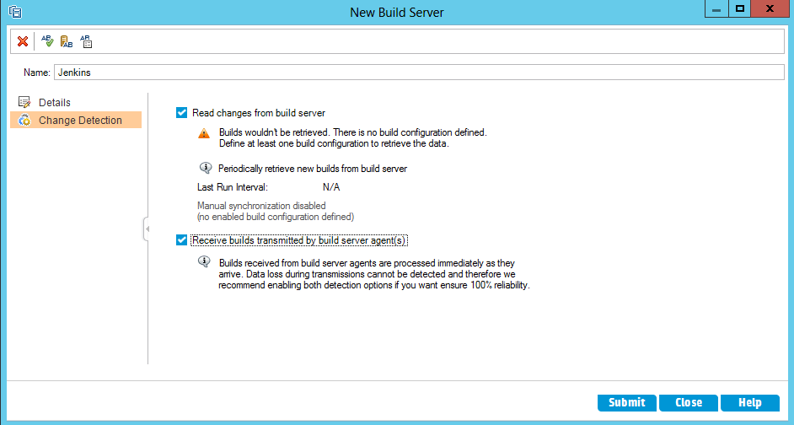

1. Click **Submit** and then click **Close**.
2. Select the build server and click the **Build Configurations** tab.

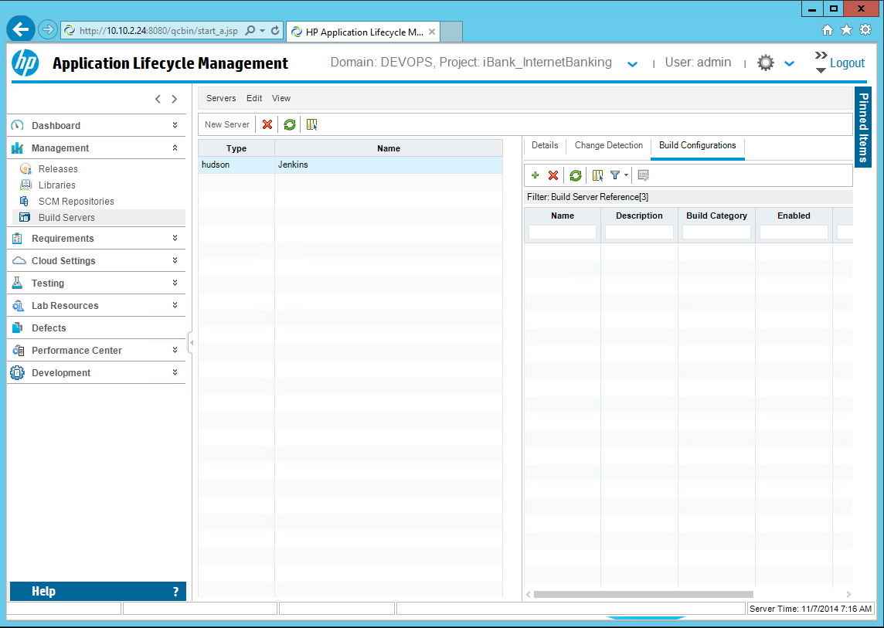

1. Click the button, under **Build Configuration tab** to add new build server configuration and select the main Jenkins project – **DEVOPS-R3.5-1-BUILD**. Click the **OK** button.

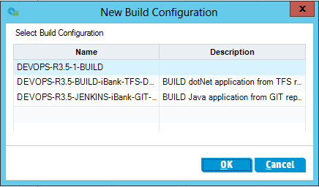

**Note:** The list contains the unused jenkins jobs with ALI integration enabled in the post-build section from the configured Jenkins server.

1. Setup the build server configuration details for **Enabled**, **Default**, **Build Category**, **Release** and click **OK**.

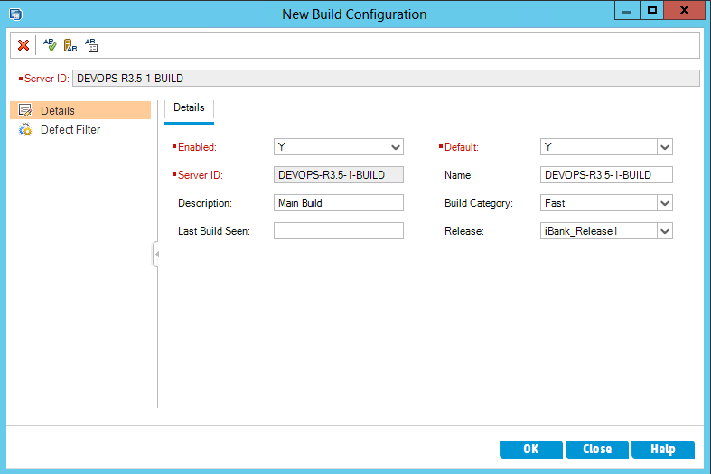

1. The new Jenkins build server is now configured.

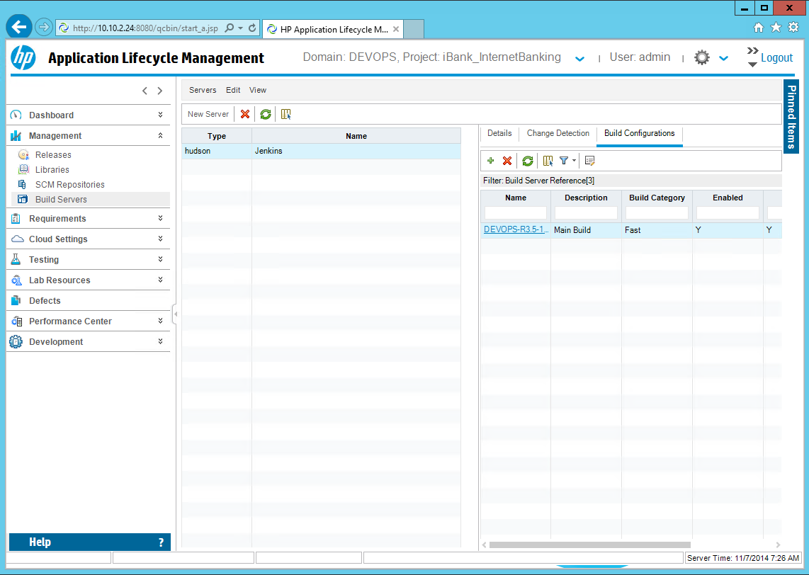

1. To verify the build integration, you need to have at least one successful/failed build for the **DEVOPS-R3.5-1-BUILD** job in Jenkins. Then go to the **Change Detection** section in ALM for this Jenkins server and click **synchronize**, to manually synchronize the build information in ALM.

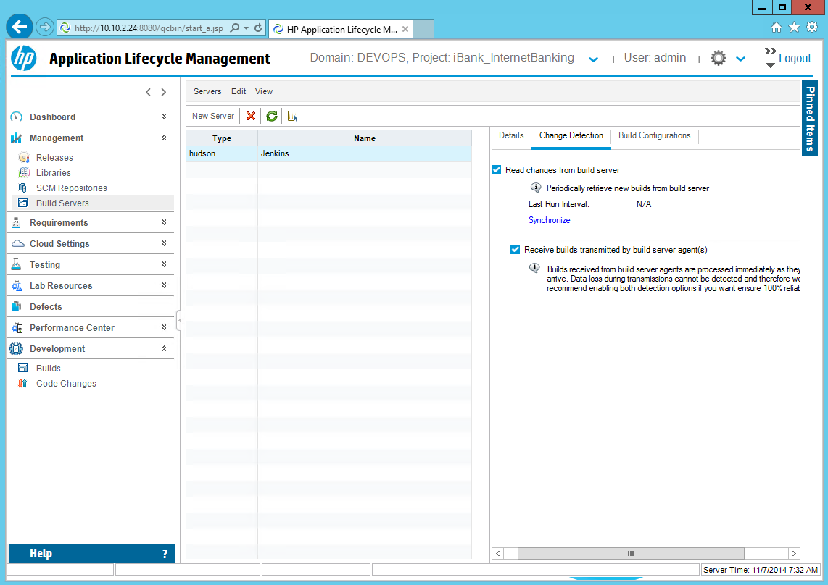

**Note:** Build information is received by manual synchronization, scheduled synchronization or automatically by data transmitted from the Jenkins build agent.

1. Go to **Development > Builds** section and click  to refresh the build information. You should see all jenkins builds for the previously selected jobs in the list below.

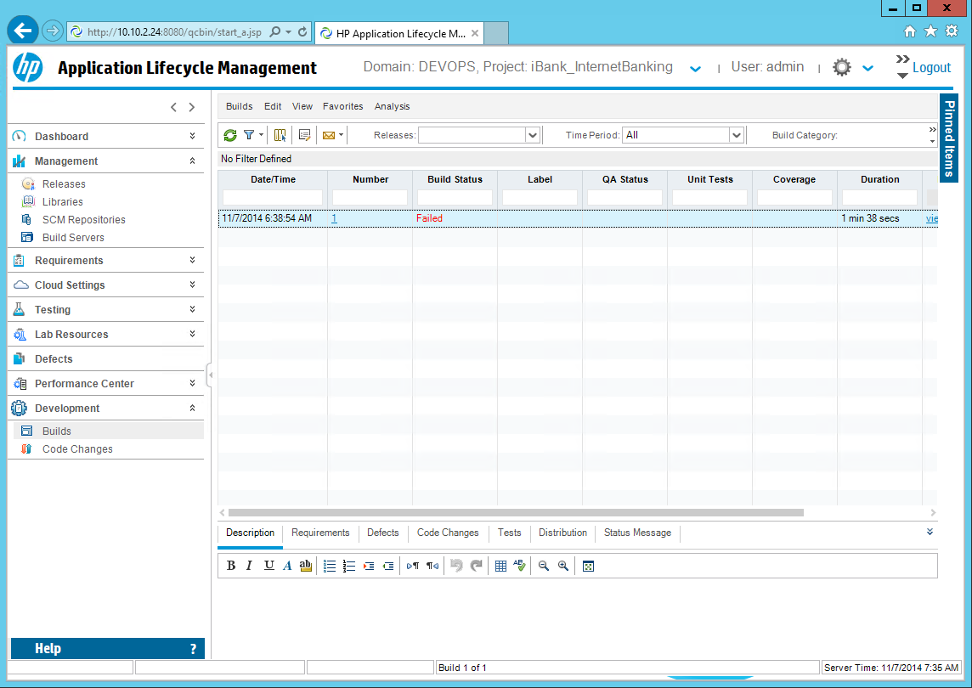

Add SCM GIT repository in ALM for iBank_IntenetBanking project

Application Lifecycle Intelligence (ALI) tracks development activities and links them to Application Lifecycle Management (ALM) entities. ALI integrates your Source Code Management (SCM) with Application Lifecycle Management(ALM) and links activities such as code changes and code coverage analyses from your SCM to ALM entities such as Releases, Requirements, Defects, and Tests.

As pre-requisite, in ALM Site Administration, enable the ALI extension for every project in which you want to use ALI.

To set up the HP ALM integration with a GIT server, complete the following steps:

1. Open the HP ALM Desktop client and login to your **Domain** and **Project**.

**Note:** The steps below are required only for the **iBank_IntenetBanking**, since this is the iBank-Java (iBank Internet Banking) GIT source code repository.

**Domain:** DEVOPS

**Projects:** iBank_InternetBanking

1. Click **Management >** **SCM Repositories:**

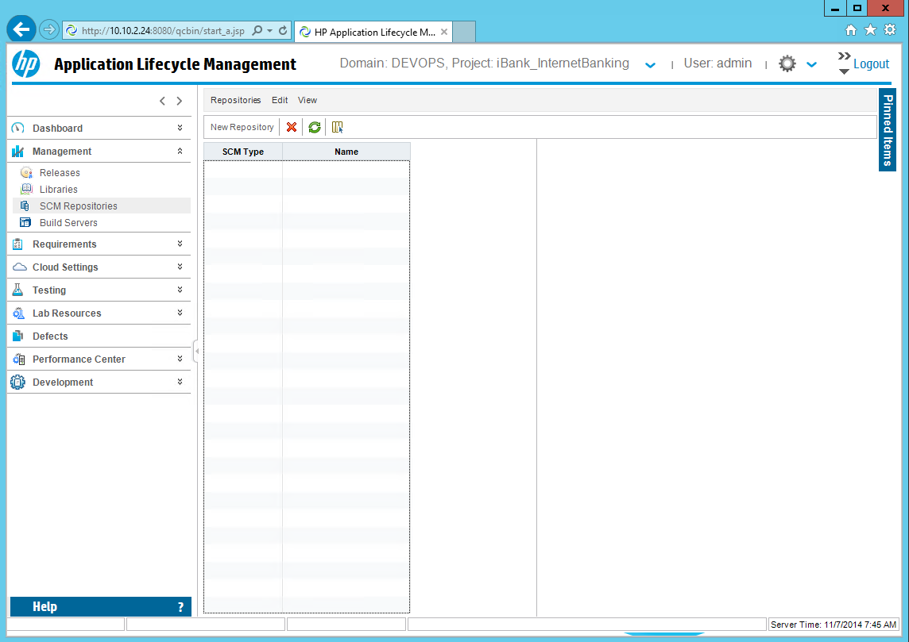

1. Click **New Repository** and select the **Git Provider** for **SCM type**. Then click **OK**.

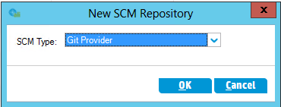

1. Enter the required inputs: **Location**, **Username**, **Password** and Directory for local Git repository.

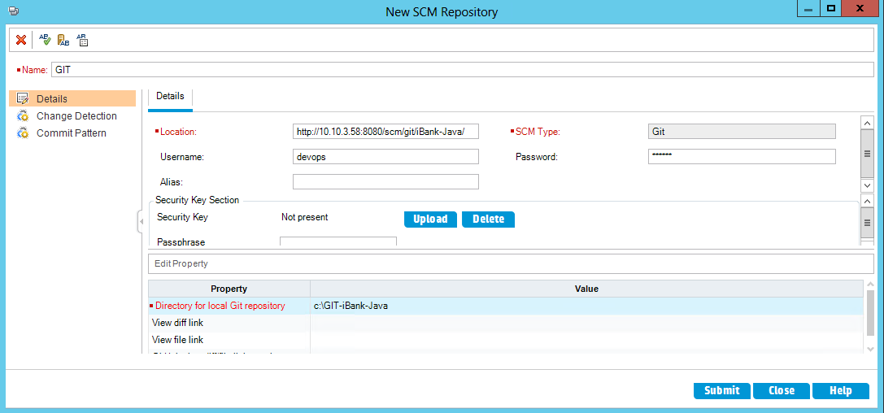

**Note:** Replace **Location** with the full Git repository URL, **username** and **password** are the default inherited from tomcat – **devops**/**devops**. **Directory for local Git repository** is mandatory and it is the absolute path where the mirror of the remote repository will be created. The path should be located in the ALM repository folder. Each location requires a separate folder. If you change the repository location, you should either change the clone directory property or delete the contents of the folder.

1. Click the Change **Detection** tab and enable the two options:

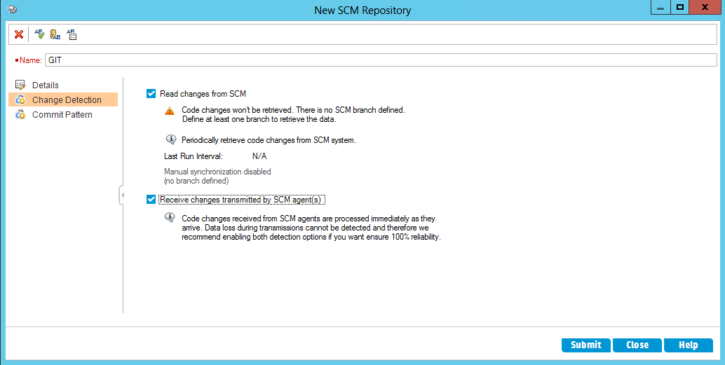

1. Click **Submit** and then click **Close**.
2. Select the GIT repository and click on the Branches tab.

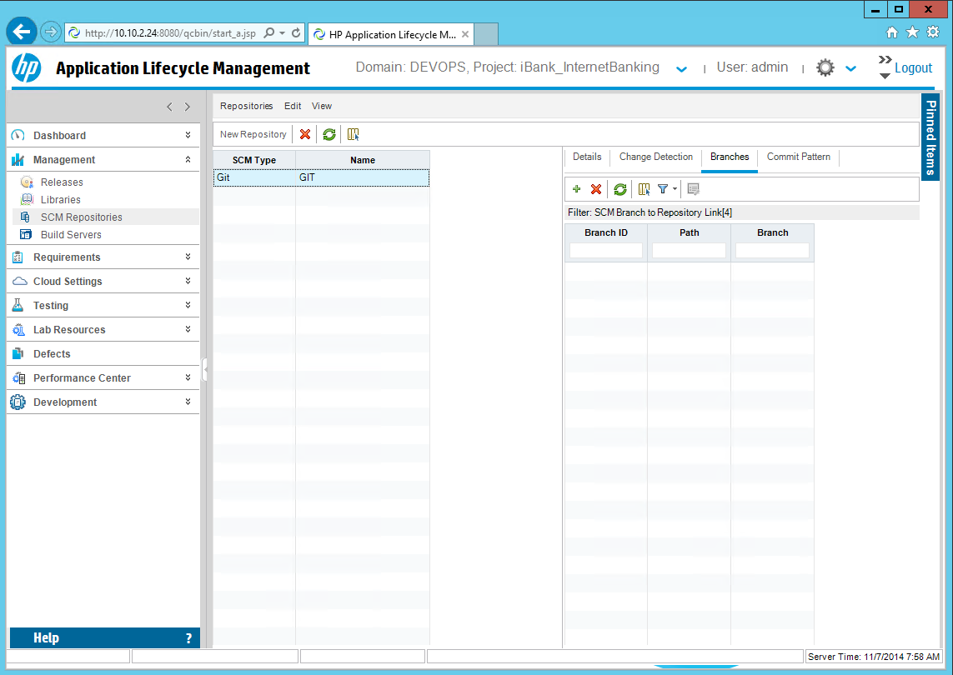

1. Click the button, to add new repository branch. Enter the required inputs and click **Submit** and **Close**.

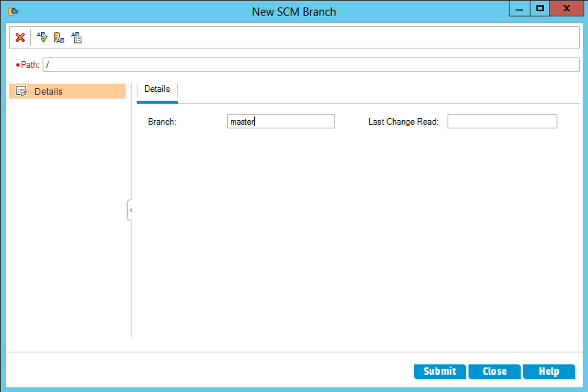

**Note:** Set the branch **Path** to **/**. The branch should be set to the real Git branch name. Use only the simple branch name in the format **master**, and not **refs/head/master**.

1. To verify the SCM integration, you need to have at least one check-in event for the **iBank-Java** repository in GIT. Then go to the **Change Detection** section in ALM for this SCM repository and click **synchronize**, to manually synchronize the scm information in ALM.

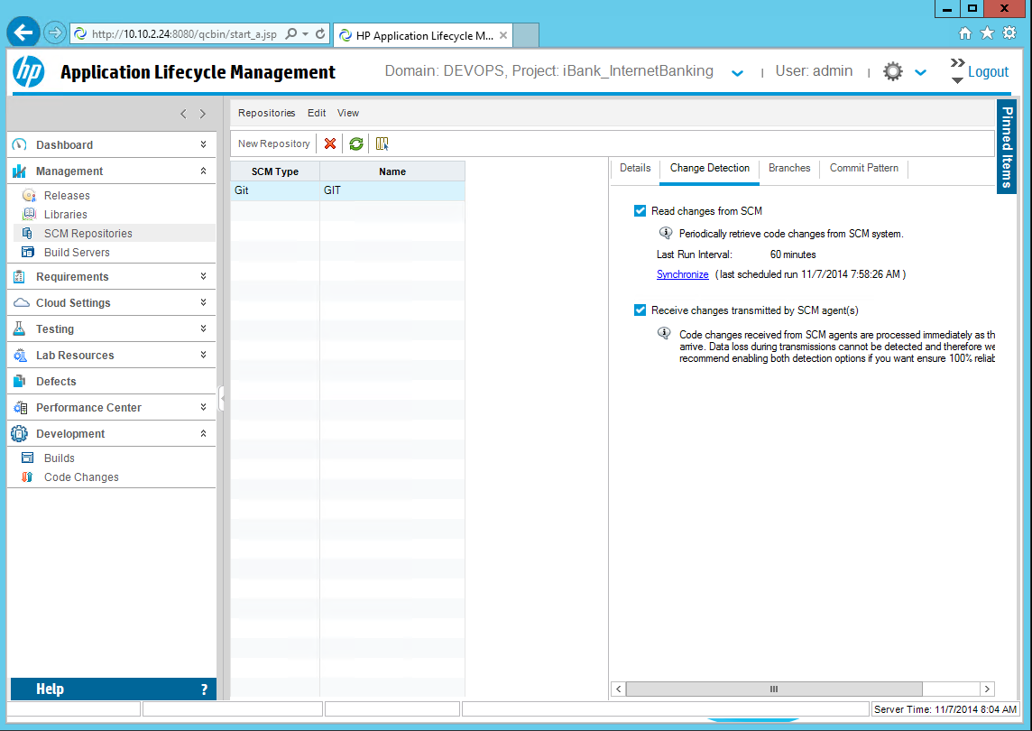

**Note:** SCM information is receved by manual synchronization, scheduled synchronization or automatically by data transmitted from the GIT agents.

1. Go to **Development > Code Changes** section and click  to refresh the SCM repository information. You should see all iBank-Java repository changes for the previously selected branch in the list below.

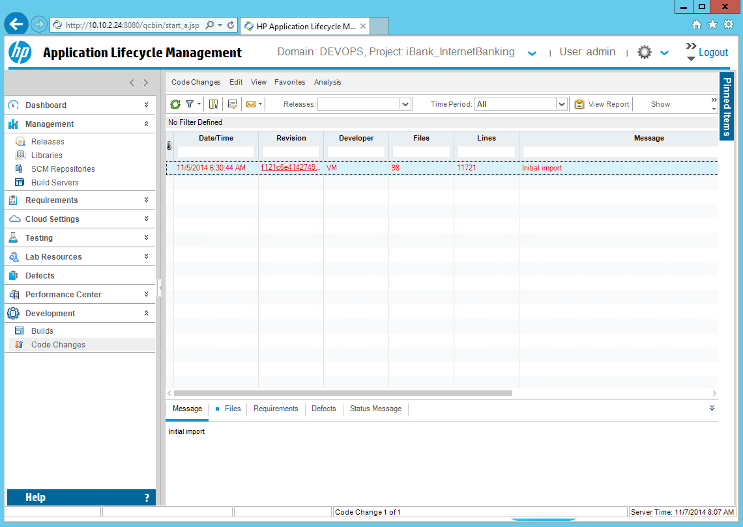

Add SCM TFS repository in ALM for iBank_Investing project

Application Lifecycle Intelligence (ALI) tracks development activities and links them to Application Lifecycle Management (ALM) entities. ALI integrates your Source Code Management (SCM) with Application Lifecycle Management(ALM) and links activities such as code changes and code coverage analyses from your SCM to ALM entities such as Releases, Requirements, Defects, and Tests.

As pre-requisite, in ALM Site Administration, enable the ALI extension for every project in which you want to use ALI.

To set up the HP ALM integration with a TFS server, complete the following steps:

1. Open the HP ALM Desktop client and login to your **Domain** and **Project**.

**Note:** The steps below are required only for the **iBank_Investing**, since this is the iBank-dotNet (iBank Investor) TFS source code repository.

**Domain:** DEVOPS

**Projects:** iBank_Investing

1. Click **Management >** **SCM Repositories:**

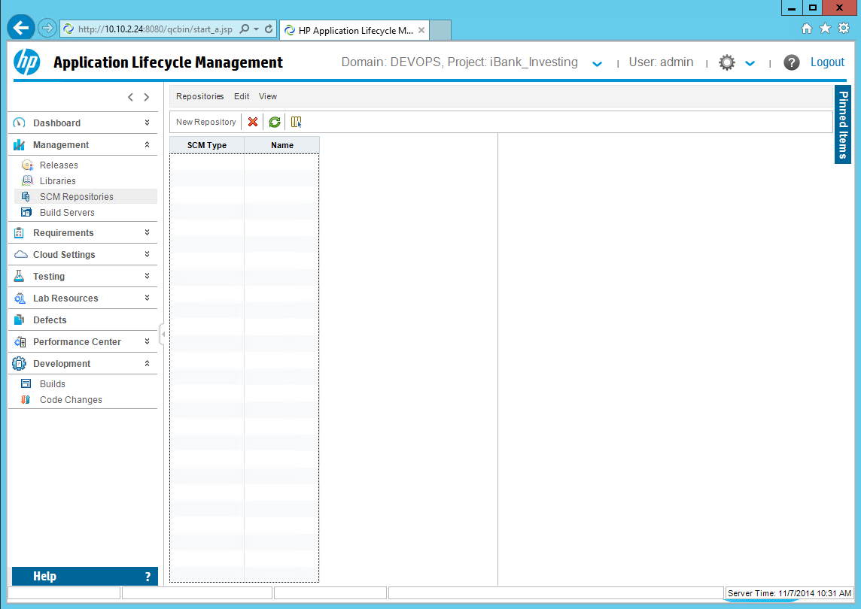

1. Click **New Repository** and select the **TFS Provider** for **SCM type**. Then click **OK**.

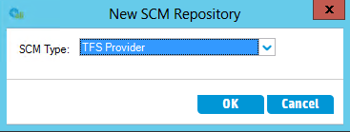

1. Enter the required inputs: **Location**, **Username**, **Password** and **Line count service URL**.

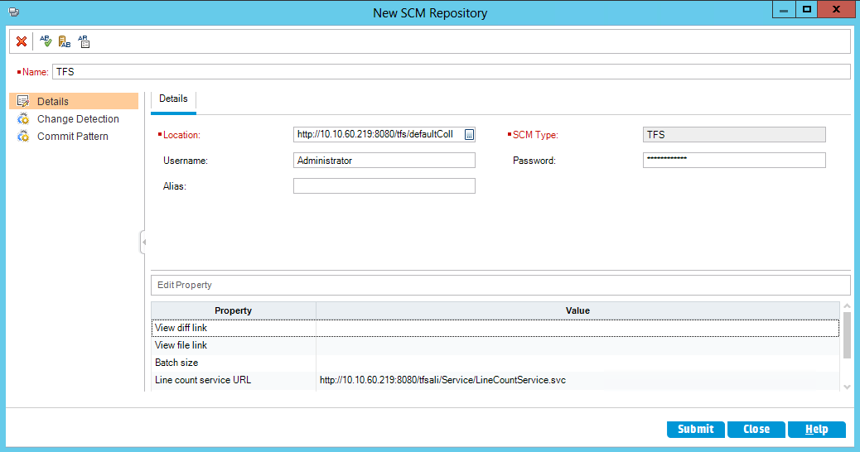

**Note:** replace **Location** with the full tfs repository URL including the TFS collection, example: <http://10.10.60.219:8080/tfs/defaultCollection>

For **username** and **password** use the MStools server computer username and password.

For **Line count service URL** provide the tfs-ali webservice URL, for example:

*http://10.10.60.219:8080/tfsali/Service/LineCountService.svc*

This is the tfsali web service, deployed during the **Install HP TFS ALI service** procedure in the MSTools server chapter.

1. Click the Change **Detection** tab and enable the two options:

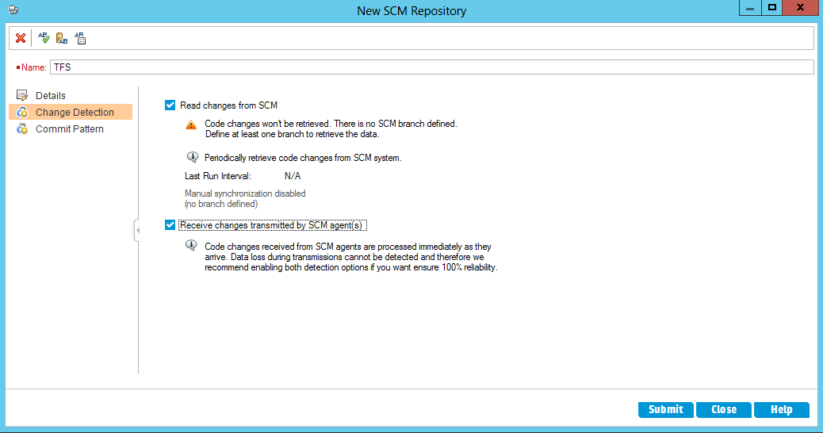

1. Click **Submit** and then click **Close**.
2. Select the new GIT repository and click on the **Branches** tab.

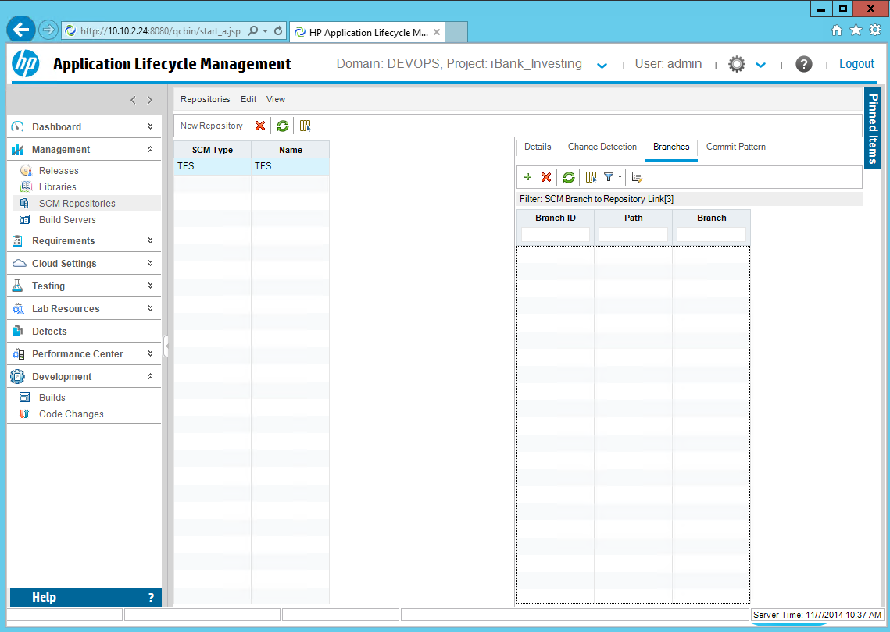

1. Click the button, to add new repository branch. Enter the required inputs and click **Submit** and **Close**.

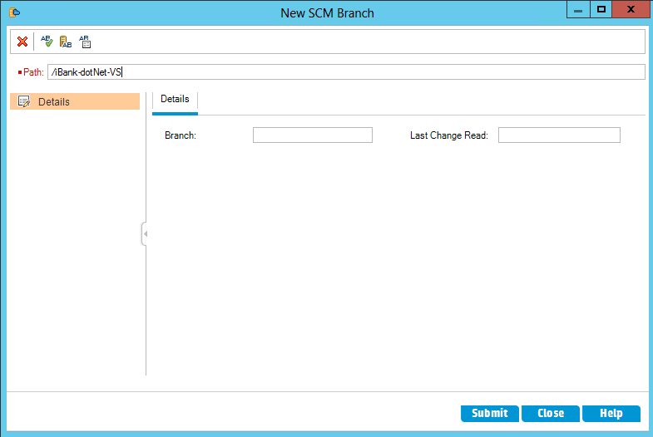

**Note:** Set the branch **Path** to **/iBank-dotNet-VS**, e.g the TFS team project name without the **$** character in-front.

1. To verify the SCM integration, you need to have at least one check-in event for the **iBank-dotNet-VS** project in TFS. Then go to the **Change Detection** section in ALM for this SCM repository and click **synchronize**, to manually synchronize the scm information in ALM.

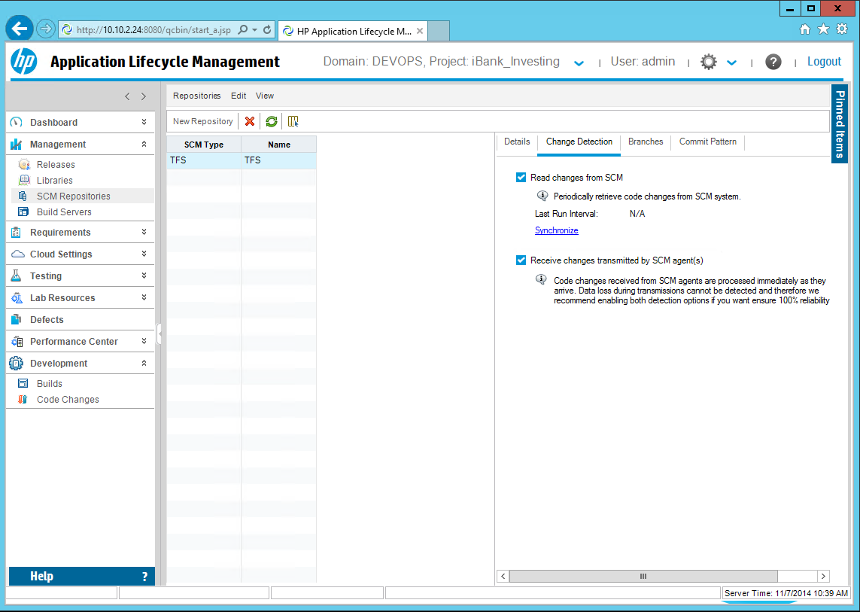

**Note:** SCM information is receved by manual synchronization, scheduled synchronization or automatically by data transmitted from the TFS agents.

1. Go to **Development > Code Changes** section and click  to refresh the SCM repository information. You should see all **iBank-dotNet-VS** project changes in the list below.

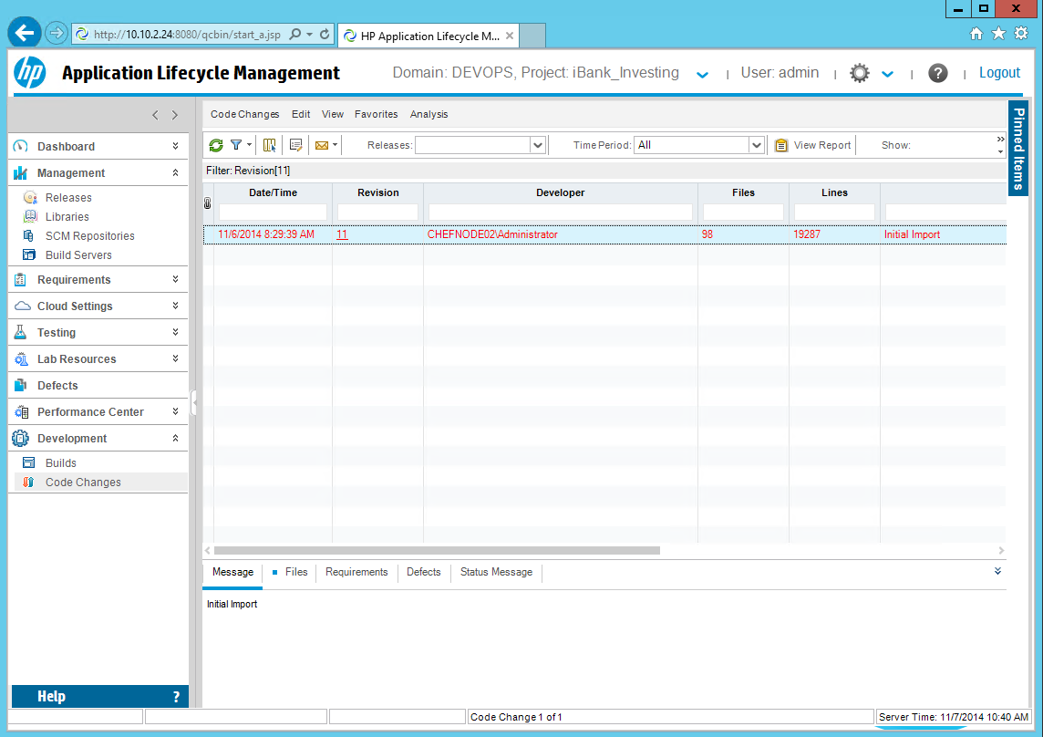

Add SCM GIT repository in ALM for iBank_Investing project (OPTIONAL)

Application Lifecycle Intelligence (ALI) tracks development activities and links them to Application Lifecycle Management (ALM) entities. ALI integrates your Source Code Management (SCM) with Application Lifecycle Management(ALM) and links activities such as code changes and code coverage analyses from your SCM to ALM entities such as Releases, Requirements, Defects, and Tests.

As pre-requisite, in ALM Site Administration, enable the ALI extension for every project in which you want to use ALI.

To set up the HP ALM integration with a GIT server, complete the following steps:

1. Open the HP ALM Desktop client and login to your **Domain** and **Project**.

**Note:** The steps below are required only for the **iBank_Investing** project, since this is the iBank-dotNet (iBank Investor) GIT source code repository. Since we can use TFS instead of GIT, these steps are optional again.

**Domain:** DEVOPS

**Projects:** iBank_Investing

1. Click **Management >** **SCM Repositories:**

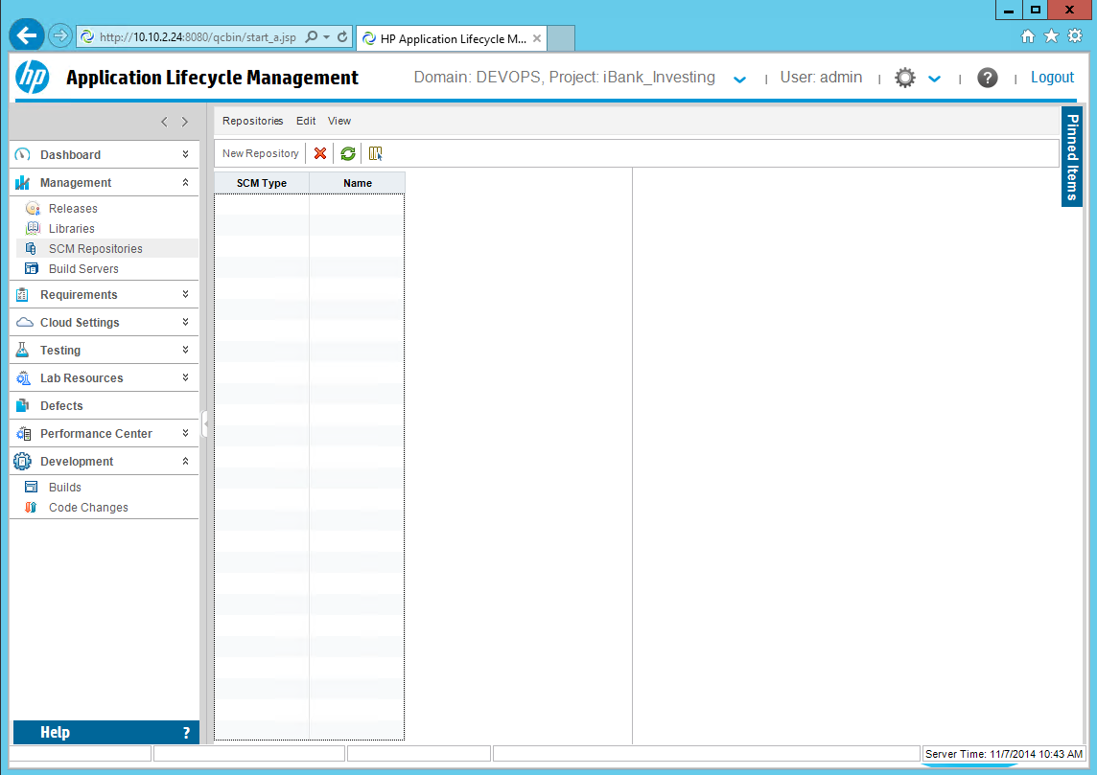

1. Click **New Repository** and select the **Git Provider** for **SCM type**. Then click **OK**.



1. Enter the required inputs: **Location**, **Username**, **Password** and Directory for local Git repository.

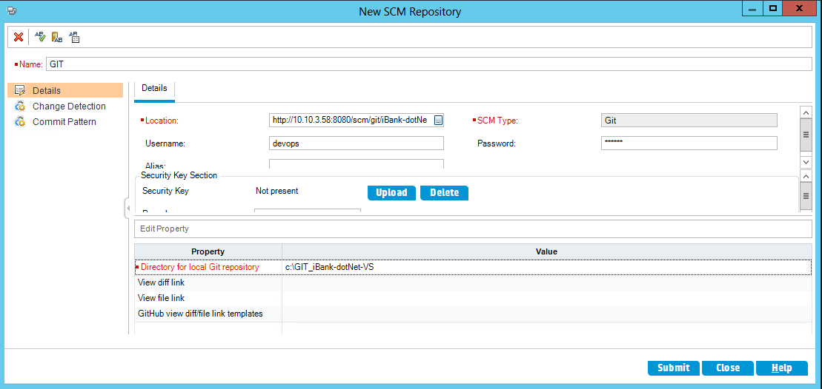

**Note:** replace **Location** with the full git repository URL, **username** and **password** are the default inherited from tomcat – **devops**/**devops**. **Directory for local Git repository** is mandatory and it is the absolute path where the mirror of the remote repository will be created. The path should be located in the ALM repository folder. Each location requires a separate folder. If you change the repository location, you should either change the clone directory property or delete the contents of the folder.

1. Click the Change **Detection** tab and enable the two options:



1. Click **Submit** and then click **Close**.
2. Select the GIT repository and click on the Branches tab.

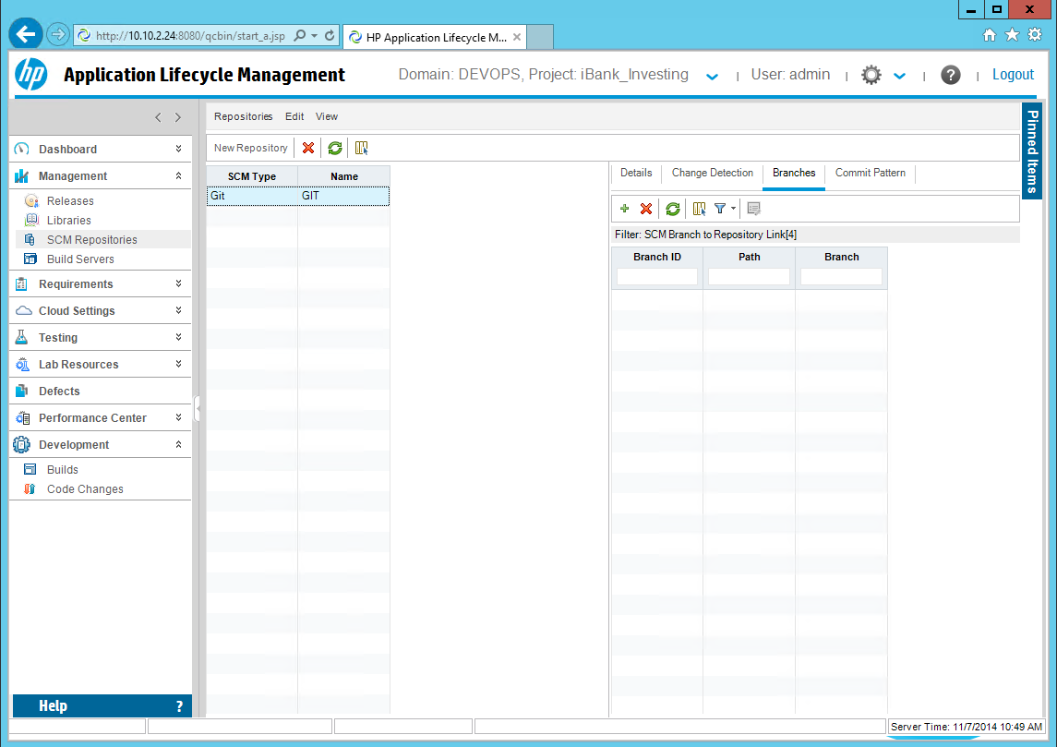

1. Click the button, to add new repository branch. Enter the required inputs and click **Submit** and **Close**.



**Note:** Set the branch **Path** to **/**. The branch should be set to the real Git branch name. Use only the simple branch name in the format **master**, and not **refs/head/master**.

1. To verify the SCM integration, you need to have at least one check-in event for the **iBank-dotNet-VS** repository in GIT. Then go to the **Change Detection** section in ALM for this SCM repository and click **synchronize**, to manually synchronize the scm information in ALM.

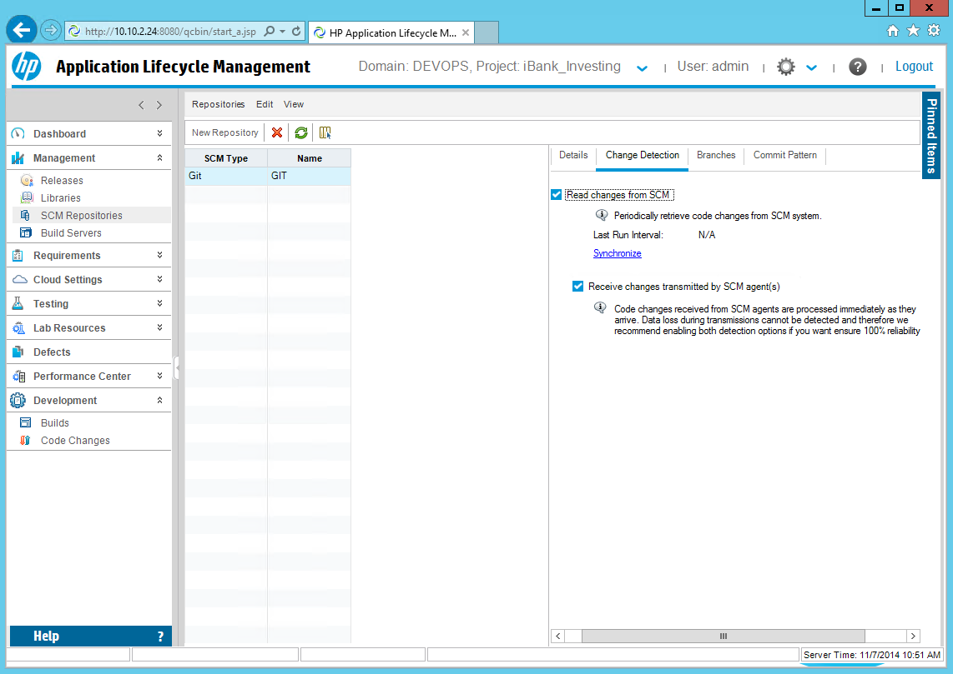

**Note:** SCM information is receved by manual synchronization, scheduled synchronization or automatically by data transmitted from the GIT agents.

1. Go to **Development > Code Changes** section and click  to refresh the SCM repository information. You should see all iBank-dotNet-VS repository changes for the previously selected branch in the list below.

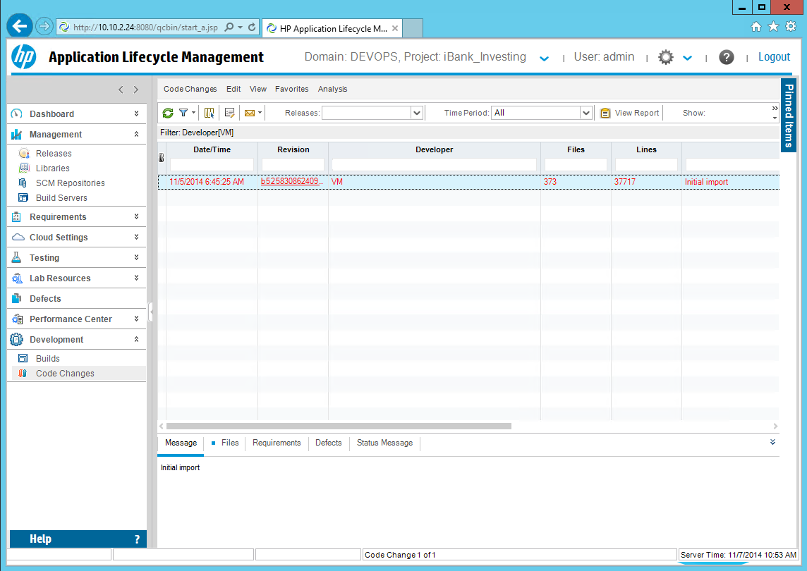

HP ALM Lab Resources Setup

UFT Testing Hosts

HP Application Lifecycle Management supports automated functional testing through HP UFT. The UFT server(s) must be available and configured in the HP ALM **Lab Management > Lab Resources** section, before an automated functional test is started. To add new Testing host and validate the list of already available UFT servers, complete the following steps:

1. Open the HP ALM Lab Management and login with the admin username and password.

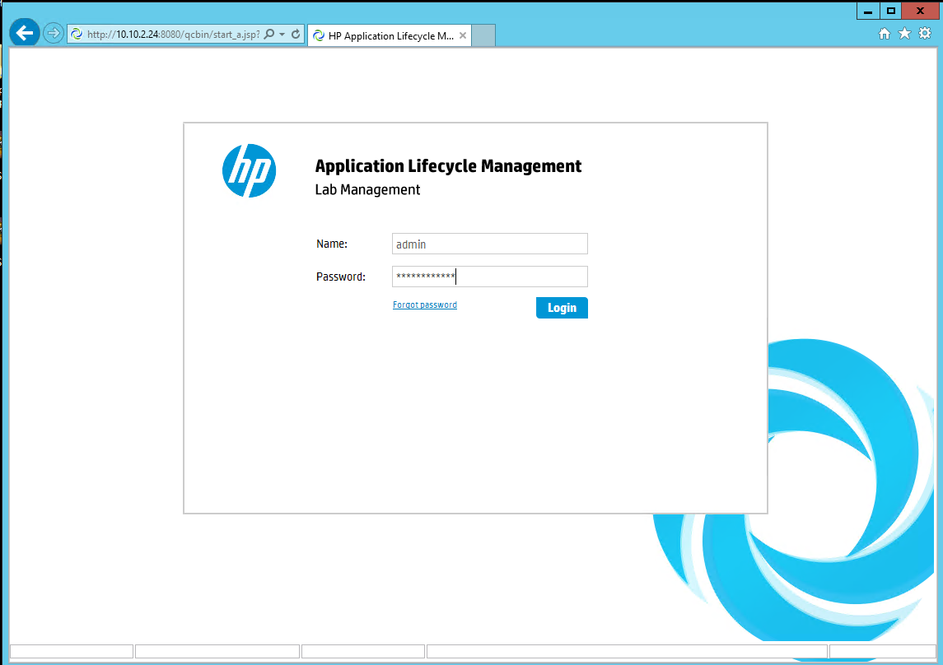

1. Go to **Lab Resources** and select **Hosts**.

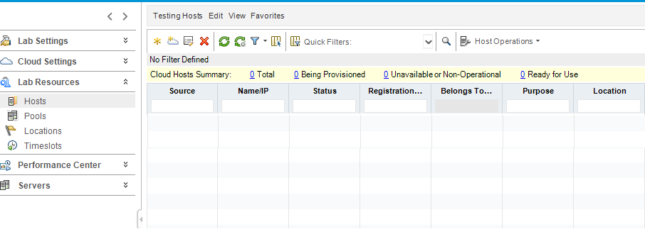

1. Click **Testing Hosts** from the right pane menu toolbar and select **New Testing Host**.

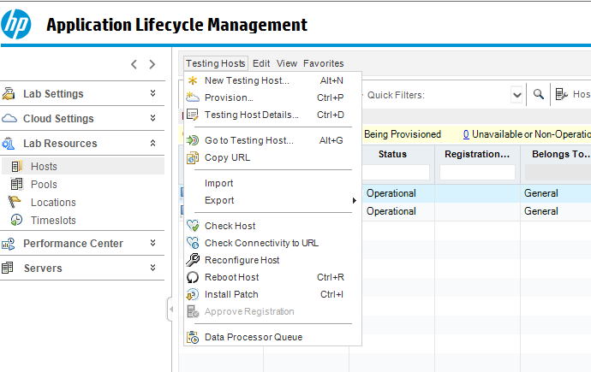

1. In the **New Testing Host** window, enter the IP address or Hostname of the UFT server in the **Name** field and select appropriate **Purpose (Business Process Testing** and **Quick Test Professional)** and any other mandatory fields and click **OK**.

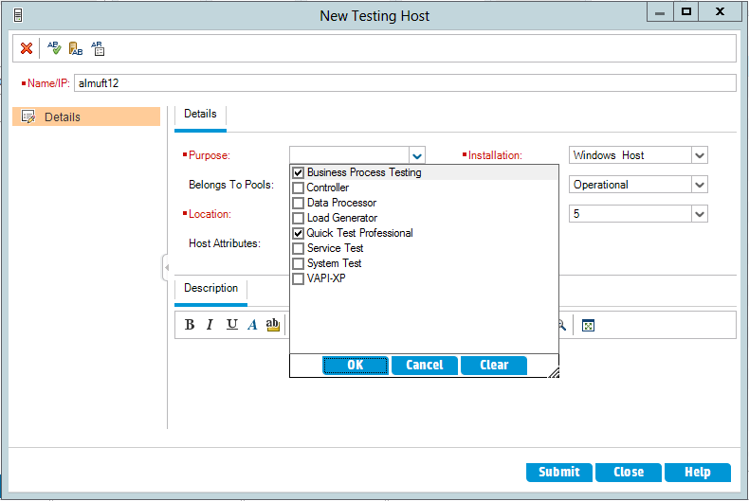

1. Click the **Submit** button.

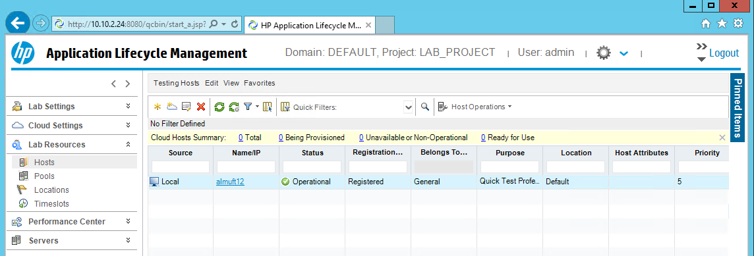

1. To validate the new testing host, select the new testing host and click **Host Operations >** **Check Host** button.

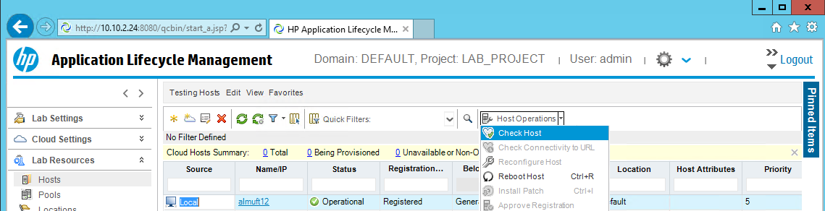

**Note**: In case of issues, please lookup the ALM and UFT troubleshooting guide.

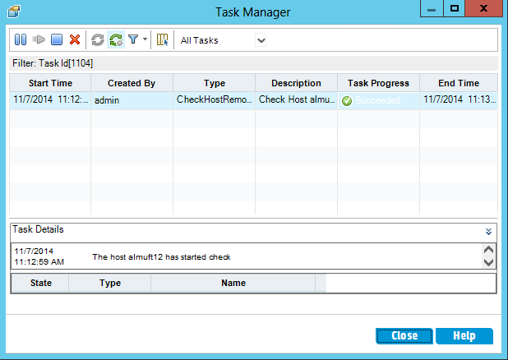

PC Testing Server & Hosts

HP Application Lifecycle Management supports automated testing through HP PC. The PC server & Host(s) must be available and configured in the **Lab Resources** section, before an automated test is started :

Open the HP ALM Lab Management and login with the admin username and password.

Click **Servers**  in the left pane of ALM Lab Management and select **PC Servers,** and then select menu **“PC Server” > “New PC Server”** on the right pane**.**

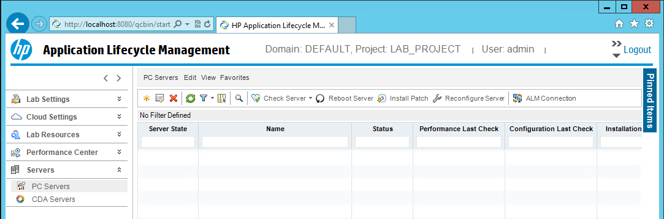

In the new **PC Server** window, enter the IP address of the PC Server that has been installed and **Tab** out from that field, the **External URL** & **Internal URL** fields will get updated automatically. Click **OK.**

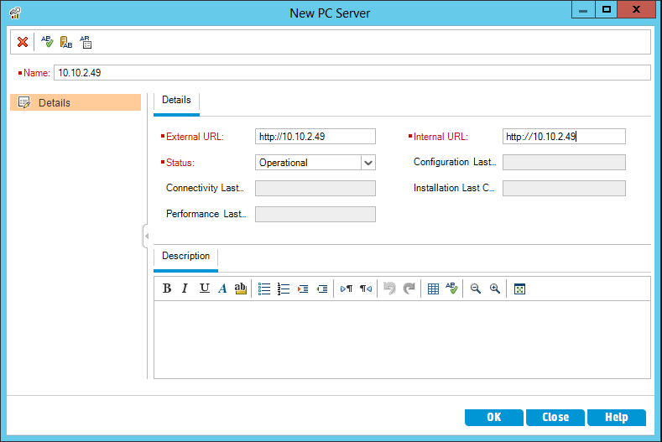

Validate the server by selecting **“PC Server” > “Check Server”.**

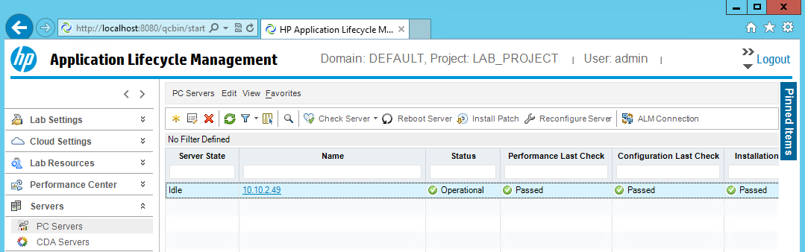

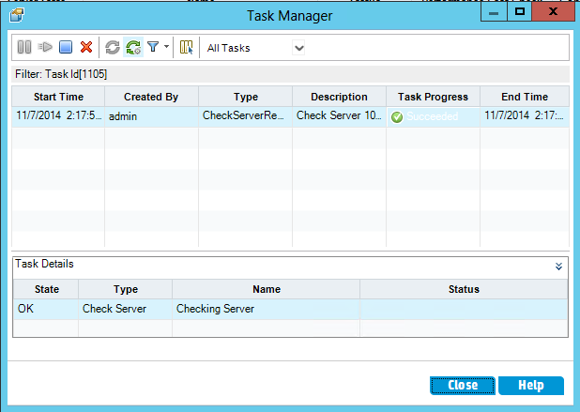

Goto Lab Resources section in Lab management. Click **Lab Resources** **> Hosts.**

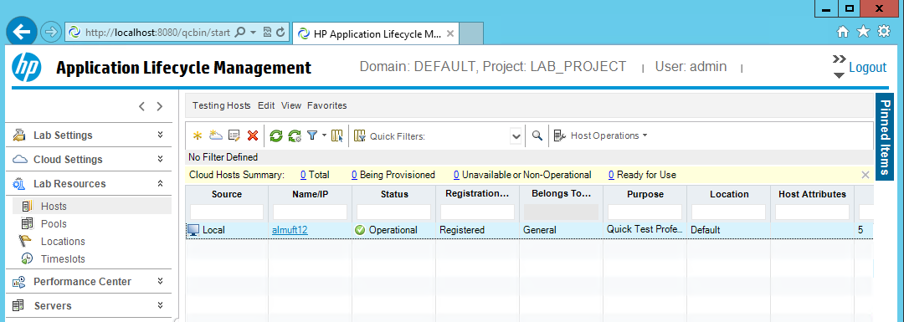

On the right pane here, click **Testing Hosts >** **New Testing Host**.In the name field enter the IP address or the computer name of the machine where PC Host has been installed, select the appropriate purpose and other mandatory field and Click **Submit.**

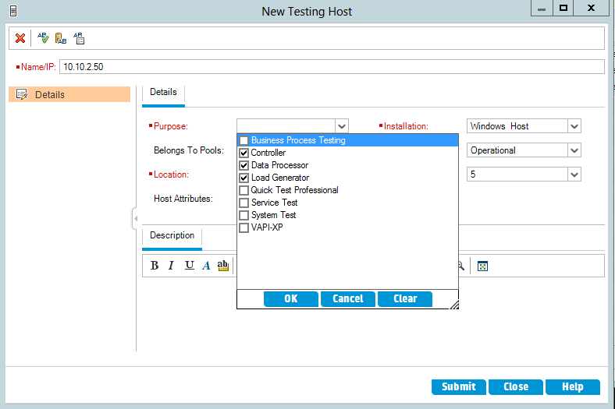

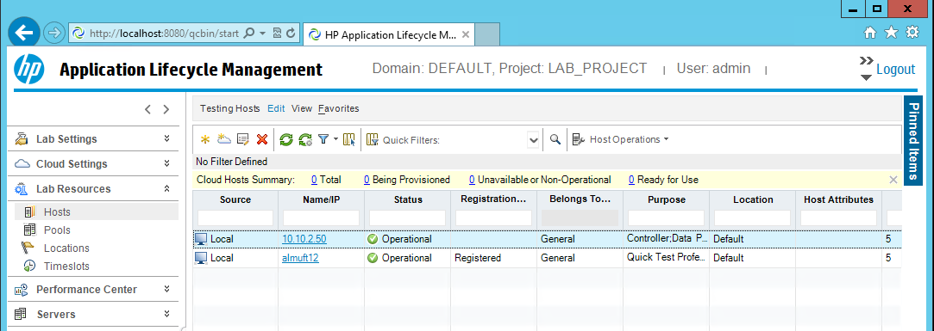

To validate the PC configuration in ALM, it is recommended to perform this check.

1. Click **Performance Center** on the left Navigation pane of Lab Management and select **System Health**.

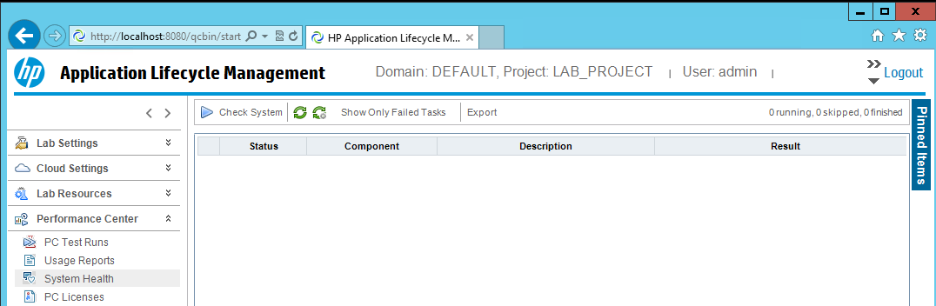

1. On the right pane, click the **Check System** button, this will open up the **Configure System Check** window.
2. Select **Check ALM Platform**, **Check Performance Center Servers** and **Check Hosts”**and click **OK.** This will perform an overall check and provide results. Click **Refresh** to review the results. All issues must be resolved prior to proceeding to PC tests execution.

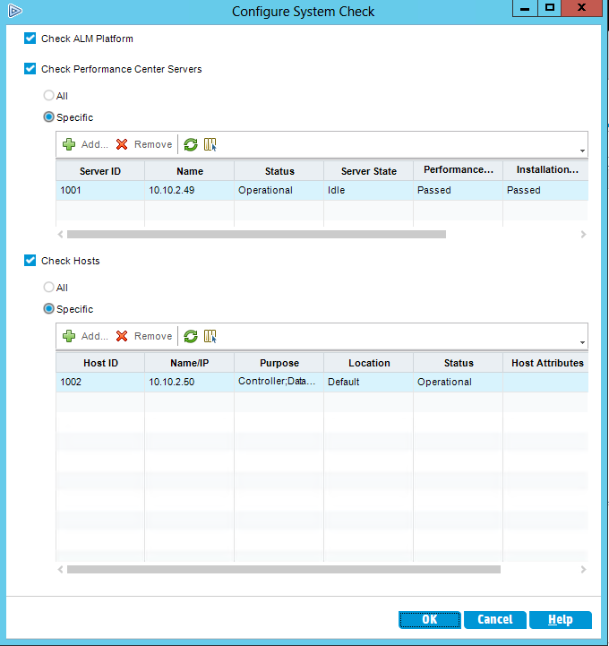

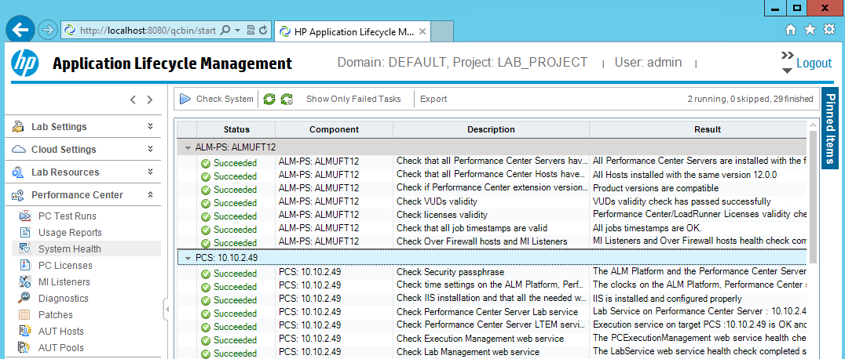

HP ALM FunctionalTesting Setup

Add & Configure UFT test for iBank-Java (iBank Internet Banking).

To import the **iBank-JAVA-FT** uft scripts and create new ALM Test Plan, complete the following steps:

1. Start the HP Unified Functional Tetsting UI, click **ALM** **>** **ALM Connection**.

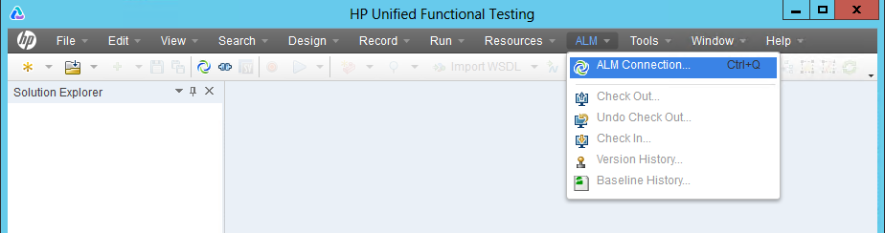

1. Enter the server connection parameters and project connection details to connect to the **iBank_IntenetBanking** project and close the window.

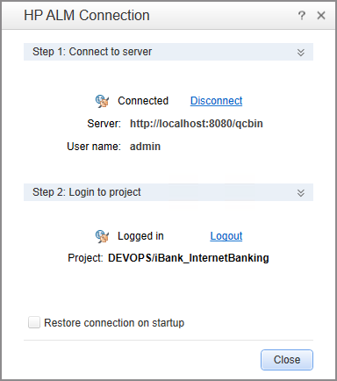

1. Copy the **iBank-JAVA-FT.zip** located in **DevOps_R3.5_Solution/Content files/hp_uft/** to a temporary folder on the UFT server.
2. To import the script, click **File > Import Test.**

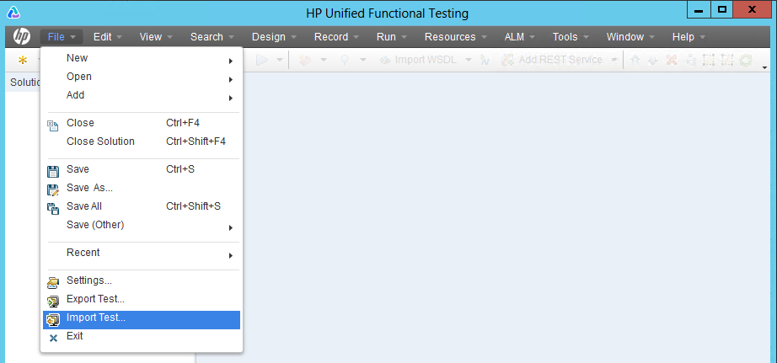

1. Browse to select the **iBank-JAVA-FT.zip** file.
2. Once the uft script is loaded, select **File > Save iBank-JAVA-FT As**. Choose **ALM Test Plan** and click to create new ALM folder. Enter the following folder name **iBank** and press **Enter**:

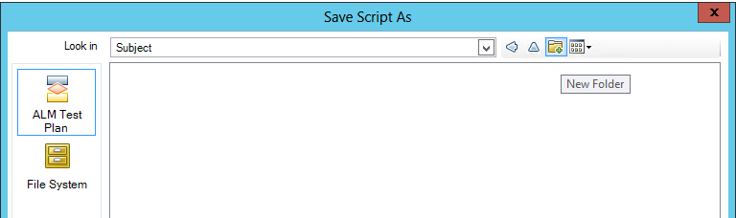

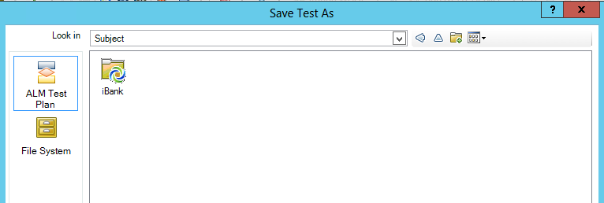

**Note**: The ALM Test Plan option is available only when UFT is connected to ALM.

1. Double click the **iBank** folder and provide the following ALM Test Plan name – **iBank_JAVA_FT**.

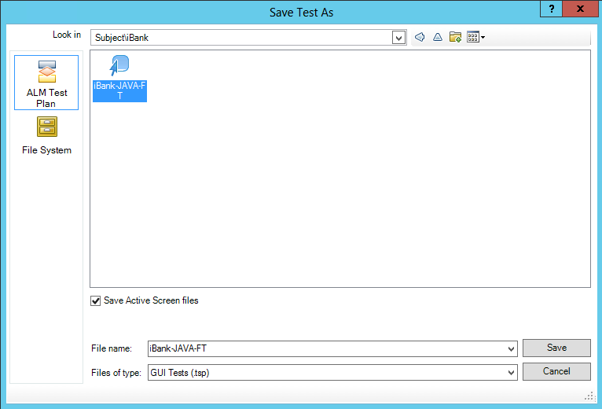

Add & Configure UFT test for iBank-dotNet (iBank Investor).

To import the **iBank-dotNet-without-Integration** uft scripts and create new ALM Test Plan, complete the following steps:

1. Start the HP Unified Functional Tetsting UI, click **ALM** **>** **ALM Connection**.



1. Enter the server connection parameters and project connection details to connect to the **iBank_Investing** project and close the window.

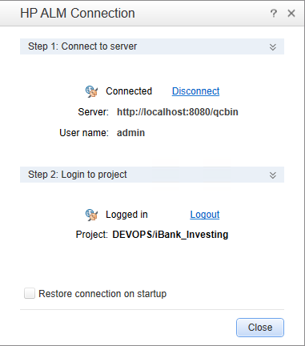

1. Copy the **iBank-dotNet-without-Integration.zip** located in **DevOps_R3.5_Solution/Content files/hp_uft/** to a temporary folder on the UFT server.
2. To import the script, click **File > Import Test.**



1. Browse to select the **iBank-dotNet-without-Integration.zip** file.
2. Once the uft script is loaded, select **File > Save iBank-dotNet-without-Integration As**. Choose **ALM Test Plan** and click to create new ALM folder. Enter the following folder name **iBank** and press **Enter**:





**Note**: The ALM Test Plan option is available only when UFT is connected to ALM.

1. Double click the **iBank** folder and provide the following ALM Test Plan name – **iBank-dotNet-without-Integration**.

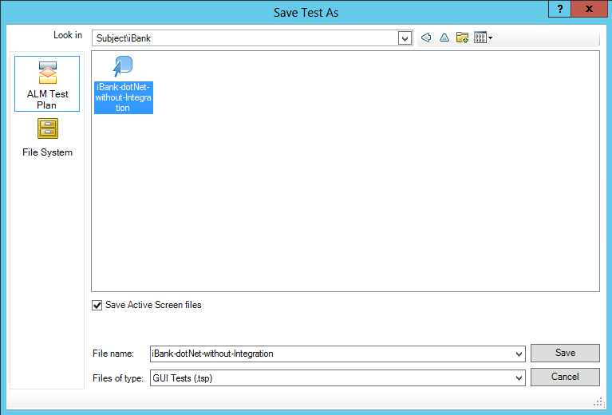

Add & Configure UFT test for iBank-dotNet-MT (iBank Investor).

To import the **iBank-dotNet-with-Integration** uft scripts and create new ALM Test Plan, complete the following steps:

1. Start the HP Unified Functional Tetsting UI, click **ALM** **>** **ALM Connection**.



1. Enter the server connection parameters and project connection details to connect to the **iBank_Investing** project and close the window.

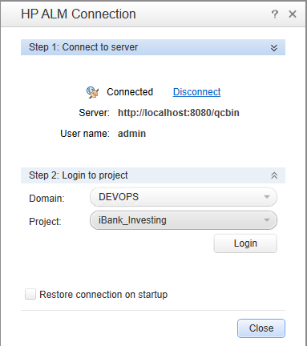

1. Copy the **iBank-dotNet-with-Integration.zip** located in **DevOps_R3.5_Solution/Content files/hp_uft/** to a temporary folder on the UFT server.
2. To import the script, click **File > Import Test.**



1. Browse to select the **iBank-dotNet-with-Integration.zip** file.
2. Once the uft script is loaded, select **File > Save iBank-dotNet-with-Integration As**. Choose **ALM Test Plan** and double click the **iBank** folder and provide the following ALM Test Plan name – **iBank-dotNet-with-Integration**.

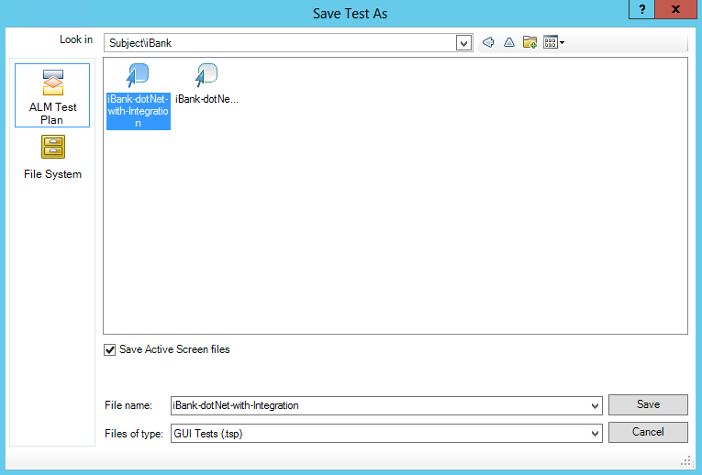

**Note**: The ALM Test Plan option is available only when UFT is connected to ALM.

Configure the UFT / PC parameterized file.

The DevOps UFT / PC testing scripts provided for this release are using parameterized file to get some values like:

* **IBank_Url_java**: iBank-Java web application URL
* **IBank_Url_dotnet**: iBank-dotNet web application URL
* **Username**: calid username for both web applications
* **Password**: valid password for both web applicatoins

To configure the UFT/PC parameterized, complete the following steps:

1. Copy the **PC_UFT_Test.dat** configuration filelocated in **DevOps_R3.5_Solution/Content**

**files/hp_uft/** folder to C:\ drive on the ALM server.

**Note:** If UFT is not installed on the ALM server, copy the same file to c:\ drive on the UFT server too. Otherwise only UFT/ PC tests triggered from ALM will have access to the configuration file.

1. Open the PC_UFT_Test.dat configuration file and update the values for **IBank_Url_java**, **IBank_Url_dotnet**, **Username**, **Password**.

Configuration file contents:

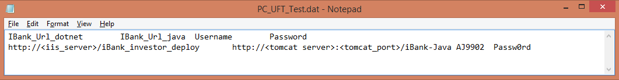

**Note**: replace **iis_server** with the ip address of the MSTools server, where the iBank-dotNet application was deployed.

replace **tomcat_server** and **tomcat_port** with the ip address of the tomcat server and tomcat port, where the iBank-Java application was deployed - 3rd Party Tools server.

Example configuration file:

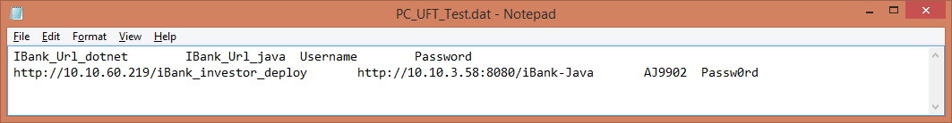

Setup the Functional Test Set for iBank-Java (iBank Internet Banking).

1. Open the HP ALM Desktop client and login to your **Domain** and **Project** with the admin username and password.

**Domain:** DEVOPS

**Projects:** iBank_InternetBanking



1. Create new ALM **Test Set** and associate it with the ALM **Test** created in the previous steps.
2. Click **Testing > Test Lab**.

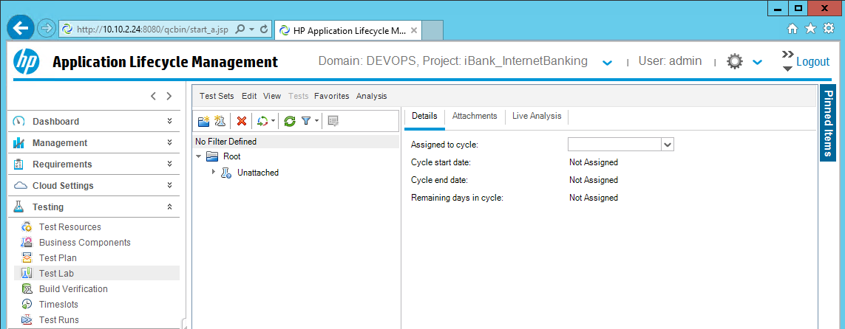

1. Click  and create new folder - **iBank**.

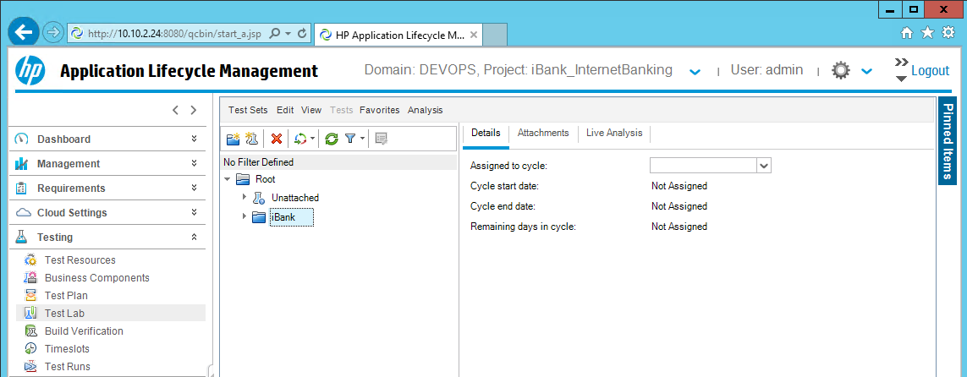

1. Click **Test Sets > New Test Set** from the toolbar above and create new test set - **iBank-Java(Functional Tests)**.

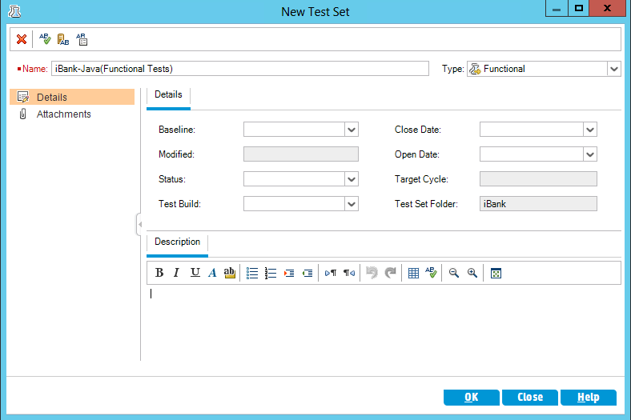

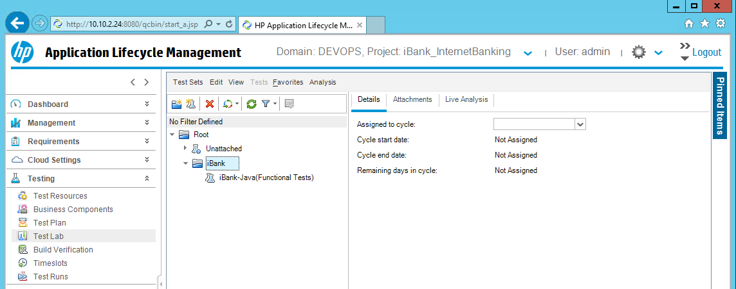

1. Associate the ALM **iBank-JAVA-FT** Test with the ALM **iBank-Java(Functional Tests)** Test Set.

Select the **Execution Grid** tab and click on the **Select Tests** button. The test plan will be loaded on the right side of the screen. From there the ALM Test can be loaded to the ALM Test Set by using button.

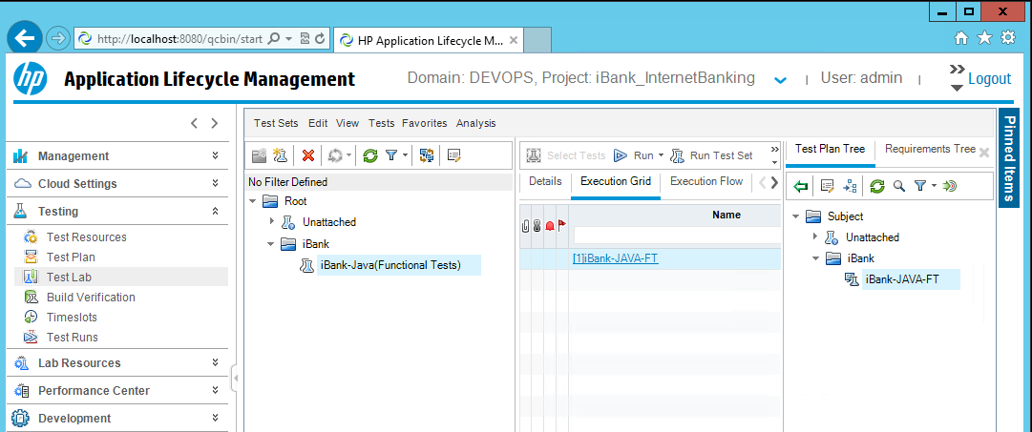

1. To verify the new Test Set is working, select the **iBank-Java(Functional Tests)** test set and click . Select **Run All Tests Locally** option and click **Run All** button.

**Important**: This functional test requires Mozilla Firefox to be installed, since the web application does not supports all IE Browser and test may fail. UFT 12.01 build 1204 is required to add support for Mozilla Firefox.

**Note:** The UFT script will read the c:\PC_UFT_Test.dat configuration file and based on the application URL for iBank-Java, it will run the functional test. If the iBank-Java application is accessible, the test should be marked as **Passed**.

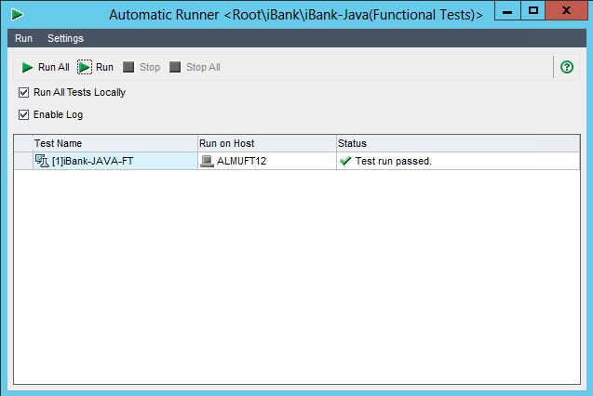

Setup the Functional Test Sets for iBank-dotNet (iBank Investor).

1. Open the HP ALM Desktop client and login to your **Domain** and **Project** with the admin username and password.

**Domain:** DEVOPS

**Projects:** iBank_Investing

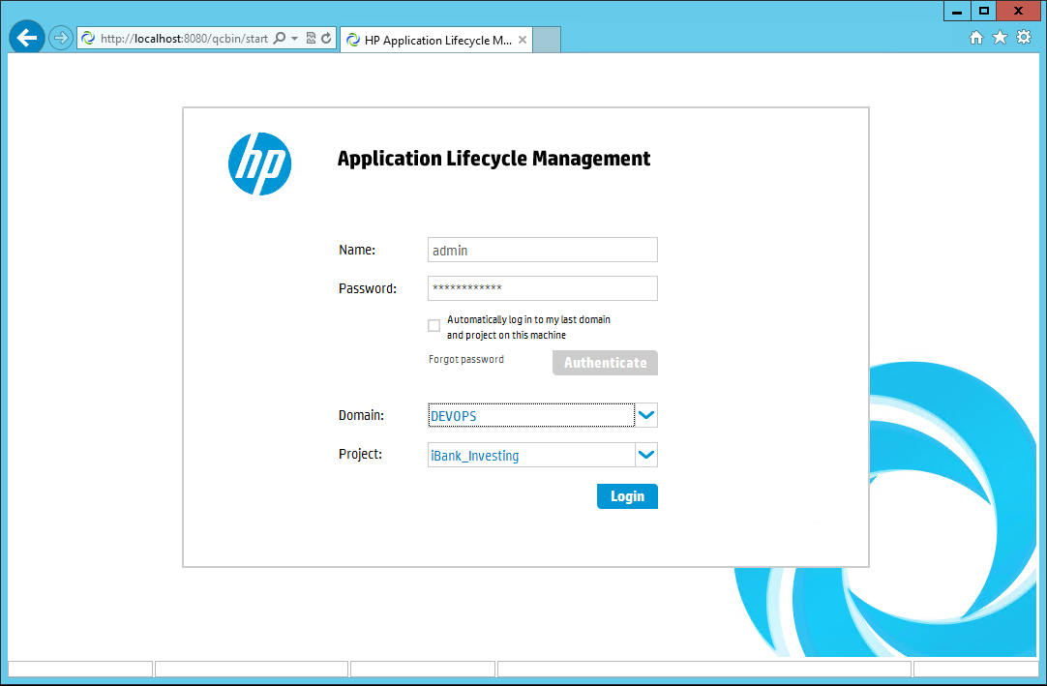

1. Create new ALM **Test Sets** and associate them with the ALM **iBank-dotNet-without-Integration** and **iBank-dotNet-with-Integration** Tests created in the previous steps.
2. Click **Testing > Test Lab**.

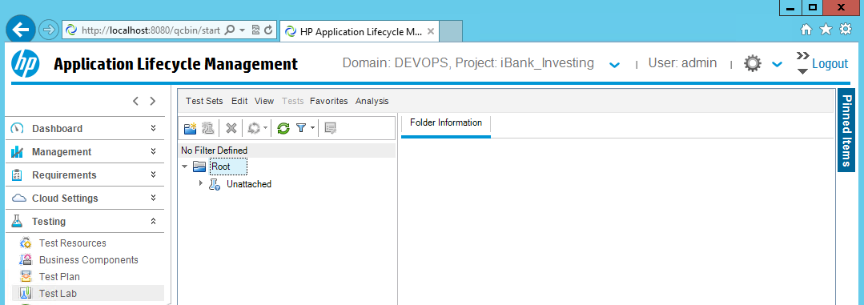

1. Click  and create new folder - **iBank**.

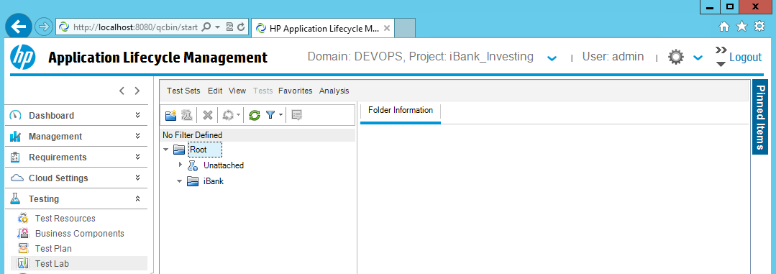

1. Click **Test Sets > New Test Set** from the toolbar above and create new test set - **iBank-dotNET(Functional Tests)**.

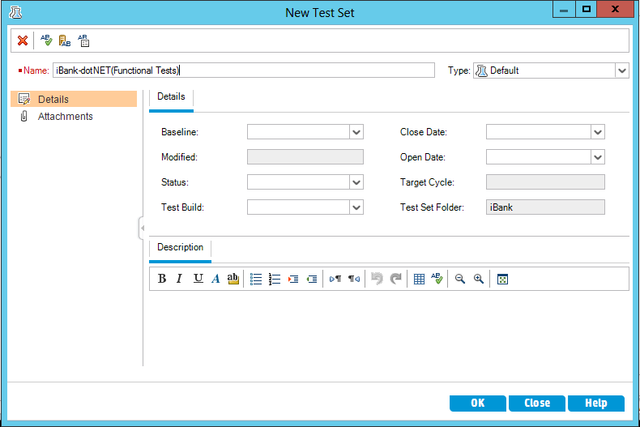

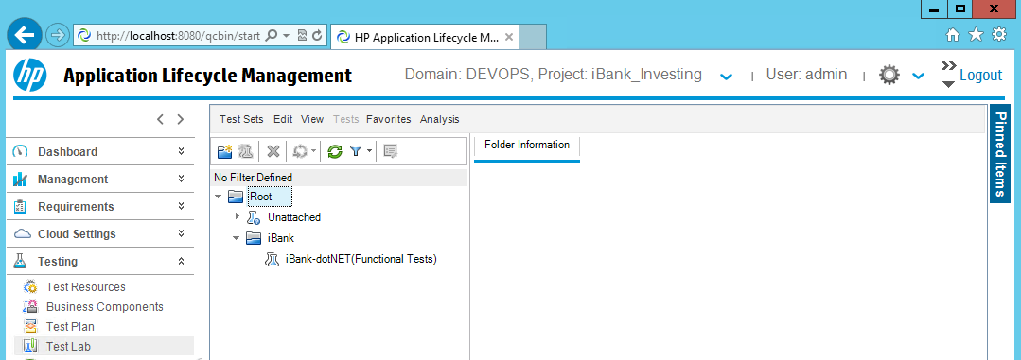

1. Associate the ALM **iBank-dotNet-without-Integration** Test with the ALM **iBank-dotNET(Functional Tests)** Test Set.
2. Select the **Execution Grid** tab and click on the **Select Tests** button. The test plan will be loaded on the right side of the screen. From there the ALM **iBank-dotNet-without-Integration** Test can be loaded to the ALM Test Set by using button.

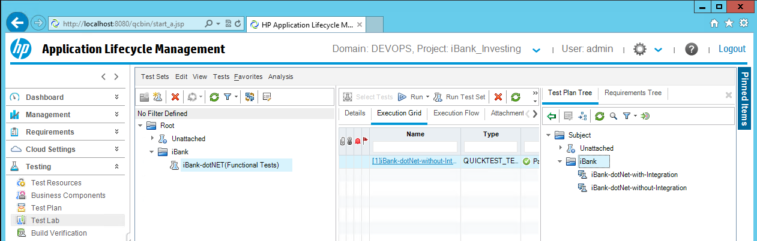

1. Click **Test Sets > New Test Set** from the toolbar above and create new test set - **iBank-MT(Functional Tests)**.

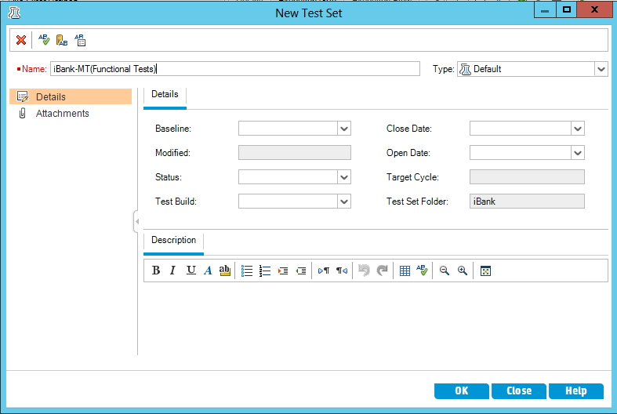

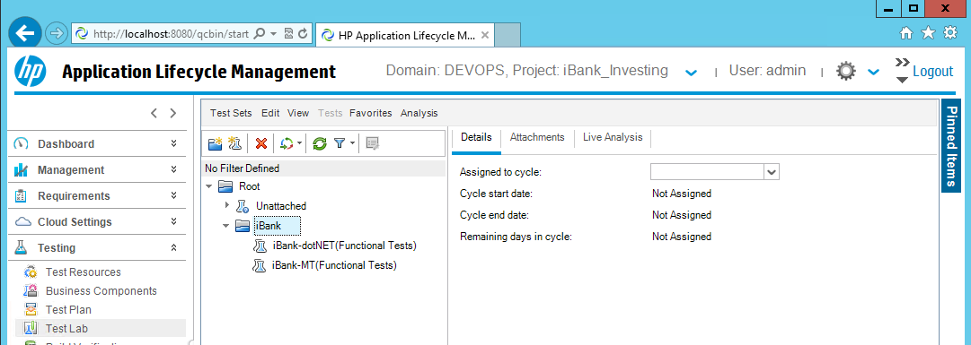

1. Associate the ALM **iBank-dotNet-with-Integration** Test with the ALM **iBank-MT(Functional Tests)** Test Set.

Select the **Execution Grid** tab and click on the **Select Tests** button. The test plan will be loaded on the right side of the screen. From there the ALM **iBank-dotNet-with-Integration** Test can be loaded to the ALM Test Set by using button.

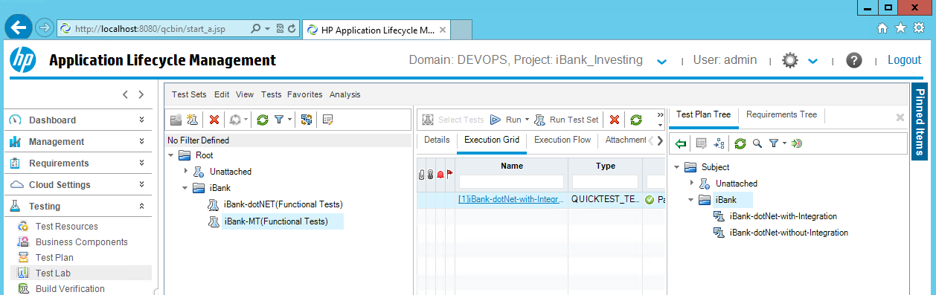

1. To verify the new **iBank-dotNET(Functional Tests)** Test Set is working, select the **iBank-dotNET(Functional Tests)** test and click . Select **Run All Tests Locally** option and click **Run All** button.

**Note:** The UFT script will read the c:\PC_UFT_Test.dat configuration file and based on the application URL for iBank-dotNet, it will run the functional test. If the iBank-dotNet application is accessible, the test should be marked as **Passed**.

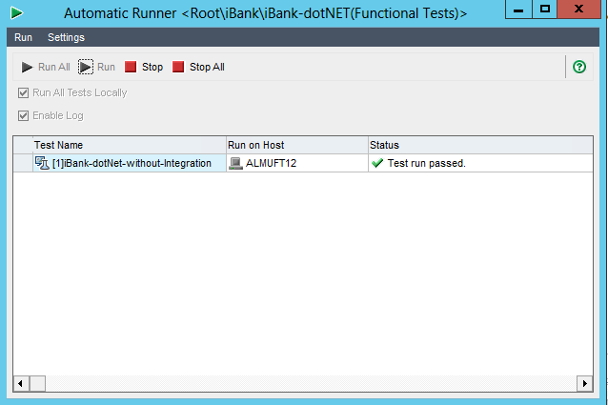

1. To verify the new **iBank-MT(Functional Tests)** Test Set is working, select the **iBank-MT(Functional Tests)** test and click . Select **Run All Tests Locally** option and click **Run All** button.

**Important**: This functional test requires Mozilla Firefox to be installed, since the iBank-Java web application does not supports all IE Browser and test may fail. UFT 12.01 build 1204 is required to add support for Mozilla Firefox.

**Note:** The UFT script will read the c:\PC_UFT_Test.dat configuration file and based on the application URLs for iBank-Java and iBank-dotNet, it will run the functional test. If the iBank-Java and iBank-dotNet application is accessible, the test should be marked as **Passed**.

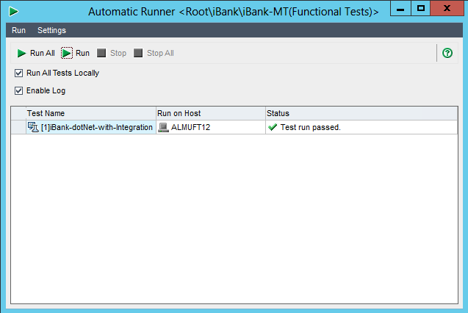

HP ALM Testing Setup for PC

Add & Configure PC Tests sets in ALM for iBank-Java (iBank Internet Banking)

1. Start the HP Virtual User Generator UI and click **ALM** **>** **ALM Connection**.

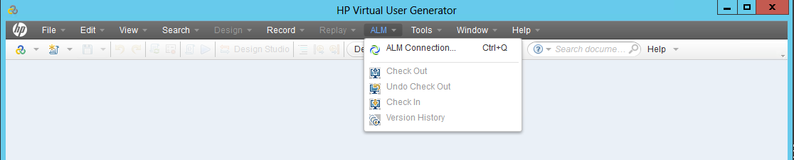

1. Enter the server connection parameters and project connection details to connect to the **iBank_InternetBanking** project and close the window.

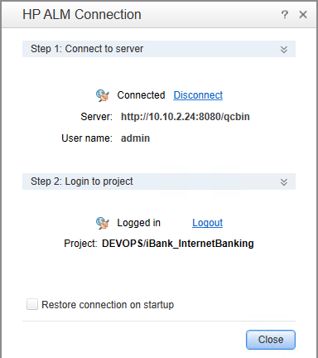

1. Copy the **iBank_JAVA_PC.zip** located in **DevOps_R3.5_Solution/Content files/hp_pc/** to a temporary folder on the PC server.
2. To import the **iBank-Java** (iBank Internet Banking) performance scripts, click **File > Manage Zip Files > Import from Zip File** and browse to select the **iBank_JAVA_PC.zip** file.

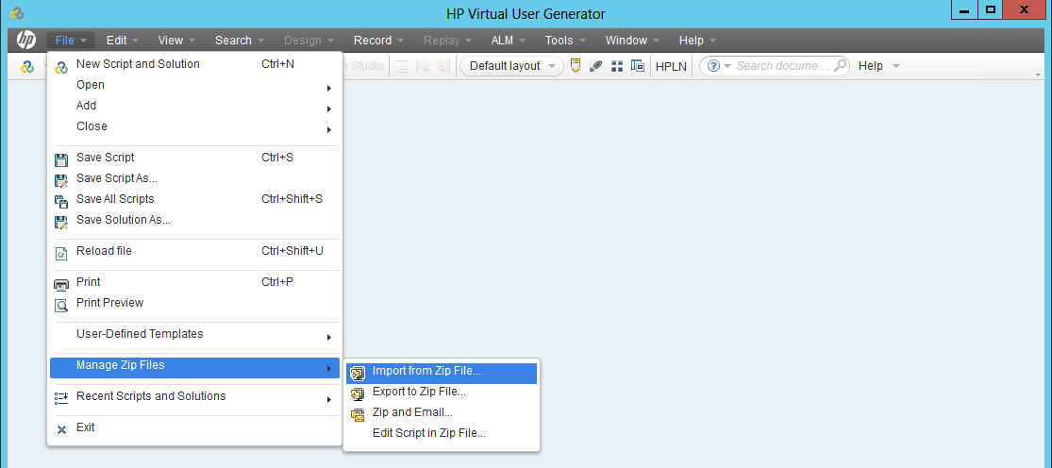

1. Once the pc script is loaded, select **File > Save Script As**. Choose **ALM Test Plan** and click to create new ALM folder. Enter the following folder name **iBank(Performance Test)** and press **Enter**.



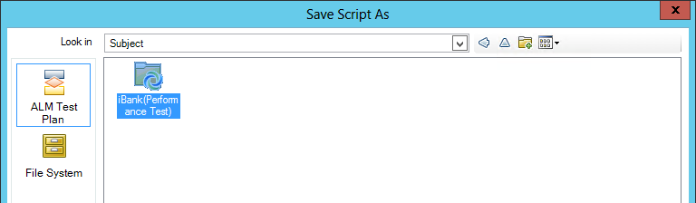

**Note**: The ALM Test Plan option is available only when VuGen is connected to ALM.

1. Double click the **iBank(Performance Test)** folder and provide the following ALM Test Plan name – **iBank_JAVA_PC_scripts**.click **Save**, then click **Runtime Mode**.

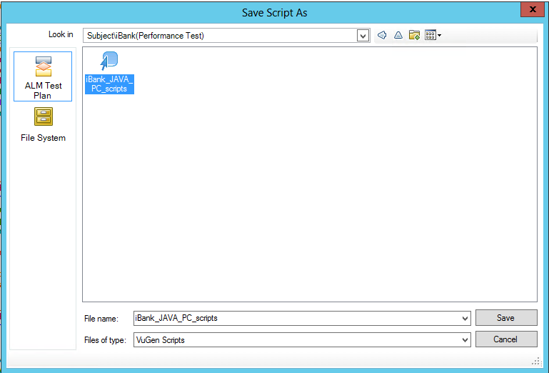

Setup the Performance Test Set for iBank-Java (iBank Internet Banking).

1. Open the HP ALM Desktop client and login to your **Domain** and **Project** with the admin username and password.

**Domain:** DEVOPS

**Projects:** iBank_InternetBanking

1. Create new ALM **Test Set** and associate it with the ALM **PC script** imported in the previous steps.
2. Click **Testing > Test Plan**.

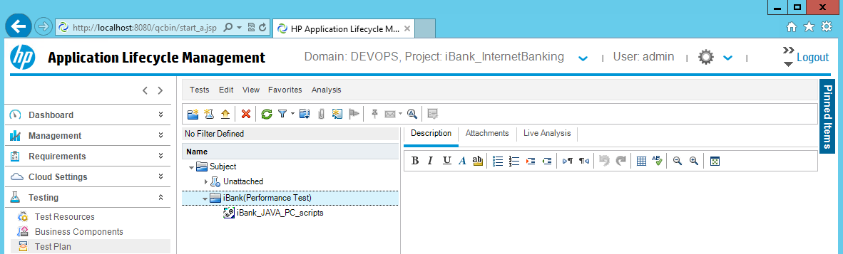

1. Click **Test > New Test** from the toolbar above and create new empty test - **iBank_JAVA_PC**. Click **OK**.

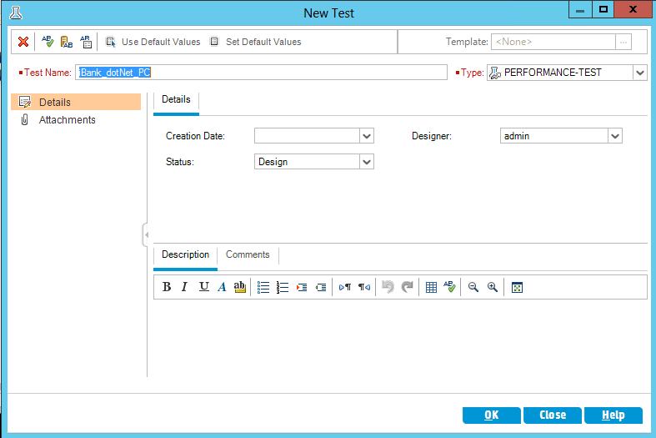

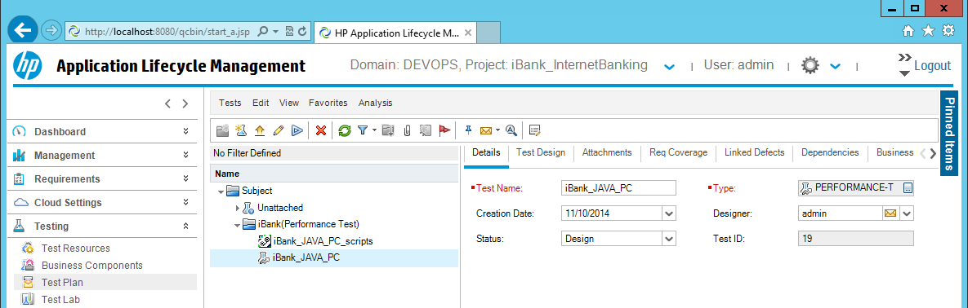

1. Click **Testing > Test Lab**.

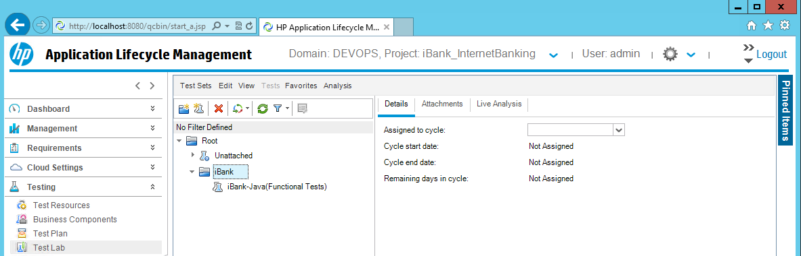

1. Select **iBank** folder. Click **Test Set > New Test set** from the toolbar above and create new test set - **iBank-Java(Performance Test)**. Click **OK**.

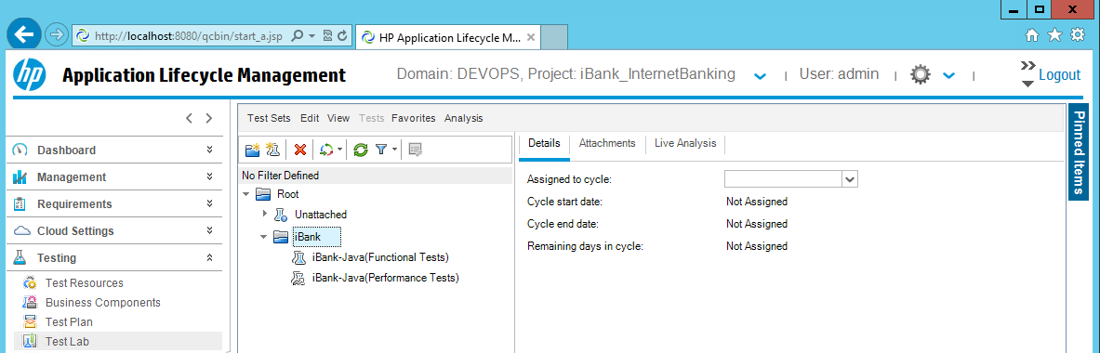

1. Associate the new ALM **Test Set** withthe **Test** created in the previous steps. Select the **iBank-Java(Performance Test)** and click on **Select Tests**.

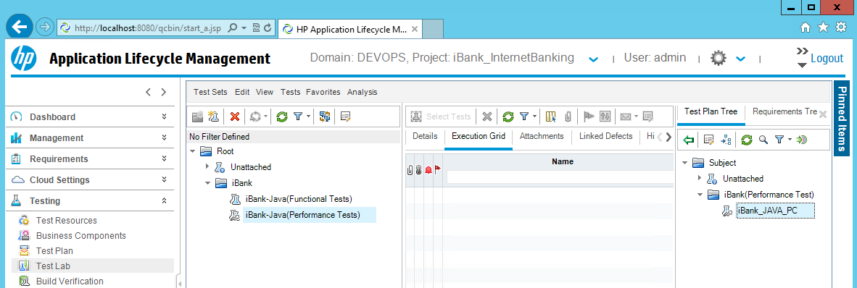

1. Select **iBank_JAVA_PC** from the **Test Plan Tree** and click to add the **Test**.

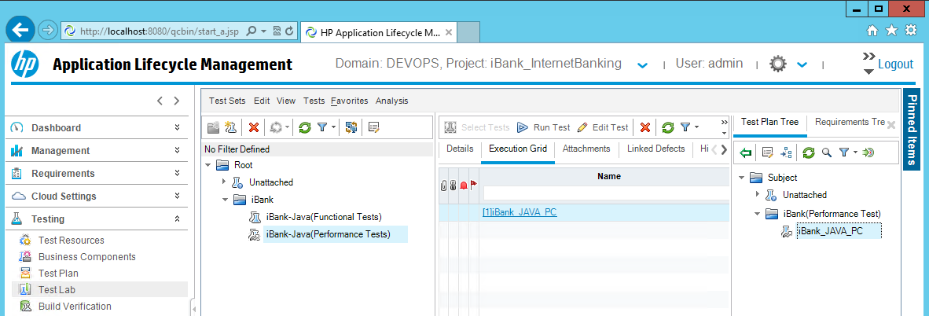

1. Click on **Execution Grid** and then click on **Edit Test**. Select  **Real-world schedule, by test** – **by number** and click **OK**.

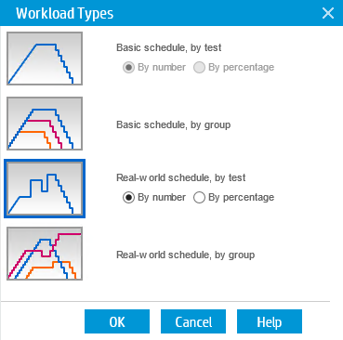

1. Click **Select Scripts**, expand the scripts tree and select **iBank_JAVA_PC_scripts**. Click  to add the pc script.

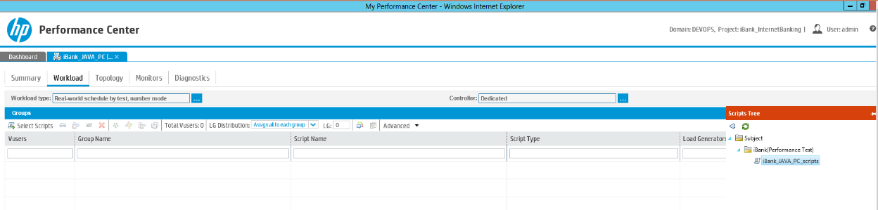

1. Select **Load Generators** and **Controller**.

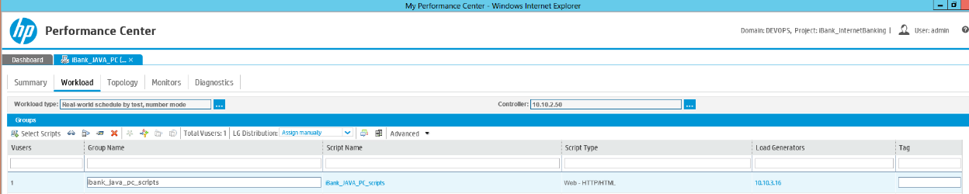

1. Configure the number of **Vusers** and **duration**,then click **Save**.

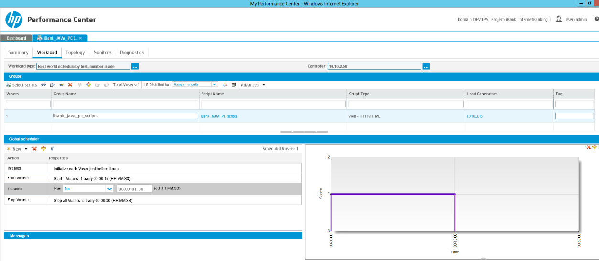

1. Click **Summary**, and under **Service Level Agreement** add new **Transaction Response Time Percentile** SLA. Click **Save** and **Close.**

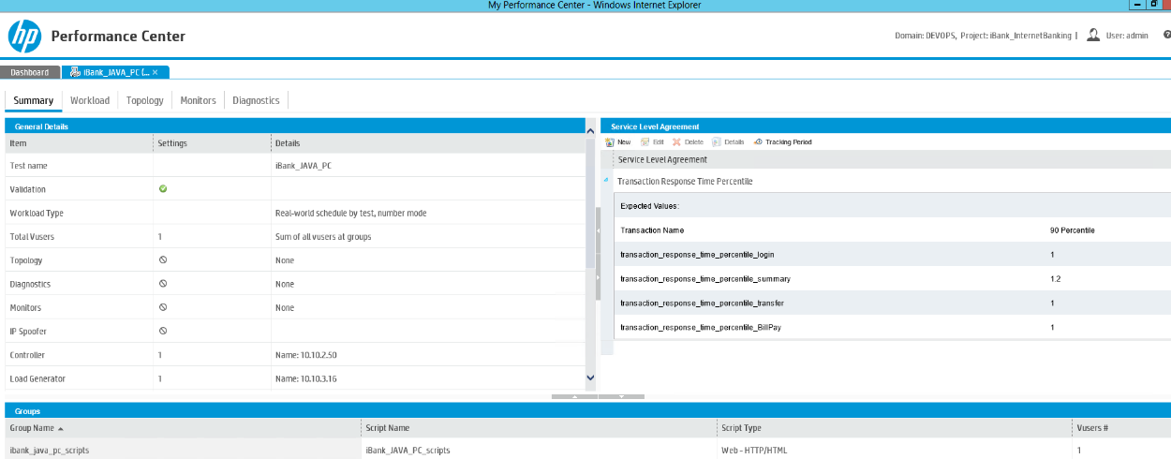

1. To verify the new Test Set is working, select the **iBank-Java(Performance Tests)** test set and click . Click **Run** button.

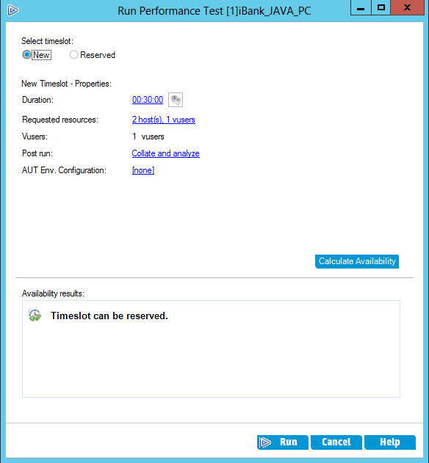

**Note:** The PC script will read the c:\PC_UFT_Test.dat configuration file and based on the application URL for iBank-Java, it will run the performance test. If the iBank-Java application is accessible, the test should be marked as **Passed**.

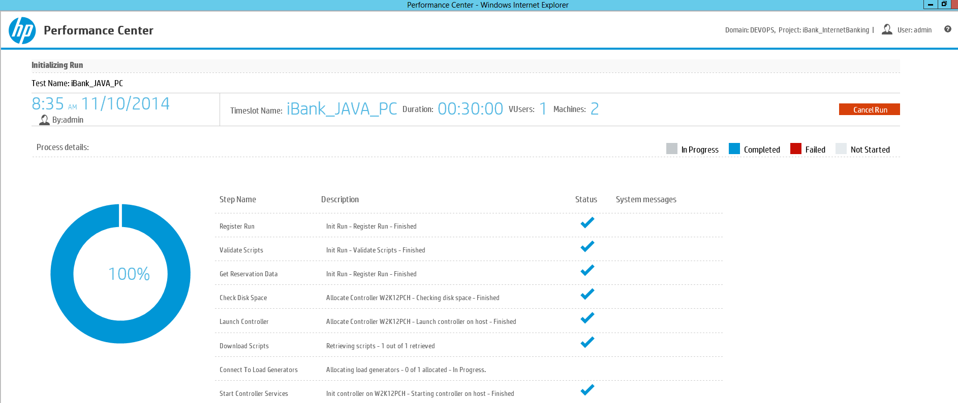

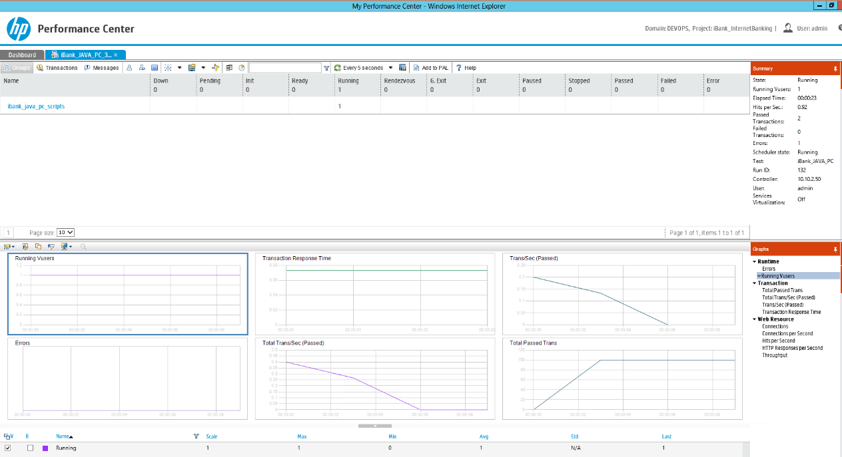

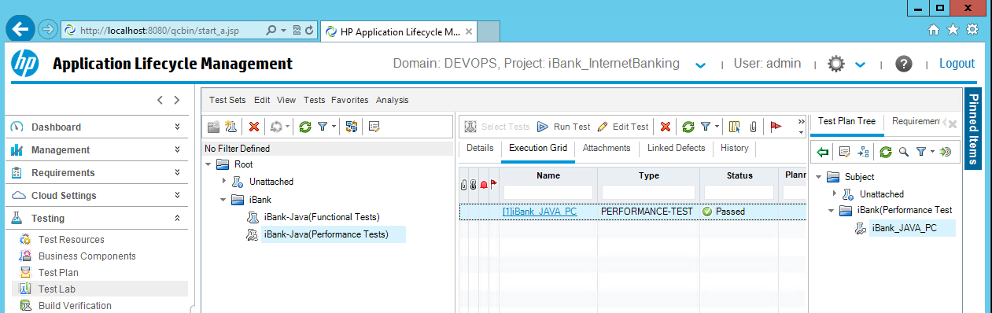

Add & Configure PC Tests sets in ALM for iBank-dotNet (iBank Investor)

1. Start the HP Virtual User Generator UI and click **ALM** **>** **ALM Connection**.



1. Enter the server connection parameters and project connection details to connect to the **iBank_Investing** project and close the window.

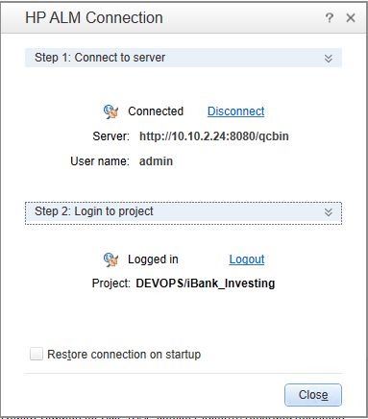

1. Copy the iBank**_dotNet_PC.zip** located in **DevOps_R3.5_Solution/Content files/hp_pc/** to a temporary folder on the PC server.
2. To import the **iBank-dotNet** (iBank Investing) performance scripts, click **File > Manage Zip Files > Import from Zip File** and browse to select the **iBank_dotNet_PC.zip** file.



1. Once the pc script is loaded, select **File > Save Script As**. Choose **ALM Test Plan** and click to create new ALM folder. Enter the following folder name **iBank(Performance Test)** and press **Enter**





**Note**: The ALM Test Plan option is available only when VuGen is connected to ALM.

1. Double click the **iBank(Performance Test)** folder and provide the following ALM Test Plan name – **iBank_dotNet_PC_scripts**.click **Save**, then click **Runtime Mode**.

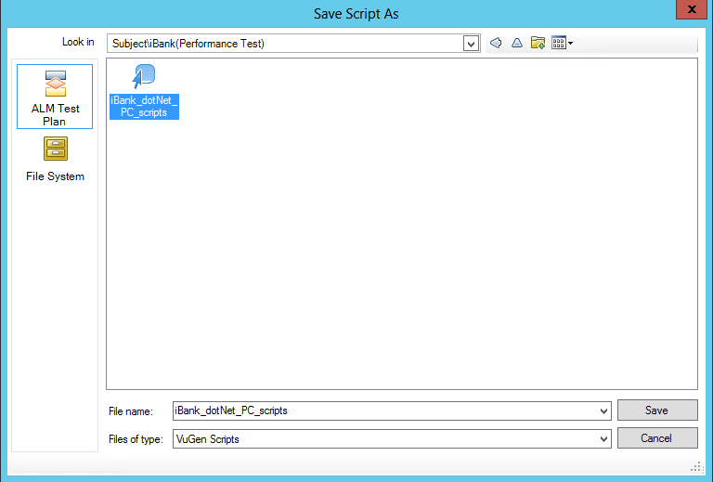

Setup the Performance Test Set for iBank-dotNet (iBank Investor).

1. Open the HP ALM Desktop client and login to your **Domain** and **Project** with the admin username and password.

**Domain:** DEVOPS

**Projects:** iBank_Investing

1. Create new ALM **Test Set** and associate it with the ALM **PC script** imported in the previous steps.
2. Click **Testing > Test Plan**.

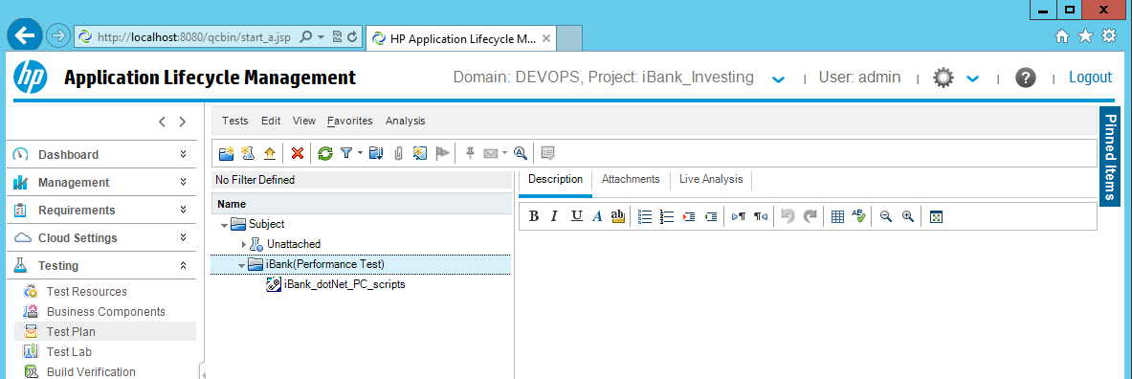

1. Click **Test > New Test** from the toolbar above and create new empty test - **iBank_dotNet_PC**. Click **OK**.



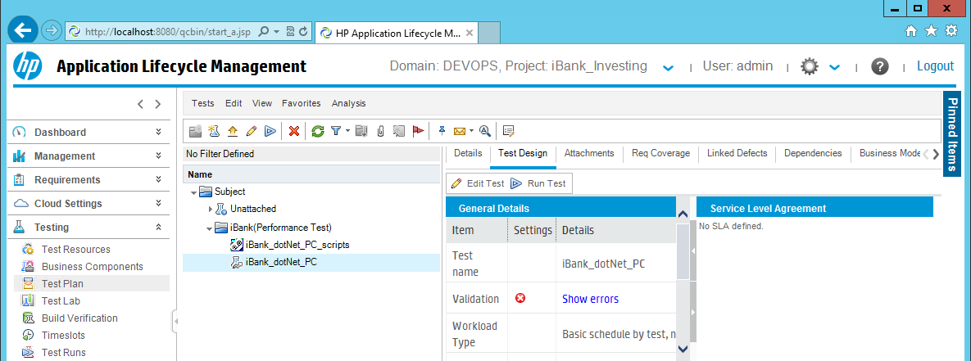

1. Click **Testing > Test Lab**.

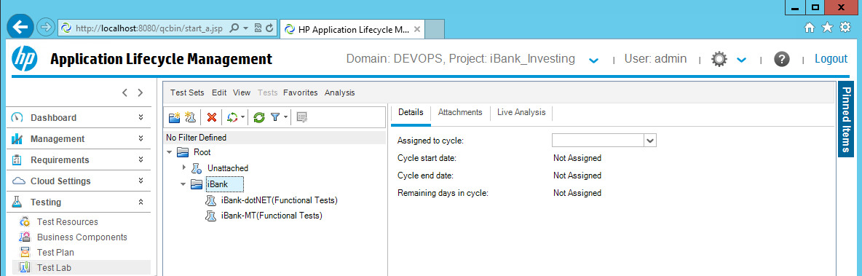

1. Select **iBank** folder. Click **Test Set > New Test set** from the toolbar above and create new test set - **iBank-dotNET(Performance Test)**. Click **OK**.

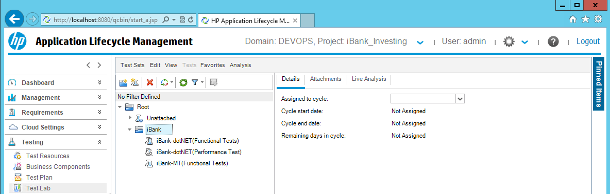

1. Associate the new ALM **Test Set** withthe **Test** created in the previous steps. Select the **iBank-dotNET(Performance Test)** and click on **Select Tests**.

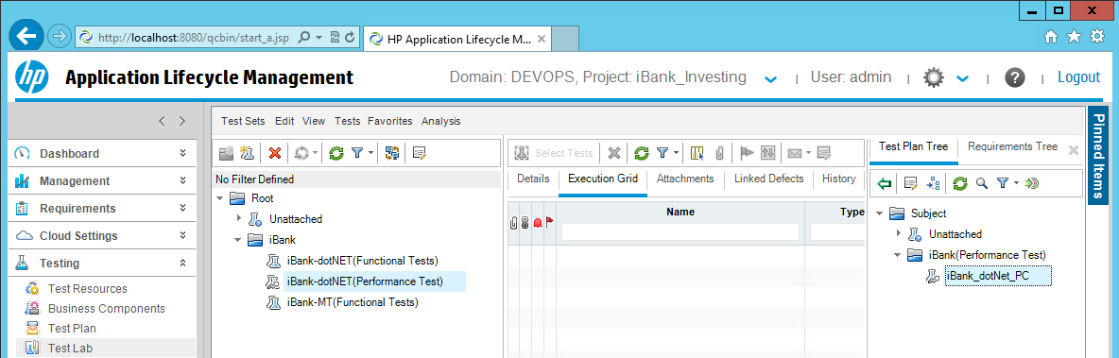

1. Select **iBank_dotNet_PC** from the **Test Plan Tree** and click to add the **Test**.

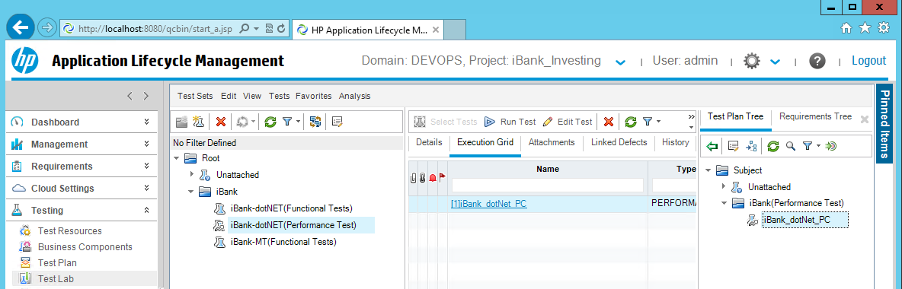

1. Click on **Execution Grid** and then click on **Edit Test**. Select  **Real-world schedule, by test** – **by number** and click **OK**.



1. Click **Select Scripts**, expand the scripts tree and select **iBank_dotNet_PC_scripts**. Click  to add the pc script.

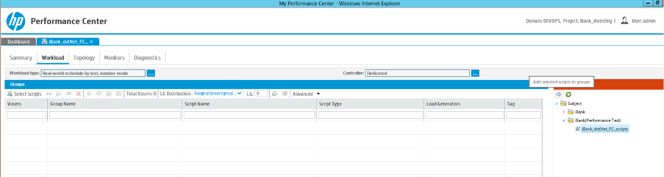

1. Select **Load Generators** and **Controller**.

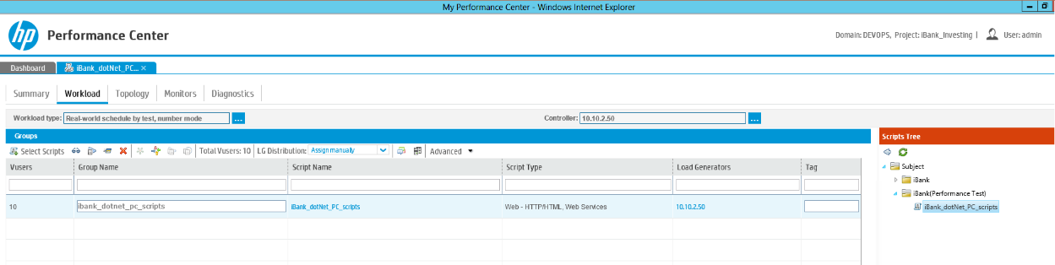

1. Configure the number of **Vusers** and **duration**,then click **Save**.

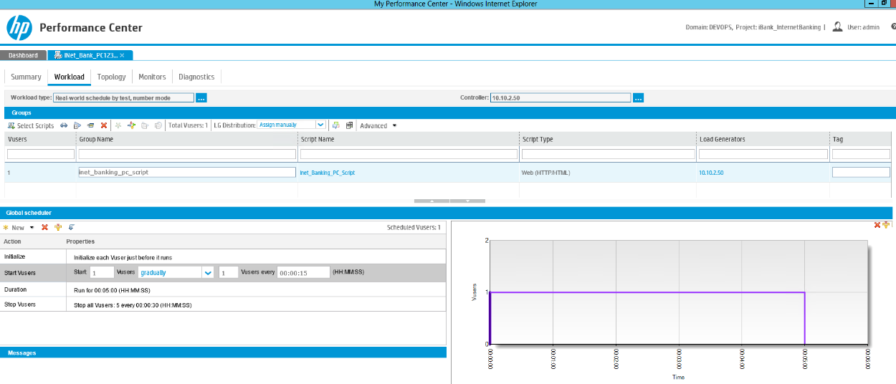

1. Click **Summary**, and under **Service Level Agreement** add new **Transaction Response Time Percentile** SLA. Click **Save** and **Close.**

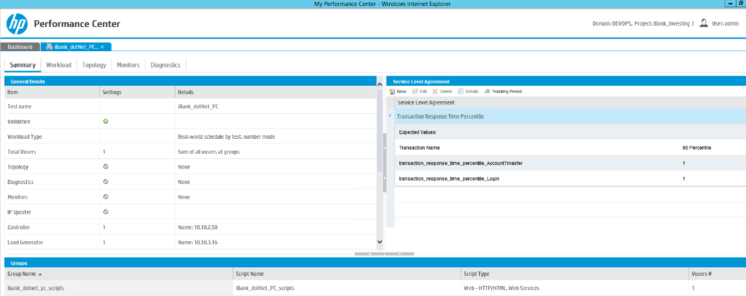

1. To verify the new Test Set is working, select the **iBank-dotNET(Performance Tests)** test set and click . Click **Run** button.

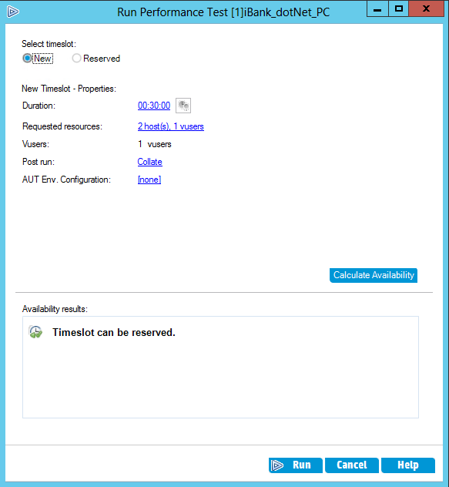

**Note:** The PC script will read the c:\PC_UFT_Test.dat configuration file and based on the application URL for iBank-dotNet, it will run the performance test. If the iBank-dotNet application is accessible, the test should be marked as **Passed**.

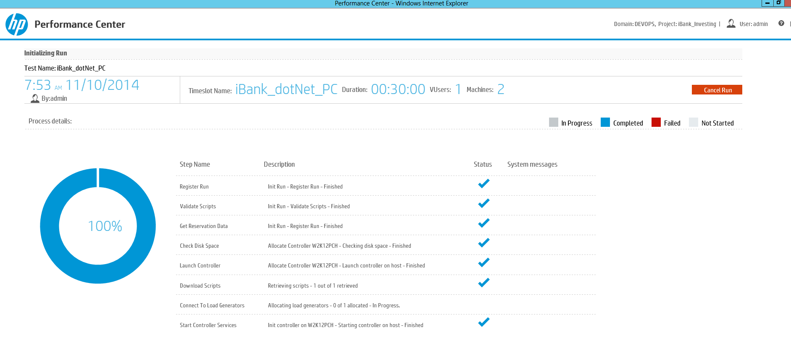

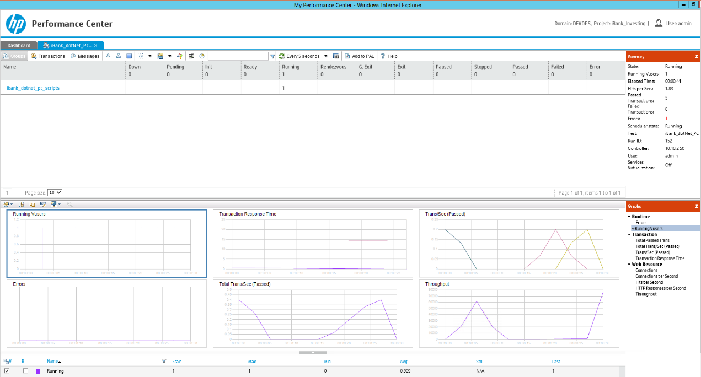

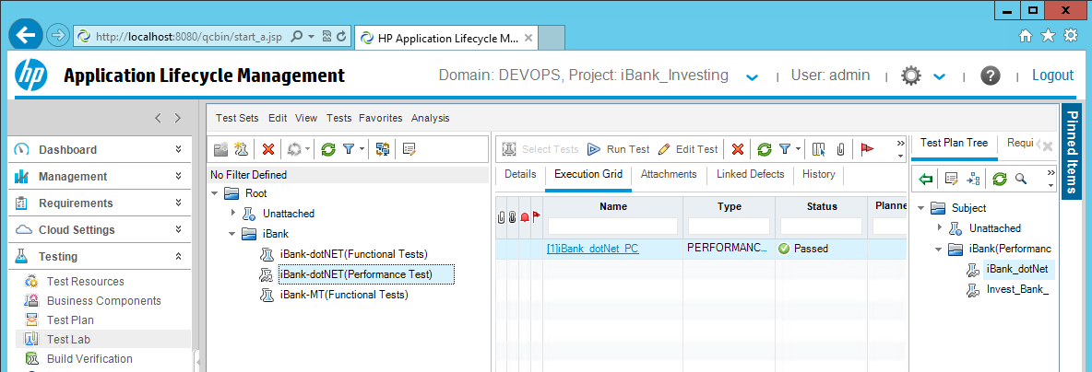

Setup HP Network Virtualization

iBank Java (iBank Internet Banking) performance testing with NV:

To set up HP Network Virtualization for iBank Java (iBank Internet Banking), please read and follow the steps in the provided document:

**DevOps_R3.5_Solution\Documentation\HP_Network_Virtualization_R3.5_Guide.docx**

HP ALM Customization for SM-ALM Synchronizer and AGM-ALM Synchronizer

Creating Customization Template Project in ALM

1. Login to ALM Site Admin.
2. Create a new template project by importing customization from existing template project file **ALMSync_Template.qcp** file in the the **Content files** **>** **hp_alm** folder.

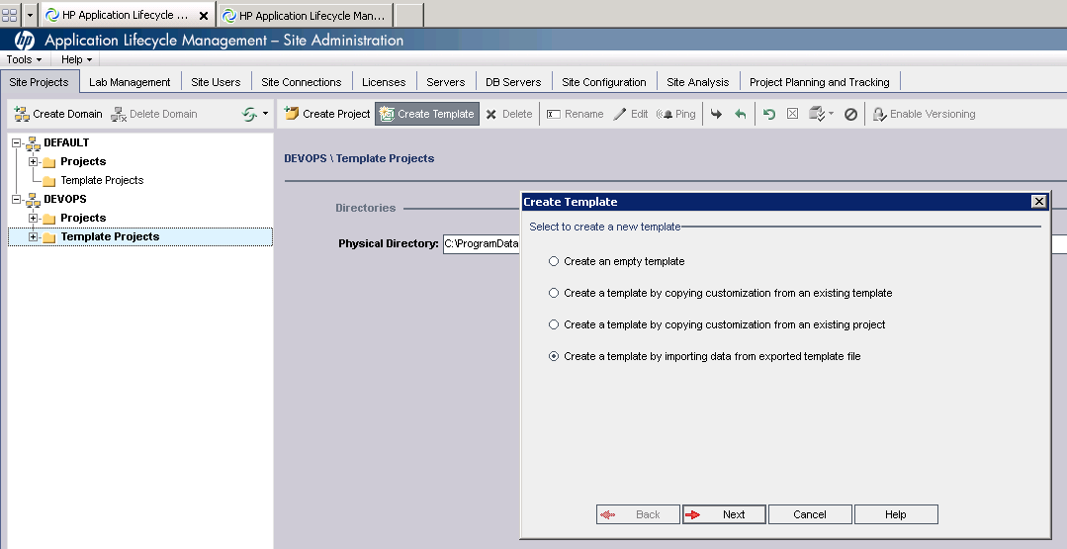

**Note :** This template has required custmization to be done at ALM with regard to integration of ALM with AGM and SM.

1. Browse the template project file **ALMSync_Template.qcp**

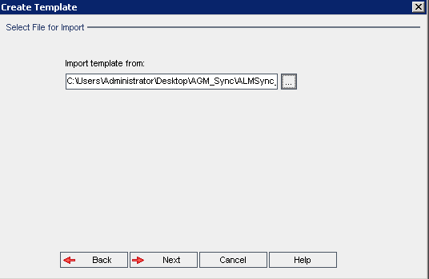

1. Provide template name and select domain.
2. Continue with rest of ALM Project creation steps that include providing DB Credentials, Selecting Project Admin.
3. Select ALM template project extensions required for DevOps link.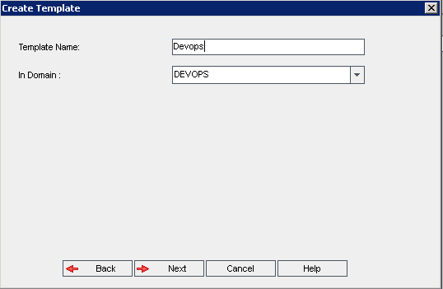
4. Click on finish to complete the template project creation. Activate the project once it is created.

Link existing/new ALM project to Template Project in ALM

1. Login to ALM Site Admin.
2. Create new ALM Project if there is not existing project to be linked to template project for Synchronizer customizations.

**Note:** New/Existing ALM Project need to have same project extensions as template project

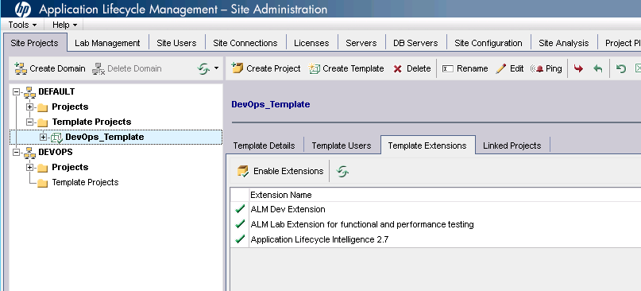

1. Select ALM Synchronizer template project that was created and go to Linked Projects tab.

Select the ALM project that needs to be linked to template project.

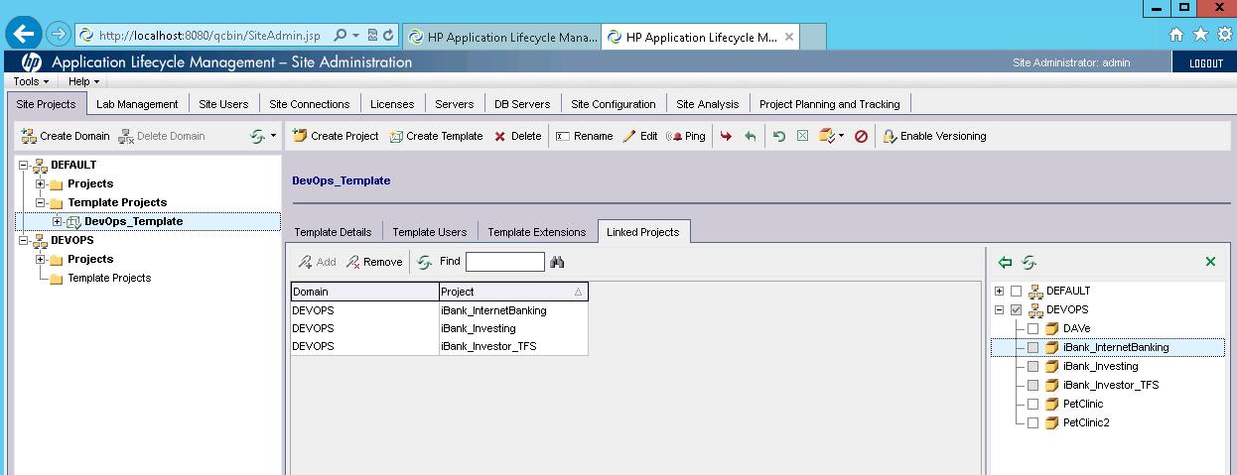

Apply Customization to ALM Project

1. Login to Template Project and select Customization link.

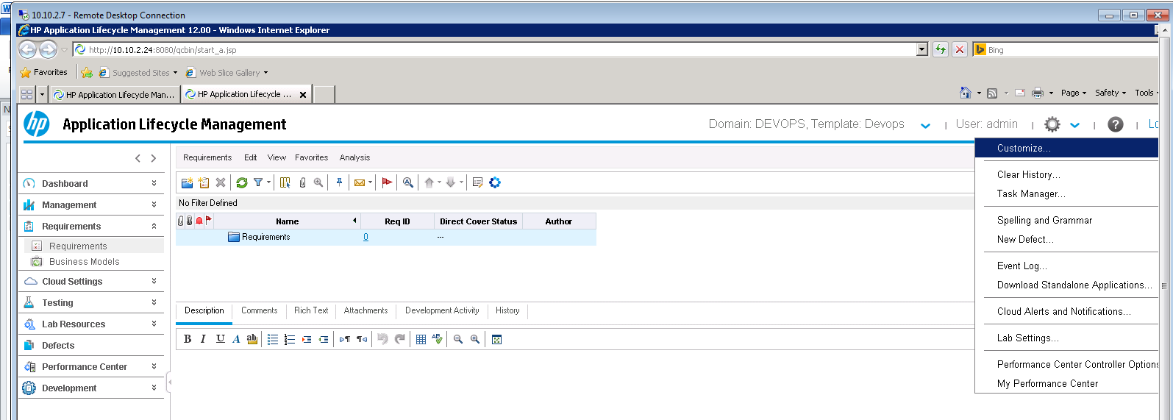

1. Select Cross Project Customization link in left navigation panel.
2. Select the project for which customization need to be applied and click on Verify Project.

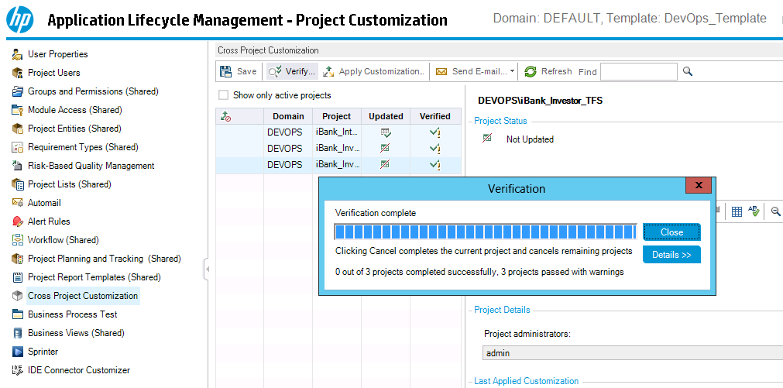

1. After successful verification, click on Apply Customization.

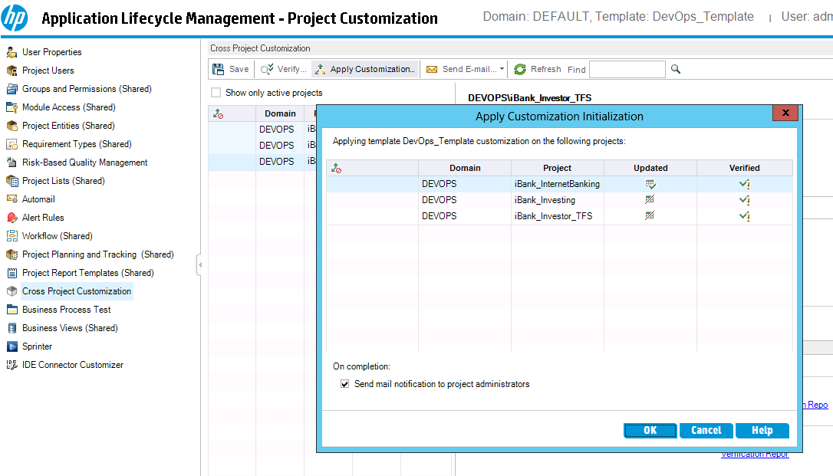

1. After successful customization, logout of template project .
2. Login to ALM Project to verify customization.

Select new defect and verify if new custom fields are apprearing.

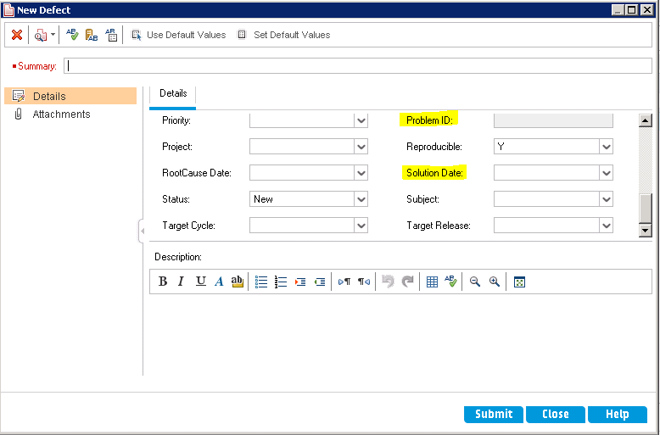

Setup HP AGM-ALM Synchronizer

Install AGM-ALM Synchronizer

1. Unzip the installation file to a location on your Synchronizer server machine and run the setup.exe file. The installation wizard opens.
2. Provide installation path.



1. The Summary Information dialog box opens. Click Next to start the installation process.
2. When the installation process completes, the Installation Complete dialog box opens. Click Finish to proceed to the server configuration process.
3. The HP ALM Synchronizer Server Configuration wizard opens.



1. The configuration wizard installs and configures the PostgreSQL database management system, and creates a service on the Synchronizer server machine.
2. Select the ALM Version
3. Configure the Service - To allow the service to run using the Windows Local System account, leave all fields empty.
4. Continue with default installation steps
5. After you install the Synchronizer server, you can install the Synchronizer client

Create Link in Synchronizer

1. Select Link > Create or click the Create Link button. The Create Link wizard opens to the General Properties dialog box. Update Link name and Description

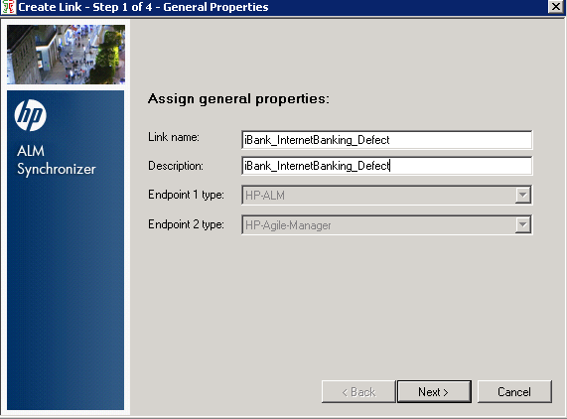

1. Update ALM Server details.

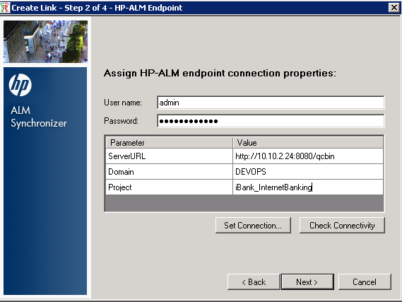

Check connectivity and click on next

**Note:** ALM Client need to be installed on Synchronizer server before configuring the link

http://<ALM servername>:<port>/qcbin/start_a.jsp?common=true

1. Configure Agile Manager details

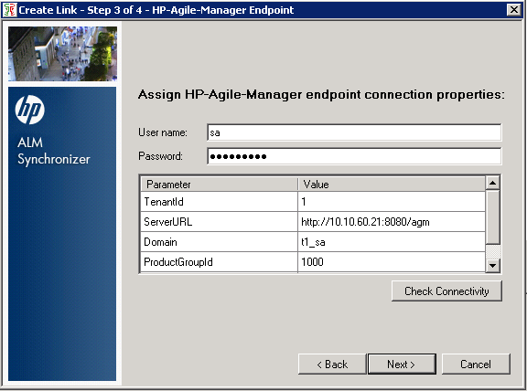

1. Select Entity Types

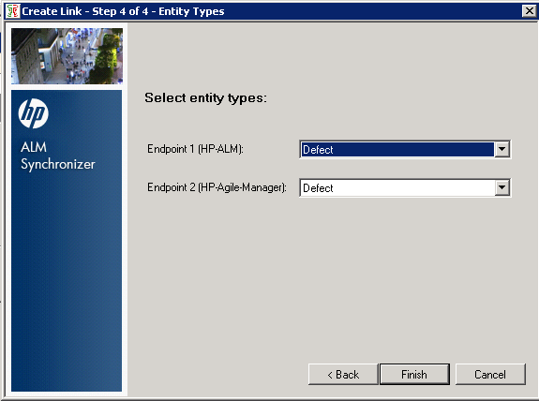

You need to create three links based on Entity types and for each ALM project

ALM - Release, AGM-Release

ALM – Requirements, AGM – Requirement

ALM – Defect, AGM - Defect

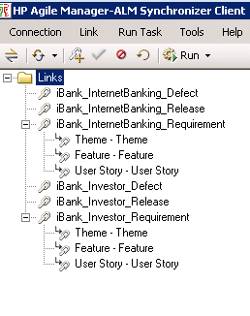

Configure Release Link

1. Following field mapping between ALM and AGM has to be done for Release

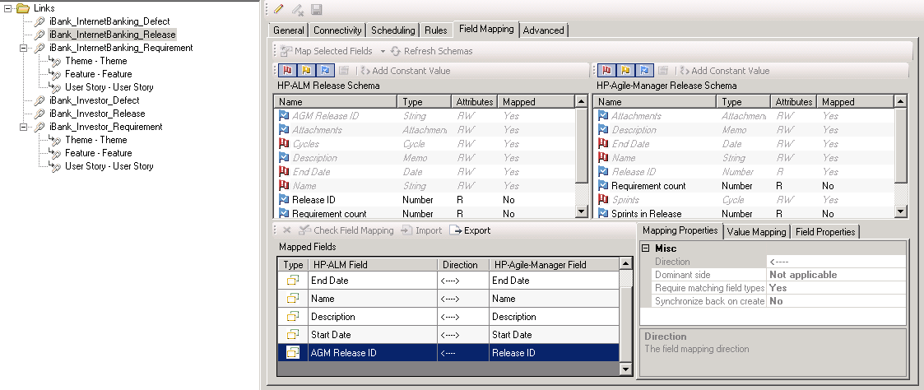

Fields to be mapped (along with directions) are :

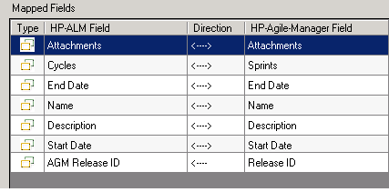

1. Following rules has to be configured for Release link

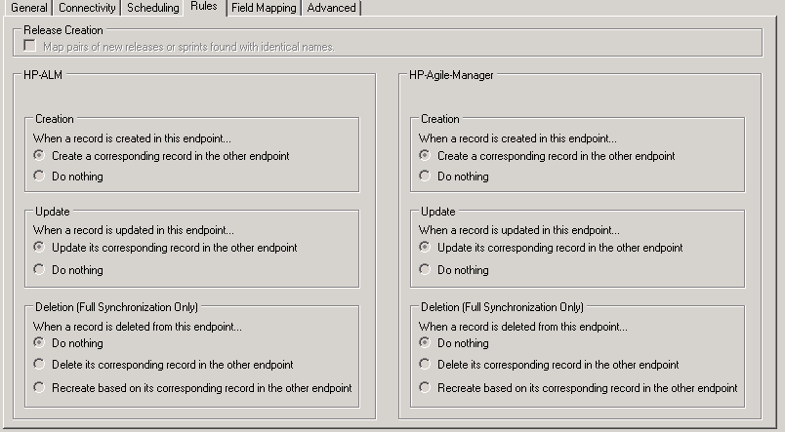

1. Save configuration to run integrity check.
2. Enable the link

Configure Defect Link

1. Following field mapping between ALM and AGM has to be done for Defect.

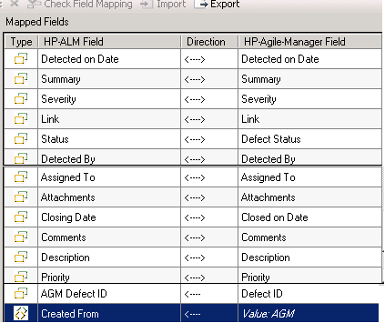

* + - Created From is Constant and the value is AGM
    - Status values in ALM and Defect Status values in AGM has to be mapped

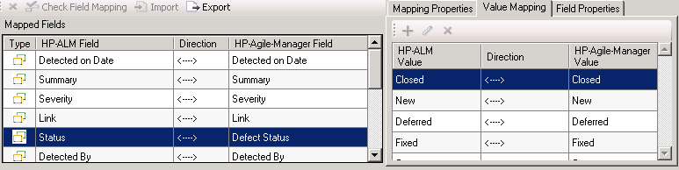

* + - AssignedTo users in ALM and AGM have to be value mapped.
    - Priority, Severity in ALM and AGM has to be value mapped.

1. Configure Rules for Defect link as shown below

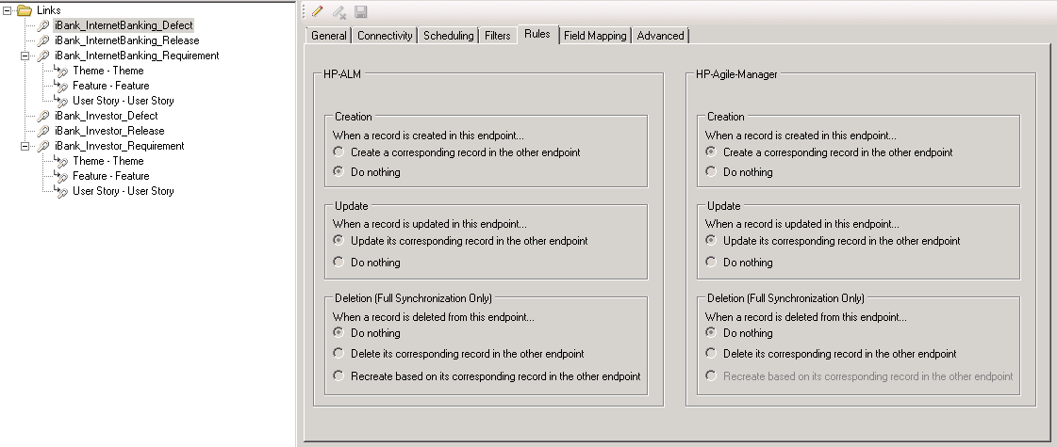

Configure Requirement Link

1. To configure, requirement link, Field mapping has to be done for 3 requirement subtypes by mapping ALM Requirement Types with AGM requirement type

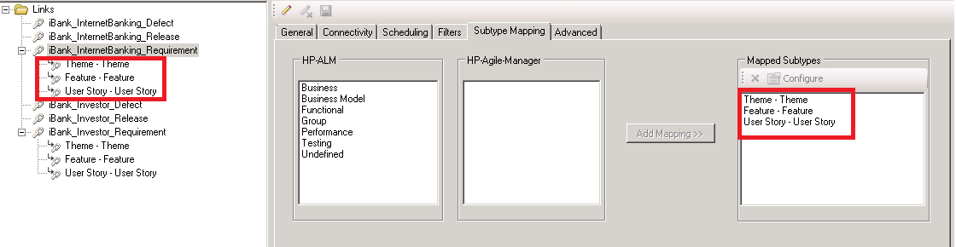

**Note:** Mapping of requirement subtypes has to be done in following order

1. *Theme*
2. *Feature*
3. *User Story*
4. Three Sub types links will be created for each requirement type.
5. Configure each sub type requirement link.
6. Following field mapping between ALM and AGM has to be done for Requirement Type Theme

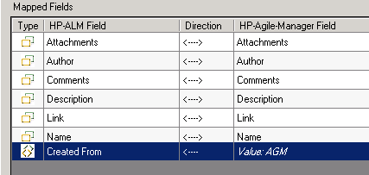

* + - Created From is Constant and the value is AGM
    - Author users in ALM and AGM have to be value mapped.

1. Configure Rules for Requirement Type Theme link are as shown below .

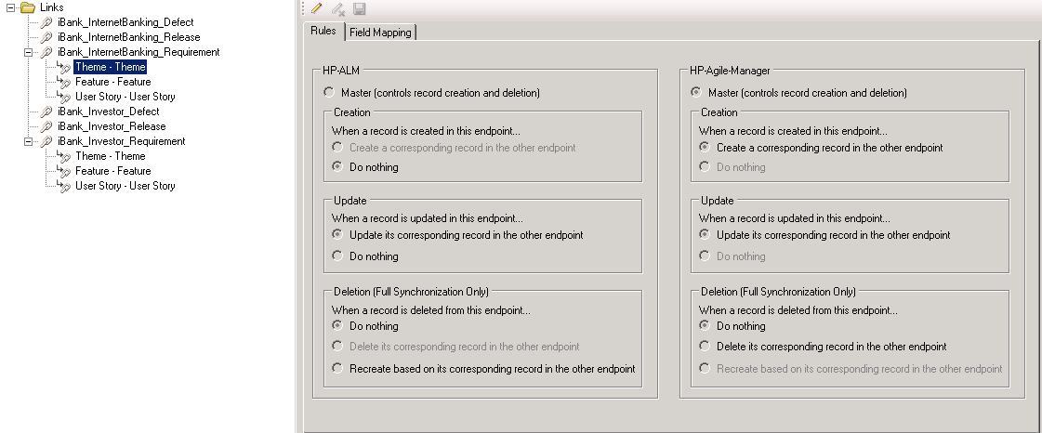

1. Following field mapping between ALM and AGM has to be done for Requirement Type Feature.

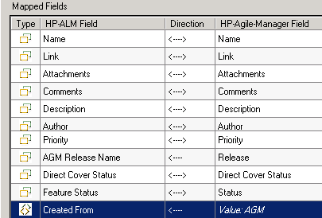

* + - Created From is Constant and the value is AGM
    - Author users in ALM and AGM have to be value mapped.
    - Priority in ALM and AGM has to be value mapped.
    - Feature Status in ALM and AGM has to be value mapped
    - Direct Cover Status in ALM and AGM has to be value mapped.

1. Configure Rules for Requirement Type Feature link are as shown below.

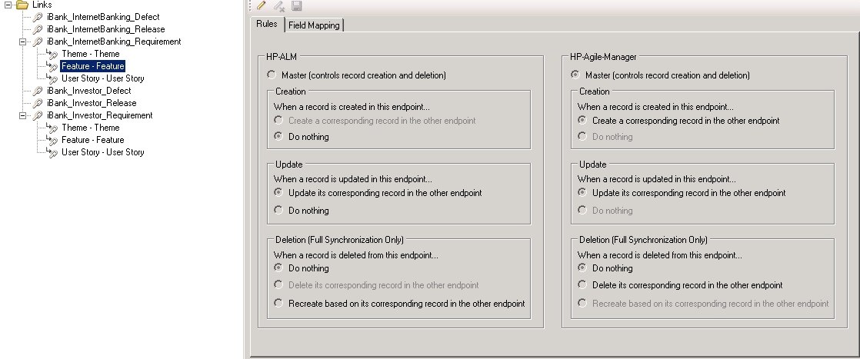

1. Following field mapping between ALM and AGM has to be done for Requirement Type User Story

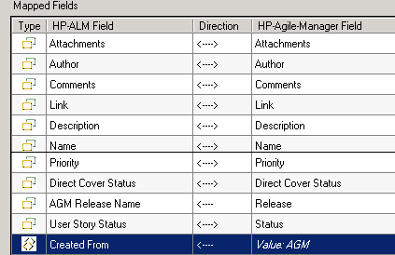

* + - Created From is Constant and the value is AGM
    - Author users in ALM and AGM have to be value mapped.
    - Priority, User Story Status and Direct Cover Status in ALM and AGM has to be value mapped.

1. Configure Rules for Requirement Type User Story link are as shown below

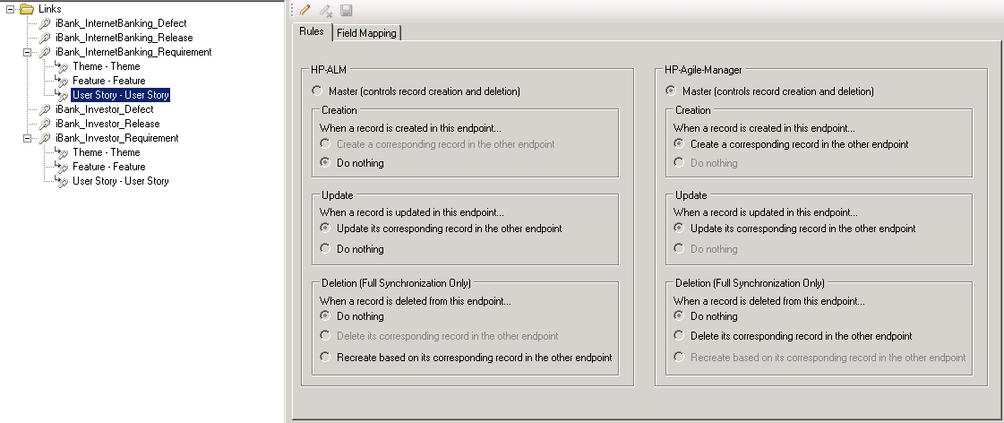

Test the Link (Requirement)

1. Create a User Story, under given Theme and Feature in Agile Manager

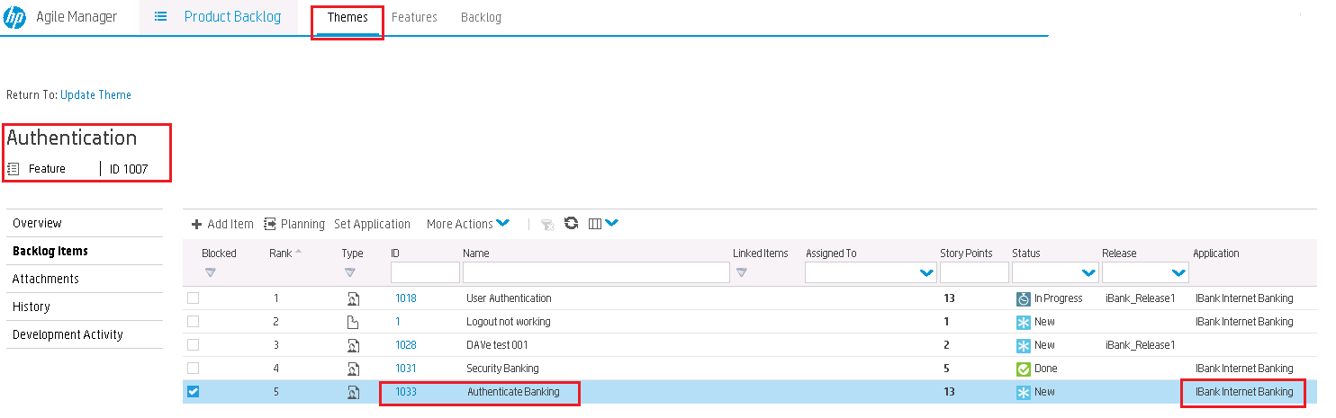

1. Run Synchronization link and verify in ALM

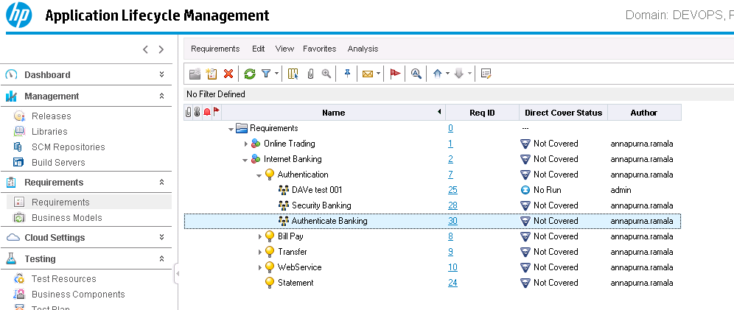

Test the Link (Release)

1. Create release in HP Agile Manager

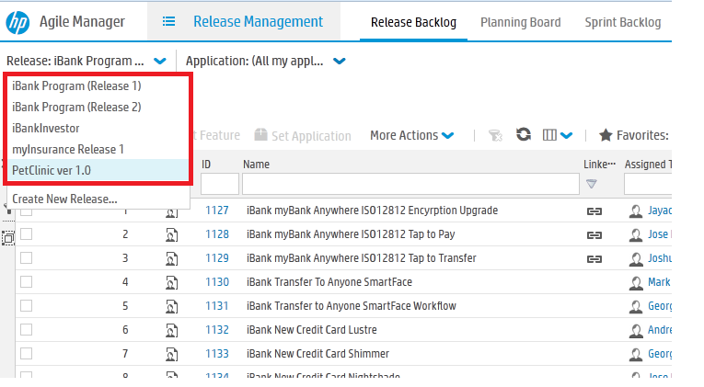

1. Run the link and verify in ALM

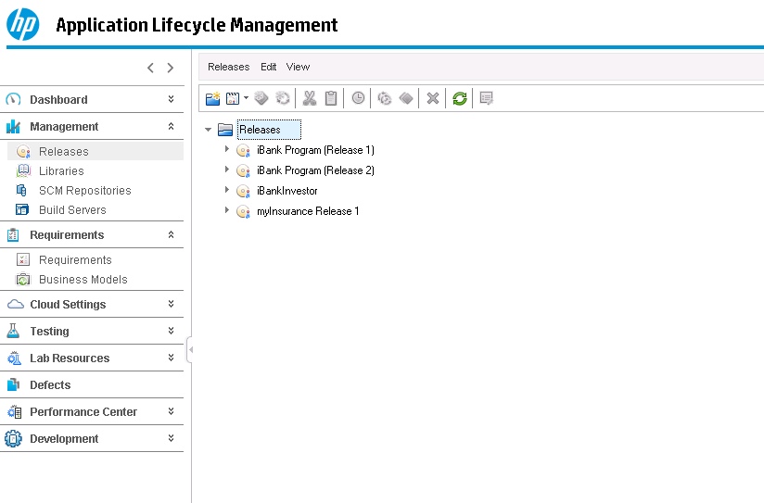

Setup HP SM-ALM Synchronizer

Install HP Synchronizer

1. Install HP Synchronizer and follow default installation steps.
2. Following items need to be considered while installing HP Synchronizer :
   * + When installing the ALM Synchronizer, select the ALM 12 mode so that it supports synchronization with ALM 12.
     + The ALM client is installed when you are logging into ALM. The correct ALM client should be installed on the ALM Synchronizer server
     + The ALM Synchronizer machine should have the same time zone with the ALM machine.
     + Make sure that the time difference in UTC between SM and ALM Synchronizer is within 5 minutes, otherwise the data might be lost during synchronization

Setting up HP SM-ALM Synchronizer

Deploy Adapters

Copy all files under the <release-package>\adapter directory to the <QCS_Install_Dir>\adapters\lib directory.

Adapters include:

sm-adapter-XX.XX.XXX.jar (XX.XX.XXX is the version number for the current release)

sm-adapter-axis-1.4.jar

sm-adapter-commons-discovery-0.2.jar

sm-adapter-commons-lang-2.3.jar

sm-adapter-jaxrpc-1.1.jar

sm-adapter-jdom-1.1.jar

sm-adapter-saaj-1.2.jar

sm-adapter-wsdl4j-1.5.1.jar

sm-adapter-commons-codec-1.3.jar

sm-adapter-commons-httpclient-3.1.jar

Generating/Deploying Stub

1. Ensure SM service is running
2. Edit the following lines in <release-package>\bin\build.properties as required for access to Service Manager

#Set up WSDL URL, please change the URL to your actual SM server, eg,

http://<your-server>:<port>/.../<service-name>.wsdl

#Comment this line by this sign "#" if you do not generate stub jar for change management module

sm.change.wsdl=http://localhost:13080/sc62server/PWS/QCIntChangeService.wsdl

#Comment this line by this sign "#" if you do not generate stub jar for problem management module

sm.problem.wsdl=http://localhost:13080/sc62server/PWS/QCIntProblemService.wsdl

1. Run the script build.bat from the operating system’s command prompt (check the console output for errors). The stub <Release_Package>\build\sm-adapter-ws-client.jar is generated.
2. Copy the stub to the *<QCS_Install_Dir>\adapters\lib* directory.

Copying SM Adapter Configuration Files

1. Restart Synchronizer Service

Click Start > All Programs > HP Quality Center Synchronizer > Start/Stop Synchronizer.

1. The directories <QCS_Install_Dir>\adapters\dat\SM ChangeManagement and SM ProblemManagement appear after the synchronizer service is started (this can take up to one minute).



1. Copy the file <Release_Package>\sample\configuration_file_default.xml to the following folders:
   * + SM ChangeManagement
     + SM ProblemManagement

Creating link in Synchronizer

1. Connect to synchronization server using Synchronization client

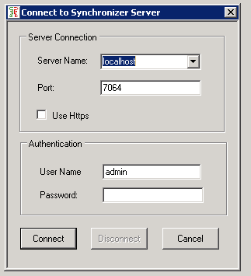

1. Create link for **SM Problem -> ALM Defect**

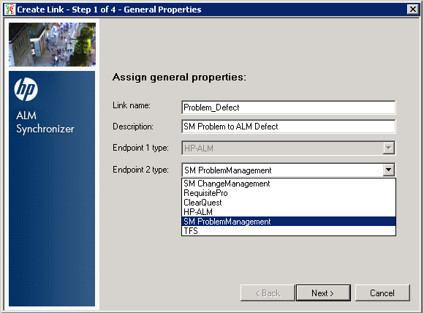

1. Update ALM server details

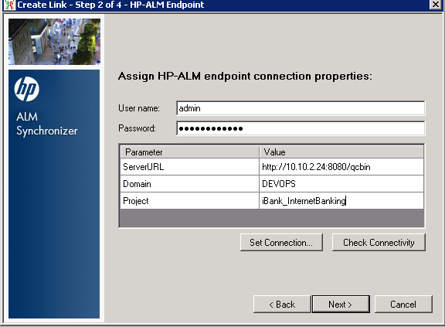

Server URL : http://<ALM servername>:<port>/qcbin

1. Update SM Server details

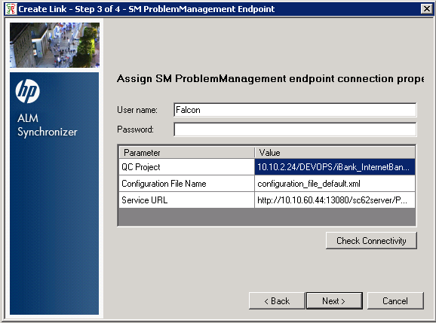

1. Select the entity type and click on finish

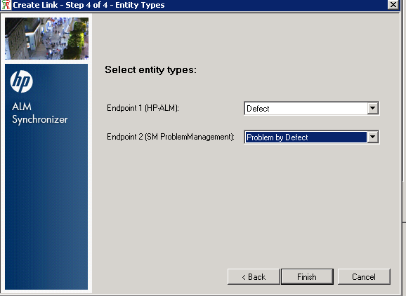

Define Field mappings Synchronizer

1. In Field mapping tab, select the below columns of ALM and SM and map the same.

|  |  |  |
| --- | --- | --- |
| **ALM Field** | **Link** | **SM Field** |
| Summary | **↔** | Description |
| Severity | ↔ | Severity |
| DefectID | → | QCEntityID |
| Problem ID | ← | ProblemID |
| Detected On Date | ← | Open Time |
| Comments | ↔ | RootCause |
| Status | ↔ | RCStatus |
| ExpectedResolutionDate | → | ExpectedResolutionDate |
| RootCause Date | → | RootCauseDate |
| Solution Date | → | SolutionDate |
| Created From | → | **ServiceManager** (Constant) |

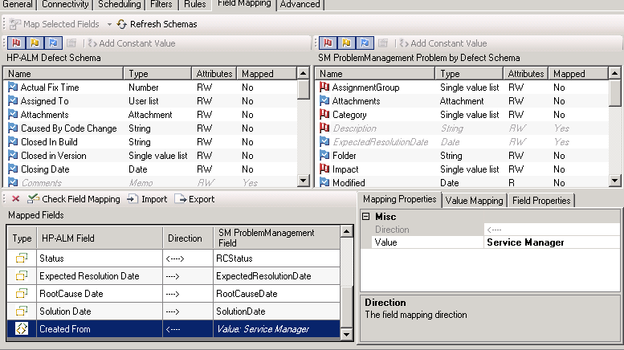

1. Set the rules for the link as shown below

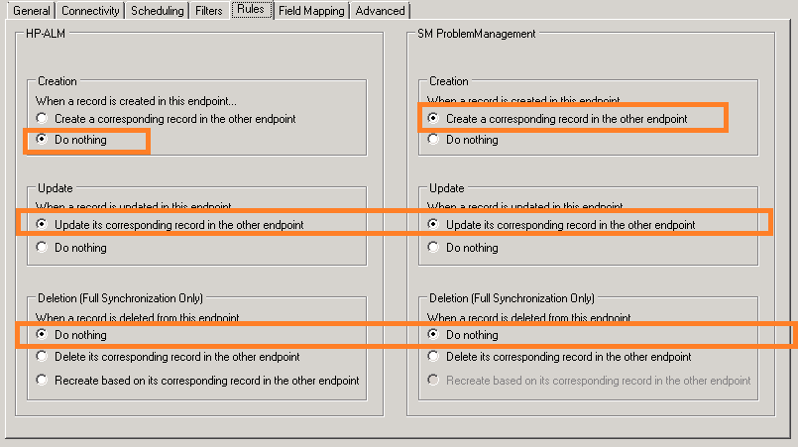

1. Save the configuration (an integrity check is automatically run).

Test the Link in Synchronizer

1. Enable the link.
2. Create a problem in Service Manager

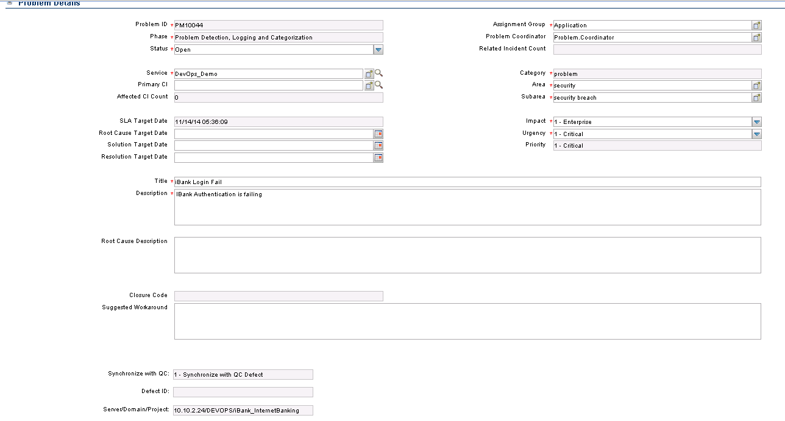

1. Run Synchronization of the link

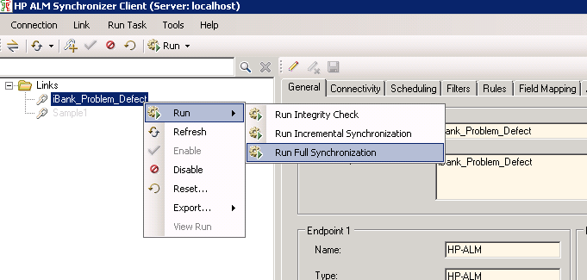

1. The defect should be created in ALM

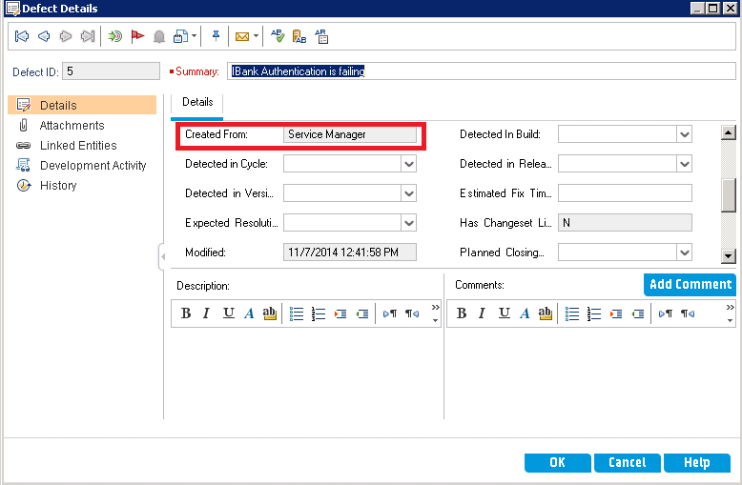

1. Any changes in ALM defect will be synchronized to SM Problem.

Scheduling in Synchronizer

1. Synchronizer process can be automated by scheduling at regular intervals.
2. Below are the scheduling options in Synchronizer :

